1-cm-Dia. x 50-cm-Long Tungsten Rod: 100 kW, k = (313+355T)/(1000+4.685T)
Bob Weggel Magnet Optimization Research Engineering (M.O.R.E.), LLC 2/23/2014
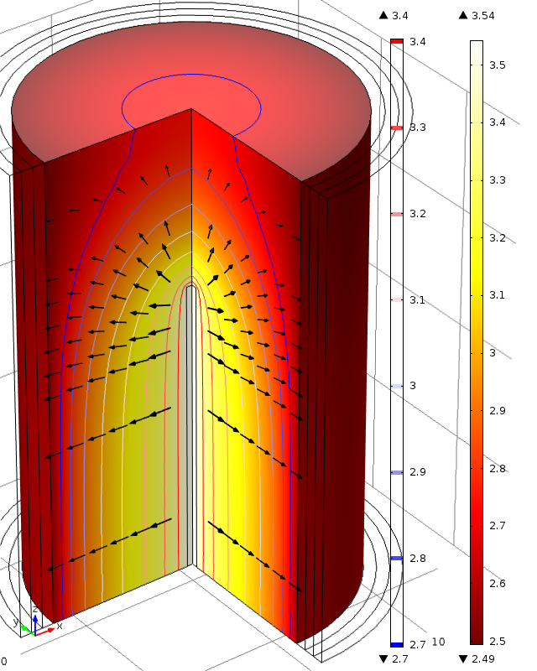
Fig. 1. Log₁₀(T) of upper half of a radiation-cooled tungsten rod of 1-cm dia. and 50-cm length; uniform power-deposition density = [100kW/39.3 cm³ = 2.55 kW/cm³. T_{max} = 10^{3.54} = 3,470 K.

