Radiationally-Cooled Tungsten Rod: 100 kW, k = (313+355T)/(1000+4.685T)
Bob Weggel Magnet Optimization Research Engineering (M.O.R.E.), LLC 2/24/2014
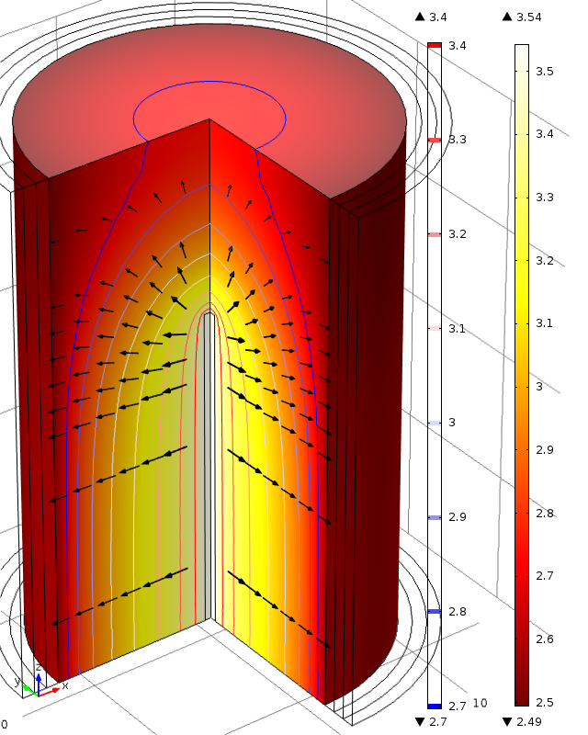
Fig. 1. Radiation direction (arrows) and log₁₀(T) of upper half of radiationally-cooled tungsten rod of 10-mm diameter and 50-cm length; uniform power-deposition density = [100kW/39.3 cm³ = 2.55 kW/cm³. T_{max} = 10^{3.54} = 3,470 K.
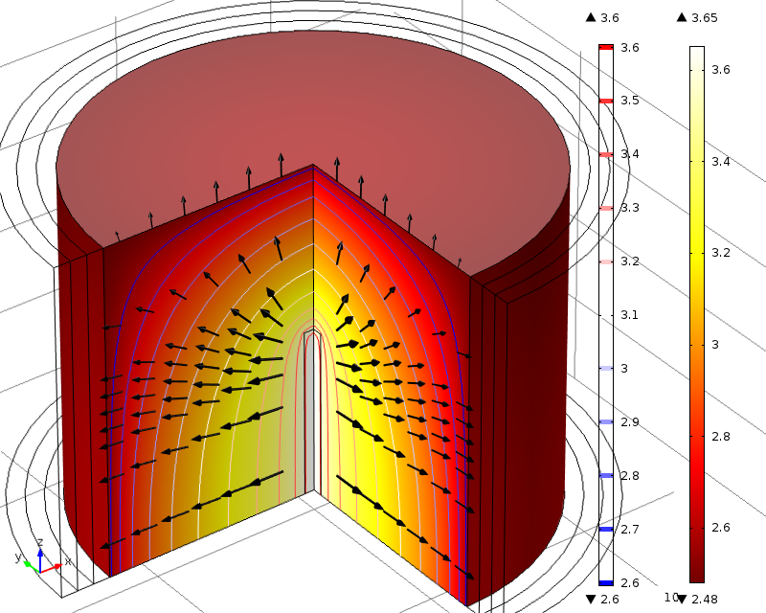
Fig. 2. Radiation direction (arrows) and log₁₀(T) of upper half of radiation-cooled tungsten rod of 12-mm dia. and 20-cm length; uniform power-deposition density = [100kW/22.6 cm³ = 4.42 kW/cm³. T_{max} = 10^{3.65} = 4,461 K.
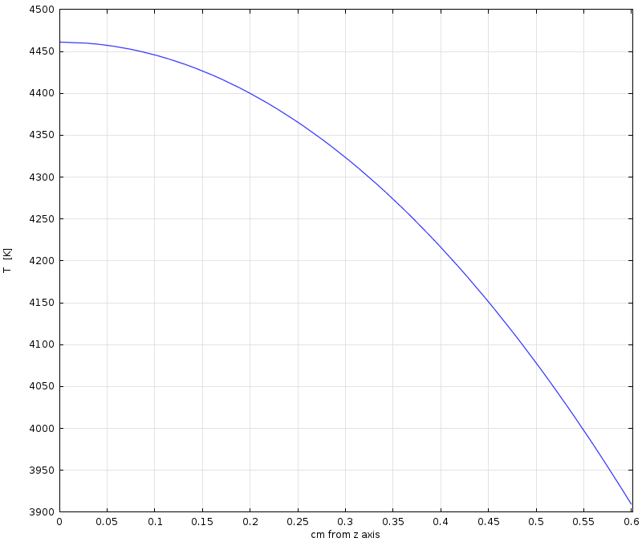
Fig. 3. Radial dependence of temperature at longitudinal midplane of Fig. 2 rod. T_{max} = 4461 K; surface temperature T(r=6mm)= 3909 K.

