Radiationally-Cooled Tungsten & Carbon Rods
Bob Weggel Magnet Optimization Research Engineering (M.O.R.E.), LLC 3/2/2014
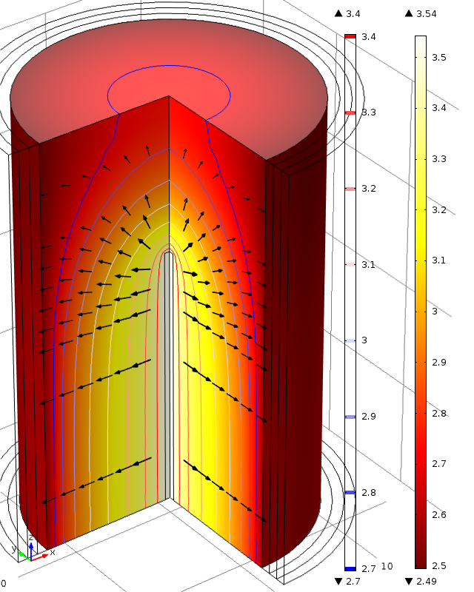
Fig. 1. Radiation direction (arrows) and log₁₀(T) of upper half of radiationally-cooled tungsten rod of 10-mm diameter and 50-cm length; uniform power-deposition density = [100kW/39.3 cm³ = 2.55 kW/cm³. T_{max} = 10^{3.54} = 3,470 K.
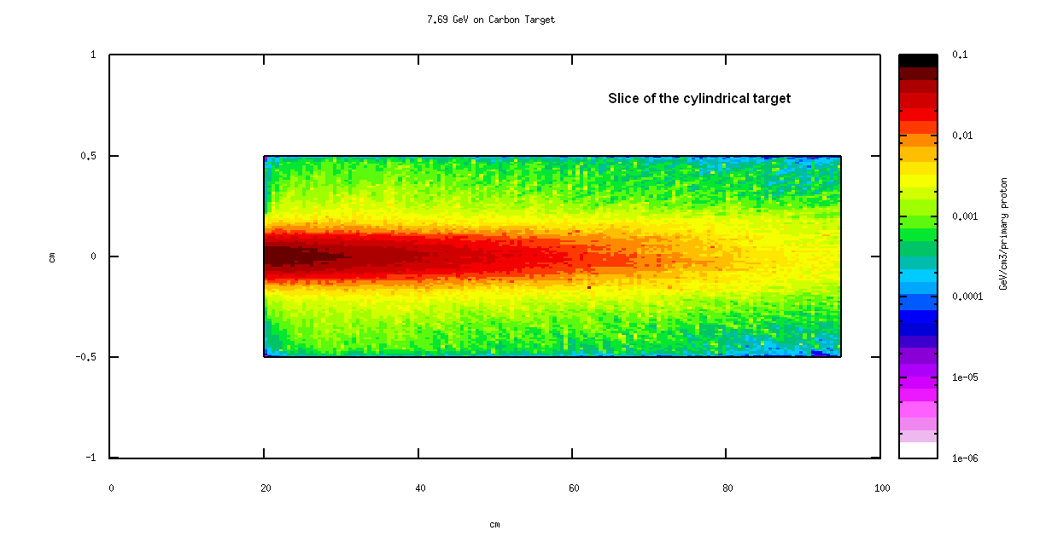
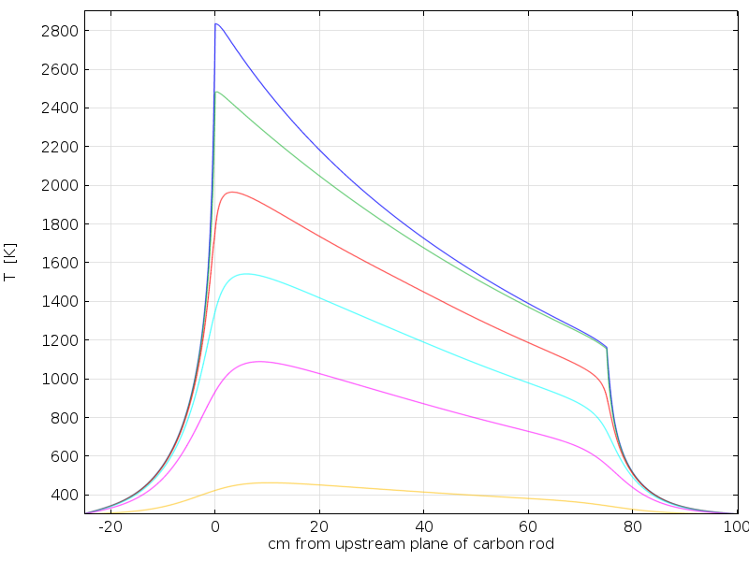Fig. 2. T(z|r) of carbon rod of thermal conductivity k = 38+51,600/T W/m-K and power deposition density p = 596 e^{−z/25} W/cm³ (25 kW in a rod 15 mm in diameter and 75 cm long). Blue curve is along rod axis: T_{max} = 2,830 K; green curve is along its surface: T_{max} = 2,490 K. Red, cyan, pink and ochre and curves are r = 1.5, 3, 6 & 12 cm, respectively.

