Target-Magnet Field Profile that Ramps from 20 T to 1.5 T at 7 m

Bob Weggel

Magnet Optimization Research Engineering, LLC

(March 30, 2013)



Fig.1. On-axis field profile of Target Magnet “IDS120'20to1p5T7m.xlsx” of 3/29/2013: 5-T, 10.8-MW resistive magnet (red); superconducting coil #1 (turquoise); 15-T superconducting magnet (blue); total field (magneta); desired field (black); and field error (grey), defined as 1000(∆B)2/B.

**Table I: Parameters of Target Magnet “IDS120'20to1p5T7m.xlsx” of 3/29/2013**

|  |  |  |  |  |  |  |  |  |  |  |
| --- | --- | --- | --- | --- | --- | --- | --- | --- | --- | --- |
| Current density jcoil | kA/cm2 | 2.078 | 1.665 | 1.513 | 1.393 | 1.294 | **1.911** | **3.453** | **4.137** | **4.359** |
| Coil length | cm | 129.2 | 165.4 | 165.4 | 165.4 | 165.4 | 397.55 | 51.63 | 50.87 | 41.44 |
| Gap between coils | cm |  |  |  |  |  |  | 121.52 | 88.73 | 89.01 |
| Upstream end | cm | **-86.7** | **-122.9** | -122.9 | -122.9 | -122.9 | **-238.2** | **280.9** | **421.2** | **561.1** |
| Downstream end | cm | **42.4** | 42.4 | 42.4 | 42.4 | 42.4 | **159.4** | **332.5** | **472.1** | **602.6** |
| Inner radius [cm] | 0.50 | 18.28 | 23.75 | 29.78 | 36.09 | 42.66 | 120.0 | 120.0 | 120.0 | 120.0 |
| Radial depth of conductor | cm | 4.760 | 5.318 | 5.579 | 5.815 | 6.031 | **79.63** | **16.501** | **8.069** | **7.945** |
| Outer radius [cm] | 50.0 | 23.04 | 29.07 | 35.35 | 41.90 | 48.69 | 199.63 | 136.50 | 128.07 | 127.94 |
| Maximum on-axis field | T | 20.00 | 18.83 | 17.77 | 16.78 | 15.86 | 15.00 | 4.89 | 2.74 | 1.82 |
| Current density jcoil | kA/cm2 | **4.570** | **4.588** | **4.548** | **4.680** | **4.716** | **4.715** | 4.715 | 4.715 | 4.715 |
| Coil length | cm | 78.10 | 358.62 | 30.00 | 20.00 | 467.14 | 20.00 | 20.00 | 467.14 | 20.00 |
| Gap between coils | cm | 70.00 | **17.86** | 17.86 | 50.00 | 17.86 | 17.86 | 40.00 | 17.86 | 17.86 |
| Upstream end | cm | 672.6 | 768.5 | 1145.0 | 1225.0 | 1275.0 | 1760.0 | 1820.0 | 1875.0 | 2360.0 |
| Downstream end | cm | **750.7** | 1127.1 | 1175.0 | 1257.1 | 1742.1 | 1780.0 | 1857.1 | 2342.1 | 2380.0 |
| Inner radius [cm] | 0.50 | 90.0 | 90.0 | 90.0 | 60.0 | 60.0 | 60.0 | 60.0 | 60.0 | 60.0 |
| Radial depth of conductor | cm | **2.658** | **2.403** | **8.474** | **4.214** | **2.449** | **6.302** | 6.302 | 2.449 | 6.302 |
| Outer radius [cm] | 50.0 | 92.66 | 92.40 | 98.47 | 64.21 | 62.45 | 66.30 | 66.30 | 62.45 | 66.30 |
| Maximum on-axis field | T | 1.51 | 1.48 | 1.53 | 1.51 | 1.51 | 1.53 | 1.51 | 1.51 | 1.53 |
|  |  |  |  |  |  |  |  |  |  |  |
|  |  |  |  |  |  |  |  |  |  |  |

The “desired field” in Fig. 1 is the inverse-polynomial B(u) = 180/[9+37u2(4-u6)], where u ≡ x/L, x ≡ z+37.5 cm, and L ≡ 737.5 cm. B(u) involves only even powers of u, and therefore is symmetric about u=0—i.e., z = −37.5 cm. The derivative, dB/du is 53280u(u2−1)[(u2+1)2−u2]/ (37u8−148u2−9)2, which is zero at u = 0 and u = 1—i.e., x = 737.5 cm, or z = 700 cm.

A more general expression, likewise with zero slope at x = 0 and x = L, is B(u) = nB0/[n+bu2(n+2−2un)], where B0 ≡ B(u=0) and b ≡ [B0/B(L)]−1. Its first derivative is n[2bu(2un−n−2)+2bnun+1]/[bu2(2u2−n+2)−n]2. The equation for the 2nd derivative is two lines long; that for the 3rd derivative takes five lines—rather inconvenient for analytic prediction of the paraxial field by a power-series expansion in Legendre polynomials.

A form more amenable to analytic differentiation is B(u) = B0−∆B(au2+bup+cuq), where the parameters q and p need not be integers but should both be greater than 2, if the field near u=0 is to be dominated by the quadratic term. The three parameters a, b & c enable the expression to achieve at the end of the ramp not only the desired field and slope (zero), but also **zero curvature**. Figure 3 plots two illustrative field profiles.

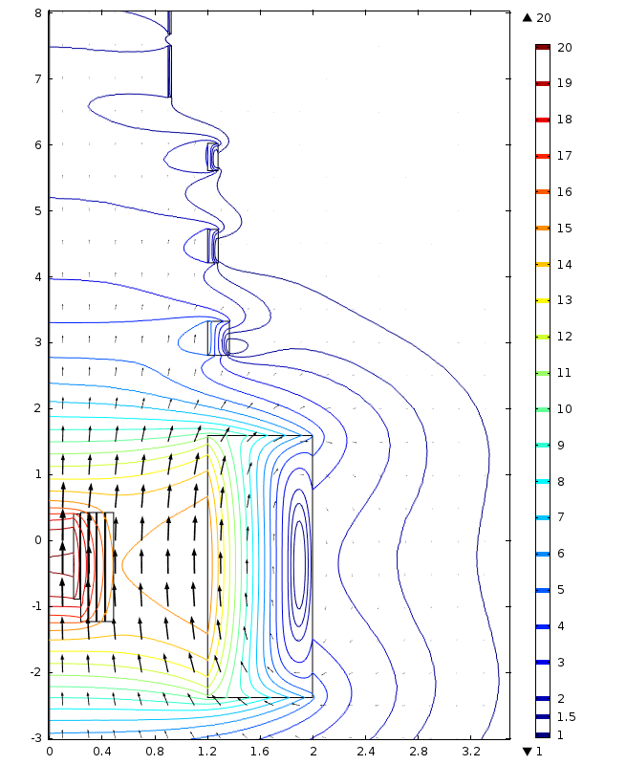

Fig. 2. Coil cross sections, and field magnitude & direction with B(r=0, z) = 20 T at z = −0.375 m, 1.5 T at z = 7 m.



Fig. 3. Illustrative field profiles with zero 1st and 2nd derivatives at end of ramp.