Target Magnet “20to2T5m100cm” & Chicane from 5 m to ~20 m
Bob Weggel Magnet Optimization Research Engineering (M.O.R.E.), LLC 2/22/2014
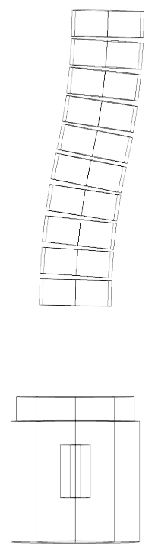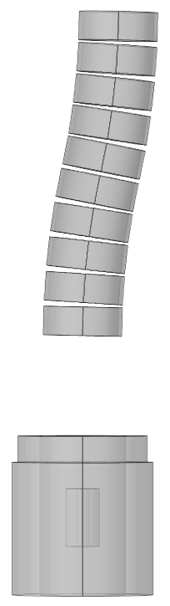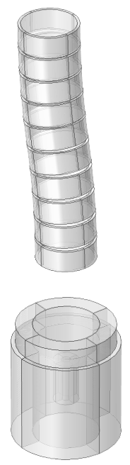
Fig. 1a-c. Views of Target Magnet “20to2T5m100cm” with 10-coil chicane. Left: y-z plane wireframe; Center: y-z plane transparency; Right: Isometric. Target-Magnet dimensions as in “20to2T5m100cm.xlsx” of 2/12/2014. Chicane dimensions: vertical (y) offset = 100 cm; toroidal half-angle θ = 12.5°; major radius = 50 cm / [1 – cos(θ)] = 21.09 m; minor radius = 100 cm; coil build = 10 cm; coil length = 80 cm; overall length ∆z = 2 R sin(θ) = 9.131 m.

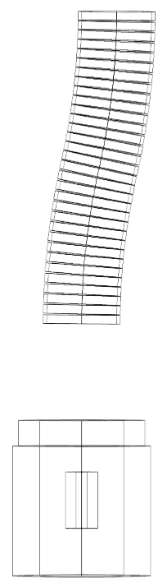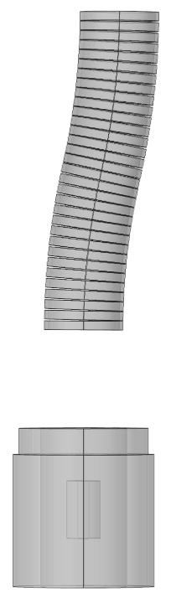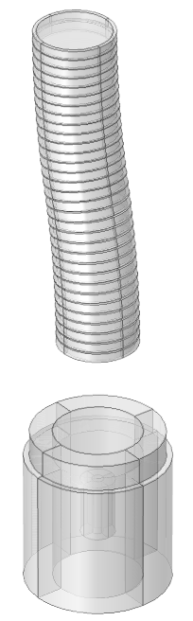
Fig. 2a-c. Views of Target Magnet “20to2T5m100cm” with 32-coil chicane. Left: y-z plane wireframe; Center: y-z plane transparency; Right: Isometric. Target-Magnet dimensions as in Fig. 1. Chicane dimensions: vertical (y) offset = 100 cm; toroidal half-angle θ = 12.8°; major radius = 50 cm / [1 – cos(θ)] = 20.12 m; minor radius = 100 cm; coil build = 10 cm; coil length = 25 cm; overall length ∆z = 2 R sin(θ) = 8.915 m.

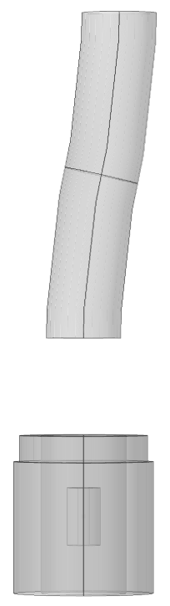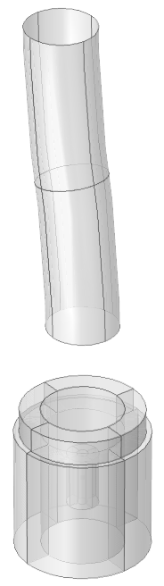
Fig. 3a-c. Views of Target Magnet “20to2T5m100cm” with toroidal current-sheet chicane. Left: y-z plane wireframe; Center: y-z plane transparency; Right: Isometric. Target-Magnet dimensions as in Figs. 1 & 2. Chicane dimensions: vertical (y) offset = 100 cm; toroidal half-angle θ = 12.5°; major radius = 50 cm / [1 – cos(θ)] = 21.09 m; minor radius = 100 cm; overall length ∆z = 2 R sin(θ) = 9.131 m.

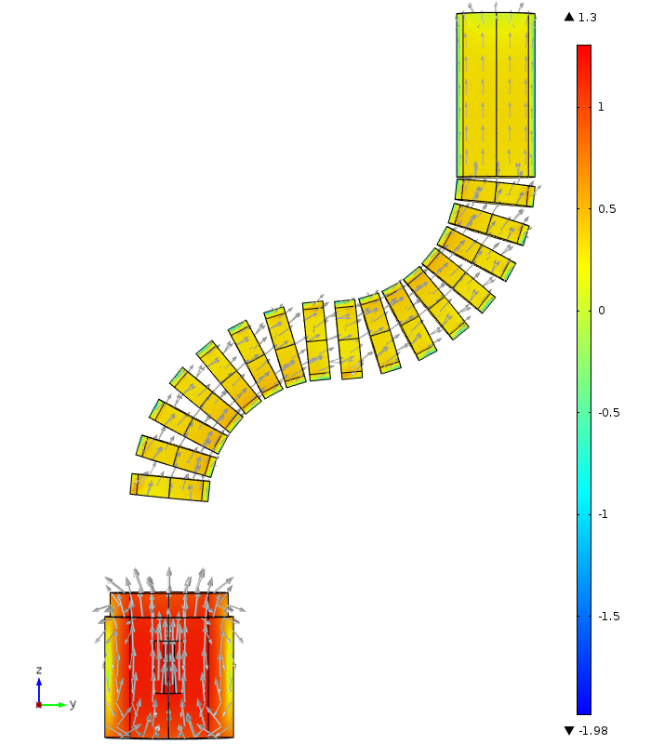
Fig. 4. Field direction (arrows) and log₁₀ of field magnitude (color) of magnet with extreme chicane bend of 90° to confirm reliability of model. As it should be, the predicted field is slightly higher on the tighter-curvature side of each half-chicane.
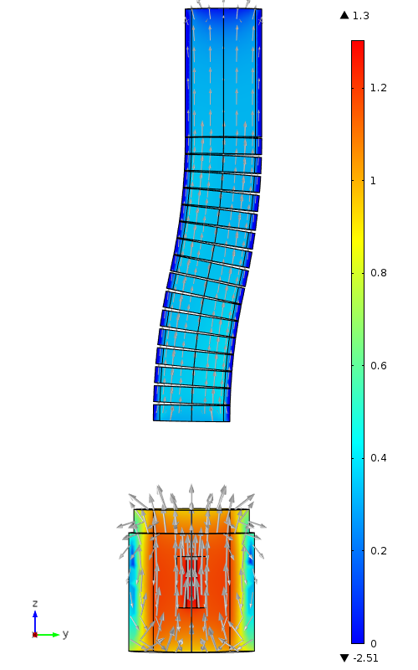
Fig. 5. Field direction (arrows) and log₁₀ of field magnitude (color) in 16-coil chicane with vertical (y) offset = 100 cm; toroidal half-angle θ = 12.8°; major radius = 50 cm / [1 – cos(θ)] = 21.09 m; minor radius = 100 cm; overall length ∆z = 2 R sin(θ) = 9.131 m. Dimensions of Target Magnet as in Fig. 1 and “20to2T5m100cm.xlsx” of 2/12/2014

