Stresses & Deformations in Vessel Containing Copper Magnet & Shielding

Bob Weggel 5/27-31/2011

**Model**: Vessel (bore tube, flanges & cylindrical shell) are of steel; specific gravity γ = 7.85; E = 200 GPa.

Shielding, of γ = 9.88 (60% WC of γ = 15.8 + 40% H20), exerts pressure proportional to depth.

Overall dimensions: outer radius r2 = 1.15 m; upstream end z1 = **−**2.35 m; downstream end z2 = 3.00 m.

Thickness of: 1) Flange: tf = 0.05 m; 2) Bore tube: 0.04 m; 3) Outer cylindrical shell: 0.03 m.

I.R. of bore tube = 0.08 m for **−**2.35<z< 0, flaring elliptically thereafter as in blue curve of Fig 1.

To reduce number of mesh elements, model effect of bore tube by its axial force on flanges.



Fig. 1: Inner radius of bore tube that flares elliptically from r = 0.08 m at z = 0 to r = 0.30 m at 3 m (gray curve), 4 m (green), 5 m (turquoise), 6 m (blue), 7.5 m (magenta); 10 m (red) or 15 m (black).

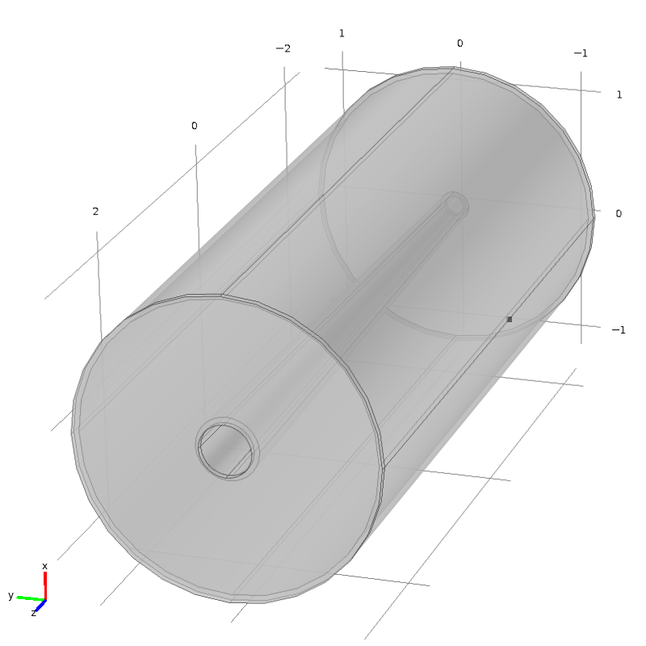

Fig. 2: Isometric view of vessel, with cylindrical shell, flanges, and bore tube of constant inner radius of 0.08 m from z = **−**2.35 m to 0, flaring elliptically thereafter to 0.262 m at z = 2.95 m.

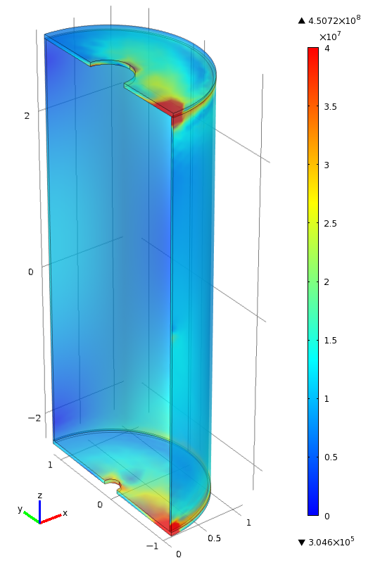 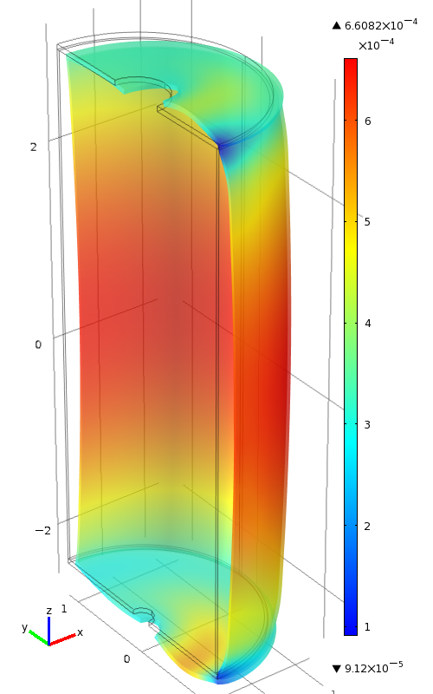 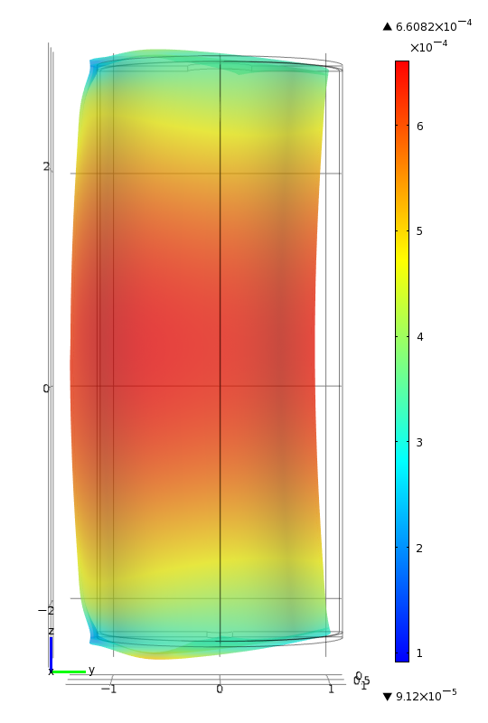

Fig. 3a-c: Von Mises stress σvM and deformation δ (magnified 400 times) with weight supported by line contact of flanges with ground (boundary condition δy ≡ 0 along line segments [x=0, y=-r2, (z1-tf) < z < z1 & z2 < z < (z2+tf)]. Bore-tube axial force ≡ 120 kN; maximum axial stress σz ≈ 4.8 MPa; maximum axial strain εz ≈ 2.4x10-5; bore-tube elongation ∆z < 0.12 mm. Left: Maximum localized σvM = 450 MPa;typical σvM ≈ 10-20 MPa. Center: Isometric view of deformation; maximum δ = 0.66 mm. Right: View from x axis, with y rightwards and z upwards.