Cross Section of Coils & Vessel Containing Magnet-Shielding Material

Bob Weggel 6/1—6/13/2011

Fig. 1 plots the trajectories of a proton beam and mercury jet designed to interact within a region of ~75-cm length centered about z = −37.5 cm, y = 0. The proton beam is 5-mm in diameter, with a dip angle of 100 mrad. Jet parameters are: diameter = 20 mm; dip angle = 67 mrad; and horizontal component of velocity = 20 m/s. For the interaction region to be centered about z = −37.5 cm, the beam and jet axes must intersect near z = −45 cm; at z = −37.5 cm the axis of the jet should be ~1.17 mm above that of the beam. With a beam/jet displacement of 2 mm at z = -37.5 cm, the beam and jet overlap at least partially from z = −75.9 cm to z = −0.6 cm, and fully from z = −63.7 cm to z = −19.6 cm.



Fig. 1: Region of overlap of 5-mm-diameter proton beam (red) with dip angle of 100 mrad interacting with coplanar 20-m/s, 20-mm-diameter mercury jet (black) with dip angle of −67 mrad at z = −37.5 cm. At z = −37.5 cm the centers of the beam and jet are at y = 0 and y = 2 mm, respectively.

The inner radius of the shielding-vessel bore tube should flare in proportion to the inverse square root of the magnetic field. An on-axis field profile that decreases from 20 T to 1.5 T implies a radius ratio of 3.65; if the radius is 7.5 cm when B = 20 T, then the radius should be ~27.4 cm when B = 1.5 T. The inner radius of the bore tube plotted in Fig. 2 flares elliptically from r = 7.6 cm at z = 0, where B ≈ 19.6 T, to r = 27.5 cm at z = 15 m. The bore tube also flares upstream of z = −1.13 m, to accommodate the proton beam. In Fig. 2b the bore tube thickness decreases from t = 2 cm at z = 15 m to t = 1 cm at z = 0, to increase the radial thickness available for shielding within the bore of the resistive magnet.



Fig. 2a: Bore tube whose I.R. flares elliptically from r1,0 = 8 cm at z = zero to r1,15 = 28 cm at 15 m, and whose O.R. flares from r2,0 = 10 cm at zero to r2,15 = 30 cm at 15 m. At z = 5.95 m the I.R. = 22.8 cm, and the O.R. = 24.7 cm.



Fig. 2b: Bore tube whose I.R. flares elliptically from r = 7.6 cm at z = zero to r = 27.5 cm at 15 m, and whose O.R. flares from r =8.6 cm at z = 0 to r = 29.5 cm at 15 m. At z = 5.95 m the I.R. = 22.4 cm, and the O.R. = 24.1 cm.

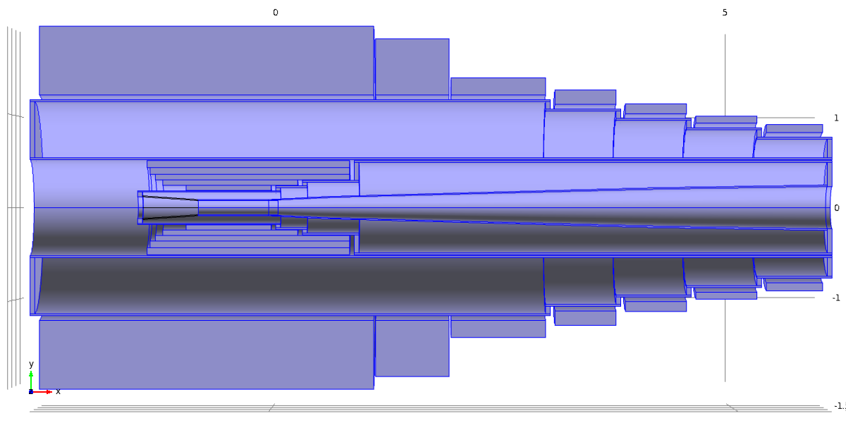

Fig. 3: Cross section of resistive magnet, upstream seven coils of superconducting magnet, and vessel of design “Shield6meter.mph”. Annular disks are 5-cm thick. Except for bore tube, all cylindrical shells are 2-cm thick. Conical and cylindrical sections of bore tube are 1 cm thick; the wall thickness of the elliptically-flaring bore tube increase from t =1 cm at z = 0 to t = 2 cm at z = 15 m. The bore tube is of constant inner radius of 7.6 cm from z = −1.085 m to z = 0, flaring elliptically thereafter to r = 22.4 cm at z = 5.95 m.