Magnetic Field, Hoop Strain, von Mises Stress & Energy of “Opt20T120cm3”

Bob Weggel 2/25/2011

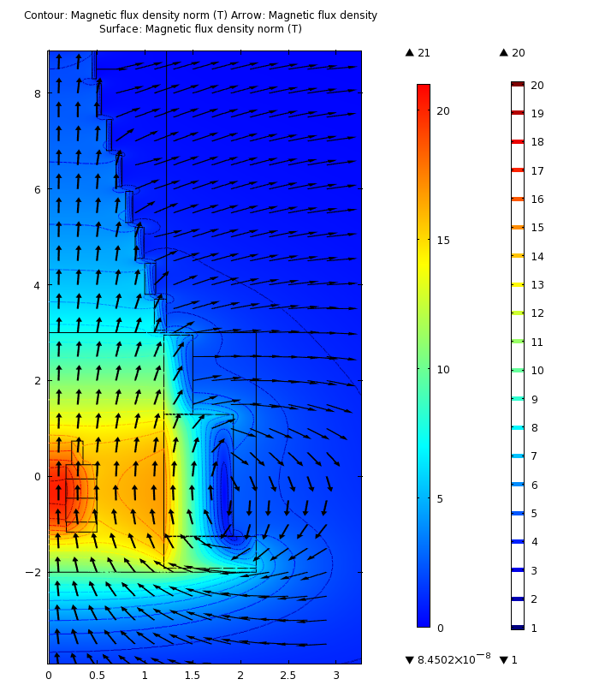 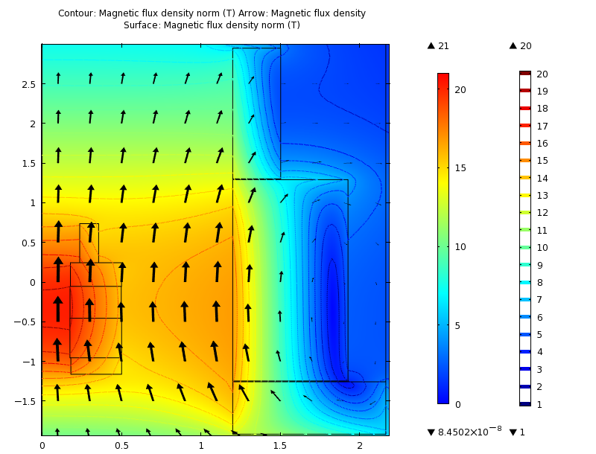

Field magnitude (color & contours) & direction (arrows); avg. field = 20 T over on-axis range -75 cm<z<0; energy = 3.22 GJ. Left: Resistive magnet and upstream eleven superconducting coils. Right: Resistive magnet and upstream three superconducting coils; peak field seen by superconductor ≈ 16.8 T, in superconducting coil #2.



On-axis field of magnets: resistive (red), superconducting (blue), combined (magneta) & desired profile (black).

Field inhomogeneity = 3% peak-to-peak; B(z) = 20.2 T at & z ≈ 37.5 cm; B(z) = 19.6 T at z = -75 cm & 0.

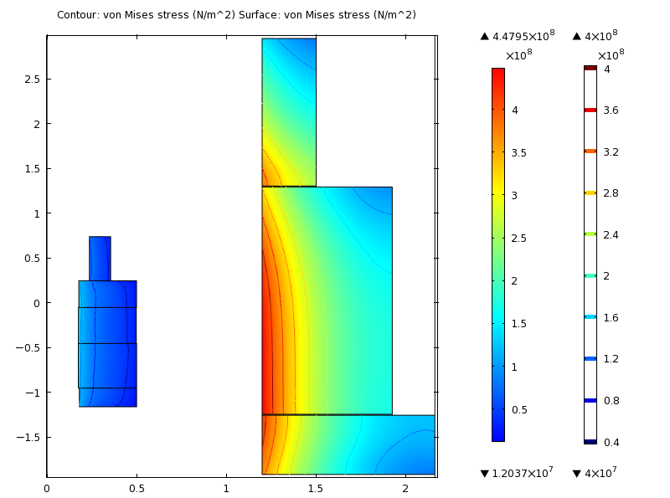

Von Mises stress, σvM; maximum σvM.= 448 MPa, in superconducting coil #2.

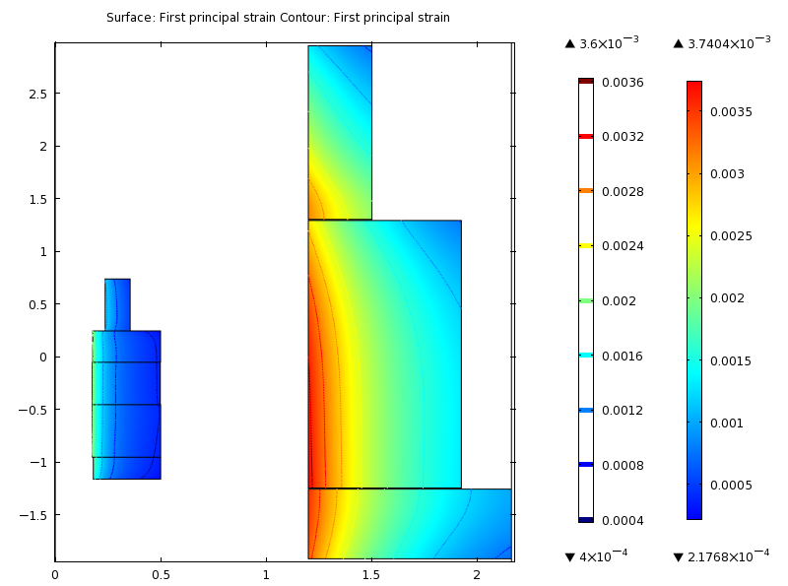

Right: Hoop strain εphi; maximum εphi = 0.374%, in superconducting coil #2.