Test of Multi-turn Coil Node: Current Density & Field Direction & Magnitude
Bob Weggel Magnet Optimization Research Engineering (M.O.R.E.), LLC 2/27/2014
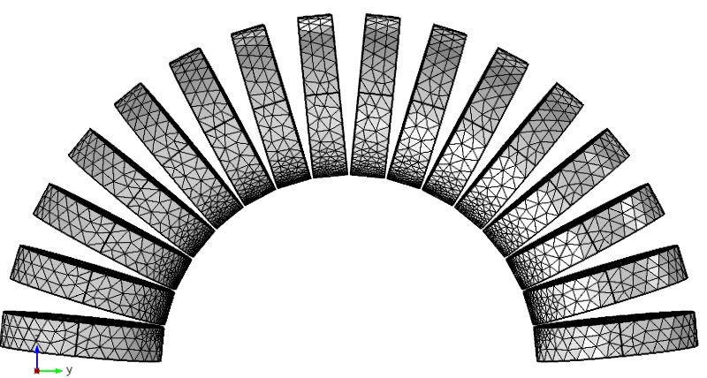
Fig. 1. Half-toroid of sixteen identical coils: geometry and mesh; O.R./I.R. = 1.2.
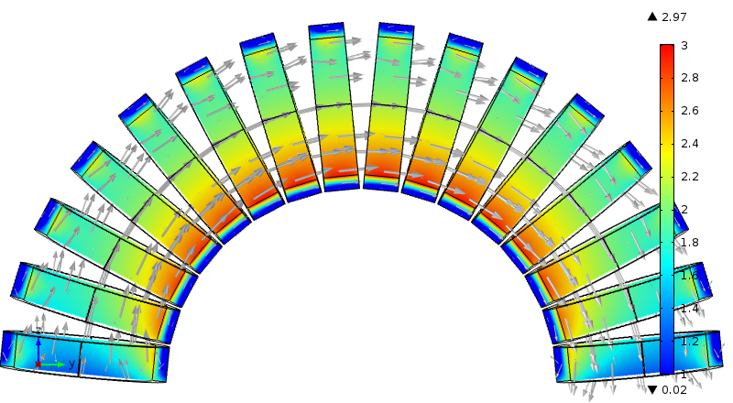
Fig. 2. Field direction & magnitude (arrows & colors) of half-toroid; O.R./I.R. = 1.2.
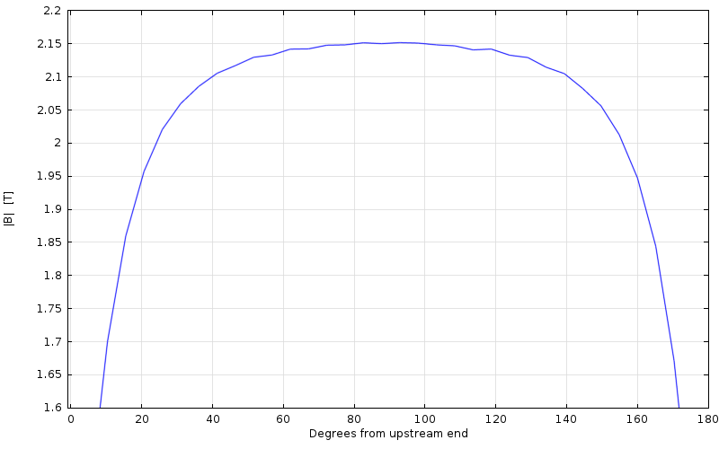
Fig. 3. Field magnitude along centerline of bore of half-toroid; O.R./I.R. = 1.2.
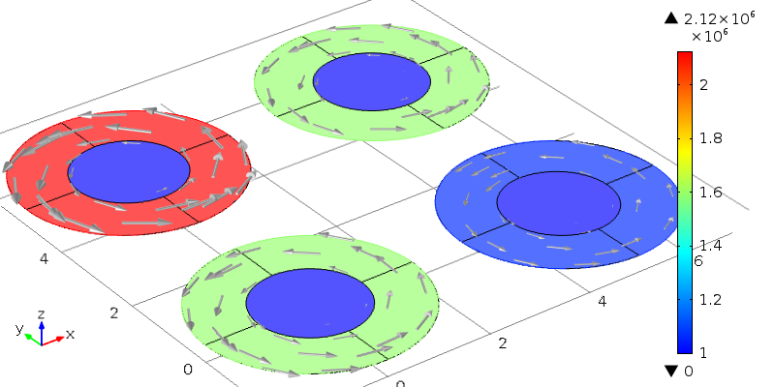
Fig. 4. Current density direction & magnitude (arrows & color); O.R./I.R. = 2. Bottom: “External current density”; Left: Reference edges = outer circumference; Right: Reference edges = inner circumference; Top: Reference edges = inner & outer circumferences.
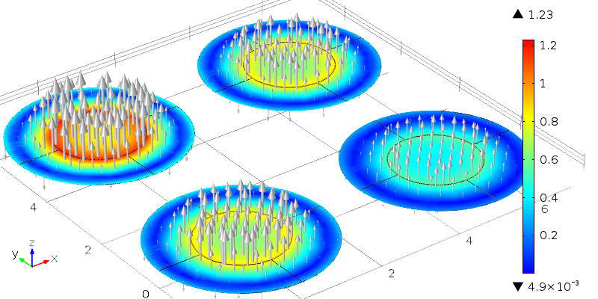
Fig. 5. Field direction & magnitude (arrows & color) with current densities as in Fig. 4.

