Axial Forces, Stresses & Deformations in Target Magnet IDS120k

Robert J. Weggel, Magnet Optimization Research Engineering, LLC

May 5, 2012

The rows labeled “SC #1” through “SC #15” tabulate the axial forces on superconducting coils (SC’s) of Target Magnet IDS120k from either: 1) its 5-coil, 11-MW copper magnet; 2) a triplet of SC’s in any one of six cryostats; or 3) all coils. The largest forces are on SC #1, SC #2 & SC #3—respectively 534, −364 and −124 MN when all coils are energized. (A minus sign indicates an upstream force.) The rows labeled “Copper” through “Cryo. 6” tabulate forces on sets of coils. The largest force is on Cryostat #1: 46 MN with all coils energized and 47 MN with only Cryostat #2 energized. The “%” values document my eventual success at reducing discrepancies—which can be large with FEM programs—between the magnitude of force on coil A from coil B and that on coil B from coil A.

Table I: Axial Forces between Coil Sets of IDS120k

|  |  |  |  |  |  |  |  |  |  |
| --- | --- | --- | --- | --- | --- | --- | --- | --- | --- |
| Energized | Copper | Cryo. 1 | Cryo. 2 | Cryo. 3 | Cryo. 4 | Cryo. 5 | Cryo. 6 | Sum | All |
| SC #1 | 3.88E+00 | 5.19E+02 | 1.11E+01 | 8.86E-02 | 1.68E-02 | 6.14E-03 | 2.76E-03 | 5.34E+02 | 5.34E+02 |
| SC #2 | -3.83E+00 | -3.68E+02 | 8.23E+00 | 3.66E-02 | 5.75E-03 | 1.88E-03 | 7.86E-04 | -3.64E+02 | -3.64E+02 |
| SC #3 | -7.63E-01 | -1.51E+02 | 2.73E+01 | 5.67E-02 | 7.27E-03 | 2.14E-03 | 8.42E-04 | -1.24E+02 | -1.24E+02 |
| SC #4 | -8.95E-02 | -4.24E+01 | 6.69E+00 | 7.96E-02 | 7.06E-03 | 1.75E-03 | 6.30E-04 | -3.57E+01 | -3.57E+01 |
| SC #5 | -7.96E-03 | -2.98E+00 | -2.61E+00 | 1.68E-01 | 5.16E-03 | 9.28E-04 | 2.86E-04 | -5.43E+00 | -5.43E+00 |
| SC #6 | -4.28E-03 | -1.24E+00 | -4.07E+00 | 1.69E+00 | 2.34E-02 | 3.01E-03 | 7.94E-04 | -3.60E+00 | -3.60E+00 |
| SC #7 | -2.08E-04 | -5.75E-02 | -1.14E+00 | 6.70E-01 | 3.90E-03 | 3.42E-04 | 7.89E-05 | -5.28E-01 | -5.28E-01 |
| SC #8 | -4.27E-04 | -1.11E-01 | -7.66E-01 | 1.51E-01 | 2.20E-01 | 3.60E-03 | 5.75E-04 | -5.02E-01 | -5.02E-01 |
| SC #9 | -5.61E-05 | -1.37E-02 | -2.69E-02 | -8.21E-01 | 6.34E-01 | 2.33E-03 | 2.61E-04 | -2.25E-01 | -2.25E-01 |
| SC #10 | -4.96E-05 | -1.20E-02 | -1.84E-02 | -7.22E-01 | 5.11E-01 | 4.33E-03 | 3.81E-04 | -2.37E-01 | -2.37E-01 |
| SC #11 | -5.77E-05 | -1.35E-02 | -1.42E-02 | -1.30E-01 | -3.55E-04 | 1.29E-01 | 1.89E-03 | -2.81E-02 | -2.81E-02 |
| SC #12 | -1.90E-05 | -4.35E-03 | -3.07E-03 | -5.34E-03 | -5.10E-01 | 7.89E-01 | 2.64E-03 | 2.69E-01 | 2.69E-01 |
| SC #13 | -1.63E-05 | -3.71E-03 | -2.39E-03 | -3.32E-03 | -7.89E-01 | 5.11E-01 | 4.33E-03 | -2.83E-01 | -2.83E-01 |
| SC #14 | -2.10E-05 | -4.73E-03 | -2.54E-03 | -2.45E-03 | -1.29E-01 | -1.07E-03 | 1.29E-01 | -1.09E-02 | -1.09E-02 |
| SC #15 | -7.73E-06 | -1.71E-03 | -7.66E-04 | -5.06E-04 | -4.33E-03 | -5.11E-01 | 7.89E-01 | 2.71E-01 | 2.71E-01 |
|  |  |  |  |  |  |  |  |  |  |
| Energized | Copper | Cryo. 1 | Cryo. 2 | Cryo. 3 | Cryo. 4 | Cryo. 5 | Cryo. 6 | Sum | All |
| Copper | -1.86E-05 | 7.21E-01 | 1.02E-01 | 6.91E-04 | 1.26E-04 | 4.51E-05 | 2.00E-05 | 8.23E-01 | 8.23E-01 |
| Cryo. 1 | -7.21E-01 | 3.96E-03 | 4.66E+01 | 1.82E-01 | 2.99E-02 | 1.02E-02 | 4.39E-03 | 4.61E+01 | 4.61E+01 |
| Cryo. 2 | -1.02E-01 | -4.66E+01 | -8.90E-05 | 1.94E+00 | 3.56E-02 | 5.69E-03 | 1.71E-03 | -4.48E+01 | -4.48E+01 |
| Cryo. 3 | -6.91E-04 | -1.82E-01 | -1.94E+00 | 3.30E-05 | 8.58E-01 | 6.27E-03 | 9.15E-04 | -1.26E+00 | -1.26E+00 |
| Cryo. 4 | -1.26E-04 | -2.99E-02 | -3.56E-02 | -8.58E-01 | -9.77E-05 | 9.22E-01 | 4.91E-03 | 3.54E-03 | 3.44E-03 |
| Cryo. 5 | -4.51E-05 | -1.02E-02 | -5.69E-03 | -6.27E-03 | -9.22E-01 | -8.56E-04 | 9.22E-01 | -2.21E-02 | -2.30E-02 |
| Cryo. 6 | -2.00E-05 | -4.39E-03 | -1.71E-03 | -9.15E-04 | -4.91E-03 | -9.22E-01 | -1.88E-03 | -9.34E-01 | -9.36E-01 |
| Sum | -8.23E-01 | -4.61E+01 | 4.48E+01 | 1.26E+00 | -3.53E-03 | 2.19E-02 | 9.34E-01 | -1.83E-04 | 8.10E-04 |
|  |  |  |  |  |  |  |  |  |  |
| Cu |  | 0.001% | 0.000% | -0.001% | 0.007% | 0.020% | 0.000% | 0.001% |  |
| Cryo. 1 |  |  | 0.000% | -0.001% | 0.004% | 0.005% | 0.013% | 0.000% |  |
| Cryo. 2 |  |  |  | 0.000% | -0.001% | -0.007% | -0.026% | 0.000% |  |
| Cryo. 3 |  |  |  |  | 0.000% | -0.001% | -0.003% | 0.000% |  |
| Cryo. 4 |  |  |  |  |  | 0.000% | -0.003% | 0.098% |  |
| Cryo. 5 |  |  |  |  |  |  | -0.025% | 1.038% |  |
| Cryo. 6 |  |  |  |  |  |  |  | 0.025% |  |

Figures 1, 2 & 3 plot the axial pressure within each coil in the three most-upstream modules of Target Magnet IDS120k. Two caveats: 1) The computer program plots the [r, z] coordinates of the magnet system as [x, y] on the page. 2) To improve page fit the longitudinal (i.e., z) coordinate (y axis) has been foreshortened by a factor of two relative to the radial coordinate (x axis).

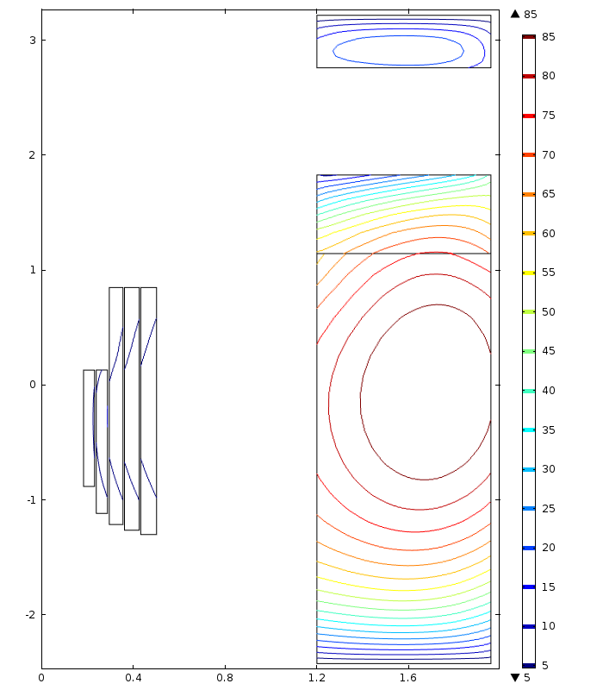

Fig. 1: Contours of axial compressive stress σz [MPa] in upstream module (Copper Magnet & Cryostat #1) of Target Magnet IDS120k with all coils energized. Radial coordinate is x-axis; z coordinate (y axis) is foreshortened by a factor of two. σz reaches 10 MPa in copper magnet and 91, 76 & 25 MPa in superconducting coils.

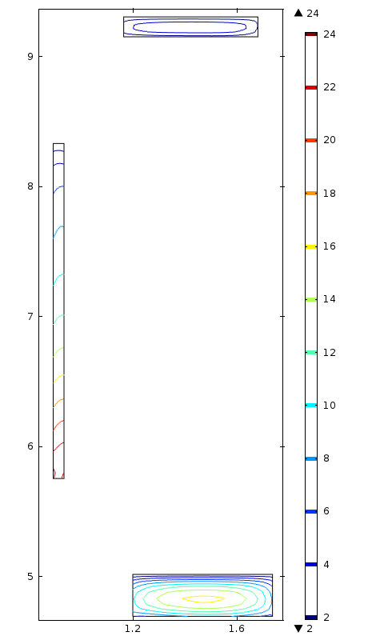

Fig. 2: In Superconducting Coils #4 thru #6 (Cryostat #2), σz reaches, respectively, 17, 24 & 5.5 MPa.

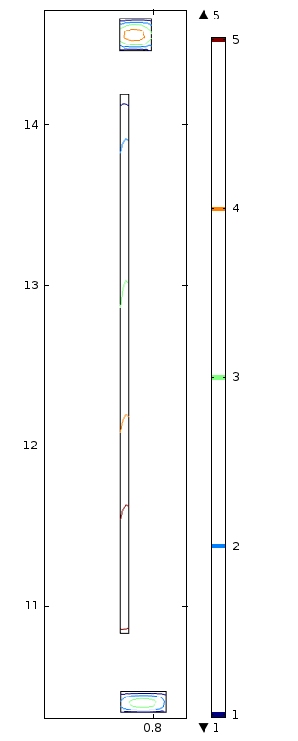

Fig. 3: In Superconducting Coils #7 through #9 (Cryostat # 3), the maximum σz is 6 MPa.

Figure 4 plots the cumulative axial force vs. axial position within modules of Target Magnet IDS120k. To fit on the graph, the red and magenta curves (coils of Cryostats #1 & #2, respectively) have been shrunk by respective factors of 100 and 10. Note that the maximum cumulative force internal to Cryostat #1 is about an order greater than the external force on the cryostat. Note also that the direction of net force on Cryostat #1 and on the Cu magnet is downstream (the compressive reaction force is on the downstream end), whereas the net force is upstream on Cryostats #2 & #3. Note also that the internal force within Cryostats #4 & #5 is tensile—each of its end coils is attracted more strongly to coils on the other side of its inter-cryostat gap than to the coils within its own cryostat.



Fig. 4. Cumulative axial force vs. axial position within modules of Target Magnet IDS120k.

Fig. 5 plots the von Mises stress and deformation in the inner & outer tubes (both 5-cm thick) and downstream three flanges (each 15-cm thick) needed to withstand the huge force of attraction between the coils in Cryostat #1. The loading condition on each flange is a uniform pressure that integrates to the axial load in Table I. Deformations as plotted are amplified by a factor of twenty. The maximum von Mises stress is 470 MPa; the maximum deformation is 2.0 mm. As with Figs. 1-3, the computer program plots the [r, z] coordinates of the magnet system as [x, y] on the page. Again to improve page fit the longitudinal, z, coordinate (y axis) is foreshortened by a factor of two relative to the radial coordinate.

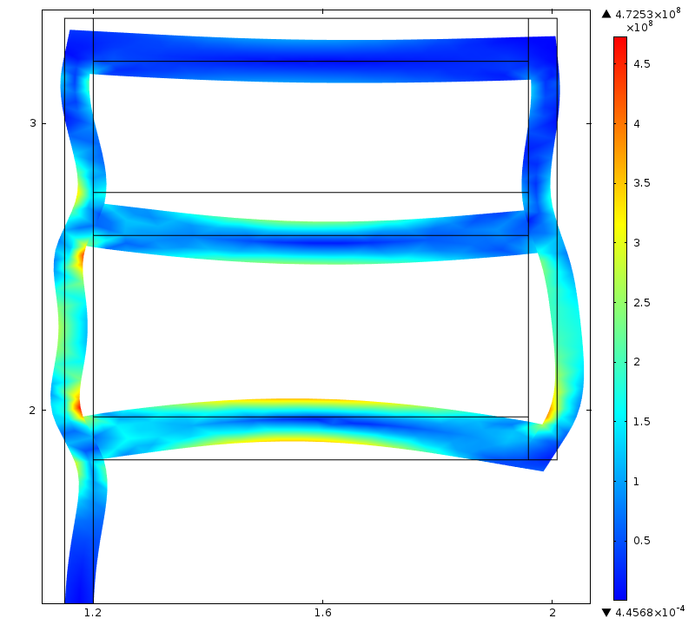

Fig. 5: Von Mises stress & deformation in inner & outer tubes (both 5-cm thick) and flanges (15-cm thick) needed to withstand the huge force of attraction between coils in Cryostat #1. The maximum von Mises stress is 470 MPa. The maximum deformation (plotted amplified by a factor of twenty) is 2.0 mm.