20-T, 120-cm-I.R. Target Magnet with 50-cm Axial Gap near *z* = 3 m

Bob Weggel, Magnet Optimization Research Engineering, LLC

12/29/2011

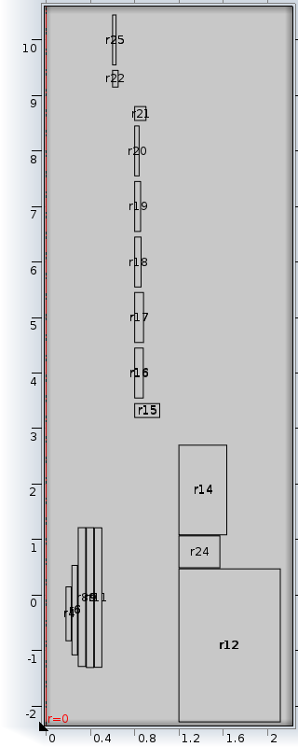

Fig. 1: Cross section of resistive & upstream twelve SC coils of Magnet IDS120i with axial gap near *z* = 3 meters.



Fig. 2: On-axis field profiles of superconducting & resistive magnets of 20-T target magnet whose on-axis field profile matches very closely the desired profile.