Target Magnets that Ramp from 20 T to 1.5 T at 7 m, 2 T at 6 m, or 2.5 T at 5 m

Bob Weggel Magnet Optimization Research Engineering, LLC April 15, 2013

Figure 1 plots the upstream conductor cross sections, field direction (arrows) & magnitude (contours) of Target Magnet IDS120L20to1.5T7m, whose on-axis field ramps from 20 T at z = −0.375 m to 1.5 T at z = 7 m. Figure 2 plots the on-axis field profiles of the magnet components: 5-T, 13-MW resistive magnet (red); superconducting coil #1 (turquoise); 15-T superconducting magnet (blue); total field (magenta); and desired field (black).

The field error (grey) is defined as 1000 (∆B)2/B ≡ 1000 B (∆B/B)2, whose least-squares minimization (as for Figs. 1&2) strongly penalizes large excursions from the desired field while virtually ignoring small ones. Compared to Target Magnet IDS120’20to1p5T7m, documented in Target20T7m’.docx of 4/8/2013, the maximum field error improves only 16% (from 20.3 to 17.1) and requires 20% more power, 13 MW instead of 10.8 MW.

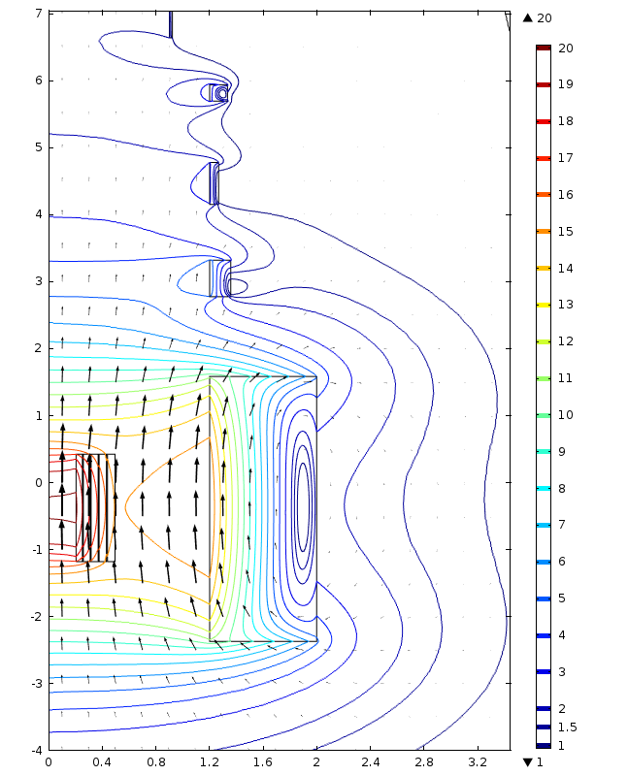

Fig. 1. Upstream conductor cross sections, field direction (arrows) & magnitude (contours) of Target Magnet IDS120L20to1.5T7m, whose on-axis field ramps from 20 T at z = −0.375 m to 1.5 T at z = 7 m.



Fig. 2. On-axis field profile of Target Magnet IDS120L20to1.5T7m: 5-T, 13-MW resistive magnet (red); superconducting coil #1 (turquoise); 15-T superconducting magnet (blue); total field (magenta); and desired field (black). The field error (grey) is defined as 1000(∆B)2/B ≡ 1000 B (∆B/B)2.

Allowing a greater discrepancy between the actual and desired field, at least in the region −1.8 m < z < 1 m, as in Figs. 3 & 4, cuts the power consumption by 24%, to 9.8 MW. For z > 7 m the field quality is better than in Fig. 2, a consequence of allowing coils to be shorter axially and deeper radially. In Fig. 3 the field error is 2∆B/B [%]; the maximum percentage discrepancy is 4.9 % in the ramp region (at z = 70 cm) and 1.6% in the decay region (at 1,320 cm).



Fig. 3. On-axis field profile of Target Magnet IDS120L20to1.5T7m%dB’: 5-T, 9.8-MW resistive magnet (red); superconducting coil #1 (turquoise); 15-T superconducting magnet (blue); total field (magenta); and desired field (black). The field error (grey) is 2|∆B|/B [%]: 4.9% at z = 70 cm and 1.2% at 1,190 cm.

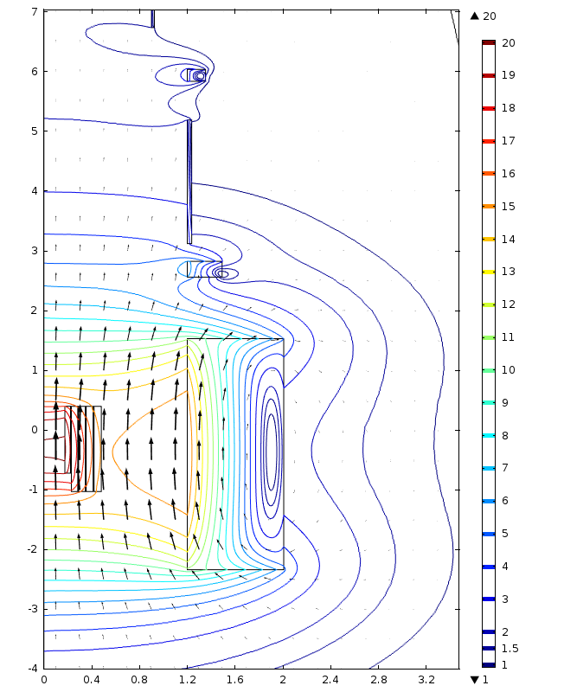

Fig. 4. Upstream conductor cross sections, field direction (arrows) & magnitude (contours) of Target Magnet IDS120L20to1.5T7m’, whose on-axis field ramps from 20 T at z = −0.375 m to 1.5 T at z = 7 m.

Figure 5 compares on-axis field profiles that ramp from 20 T to 1.5 T, 2.0 T or 2.5 T with the same curvature near z = −0.375 meters. The ramp to 2.0 T bottoms out at z = 6.0 m; the ramp to 2.5 T, at 5.3 meters.

Figures 6 and 7 plot the field profile and conductor cross sections of a magnet whose field ramps to 2 T at 6 m.



Fig. 5. Comparison of on-axis field profiles that ramp from 20 T to 1.5 T, 2.0 T or 2.5 T with the same curvature near z = −0.375 meters. The ramp to 2.0 T bottoms out at z = 6.0 m; the ramp to 2.5 T, at 5.3 meters.



Fig. 6. On-axis field profile of Target Magnet IDS120L20to2T6m%dB: 5-T, 9.9-MW resistive magnet (red); superconducting coil #1 (turquoise); 15-T superconducting magnet (blue); total field (magenta); and desired field (black). The field error (grey) is 2|∆B|/B [%]: 5.0% at 70 cm, 1.0% at 1,090 cm and 1.4% at 1,210 cm.

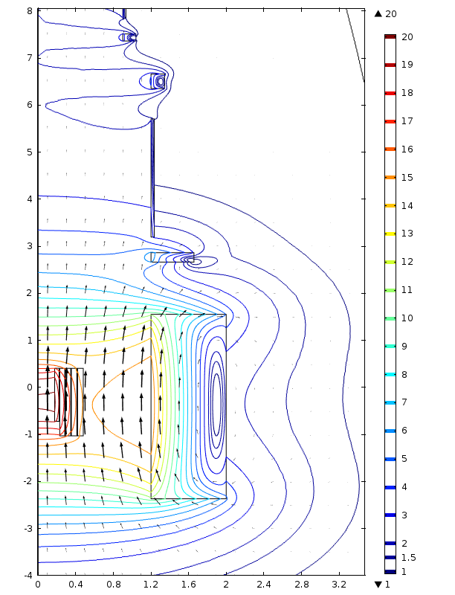

Fig. 7. Upstream conductor cross sections, field direction (arrows) & magnitude (contours) of Target Magnet IDS120L20to2T6m, whose on-axis field ramps from 20 T at z = −0.375 m to 2 T at z = 6 m.

Figures 8 and 9 plot the conductor cross sections, field direction and magnitude, and on-axis field profile of a magnet that ramps from 20 t to 2.5 t at 5 m. All of the magnet parameters—including geometry and field profile—are very similar to those for magnets with ramps that bottom out at 6 m and 7 m.

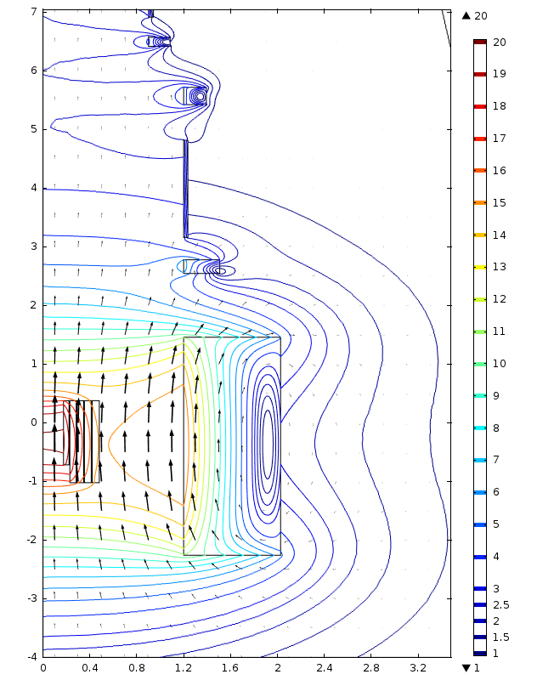

Fig. 8. Upstream conductor cross sections, field direction (arrows) & magnitude (contours) of Target Magnet IDS120L20to2.5T5m, whose on-axis field ramps from 20 T at z = −0.375 m to 2.5 T at z = 5 m.



Fig. 9. On-axis field profile of Target Magnet IDS120L20to2.5T5m: 5-T, 9.6-MW resistive magnet (red); superconducting coil #1 (turquoise); 15-T superconducting magnet (blue); total field (magenta); and desired field (black). The field error (grey) is 2|∆B|/B [%]: 4.8% at 60 cm and 1.5% at 1,130 cm.