20to2-3T5m2+5: 16-cm I.R., 46-cm O.D., 8.6 MW, Optimized Cooling

Robert J. Weggel; Magnet Optimization Research Engineering (M.O.R.E.), LLC; 1/26/2014



Fig. 1. On-axis field profiles of 20-T magnets of 16-cm I.R. The copper magnet generates 5 T at 8.6 MW with five tightly-nested two-layer coils of mineral-insulated hollow conductor. The conductor is rectangular, with aspect ratio ∆z/∆r = 2, optimized in size and cooling-hole diameter to maximize the incremental efficiency dB/dP [T/MW]. The peak hot-spot temperature is 90 ºC with inlet water at 10 ºC, a water-pressure drop of 40 atm, and three hydraulic passages per coil.

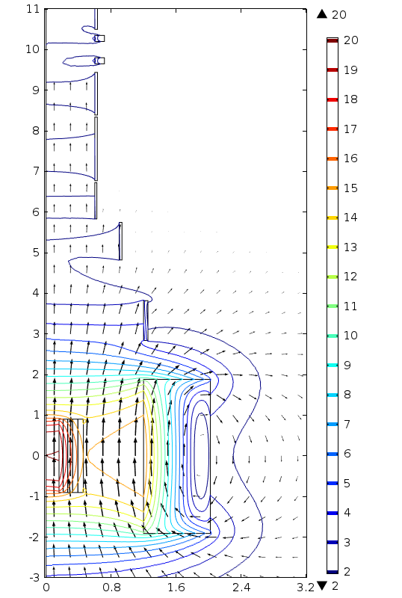

Fig. 2: Coil cross sections and field direction (arrows) & magnitude (color & contours) of Fig-1 Target Magnet 20to2T5m2+5, whose field tapers to 2 T at z = 5 m.

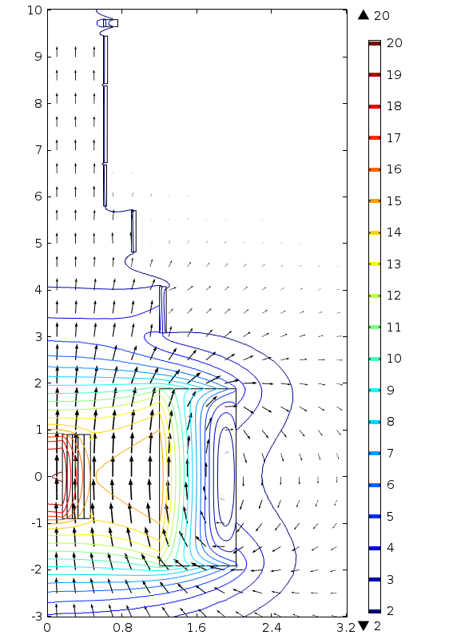

Fig. 3: Coil cross sections and field direction (arrows) & magnitude (color & contours) of Fig-1 Target Magnet 20to2p5T5m2+5, whose field tapers to 2.5 T at z = 5 m.

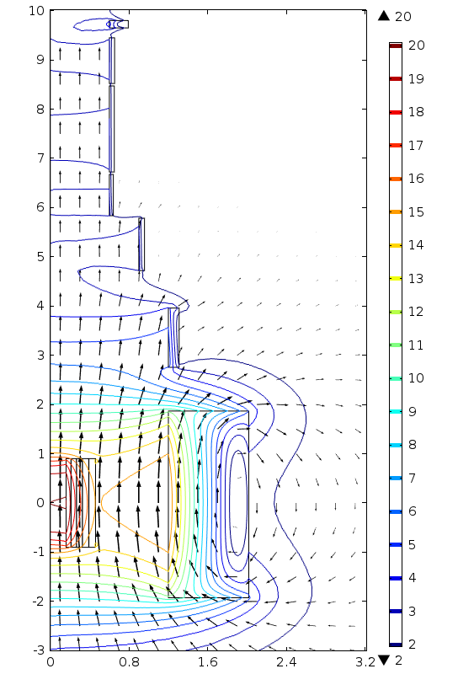

Fig. 4: Coil cross sections and field direction (arrows) & magnitude (color & contours) of Fig-1 Target Magnet 20to3T5m2+5, whose field tapers to 3 T at z = 5 m.