Bob Weggel Particle Beam Lasers, Inc. June 13, 2015

Magnets 20&15to4T5m120cm Winding-pack X-sections, Field Profiles & Parameters

Figure 1 shows the coil cross sections and field magnitude, direction & streamlines of a magnet with superconducting solenoids of 120-cm I.R. to z = 10 meters; Fig. 2 plots the on-axis field profile. Figure 3 applies for the superconducting coils only. Table I lists selected parameters, with dimensions in cm and current densities in A/mm2. Between SC coils #2 and #3 is an axial gap of 155 cm that will be very convenient for facilitating robotic assembly and disassembly.

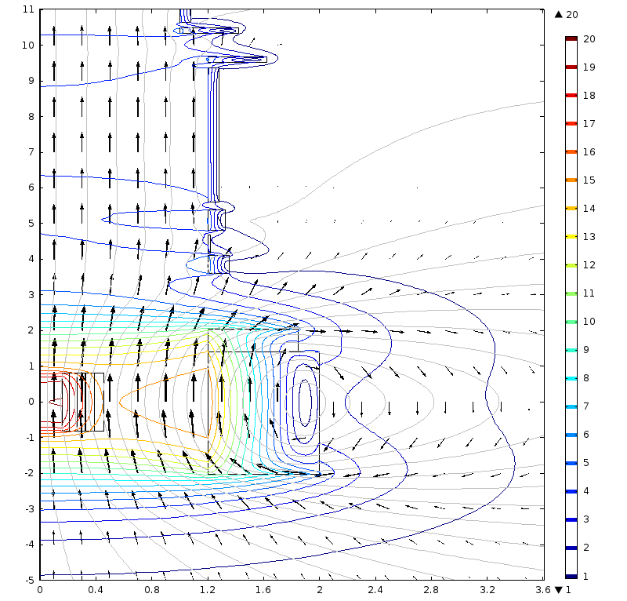

Fig. 1: Target Magnet “20to4T5m120cm4pDL,” whose on-axis field B(z) tapers to ~4 T at z ≈ 5 m: winding-pack cross sections, field direction (arrows), streamlines (grey), & field magnitude (contour lines).





Fig. 2. On-axis field profile of Target Magnet 20to4T5m120cm4pDL; B = 4 T at 4.7 m, 4.24 T at 4 m, & 5.21 T at 3 m.

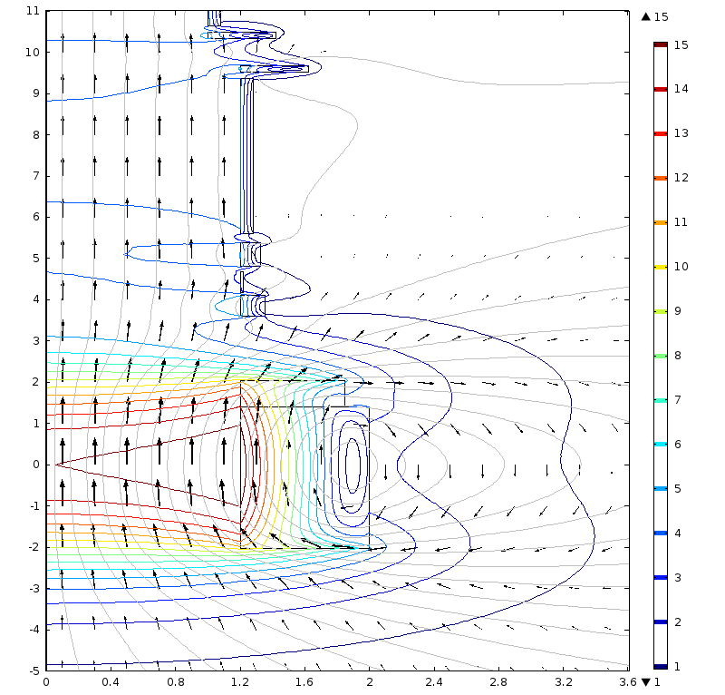

Fig. 3: Target Magnet “15to4T5m120cm,” identical to the superconducting solenoids of “20to4T5m120cm4pDL”: winding-pack cross sections, field direction (arrows), streamlines (grey), & field magnitude (contour lines).

Table I: Parameters of Superconducting Solenoids of Target Magnet 20to4T5m120cm4pDL

|  |  |  |  |  |  |  |  |  |  |  |
| --- | --- | --- | --- | --- | --- | --- | --- | --- | --- | --- |
| Cur. density | 1.911 | 2.101 | 3.702 | 3.809 | 3.824 | 3.800 | 3.590 | 3.590 | 3.590 | 3.590 |
| Inner radius | 120.0 | 120.0 | 120.0 | 120.0 | 120.0 | 120.0 | 120.0 | 100.0 | 100.0 | 100.0 |
| Radial depth | 79.66 | 64.82 | 15.28 | 1.63 | 12.59 | 8.15 | 42.12 | 12.11 | 8.15 | 42.12 |
| Outer radius | 199.66 | 184.82 | 135.28 | 121.63 | 132.59 | 128.15 | 162.12 | 142.12 | 108.15 | 142.12 |
| Upstr. end | -201.6 | 141.5 | 359.4 | 417.6 | 480.6 | 561.2 | 952.0 | 1033 | 1063 | 1455 |
| Coil length | 343.12 | 62.97 | 51.64 | 49.57 | 57.36 | 376.28 | 15.00 | 15.00 | 377.00 | 15.00 |
| Down. end | 141.5 | 204.5 | 411.0 | 467.2 | 538.0 | 937.5 | 967.0 | 1048 | 1440 | 1470 |
| Axial gap | 0.00 | 154.91 | 6.55 | 13.44 | 23.22 | 14.54 | 66.00 | 15.00 | 15.00 | 600.0 |