Magnetic Field, Energy, Field Profile, Hoop Strain, von Mises Stress

& Forces Between Coils of “120cm19T1e7s”

Bob Weggel 3/11/2011

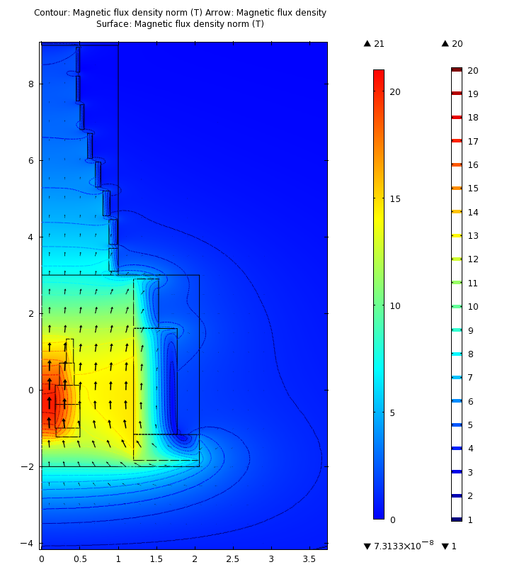 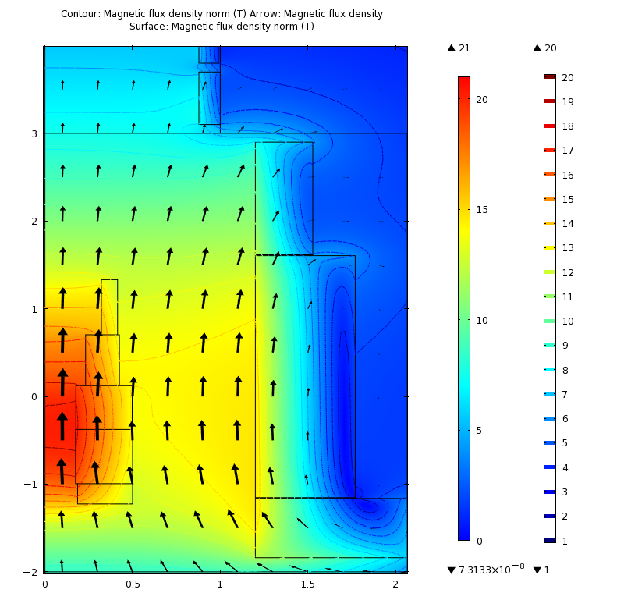

Field magnitude (color & contours) & direction (arrows). Energy = 2.53 GJ. Left: Resistive magnet and upstream eleven superconducting coils. Right: Upstream coils. Peak field seen by superconductor ≈ 14.7 T.



On-axis field of magnets: resistive (red) & superconducting (blue). Combined field (magneta) is excellent fit to desired profile (black). Avg. field = 20 T from -75 cm to 0. Field inhomogeneity = 3%: max. = 20.2 T; min. = 19.6 T. Resistive & SC field contributions = 6.1 T & 14.1 T, repectively.

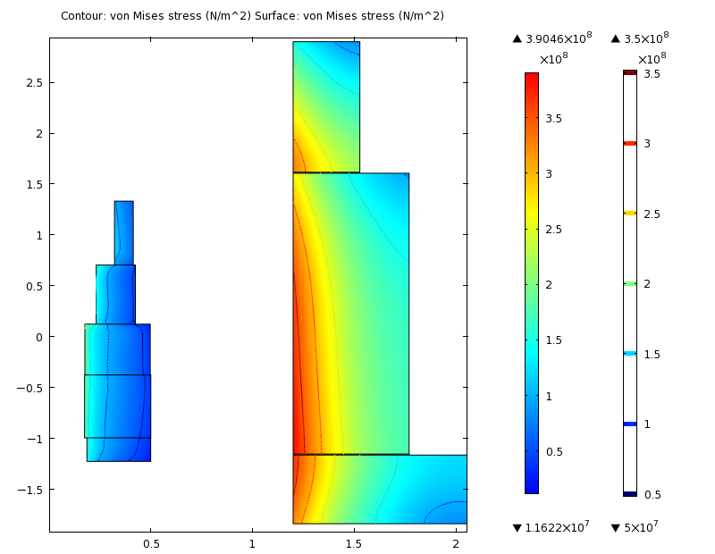

Von Mises stress, σvM; maximum σvM.= 390 MPa, in superconducting coil #2.

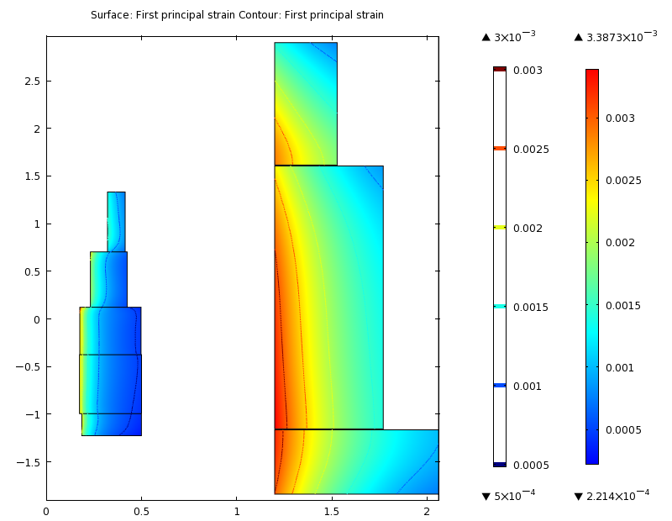

Right: Hoop strain εphi; maximum εphi = 0.34%, in superconducting coil #2.