MERCURY HANDLING FOR THE TARGET SYSTEM FOR A MUON COLLIDER
V. B. Graves#, ORNL, Oak Ridge, TN 37831, USA
H. G. Kirk, H.K. Sayed, BNL, Upton, NY 11973, USA
K. T. McDonald, Princeton University, Princeton, NJ 08544, USA
N. Souchlas, R. J. Weggel, Particle Beam Lasers, Inc., Northridge, CA 91324, USA
X. Ding, UCLA, Los Angeles, CA 90095, USA
Abstract
The baseline target concept for a Muon Collider or Neutrino Factory is a free-stream mercury jet being impacted by an 8-GeV proton beam. The target is located within a 20-T magnetic field, which captures the generated pions that are conducted to a downstream decay channel. Both the mercury and the proton beam are introduced at slight downward angles to the magnetic axis. A pool of mercury serves as a receiving reservoir for the mercury and a dump for the unexpended proton beam. The impact energy of the remaining beam and jet are substantial, and it is required that splashes and waves be controlled in order to minimize the potential for interference of pion production at the target. Design issues discussed in this paper include the nozzle, splash mitigation in the mercury pool, the mercury containment vessel, and the mercury recirculation system.

INTRODUCTION
The baseline target concept for a Muon Collider or a Neutrino Factory facility is a free jet of mercury impacted by a 4 MW, 8-GeV proton beam within a 20-T magnetic field [1]. The magnetic field is produced by an array of cryogenically cooled superconducting (SC) coils and water-cooled resistive magnets. Recent work has suggested that a 15-T field may provide adequate pion production, which would eliminate the resistive magnets and provide additional space for the target module within the primary cryostat [2]. This target module concept discussed in this paper assumes the elimination of the resistive coils. During operation, the Target Module resides within a shielding module that protects the SC coils from the impinging radiation. These modules are components within a cryostat that contains the SC coils. The basic arrangement of this cryostat system is shown in Figure 1.

TARGET MODULE DESCRIPTION AND REQUIREMENTS
Particle production studies have indicated that maximum production occurs when both the mercury jet and the proton beam are at small downward angles to the magnetic axis during their interaction. The current baseline is 137 mrad for both the jet and the beam; the jet and the magnetic axis are in the same vertical plane, but the proton beam enters the target region from the side. The baseline jet has a diameter of 0.8 cm and a velocity of 20 m/s.
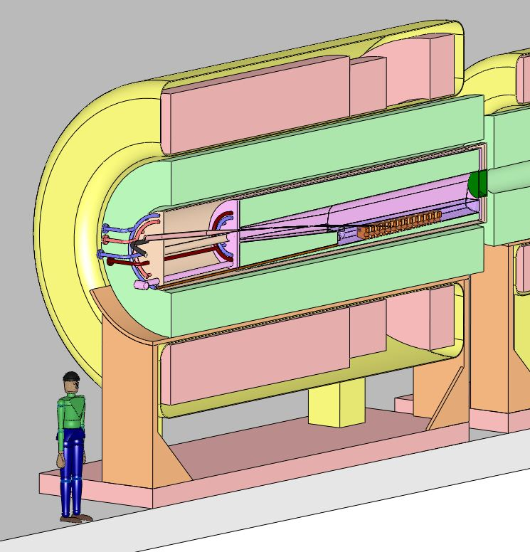
SC Coil
Cryostat
Target
Module
Shielding
Module
Figure 1: Target cryostat.
The primary function of the Target Module is to place the jet nozzle in the correct spatial location such that the center of the jet/beam interaction region is in the location of the highest magnetic field. A secondary function is to provide SC coil shielding in addition to that provided in the separate shielding module.
There are several Target Module design requirements and operational features that will allow the module to perform its intended function. These include
- Accuracy and repeatability of its placement within the Shielding Module in a totally remote environment
- Provide double containment of the mercury
- Long lifetime through the elimination of radiation sensitive electronics or sensors
- Provide a mercury pool that serves as a dump for both the jet and the remaining proton beam after target impact
- Designed as a single chamber with no elastomeric seals that would limit its lifetime
- Provide provisions for adequate mercury draining and venting of the gas volume above the pool
- Incorporate a means of cooling the chamber and its internal shielding
- Minimize mercury splashes and waves within the pool
- Provide upstream and downstream beam windows, with the upstream window being a remotely replaceable maintenance item.

tARGET MODULE DESIGN ISSUES
There are several aspects of the Target Module design that are mechanically challenging and which are being considered in the conceptual design, and some of them are described in this section. Figure 2 shows a vertical cross section through the Target Module which highlights many of the design features.
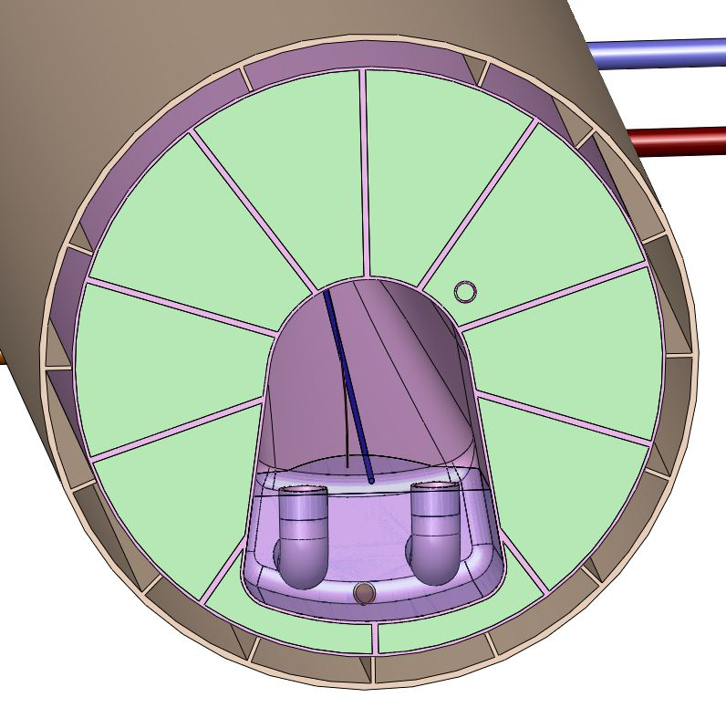
Overflow
Drains
Maintenance
Drain
He-cooled
Tungsten
Mercury
Vessel
Secondary
Mercury
Containment
Figure 2: Target Module viewed from downstream.

Jet and Beam Entry
Due to the requirement of containing mercury vapors within the Target Module chamber, the chamber was designed as a single volume, and the jet and proton beam enter this volume through pipes upstream of the interaction region. At small angular displacement between the jet nozzle and the beam entry pipe, maintaining required clearances around the beam becomes an issue since the nozzle and beam entry pipe converge in this area. This close proximity is shown in Figure 3. There is consideration of using multiple beams to supply the total 4 MW of beam power, so this issue could become more complex in the future.
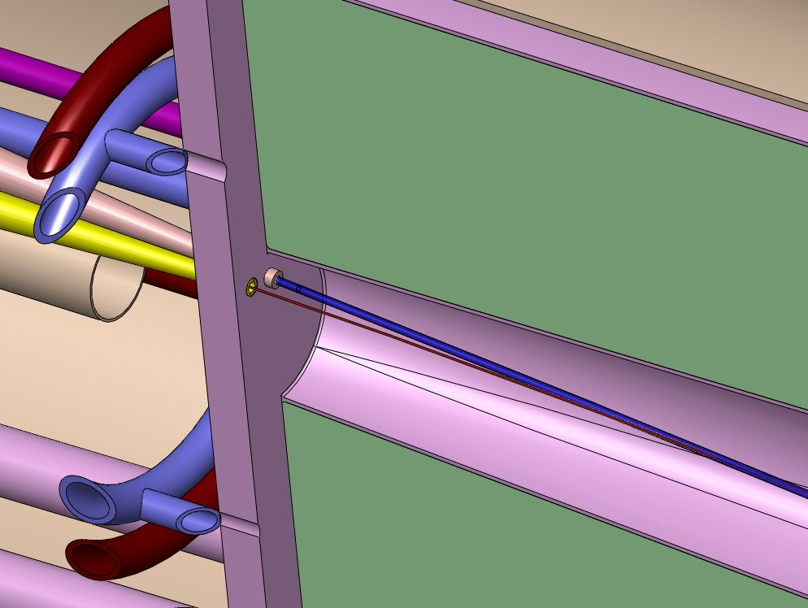
Mercury Jet
Interaction
Region
Proton Beam
Figure 3: Jet nozzle and beam entry pipe.

Mercury Containment
The mercury jet is produced using a closed-loop process with a pump, heat exchanger, and storage tank being the major equipment components, along with the piping, nozzle, and mercury pool vessel within the Target Module. Shown in Figure 4, the major components will be located in a hot cell adjacent to the beam line with its own remote maintenance capabilities. Mercury leaks within this area will be more easily contained, but provisions for double containment of the mercury will be required within the supply and return piping and mercury pool vessel. This double wall requirement introduces an interstitial space that can either be filled with tungsten shielding or can be left empty, but in either case the space must provide a mechanism for cooling the inner wall.
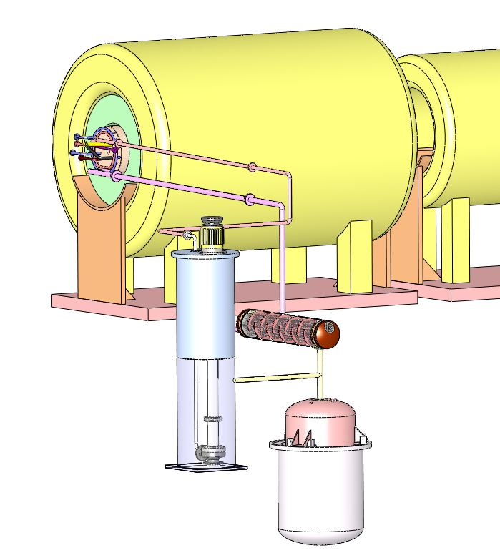
Heat
Exchanger
Pump
Storage
Tank
Figure 4: Major components of the mercury flow loop.

Mercury Splash Mitigation
The mercury dump is a liquid pool contained in a cylindrical shell. It serves as a dump for both the mercury jet and the remaining portion of the proton beam. To serve as a beam dump, the mercury must simply have sufficient depth for four interaction lengths (120 cm), although in practice this may be more difficult given that the beam and jet will both impact the pool and may create “holes” in the fluid that reduce the effective beam stopping distance. Mechanical features within the chamber will be required to minimize splashing and waves that might impact the downstream beam window as well as reduce the effective pion yield. As this mercury pool will be heated by the decay radiation, it is critical that no stagnation zones develop within the pool and that the mercury drains properly. Due to the high radiation in this area and the difficulty in providing remote maintenance, no powered means of pool circulation is anticipated, so the chamber concept and drain configuration must be tested and verified prior to final design.

Drainage
Drainage of mercury from Target Module is a major design consideration. To allow the module to be removed as a single component, the mercury is drained from the upstream end of the module. Two separate drains are incorporated into the module: overflow drains are used during operation to guarantee an adequate pool depth, and a maintenance drain tangent to the floor of the sloped chamber floor allows complete draining during shutdown. The maintenance drain piping must incorporate a flow control valve to allow a relatively small flow through the maintenance drain during beam operation in order to eliminate potential boiling issues in static fluid.

Utility services
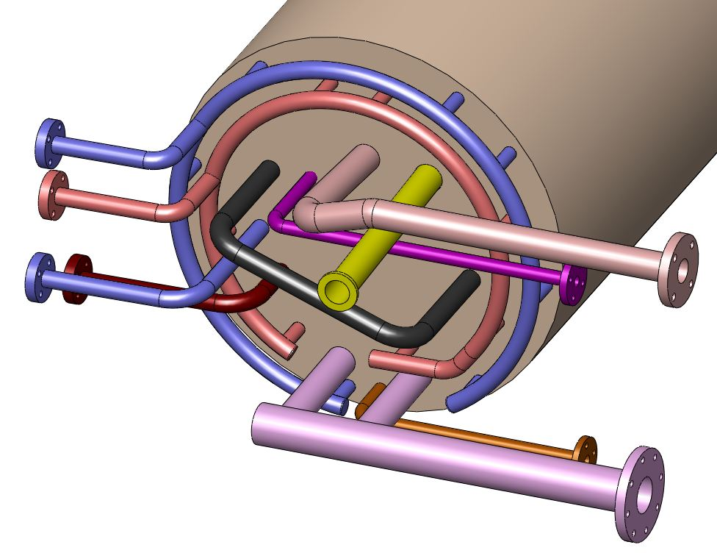
Helium
Supply &
Return
Hg Jet
Inlet
Hg Return
Remote
Access
Handle
Vent
Maintenance Drain
Figure 5: Target Module utility services.
In the baseline Target Module concept, the module incorporates both mercury containment features along with shielding for the SC coils. Recent studies have estimated that up to 1.5 MW of heat is generated in the mercury containment and the tungsten shielding vessels [reference needed]; the baseline cooling medium for these components is gaseous helium. The Target Module requires numerous utility services, shown in Figure 5, and these services will be attached at the upstream end of the module for easier access. It is assumed that the mercury system would be located on one side of the beam line and that the helium and cryogenic services would be located on the other. Providing adequate space for these services in the Target Module will continue to be a mechanical challenge in the design.

Remote handling
The high radiation levels and presence of hazardous, activated mercury vapors requires that all maintenance within the Target Facility be performed in a totally remote fashion. Access to all the beam line components by the remote maintenance system(s) will be required; the physical size and number of components will dictate the use of a highly dextrous, bridge-mounted system that can cover the entire facility. A dual-arm servomanipulator system such as that incorporated in the Spallation Neutron Source Target Facility at the Oak Ridge National Laboratory is likely to be required, along with additional tooling and remotely controlled mechanisms.
The Target Module will be designed such that it is a self-contained module which can be handled separately from the Shielding Module and the Cryostat. It is currently envisioned the Target Module will be removed from the cryostat in an axial fashion, as shown in Figure 6. Due to its length and the potential for interference with upstream final focus magnets, it is likely that the entire Cryostat will have to be laterally displaced from the beam line before the Target Module could be removed. A special-purpose mechanism would be placed behind the cryostat in order to install or remove the Target Module.
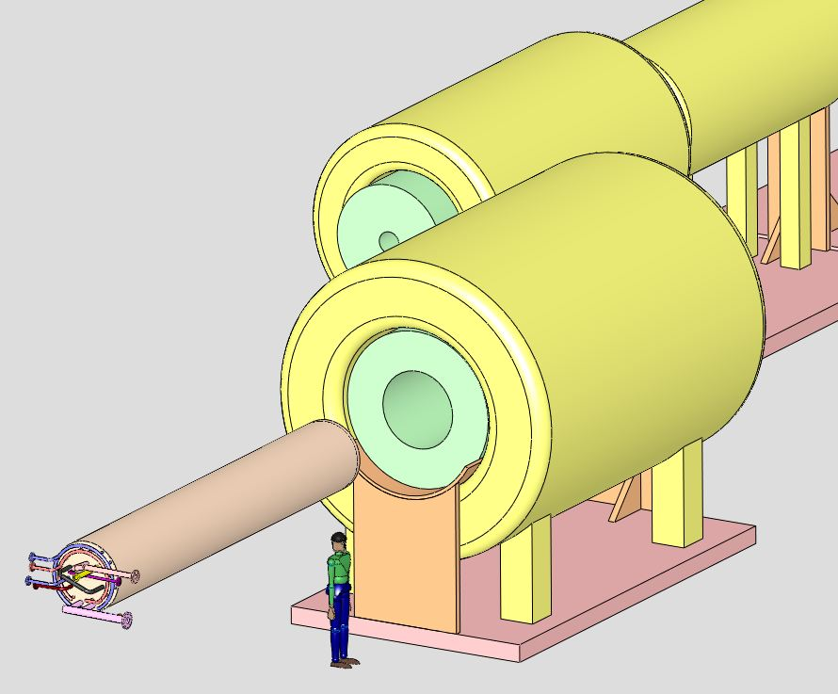
Target
Module
Figure 6: Target Module extracted from cryostat.

FUTURE WORK
The Target Module concept is early in its development, and many issues have developed as the concept progressed. Future efforts will focus on separating the shielding function from the mercury containment function with the goal of reducing the complexity of the module’s design.

ACKNOWLEDGEMENT
This work was supported by the Oak Ridge National Laboratory for the U.S. Department of Energy under contract DE-AC05-00OR22725.

References
[1] M.M.Alsharo'a et al, Status of Neutrino Factory and Muon Collider Research and Development and Future Plans, Phys. Rev. ST Accel. Beams 6, 081001 (2003).
[2] A. Name et al., Phys. Rev. Lett. 25 (1997) 56.
[3] A.N. Other, “A Very Interesting Paper,” EPAC’96, Sitges, June 1996, MOPCH31, p. 7984 (1996); http://www.JACoW.org
[4] F.E. Black et al., This is a Very Interesting Book, (New York: Knopf, 2007), 52.

