**SHIELDING OF SUPERCONDUCTING COILS FOR A 4-MW MUON COLLIDER TARGET SYSTEM**

R.J. Weggel# & N. Souchlas, Particle Beam Lasers, Northridge, CA 91324, USA

V.B. Graves, Oak Ridge National Lab., Oak Ridge, TN 37832, USA

H.G. Kirk, Brookhaven National Lab., Upton, NY 11973, USA

K.T. McDonald, Princeton U., Princeton, NJ 08544, USA

D. Xiaoping, UCLA, Los Angeles, CA 90095, USA

*Abstract*

The target-magnet system for a muon collider/neutrino factory is a very challenging project. Field quality limits inter-coil gaps to ~40 the O.D. of the flanking coils. Longitudinal sag of the shielding vessels limits their length to ~7 m. Support members adequate to resist inter-cryostat axial forces require an aggregate cross section of ~0.1 m2; the cryogenic heat leakage may be large. Even if limited to a thickness of 1 cm, the vessel wall that receives the greatest radiational heating can be cooled by helium gas only if its pressure is ~10 atm its velocity is ~200 m/s. However, the analysis in this paper found none of the engineering challenges completely insurmountable.

**GEOMETRY OF COILS & SHIELDING**

Fig. 1 diagrams (in pink) the cross sections of the first dozen superconducting (SC) coils in a target-magnet design of recent vintage. Every cryostat has three coils. Cryostat #1 begins at z ≈ 3 m and ends at z ≈ 4 m; subsequent inter-cryostat gaps are at multiples of 5 m.

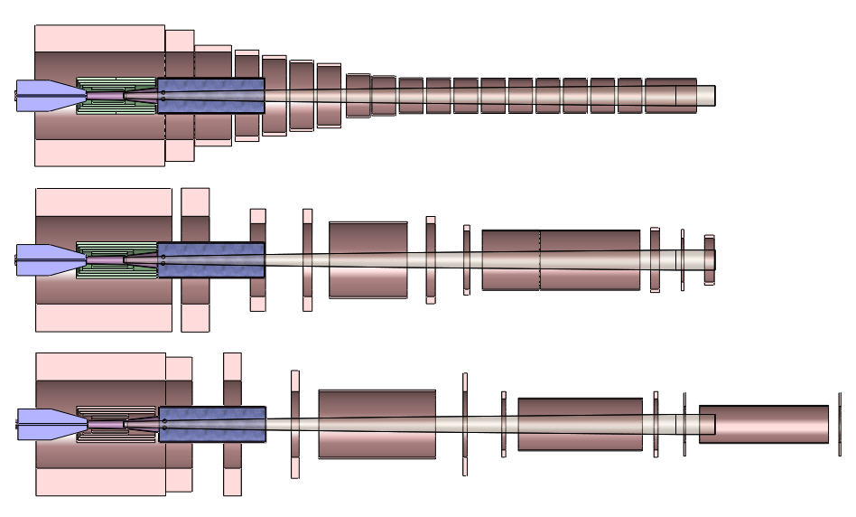

Fig. 1: Coil X-sections in recent Target-Magnet design.

Fig. 2 sketches the cross sections of components in the most-upstream module. Outermost is a set of three coaxial SC coils (cryostat not shown). Inside it is a shielding vessel consisting of two coaxial stainless steel (SSt) tubes capped by flanges. Innermost, toward the downstream end, is another shielding vessel. Upstream of z ≈ 1 m is an optional resistive magnet, consisting of five nested coils, that adds ~5 T to the ~15 T from the SC coils.

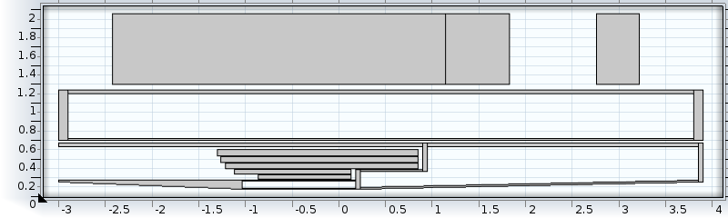

Fig. 2: X-sections of components of upstream module.

*Work supported by . . .

# bob_weggel @mindspring.com

**QUALITY OF ON-AXIS FIELD PROFILE**

Fig. 3 plots the on-axis field profile of a typical magnet. Despite very large intercoil gaps, the on-axis field never differs by more than a few percent from the desired field.



Fig. 3: On-axis field profile of component magnets.

**SAG IN SHIELDING VESSELS**

The preferred shielding material is tungsten, because of its density and high atomic number. Beads [1], such as in Fig. 4, have an abundance of cooling surface and can fill all crannies of a vessel. The larger beads are of 97% purity and density 18.2 g/cm3; the smaller ones are cobalt-bonded tungsten-carbide of density 14.5 g/cm3. Both materials are quite strongly ferromagnetic.

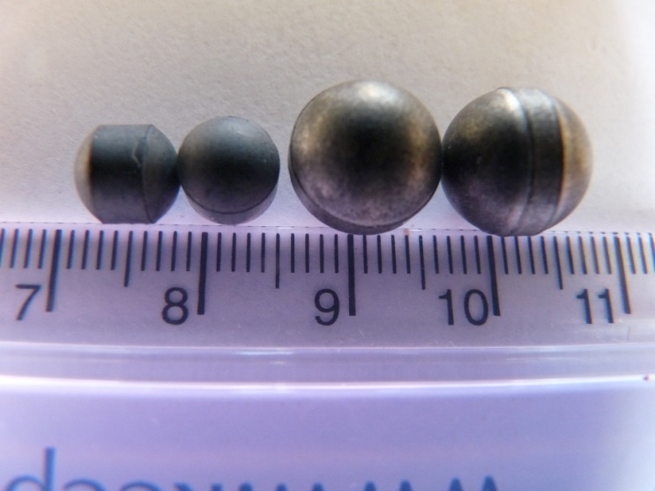

Fig. 4: Tungsten (right) and tungsten-carbide beads.

Experimental verification [2] with marbles in water found their packing factor to be 61-62%: beads of density 16.2 g/cm3 would pack to a density of 10 g/cm3. With such beads the outer shielding vessel would weigh nearly 30 metric tons per meter; the weight per unit length of the inner vessel is about one fourth as much.

During assembly or removal for replacement, it is difficult to support any shielding vessel from more than one end. Fig. 5 graphs the deflection vs. length for each of the vessels if cantilevered from the upstream end. To limit the sag to 4 mm, the outer vessel should be no longer than ~8 m; the inner vessel, ~7 m.



Fig. 5: Sag vs. length of shielding-filled SSt vessels.

The shielding vessels not only sag along their length, they also bulge under the weight of their shielding beads—and internal pressure, if cooled by helium gas. Fig. 6 shows side views of the outer shielding vessel of Fig. 2, both its outer and inner tubes. The von Mises stresses and deformations (magnified 200-fold) are modest: σvM < 107 MPa; δ < 2.7 mm). Some bulging is evident.

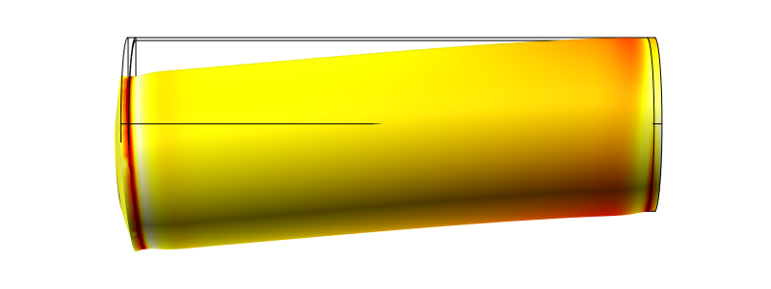

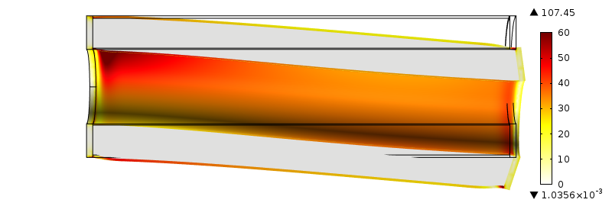

Fig. 6: σvM & δ in outer shielding vessel of Cryostat #1,

**AXIAL LOADS BETWEEN COILS**

Table 1a details the axial forces on each SC coil of the latest target-magnet design from either: 1) a triplet of SC’s in any one of five cryostats; or 2) all coils—its 5-coil, 11-MW copper magnet plus the eighteen SC coils in Cryostats #1 through #6. The largest forces (negative if upstream) are on SC#1 through #3—respectively 534, −364 and −124 MN when all coils are energized.

Table 1a: Axial Forces on Each Coil from Each Coil Set

|  |  |  |  |  |  |  |
| --- | --- | --- | --- | --- | --- | --- |
|  | Cryo. 1 | Cryo. 2 | Cryo. 3 | Cryo. 4 | Cryo. 5 | All |
| Cu | 0.721 | 0.102 | 0.0007 | 0.0001 | 0.0000 | 0.823 |
| SC#1 | 519 | 11.1 | 0.0886 | 0.0168 | 0.0061 | 534 |
| SC#2 | -368 | 8.23 | 0.0366 | 0.0058 | 0.0019 | -364 |
| SC#3 | -151 | 27.3 | 0.0567 | 0.0073 | 0.0021 | -124 |
| SC#4 | -42.4 | 6.69 | 0.0796 | 0.0071 | 0.0018 | -35.7 |
| SC#5 | -2.98 | -2.61 | 0.168 | 0.0052 | 0.0009 | -5.43 |
| SC#6 | -1.24 | -4.07 | 1.69 | 0.0234 | 0.0030 | -3.60 |
| SC#7 | -0.058 | -1.14 | 0.670 | 0.0039 | 0.0003 | -0.528 |
| SC#8 | -0.111 | -0.766 | 0.151 | 0.220 | 0.0036 | -0.502 |
| SC#9 | -0.0137 | -0.0269 | -0.821 | 0.634 | 0.0023 | -0.225 |
| SC#10 | -0.0120 | -0.0184 | -0.722 | 0.511 | 0.0043 | -0.237 |
| SC#11 | -0.0135 | -0.0142 | -0.130 | -0.0004 | 0.129 | -0.028 |
| SC#12 | -0.0044 | -0.0031 | -0.0053 | -0.510 | 0.789 | 0.269 |
| SC#13 | -0.0037 | -0.0024 | -0.0033 | -0.789 | 0.511 | -0.283 |
| SC#14 | -0.0047 | -0.0025 | -0.0024 | -0.129 | -0.0011 | -0.0109 |
| SC#15 | -0.0017 | -0.0008 | -0.0005 | -0.0043 | -0.511 | 0.271 |
| Sum | -46.1 | 44.8 | 1.26 | -0.0035 | 0.0219 | 0.0008 |

Table 1b summarizes the forces between cryostats from coils in one other cryostat or from all coils in the magnet.

Table 1b: Axial Forces between Coil Sets (Cryostats)

|  |  |  |  |  |  |  |
| --- | --- | --- | --- | --- | --- | --- |
|  | Cryo. 1 | Cryo. 2 | Cryo. 3 | Cryo. 4 | Cryo. 5 | All |
| Cu | 0.721 | 0.102 | 0.0007 | 0.0001 | 0.0000 | 0.823 |
| Cryo.1 | 0.0040 | 46.6 | 0.182 | 0.0299 | 0.0102 | 46.1 |
| Cryo.2 | -46.6 | -0.0001 | 1.94 | 0.0356 | 0.0057 | -44.8 |
| Cryo.3 | -0.182 | -1.94 | 0.0000 | 0.858 | 0.0063 | -1.26 |
| Cryo.4 | -0.0299 | -0.0356 | -0.858 | -0.0001 | 0.922 | 0.0034 |
| Cryo.5 | -0.0102 | -0.0057 | -0.0063 | -0.922 | -0.0009 | -0.0230 |
| Sum | -46.1 | 44.8 | 1.26 | -0.0035 | 0.0219 | 0.0008 |

Fig. 7 plots the cumulative axial force vs. axial position within the cryostats. To fit on the graph, the red and magenta curves (coils of Cryostats #1 & #2, respectively) have been shrunk by respective factors of 100 and 10.



Fig. 7: Cumulative axial force vs. axial position within modules of latest target-magnet design.

Note that the 534-MN force on SC #1 is nearly an order of magnitude greater than the 46-MN net force on its cryostat. Note also that the force on Cryostat #1 is downstream (the compressive reaction force is on its downstream end), whereas the force is upstream on Cryostats #2 & #3. Note also that the internal force within Cryostats #4 & #5 is tensile—each of its end coils is attracted more strongly to coils on the other side of its inter-cryostat gap than to the coils within its own cryostat.

**VESSEL STRESSES & DEFORMATIONS**

To withstand the force of attraction between Cryostats #1 & #2 requires structural members that are very hefty indeed, with an aggregate cross section on the order of 46 MN/ 460 MPa = 0.1 m2! Fig. 8 plots the von Mises stress and deformation, amplified 100-fold, with bore tubes of 5-cm wall and flanges 10 cm thick, plus SSt that fills the 93-cm gap between SC coils #2 and #3. Loads on each flange are as in Fig. 7, distributed uniformly over the face of the flange. In both flanges of Cryostat #2 the maximum values of σvM and δ are ~540 MPs and ~5.5 mm, respectively. These values compare with analytic estimates [3] of 350 MPa and 3.9 mm for flanges that share the load equally and whose inner edges are “guided”—i.e., free to move axially but not radially.

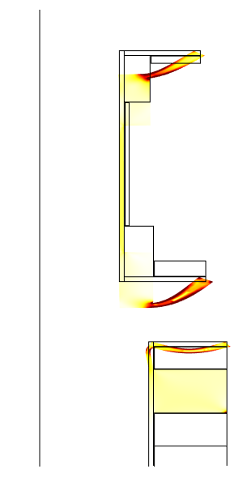

Fig. 8: σvM and δ in Cryostat #2 (z axis shown vertical).

**GAS COOLING OF BORE TUBE**

Helium gas is much poorer a coolant than water, which has an extraordinarily high heat capacity, but suffers much less activation and is chemically inert. Helium should be capable of cooling shielding in the form of beads—they have enough surface area—provided the helium does not heat up too much on its way from the inlet to the outlet of any shielding vessel. However, helium may have difficulty cooling any vessel walls that are highly heated by radiation emanating from the target.

Fig. 9 plots the deposited power density (DPD) vs. axial position in the vessel wall with the highest power density—the bore tube near the interaction region. The solid red curve plots the DPD along the line (constant azimuthal coordinate) where it is highest, reaching 67 W/cm3 [4] near z = −20 cm. An assumption of mirror symmetry about the plane z = −20 cm gives the black curve for the DPD in the region beyond that covered by the data file generated by the program (MARS15) that predicts the DPD. The integral under the curve is 3,400 W per cm of azimuthal extent for a bore tube of 1-cm wall thickness. A square-wave approximation to the curve would has an axial extent of 3,400/67 = 50 cm.

A computer program assesses the feasibility of cooling a slab with a uniform DPD of 67 W/cm3 DPD and 50-cm length of heated zone. Cooling with helium gas turns out to be challenging. Even with a velocity of 210 m/s and pressure of 10 atm, helium can cool a slab only ~9 mm thick, if cooling is from one side only and the temperature rise in the bore tube is limited to 80°C. The optimum depth of helium channel is 6 mm. The bulk, boundary-layer and conduction temperature rises are 60°C, 18°C and 2°C, respectively. The hot-spot temperature rise in a bore tube 1 cm thick would be 92°C.



Fig. 9: Deposited-power density in beam pipe.

**REFERENCES**

[1] P. Sedor, Global Tungsten & Powders Corp., www.globaltungsten.com

[2] R.J. Weggel e-mail to H. Kirk, K. McDonald & R. Palmer, 6/3/2011.

[3] N. Souchlas, “Energy flow and deposition in a 4-MW muon-collider target system”, IPAC’12.

[4] W.C. Young & R.G. Budygas, *Roark’s Formulas for Stress and Strains,* 7th edition, McGraw Hill (2002).