**A TARGET MAGNET SYSTEM**

**FOR A MUON COLLIDER AND NEUTRINO FACTORY\***

R.J. Weggel#, N. Souchlas, Particle Beam Lasers, Inc., Northridge, CA 91324, U.S.A.

H.G. Kirk, Brookhaven National Laboratory, Upton, NY 11973, U.S.A.

K.T. McDonald, Princeton U., Princeton, NJ 08544, U.S.A.

V.B. Graves, Oak Ridge National Laboratory, Oak Ridge, TN 37831, U.S.A.

*Abstract*

The target system envisioned for a Muon Collider or Neutrino Factory calls for a solenoidal magnetic field that tapers from 20 T to 1.5 T over 15 m. Proposed here is a magnet with both superconducting (SC) coils and resistive ones. A set of nineteen large-bore, helium-cooled, cable-in-conduit SC coils contributes ~ 75% of the peak field − and an even higher percentage elsewhere. Within the bore of the SC magnet is a 12-MW water-cooled resistive magnet of copper hollow conductor insulated with ceramic (MgO) for radiation resistance. The design addresses simultaneous constraints on field profile, superconductor current density, conductor cooling and stresses. Vessels filled with tungsten-carbide pellets attenuate the radiation issuing from the 4-MW proton beam impacting the mercury-jet target.

**GEOMETRY OF COILS AND SHIELDING**

This paper presents a refined conceptual design of an earlier study [1] for the magnets of the target system for a Muon Collider or Neutrino Factory. The system proposed here includes five resistive coils of copper hollow conductor and 19 SC coils of cable-in-conduit conductor (CICC). Figure 1 shows a vertical section of components of the upstream, higher-field half of the system, downstream to *z* ≈ 7 m. The resistive magnet has an I.R. of 0.18 m and an O.R. of 0.50 m. The three most-upstream SC coils have an I.R. of 1.2 m. The white enclosed regions accommodate shielding material − tungsten-carbide pellets (~ 60% by volume, cooled by water). The remaining shaded regions are tubes and annular flanges of the vessels that contain the shielding.

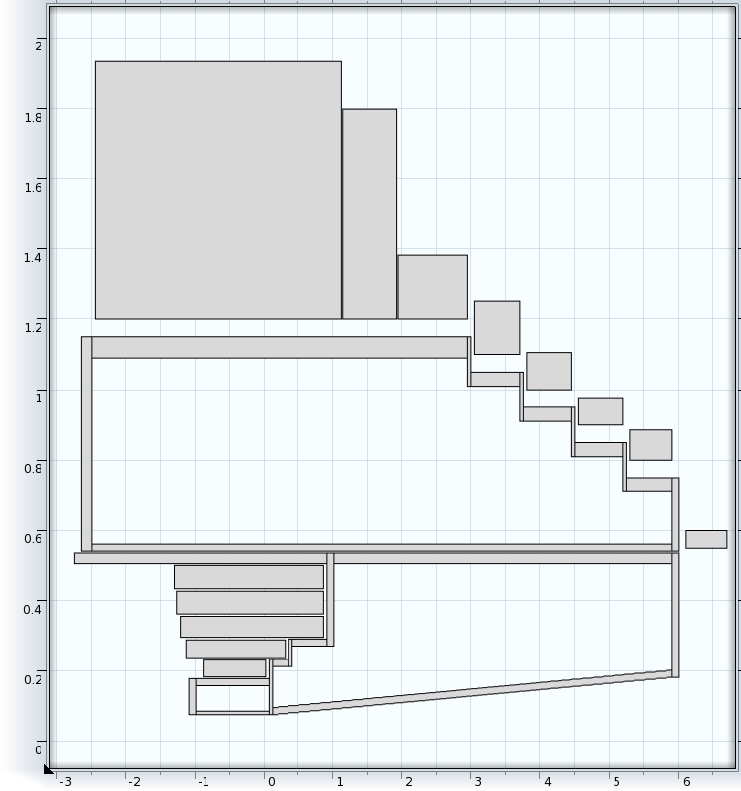

Fig. 1: Cross section of resistive & SC coils & shielding vessels; longitudinal axis compressed ~ threefold.

* Supported in part by US DOE Contract NO. DE-AC02-98CH10886.

# [bob_weggel@mindspring.com](mailto:bob_weggel@mindspring.com)

Figure 2 plots the on-axis field of the system, and also the minimum radius of the bore tube, which must flare as *B*−½ to keep pace with the increasing diameter of the flux tubes that retain captured pions and muons. The desired on-axis field *B*0*(z)* between the beam-target interaction region, *z* = 0 and - 0.75 m, should average 20 T, with a field homogeneity of 3% peak to peak: *B*0*(z)* ≈ 20.2 T near the middle of the region and ~ 19.6 T at each endpoint. For *z* between 0 and 15 m, the field profile should mate smoothly (continuous 1st derivative) with the above profile and likewise with the constant 1.5-T field beyond *z* = 15 m. An equation that satisfies these requirements is *B*0*(z)* = *B*3 / [1 + *c*2ζ2(1 - cζ)], where *B*3= 20.56 T and ζ = *z+∆z*, with ∆*z* = 0.565 m. With β ≡ *B*3/1.5 and ζ15 = 15*+∆z,* the coefficients *c2* and *c* are *c*2 = 3(β-1)/ζ15 = 0.1573 and *c* = 2ζ15/3 = 0.428

The actual field profile agrees very well with the desired one over the entire range, with deviations of only a few percent arising from the gaps between consecutive superconducting coils. The bore radius is 7.5 cm when *B* = 20 T, 18 cm at *z* = 6 m (where *B* ≈ 3.4 T) and 27 cm at *z* = 15 m, where *B* = 1.5 T.



Fig. 2: On-axis field profiles of resistive, SC and all magnets, and bore-tube radius *r* = 7.5 (*B*/20 T)−½ cm.

**CURRENT DENSITY; STRESS; COOLING**

*Resistive coils*

Each of the five coils of the resistive magnet has two layers of copper hollow conductor. For radiation resistance, the insulation is ceramic (MgO). The innermost coil uses conductor identical to that developed [2] for the Japan Hadron Facility (JHF) of 23.8-mm square O.D. and 11-mm round I.D. For magnetic and hydraulic efficiency, subsequent coils use heftier conductor (*e.g*., O.D. = 34.3 mm in coil #5; current density = 48% that in coil #1) with all dimensions scaled from the JHF conductor.

Electrical and hydraulic connections are at only the upstream end. Winding is four-in-hand, electrically in series but hydraulically in parallel, with a total water flow of ~50 l/sec at a water pressure of 40 atm (4 MPa).

Reinforcing each coil is a thin tightly-nested cylindrical tube or layer of banding with a permissible stress σs of ~ 800 MPa. The hollow-conductor copper is soft, for fabricability, with a yield strength of only ~100 MPa. All coils are electrically in series (12.6 kA); the total voltage is 76 V. Coil #2 runs the warmest: ∆*T*bulk = 73°C in the water and ∆*T*max = 85°C in the conductor itself. The magnets are distressingly inefficient, requiring nearly twice as much power as would a Bitter magnet, because the MgO layer is thick and must be contained by a sheath; only 55% of the cross section carries current.

*Superconducting coils*

The CICC includes superconductor, copper stabilizer, void for helium coolant, insulation, and high-strength structural-support − the only member counted on to carry load. All coils use Nb3Sn, even if NbTi might suffice, and each coil uses only a single type of conductor; throughout each coil the current density *J*coil is uniform.

The fraction of superconductor in a coil is *J*coil/*J*SC, where the current density *J*SC in the superconductor itself depends on the desired temperature margin and the maximum ambient field *B*max seen be the coil. Curve fitting of data given by Iwasa (p. 645 of [3]) for Nb3Sn for the “barrel” coils of ITER (International Thermonuclear Experimental Reactor) at temperatures of 4.2 and 10 K and fields of 5, 8, 12 and 15 T predicts *J*SC throughout this range of temperature and field. For the assumed temperature of 6 K the fit is:

[A/mm2].

The volume fraction of structural support is σ1/σ0, with σ0 ≡ 600 MPa. σ1 is the hoop (circumferential) stress predicted (p. 101 of [3]) at the inner radius of a long uniform-current-density coil with current density *J*coil, inner radius *a*1, central field *B*1, external field *B*2, and O.R./I.R. ratio α sufficiently modest (valid for all coils here) so that the peak stress is indeed at the inner radius. For a Young’s modulus μ = 0.3 the equation is:

$σ_{1}={ a}_{1} J_{coil} \frac{\left(7+14α+85α^{2}\right)\left(B_{1}+B_{2}\right)+14(B_{1}+α^{2}B_{2})}{120(1+α)}$ [MPa].

Subsequent computation by FEM confirms that the maximum von Mises stress is less than the ~ 800 MPa employed in the CICC conductor of the NHMFL 45-T hybrid magnet’s three coils (two of Nb3Sn and one of NbTi [4]). For all coils (resistive as well as SC) the maximum strain is no more than ~ 0.4%.

The area fraction of copper and “void” (for coolant and insulation) are assumed equal to each other. The quench current density allowed in the copper is 100 A/mm2, implying ~ 10 s for copper of residual resistivity ratio (RRR) = 50 — a conservative value — to warm from 4 to 180 K (p. 473 of [3]), limiting thermal strains to ~ 0.1%. A quench-protection system to force the current to decay exponentially as *I(t) = I*0 *e−t/τ* should have a time constant τ ≡ *L/R* of 20 s.

Because the magnet is so large and high in field, its magnetic energy storage is huge, *U*0 = 3 GJ − nearly half the 6.4 GJ of the ITER central solenoid (though only 1/15th that of its 46-GJ toroidal magnet). To remove the energy with a time constant *τ* requires a maximum discharge voltage (at *t* = 0) of *V*0 *= 2 U*0 */ (I*0 *τ*); if *I*0 were 100 kA, then *V0* would be 3 kV.

Selected parameters of the most-upstream, most massive, and highest field coil are: O.R. = 193 cm, length = 356 cm, *J*coil = 20 A/mm2, and σ1 = 306 MPa. The fractions of superconductor, copper, steel and “void” (coolant plus impregnant) are, respectively, 9.6%, 16%, 51% and 16%. The mass of this coil is nearly 140 tons, 76% of the total for all nineteen superconducting coils.

**FIELD-QUALITY, COST OPTIMIZATION**

The optimization adjusts magnet dimensions and other parameters to minimize a weighted sum of terms: on-axis field discrepancy ≡ Σ(*B*actual – Bdesired)2, yearly operational cost and penalties for imperfect satisfaction of constraints or encroachment on forbidden parameter territory.

The yearly operational cost of the system is the cost of the electrical power plus the amortized cost of the resistive and SC magnets, at an amortization rate of 10% per year. The cost per kW-hr is that reported by the NHMFL: $4k/hr @ 33MW, $121/MW-hr [5]. At 11.5 MW, this is $7.7 M per operational year of 2x107 s.

Capital cost of the magnets likewise draws on values reported by the NHMFL: $200-250/kg for resistive magnets and $400-500/kg for ones including superconductor [5]. To acknowledge inflation and the neglected mass of cryostats and other components, the program uses cost coefficients of $400/kg for fabricated copper and steel and ~ ($800/kg for fabricated SC coils. The capital cost of the magnets, with their cumulative mass of nearly 200 tons (7 tons for the resistive coils; 183 tons for the SC ones), therefore is nearly $160 M, and the yearly amortized cost, $16 M/yr. Note that the operational and amortization costs are in the same ballpark, a typical consequence of cost-optimization.

**STRESSES & STRAINS IN COILS**

Figure 3 plots the hoop strain εθ in the resistive and superconducting magnets, as predicted by FEM. To avoid mesh elements awkwardly thin in the radial direction, the thin banding about each resistive coil was simulated by the radially-inward pressure generated by its hoop tension. For the SC coils, FEM predicted the stress averaged over the CICC cross section; dividing this averaged stress by the fraction of support structure predicts the stress in the structural material.

For all coils the maximum strain is ~ 0.4%. For SC #1 (by far the most massive and costly coil in the system) the maximum strain is 0.36% which, multiplied by a Young’s modulus of 200 GPa, implies a hoop stress of 720 MPa. For this coil FEM analysis predicts the von Mises stress (averaged over the CICC cross section) to be 390 MPa; dividing by 0.51, the fraction of structural-support material, implies a von Mises stress of 760 MPa.

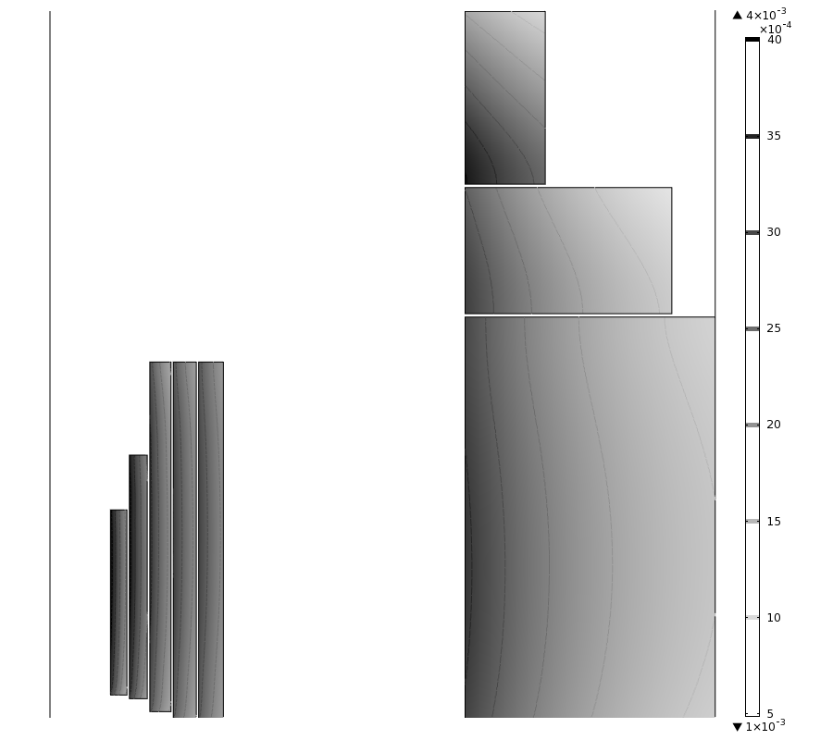

Fig. 3. Hoop strain εθ in resistive coils and SC coils #1-3; maximum εθ is ~ 0.4%; in SC coil #1 it is 0.36%, implying a hoop stress of 720 MPa in the CICC conduit.

**STRESSES & DEFORMATIONS IN VESSELS**

All of the coils need shielding from the intense radiation emanating from the interaction of the proton beam and mercury-jet target and, further downstream, from the decay of pions and muons. This shielding, anticipated to be pellets of tungsten-carbide cooled by water, has to be supported by sturdy vessels of stainless steel. Of concern is the deformation of these vessels under the weight of the shielding. A challenge in modeling these vessels is that they are so thin radially, compared to their axial and circumferential dimensions. Figure 4 shows the user-mapped mesh that gives the highest mesh quality where stresses and stress gradients are highest — at the junctions between tubular members and annular disks.

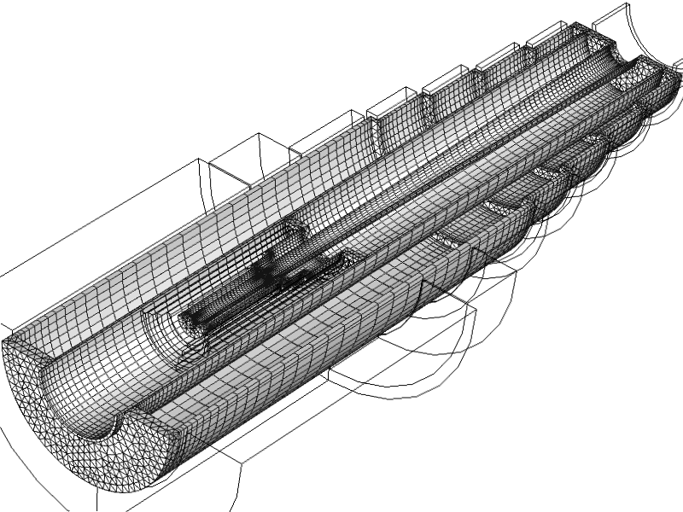

Fig. 4: Finite-element mesh, user mapped for highest quality where stresses and stress gradients are highest, at the junctions between tubular members and annular disks.

The von Mises stress σvM with each vessel fixed only at its upstream end is 253 MPa. Figure 5 shows the deformation δ magnified twenty-fold; δmax = 39 mm. Fixing the inner vessel at both ends reduces σvM to 99 MPa and δmax to 6.2 mm. With both vessels fixed at both ends σvM = 88 MPa and δmax = 1.7 mm.

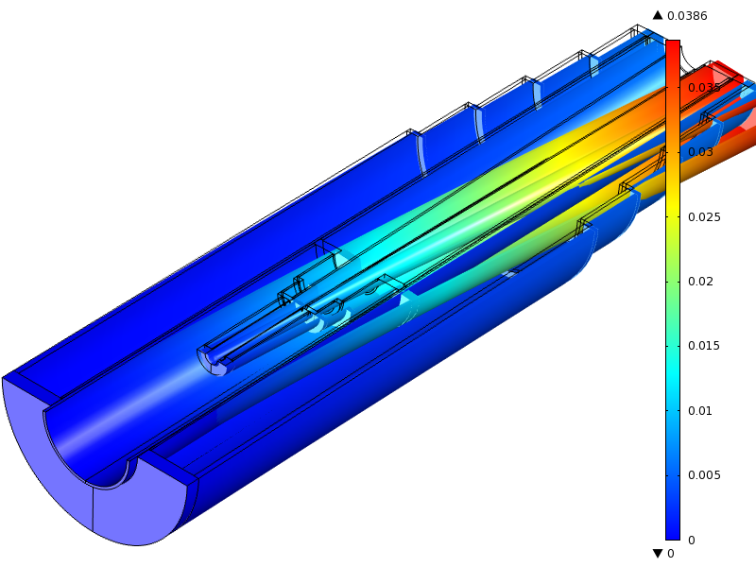

Fig. 5: Deformation δ, magnified 20-fold, with each shielding vessel fixed only at its upstream end; δmax = 39 mm.

**REFERENCES**

[1] R.J. Weggel, C.E. Pearson and B.J. King, *Design Study for 20 T, 15 cm Bore Hybrid Magnet with Radiation-Resistant Insert for Pion Capture*, PAC01, p. 3398.

[2] K.H. Tanaka *et al*., *Development of Radiation-Resistant Magnet Coils for High-Intensity Beam Lines*, IEEE Trans. Magn. **30**, 2511 (1994).

[3] Y. Iwasa, *Case Studies in Superconducting Magnets, Design and Operational Issues, 2nd ed*. (Springer, 2009).

[4] J.E.C. Williams, personal communication.

[5] <http://magnet.fsu.edu/mediacenter/features/meetthemagnets>