The Muon Collider/Neutrino Factory Target System

H.G. Kirk (BNL) and K.T. McDonald (Princeton U.)
(Aug. 14, 2010)

Abstract

We outline a program of engineering design and simulation for a target station and pion production/capture system for a 4-MW proton beam at the front end of a Muon Collider or a Neutrino Factory. The target system consists of a free liquid mercury jet immersed in a high-field solenoid magnet capture system that also incorporates the proton beam dump.

1 Introduction: the Target System Baseline

The requirements for a Muon Collider/Neutrino Factory (some of which are summarized in Table 1) call for a target capable of intercepting and surviving a 4-MW pulsed (15-50 Hz) proton beam. The target, the proton beam dump, and a shield/heat exchanger are to be located inside a channel of superconducting solenoid magnets that capture, confine and transport secondary pions and their decay muon, of energy 100-400 MeV, to the bunching, phase-rotation, cooling and acceleration sections downstream. Most of the 4-MW beam power is to be dissipated within a few meters, inside the solenoid channel, which presents a severe challenge that has only been partially addressed to date. Rather, the main effort over the past decade has been in exploring a concept for the target, and to a lesser extent the proton beam dump.

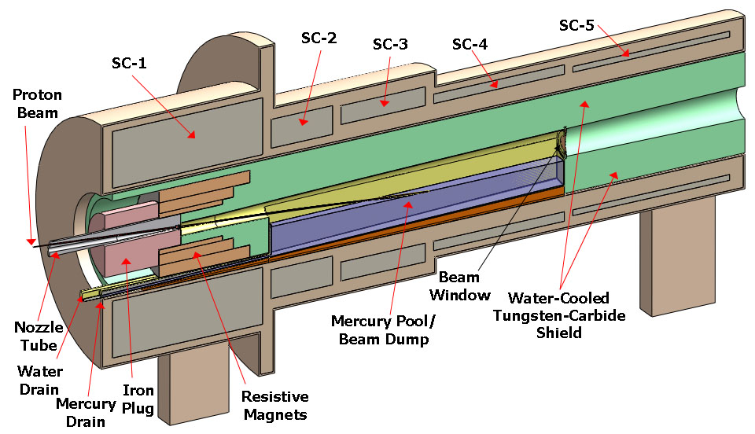
Fig. 1. Baseline target-system concept.Error: Reference source not found

Table 2. Baseline proton beam parameters.
Proton Beam Energy | 8 GeV
Rep Rate (Neutrino Factory) | 50 Hz
Rep Rate (Muon Collider) | 15 Hz
Bunch Structure (Neutrino Factory) | 3 bunches, 200 μsec total
Bunch Structure (Muon Collider) | 1 bunch
Bunch Width | 2 ± 1 ns
Beam Radius | 1.2 mm (rms)
Beam Power | 4 MW (3.125 × 10¹⁵ protons/sec)

Maximal production of low-energy pions is obtained with a proton beam of 1-2 mm (rms) radius and a target of radius 2.5 times this, such that the secondaries exit the side of the target rather than its end. The resulting high density of energy deposition in the target makes it questionable whether any passive solid target could survive at 4-MW beam power. Schemes for a set of moving solid targets are not very compatible with the surrounding solenoid magnets. Hence, the baseline target concept is for a free liquid jet target, in particular mercury. The present baseline parameters of the target are summarized in Table 2.
Table 3. Baseline target parameters
Target type | Free mercury jet
Jet diameter | 8 mm
Jet velocity | 20 m/s
Jet/Solenoid Axis Angle | 96 mrad
Proton Beam/Solenoid Axis Angle | 96 mrad
Proton Beam/Jet Angle | 27 mrad
Capture Solenoid (SC-1) Field Strength | 20 T

This target concept has been validated by R&D over the past decade, culminating in the so-called MERIT experiment that ran in the Fall of 2007 at the CERN PS. The experiment benefited from the intensity of the beam pulses (up to 30 x 10¹² ppp) and the flexible beam structure available for the extracted PS proton beam. Key experimental results include demonstration that:
- The magnetic field of the solenoid greatly mitigates both the extent of the disruption of the mercury and the velocity of the ejected mercury after interception of the proton beam. The disruption of a 20-m/s mercury jet in a 20-T field is sufficiently limited that 70-Hz operational is feasible without loss of secondary particle production.
- Individual beam pulses with energies up to 115 kJ can be safely accommodated.
- Subsequent proton beam pulses separated by up to 350 μsec have the same efficiency for secondary particle production as does the initial pulse.
- Two beam pulses separated by more than 6 μsec disrupt the mercury independently.

The mercury jet is collected in a pool, inside the solenoid magnet channel, that also serves as the proton beam dump, as sketched in Fig. 1. Disruption of this pool by the mercury jet (whose mechanical power is 20 kW) and by the noninteracting part of the proton beam is nontrivial, and needs further study.

The superconducting magnets of the target system must be shielded against the heat and the radiation damage caused by secondary particles from the target (and beam dump). A high-density shield is favored to minimize the inner radii of the magnets. The baseline shield concept is for water-cooled tungsten-carbide beads inside a stainless steel vessel (of complex shape, as sketched in Fig. 1). However, the present baseline concept is not technically feasible, and considerable effort is needed to produce a new, viable baseline.

The solenoid magnets of the target system vary in strength from 20 T (SC-1 in Fig. 1) down to 1.5 T in the subsequent constant-field transport channel. This adiabatic reduction in field strength permits the solenoid magnet string to reduce the rms emittance of the secondary particles. For the baseline parameters of the downstream π/μ capture channel, a peak field of 20 T in magnet SC-1 provides good reduction of the emittance of the secondary pions. Further study is warranted to optimize this effect (which improves with the use of a higher initial field).

A 20-T field is beyond the capability of Nb₃Sn, and magnet SC-1 is proposed as a hybrid of a 14-T superconducting coil with a 6-T hollow-core copper solenoid insert. A 45-T solenoid of this type of construction has been operational since 2000 at the National High Magnetic Field Laboratory (Florida), and a 19-T magnet of this type with 16-cm-diameter bore exists at the Grenoble High Magnetic Field Laboratory (and was used in an earlier phase of our R&D program). A topic for further study is possible fabrication of SC-1 as of a high-T_{C} magnet with no copper solenoid insert, which could provide more space for internal shielding of SC-1 and/or permit operation at a higher field for improved reduction of the initial beam emittance.

The target system (and also the subsequent π/μ solenoid transport channel) will be subject to considerable activation, such that once beam has arrived on target all subsequent maintenance must be performed by remote-handling equipment. The infrastructure associated with the target hall, with its remote-handling equipment, and hot-cells for eventual processing of activated materials, will be the dominant cost of the target system.

2 Future Plans

The target system is comprised of subsystems with a wide variety of issues that deserve further study, via simulation, engineering design, and hardware testing, as reviewed briefly below in this section. The interrelated character of these issues is such that they should not be addressed separately, but rather via an integrated design effort led by a physicist and a (chief) engineer.

2.1 Simulations and Engineering Design

2.1.1 Mercury Jet-Proton Beam Interactions in a Magnetic Field

Simulation of the interaction of behavior of a free mercury jet in a magnetic field when subject to intense, pulsed energy deposition by a proton beam is a state-of-the-art problem in computational physics. For several years, R. Samulyak of SUNT Stony Brook has led an effort to enhance the so-called FronTier code to address this challenging problem, with increasingly sophisticated results. An example is shown in Fig. 2 of how high magnetic fields suppress the disruptions of a mercury jet. Effort is ongoing to simulate one of the subtler effects of the mercury-beam interaction, the apparent (transient) reduction in the speed of sound within the mercury after a beam pulse.

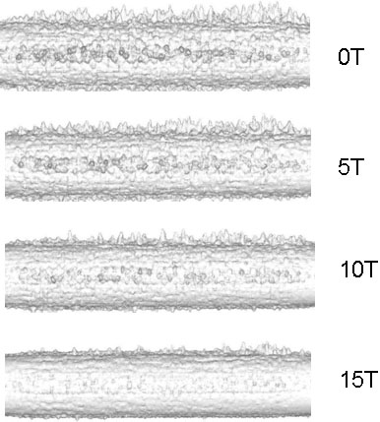
Fig. 2. FronTier simulation of the suppression by high magnetic field of filamentation of a mercury jet.Error: Reference source not found

2.1.2 High-Reynolds-Number Flow of Mercury from a Nozzle

One aspect of the MERIT experiment that deserves further study is that the quality of the 1-cm-diameter mercury jet at 15-20 m/s velocity was rather poor.Error: Reference source not found To address this issue a program of simulation has recently begun, led by F. Ladiende of SUNY Stony Brook. It is too early to report results of this effort, other than preliminary studies of the flow of mercury in the piping that fed the nozzle in the MERIT experiment, one plot of which is shown in Fig. 3.

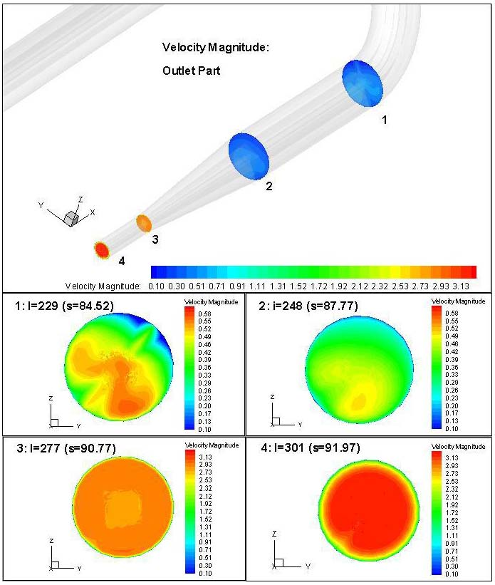
Fig. 3. Velocity profiles at four sections near the nozzle of the MERIT mercury delivery pipe.Error: Reference source not found

2.1.3 Solid-Target Options

It is prudent to maintain some level of effort for solid-target options, such as a radiation-cooled graphite or beryllium target that would be replaced every few weeks. More speculative options include a flowing tungsten-power target, and a rotating band of tungsten targets.

2.1.4 Optimization of the Pion Production in the Target

Many factors influence the pion production in the target: proton beam energy, target material, target radius, target length, target and beam angles with respect to the magnetic axis. Simulations of pion production at the target station of a Muon Collider have been performed using the MARS code since at least 1997, and need to be continued with greater sophistication so as to optimize the various relevant parameters.

2.1.5 Proton Beam Dump

One of the many challenges of the Muon Collider/Neutrino Factory target system is the placement of the proton beam dump inside the superconducting magnet channel. The baseline design is to use the pool that collects the mercury from the target jet as the beam dump. This concept leads to substantial challenges as to the perturbation of the pool by the jet and beam (Fig. 4), and to the flow of the mercury out of the target system.

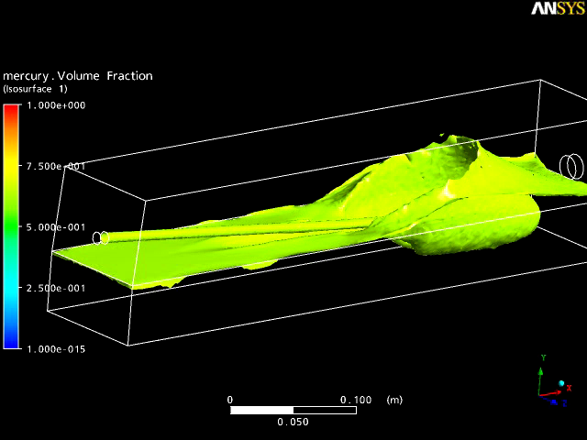
Fig. 4. ANSYS simulation of a mercury jet entering a mercury pool.Error: Reference source not found

2.1.6 The Internal Shield

A major challenge of the target system is the dissipation of the 4-MW of beam power inside the superconducting magnet string without quenching of the magnets, or extreme shortening of the operational lives due to radiation damage. Space is very limited for the shield, and the geometry is awkward as the shield envelops the mercury pool and the copper magnet (Fig. 5). The shield must be cooled by a liquid; water in the baseline scenario, but with mercury as an option.

The baseline scenario is for a shield of tungsten-carbide beads cooled by water. However, the baseline assumed an effective density of the beads (80% of the density of tungsten-carbide) that cannot be achieved with beads of a single radius. Use of multiple bead radii or tungsten-carbide sheets with machined microchannel raises issues of whether that water flow could be sufficient to keep the water form completely vaporizing in portions of the shield. Furthermore, the coolant must enter and exit the system from the upstream end, where the shield cross section is much smaller than in its downstream region. Initial simulations using the MARS15 code indicates that the current shielding approach allows for ~25 kW of power to be deposited within magnet SC-1 alone. This is not considered acceptable and must be addressed.

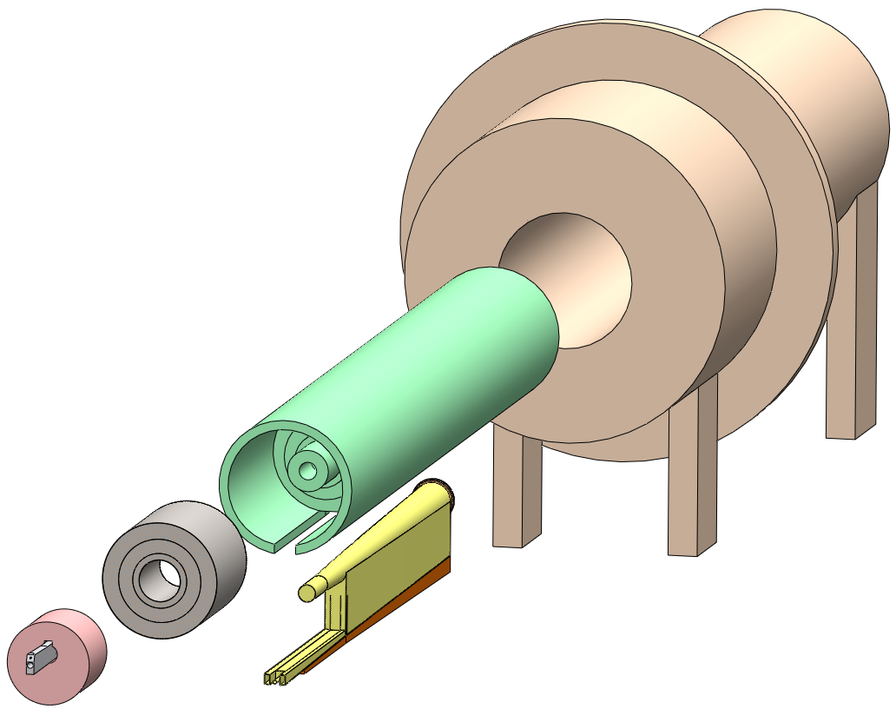

Fig. 5. Tentative scenario for assembly of the iron plug, the copper magnet, the mercury collection chamber and the internal shield within the target system magnets.Error: Reference source not found

The search for a solution is complicated by the present lack of a clear criterion as to how much shielding is required for viable operation of the superconducting magnets in the presence of pulsed heating and radiation damage from secondary particles from the target.

The baseline scenario for the internal shield of the superconducting magnets is a vessel filled with tungsten-carbide spheres, cooled by water flow. As the geometry of the internal shield is complex, it is not evident that sufficient uniformity of the water flow can be achieved to avoid regions in which there is only steam rather than water, which could then lead to local melting of the shield wall. To address this issue, and to consider alternatives with, say, tantalum shielding with long channels for the coolant, or shielding with mercury, simulations of heat transfer in complex geometries are required.

We are presently exploring the prospect of such simulation with the Peles group at RPI.

2.1.7 Magnet Design

The design of the first magnet, with baseline field of 20 T is challenging. The use of a 6-T water-cooled, hollow core copper solenoid insert is required if the superconducting outsert is to be made from Nb₃Sn. This copper magnet receives a very high radiation dose (while acting as a partial shield of the superconducting outsert) and is anticipated to be a replaceable component with a lifetime of 4 years or less. If the presence of this copper magnet leads to a requirement for thicker shielding and consequent larger inner diameter the superconducting outsert, such that the latter is untenable, we must consider the option of only a 14-T Nb₃Sn magnet, or development of a large-bore high-T_{C} magnet (or more simply, a high-T_{C}-Nb₃Sn hybrid; tests of YBCO indicate that it has good resistance to radiation damage).

Another issue is the very large axial forces between the various magnets of the target system. A further complication is the requirement that the axial field profile in the beam-jet interaction region be smooth, such that the mercury jet is minimally perturbed as it enters this field. The baseline scenario calls for an iron plug at the upstream end of the first magnet, through which the proton beam and mercury jet enter. The presence of this plug adds considerable complexity to the mechanical design of the system, with as-yet unresolved technical issues.

2.1.8 Optimization of Emittance Reduction by the Target System Magnets

Although the “true” emittance of a beam is an invariant under transport through a system of magnets, the rms emittance (which is of more practical importance than the possibly filamented “true” emittance) is affected by details of the magnetic transport. If the a secondary beam is created in a region of high magnetic field, and transported through a region of adiabatically reduced field, then in principle both the longitudinal and transverse emittance can be reduced.Error: Reference source not found The baseline design of the target system, in which the field drops from 20 T to 1.75 T over 12 m, provides such rms emittance reduction (or alternatively, permits capture of a larger number of secondary pions into the aperture of the 1.75-T solenoid transport channel). A global optimization of the target system plus capture channel magnetic fields has never been performed, while numerous changes in the latter have been considered in recent years. Hence, it is timely that this issue be simulated in the near future.

While better performance can be obtained with a higher field than 20 T in the first target-system magnet (SC-1), engineering reality may require us to use a lower field (such as 14 T as might be obtained in a Nb₃Sn magnet. A related issue is the rapidity of the reduction of the field strength from 20 T to 1.75 T. The effect of the transverse-momentum “kick” on the muons in the decay π→μν is less if the decay occurs in a higher magnetic field, which may favor a slowly falloff of field with position than in the present baseline.

2.1.9 Mercury Flow Loop, Remote Handling Maintenance Systems, Target Hall

When it comes time to build a target system for a Muon Collider or Neutrino Factory, substantial effort will be needed on the engineering of infrastructure issues such as the target hall, the remote handling systems for maintenance, and the mercury flow loop.

  - Hardware R&D

2.2.1 Nozzle Tests

As previously mentioned, the performance of the 1-cm-diameter nozzle for the mercury jet in the MERIT experiment was poorer than desired at jet velocities of 15-20 m/s. As such, a program of simulation and design is underway with the goal of developing a better nozzle. This issue should not, however, be left only to design, but should be addressed in laboratory tests once a revised design is developed, on the time scale of 2 years. The nozzle tests should be performed with mercury, but a proton beam and magnetic field are not needed.

2.2.2 Splash Mitigation in the Mercury Collection Pool/Proton Beam Dump

Another difficult hydrodynamic issue is the perturbation of the mercury collection pool by the impinging mercury jet (and to a lesser extent by the noninteracting proton beam). Once a candidate design for splash mitigation has been well simulated, it will be desirable to test this in the laboratory. Again, the tests can be conducted without magnetic field or proton beam, but with a quasicontinuous mercury jet of 20 m/s

2.2.3 Coolant Flow in the Internal Shield

Should the baseline continue to be a water-cooled shield with high-Z beads, it would be prudent to test the coolant flow patterns in a full size mockup, for which inexpensive low-Z beads will suffice.

2.2.4 Further Particle Production Experiments

The simulations of particle production in the target system rely on extrapolation from experimental data that unfortunately have various inconsistencies in the relevant regions of parameter space. Assessment of the seriousness of this issue is ongoing, but it may well be desirable to collect additional data relevant to particle production at a Muon Collider/Neutrino Factory. The Fermilab MIPP experiment affords an opportunity for such studies.

- Estimate of Required Resources

An emerging result is that the baseline internal-shielding of the target-system magnet, as defined in the Neutrino Factory Study 2,Error: Reference source not found is not viable for operation with an 8-GeV, 4-MW proton driver. MARS calculations using this baseline indicate that 25 kW of power would be deposited within SC-1 alone,Error: Reference source not found which needs to be reduced by an order of magnitude. The design of the target system encompasses a suite of engineering requirements, for the mercury nozzle, the beam dump, the internal shield, the solenoid magnets, the mercury supply loop, remote handling and the target hall, which interplay with each other. Amongst the diverse disciplines involved are cryogenics, magnet design, mechanical engineering, fluid flow, and thermal management. Due to the interlocking nature of these activities in the present context it is desirable to address them by a team led by a physicist and project engineer. These tasks will require a team of 3 FTEs active for four years. Other activities requiring attention include magnetohydrodynamics studies to advance our understanding of the complex dynamics of the Hg jet in a strong magnetic field and an intense proton beam, pion-yield optimization (coordinated with the parameters of the entire Muon Collider/Neutrino Factory front end, and possibly even additional pion-yield measurements.

Table 3. Summary of requested resourses.
Item | Years | FTE | M&S
MHD simulations | 3 | 1.5
Pion-yield optimization | 2 | 1
Integrated design
Project engineer | 4 | 2
Nozzle development | 3 | 2 | $200k
Solid target options | 2 | 0.5
Beam dump | 3 | 3 | $200k
Internal shield | 3 | 4 | $200k
Magnet design | 2 | 2
Hg loop | 1 | 0.5
Remote handling | 1 | 0.5
Target hall | 1 | 0.5
Pion-yield measurements | 2 | 1 | $200k
Totals |  | 18.5 | $800k

References

The intense pressure waves in a liquid target due to a pulsed beam lead to damage/failure of any pipe that contains the liquid in the interaction region. Thus, the baseline is for a free liquid jet.
The “true” emittance of a beam cannot be reduced by nondissipative elements such as magnets, but the rms emittance can be reduced by magnets when, as in the present case, it greatly exceeds the “true” emittance.
M.M. Alsharo’a et al., Status of Neutrino Factory and Muon Collider Research and Development and Future Plans, Phys. Rev. ST Accel. Beams 6, 081001 (2003).
X. Ding et al., A Pion Production and Capture System for a 4 MW Target Station, Proc. 2010 Int’l. Part. Accel. Conf. (Kyoto), THPEC102, http://www.hep.princeton.edu/~mcdonald/mumu/target/ipac10/thpec092.pdf
S. Ozaki et al., Feasibility Study II of a Muon-Based Neutrino Source (June 14, 2001), http://www.cap.bnl.gov/mumu/studyii/FS2-report.html
J.R.J. Bennett et al., Studies of a Target System for a 4-MW, 24-GeV Proton Beam, proposal to the ISOLDE and Neutron Time-of-Flight Experiments Committee, CERN-INTC-P-186 (April 26, 2004), http://www.hep.princeton.edu/~mcdonald/mumu/target/cern_proposal.pdf
K.T. McDonald et al., The MERIT High-Power Target Experiment at the CERN PS, Proc. 2009 Part. Accel. Conf. (Vancouver, Canada), TUGRI03, http://www.hep.princeton.edu/~mcdonald/mumu/target/pac09/tu4gri03.pdf
K.T. McDonald, The Capture Solenoid as an Emittance-Reducing Element (Jan. 14, 2010), http://www.hep.princeton.edu/~mcdonald/mumu/target/targettrans72.pdf
45-T Hybrid, NHMFL, http://www.magnet.fsu.edu/mediacenter/features/meetthemagnets/hybrid.html
Magnet M8, GHMFL, http://ghmfl.grenoble.cnrs.fr/spip.php?rubrique77&lang=en
A. Fabich, High Power Proton Beam Shocks and Magnetohydrodynamics in a Mercury Jet Target for a Neutrino Factory, Ph.D. thesis (U. Vienna, Nov. 2002), http://www.hep.princeton.edu/~mcdonald/mumu/target/thesis-2002-038.pdf
R. Samulyak et al., Computational algorithms for multiphase magnetohydrodynamics and applications to accelerator targets, subm. to Cond. Matter Phys. (July 6, 2010), , http://www.hep.princeton.edu/~mcdonald/examples/accel/samulyak_cmp_10.pdf
Y. Zhan, Hg Supply Piping Simulation (No MHD) (Jan. 29, 2010), http://www.hep.princeton.edu/~mcdonald/mumu/target/Yan/yan_070210.pdf W. Li and F. Ladiende, Mercury Flow through a Long Curved Pipe (Jan. 26, 2009), http://www.hep.princeton.edu/~mcdonald/mumu/target/Ladiende/Results-Summary.pdf
C. Densham, The Potential of Fluidised Powder Target Technology in High Power Accelerator Facilities, Proc. 2009 Part. Accel. Conf. (Vancouver), WE1GRC04, http://www.hep.princeton.edu/~mcdonald/mumu/target/pac09/WE1GRC04.pdf
T.R. Edgecock et al., Overview of Solid Target Studies for a Neutrino Factory, Proc. 2010 Int’l. Part. Accel. Conf. (Kyoto), THPEC089, http://www.hep.princeton.edu/~mcdonald/mumu/target/ipac10/thpec089.pdf
The MARS Code System: http://www-ap.fnal.gov/MARS/
N.V. Mokhov and A. Van Ginneken, Pion Production and Targetry at μ+μ- Colliders, (Dec 17, 1997), AIP Conf. Proc. 441, 320 (1998), http://www.hep.princeton.edu/~mcdonald/examples/accel/mokhov_aipcp_441_320_98.pdf
T. Davenne et al., Mercury Beam Dump Simulations (Dec. 15, 2008), http://www.hep.princeton.edu/~mcdonald/mumu/target/Davenne/davenne_121708.pdf
V.B. Graves and C. Caldwell, Neutrino Factory Target Cryostat Review (Aug. 12, 2010), http://www.hep.princeton.edu/~mcdonald/mumu/target/graves/graves_081210.pdf
See, for example, X. Ding, Comparison of Power Depositions in SC1 Coil (June 29, 2010), https://pubweb.bnl.gov/~kirk/Target_Studies/2010_06_29/xding_ED.ppt
K.T. McDonald, Materials for the Target System Internal Shield (June 29,2010), http://www.hep.princeton.edu/~mcdonald/mumu/target/targettrans74.pdf
A. Peles, http://www.rpi.edu/~pelesy/lib/research_interests.htm
R.C. Gupta, private communication (Aug. 13, 2010).
R.C. Gupta et al., HTS for Magnets in High Radiation Enviornments (June 18, 2010), http://www.bnl.gov/magnets/Staff/Gupta/Talks/cimtec/cimtec2010-%20FK-7.pdf
J. Strait, N. Mokhov and S. Striganov, Comparisons between MARS and HARP Data (July 24 2009), http://www.hep.princeton.edu/~mcdonald/mumu/target/Strait/strait_marsvsharp.pdf
The MIPP Experiment (Fermilab E-907), http://ppd.fnal.gov/experiments/e907/

