Driver Installation Under Win ME

- Step 1: Plug in the USB type A receptacle of the cable to the USB
connector of your computer.
Step 2: Place the enclosed CD Driver into the CD ROM.
Step 3: Click “next” at the Add New Hardware Wizard screen.
See Figure 1
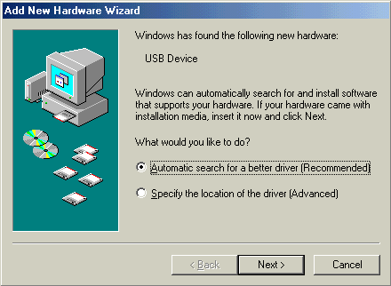
Figure 1

2.Please select the driver that matches your language and device and click “OK”.
See Figure 2
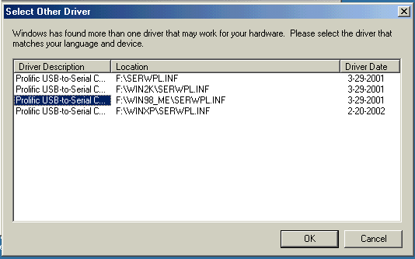
Figure 2

- Windows has finished installing the software your new hardware
device requires, click “Finish” to close the Wizard. See Figure 3
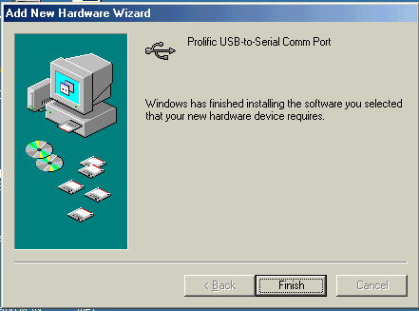
Figure 3

- Double click “My Computer” →”System Properties”→
”Device Manager” to make sure the device you install is
correctly displayed. See Figure 4
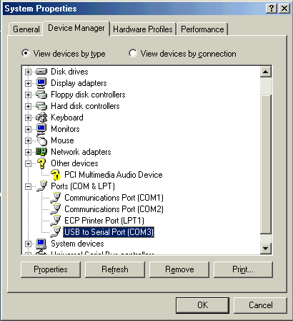
Figure 4

