Driver Installation Under Windows 2000

- Step 1: Plug in the USB type A receptacle of the cable to the USB
connector of your computer.
Step 2: Place the enclosed CD Driver into the CD ROM.
Step 3: Click “next” at the welcome screen. See Figure 1
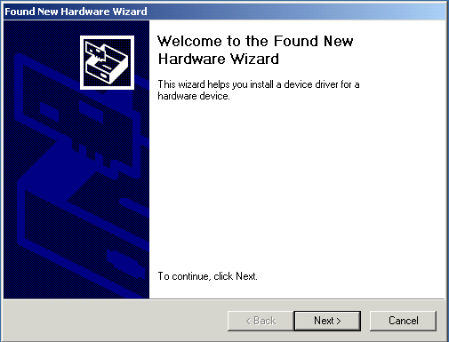
Figure 1

2.The “Found New Hardware Wizard” will install the driver automatically.
Click “next” button to search for a suitable driver
(default and recommended). See Figure 2
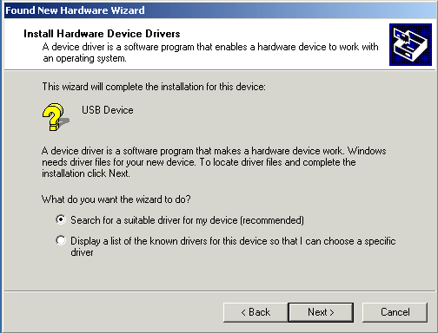

Figure 2

3.Choose “ CD-ROM “ drives and click “next”. See Figure 3
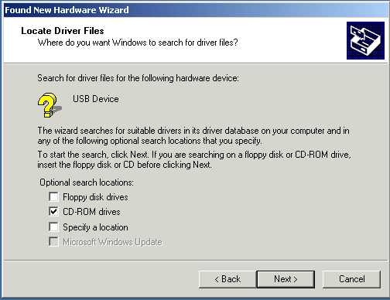
Figure 3

4.Click “next” to install the driver. See Figure 4
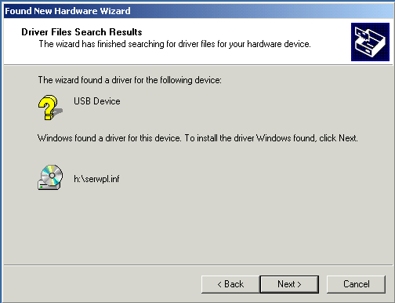
Figure 4

5.Click “ Finish “ to close the Wizard. See Figure 5
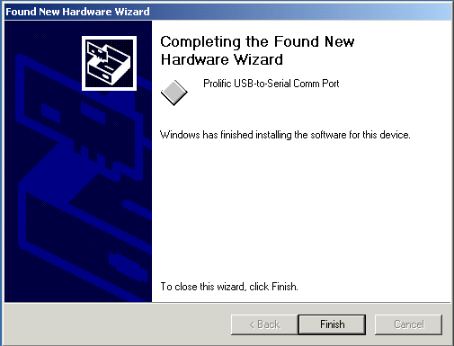
Figure 5

6.Double click “My Computer” →”System Properties”→”Device Manager”
to make sure the device you install is correctly displayed. See Figure 6
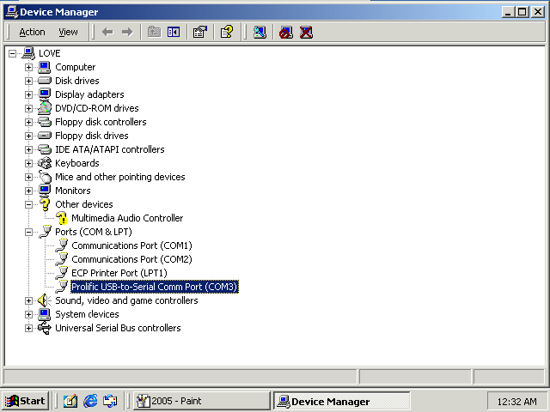
Figure 6

