Loose Ends in the Daya Bay RPC Gas System Design
Changguo Lu
Princeton University
(March 19, 2008)

Since we are approaching the FDR of gas system, some loose ends should be identified and resolved.
0. Gas storage room
In an earlier specification of the three underground experimental halls, there were gas storage rooms in each hall. However, these rooms are not present in the present specification; instead the isobutane tanks will be located in gas cabinets. Question: who will pay for this part of system? In the original gas system design, the gas storage room and associated gas plumbing was not part of the US scope. This budget for the gas storage areas + plumbing is not negligible.

- Gas consumption rate
Gas consumption rate estimate, based on 1 volume change/day, and use of the OPERA gas mixture Ar/R134a/Isobutane/SF6 (75.5/20/4/0.5).
Experimental Hall | Gas | Cylinder | Days/90% of cylinders used
Near hall | Ar | 6 #300 cylinders @2400psi | 35
Near hall | R134a | 90 LB | 24
Near hall | Isobutane | 40 LB | 87
Near hall | SF₆ | 35 LB | 243
Far hall | Ar | 6 #300 cylinders @2400psi | 22
Far hall | R134a | 90 LB | 15
Far hall | Isobutane | 40 LB | 54
Far hall | SF₆ | 35 LB | 150

- Gas cylinders
Except for the Argon gas the other three gases actually are stored in the liquid phase. We will use their vapors in the gas mixture. The saturated vapor pressure in these tanks won’t change until the last drop of liquid has been vaporized. If the tank is used until empty, there will be a rapid change in gas pressure at the last moment, which will likely trigger a shutdown of the gas system. To avoid this, the weight of the liquid in the tanks should be monitored by electronic scales, and the tanks changed when 90-95% empty.
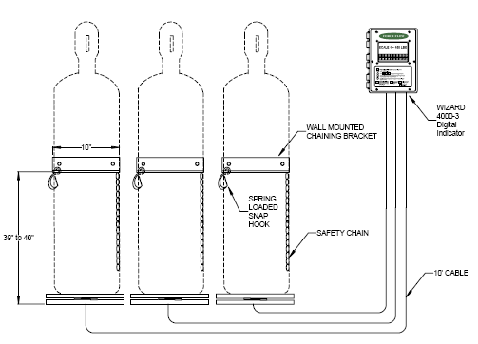
Fig. 1. Force Flow WR200-3HA electronic weight scale system (3 stages).

Figure 1 shows a Force Flow model WR200-3HA electronic scale system with remote readout capability; cost ~$5215/set. We could use an inexpensive system: bathroom scale, with shift person checking the weight daily, but the reliability of this approach would be less..
To avoid the gas flow interruption during replacement of the exhausted gas cylinders, each gas supply line should be arranged as shown in figure 2. The main gas supply cylinder provides the gas to the mixing system; the backup cylinder is on standby. When the content of the main cylinder drops to the preset lower limit, the gas supply line will be switched over to the backup cylinder temporarily, and the main supply cylinder will be shut off. The shift taker can replace the exhausted cylinder. The gas cylinder switch board provides a ventilation path for purging the pipe after installing the new cylinder. Thereafter the gas supply line can be switched back to the main supply cylinder, and the backup cylinder returned to standby.
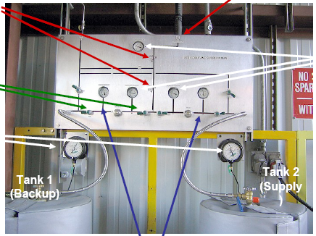
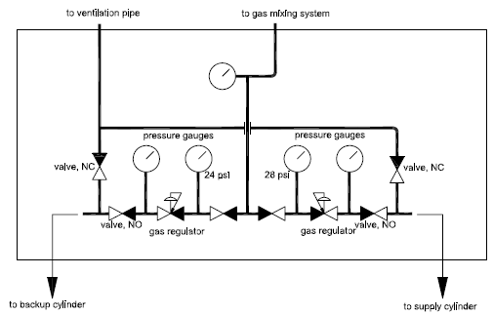
Fig. 2. Gas cylinder(s) switch board.

Because consumption of Argon gas is the highest, it is advantageous to use “six-packs” of cylinders rather than individual cylinders. that is similar to BaBar RPC Ar backup source, see Figure 3 shows such an installation as used in the BaBar RPC gas system (the circled panel would be replace by the switch board mentioned above).
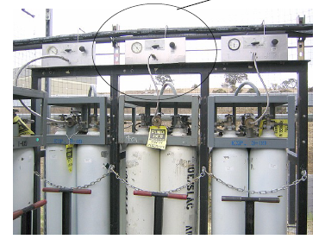
Fig. 3. Six-pack of argon gas cylinders.

- Isobutane cabinet
This cabinet should be able to store two 40 lb (16 kg) Isobutane cylinders with their weight scales, should be ventilated with ventilation sensors, and should have HAD sensors installed to monitor the Isobutane concentration level in the surrounding air.

- Gas pipe installation
Who is responsible for the design, procurement and installation of the gas tubing from gas cylinders to mixing system and from gas mixing system to experimental hall?

