Daya Bay RPC Gas System Loose Ends

Since we are approaching the FDR of gas system, some loose ends should be defined and solved.
0. Gas storage room
There was a gas storage room for three experimental halls, but now this room won’t be existing, instead the isobutane tank will be located in a cabinet. Question: who will pay for this part of system? In our original gas system design, the gas storage room’s equipment is not in our budget. This part of the budget is not negligible.

- Gas consumption rate
Gas consumption rate estimation: (This estimation is based on 1 volume change/day, OPERA gas mixture Ar/R134a/Isobutane/SF6 (75.5/20/4/0.5).)
Experimental Hall | Gas | Cylinder | Days/90% of cylinders used
Near hall | Ar | 6 #300 cylinders @2400psi | 35
Near hall | R134a | 90 LB | 24
Near hall | Isobutane | 40 LB | 87
Near hall | Sf₆ | 35 LB | 243
Far hall | Ar | 6 #300 cylinders @2400psi | 22
Far hall | R134a | 90 LB | 15
Far hall | Isobutane | 40 LB | 54
Far hall | Sf₆ | 35 LB | 150

- Gas cylinders
Except Argon gas the other three gases actually are in the liquid phase. We will use their vapors in the gas mixture. Since the saturated vapor pressure in these tanks won’t change until the last drop of liquid has been vaporized. In the case of pressure having significant change the tank is already near empty and may cause the gas flow interrupted. To avoid this from happen the gas system should be able to know how much liquid is left in the tank. We will use electronic weight scale to monitor the remaining liquid quantity for these three gases. This digital weight scale system is not cheap at all.
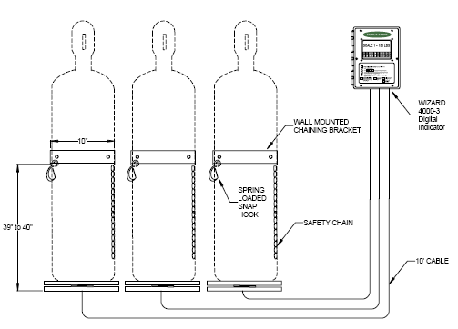
Fig. 1. Force Flow WR200-3HA electronic weight scale system (3 stages).

Figure 1 shows a Force Flow model WR200-3HA electronic scale system, it costs ~$5215/set. We also can do it in very cheap way: bathroom scale, shift taker needs to check the weight every day.
To avoid the gas flow interruption during replacement of the exhausted gas cylinder, each gas supply line has to be arranged as the way shown in figure 2. The main gas supply cylinder provides the gas to the mixing system; the backup cylinder is at the standby state. When the content of the main cylinder drops to the preset lower limit, the gas supply line will be switched over to the backup cylinder temporally, the path to the main supply cylinder will be shut off. The shift taker can replace the exhausted cylinder. The gas cylinder switch board provides a ventilation path for purging the pipe after installed the new cylinder. Thereafter the gas supply line can be switched back to the main supply cylinder, and put the backup cylinder to standby state.
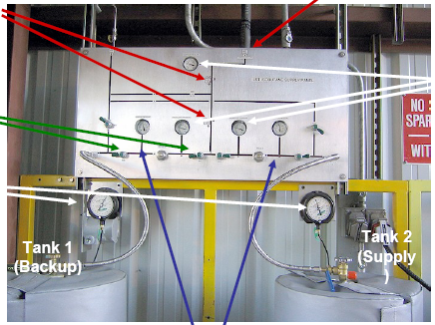
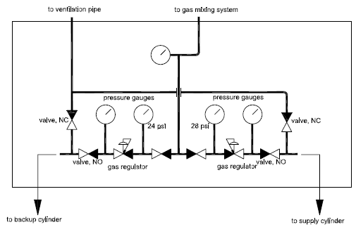
Fig. 2. Gas cylinder(s) switch board.

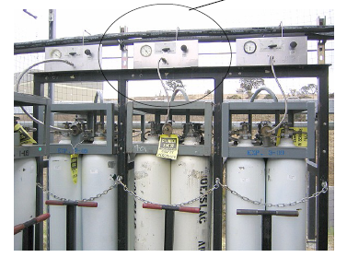
For the other three gases similar switch boards are used. Argon gas can use six-pack that is similar to BaBar RPC Ar backup source, see figure 3 for a real example photo (ignore the circled panel, in our case it should be replaced by the switch board mentioned above).
Fig. 3. Six-pack of argon gas cylinders.

- Isobutane cabinet
This cabinet should be able to store two 40LB Isobutane cylinders with their weight scales, should be ventilated with ventilation sensors, should have HAD sensors installed to monitor the Isobutane concentration level. Now the gas storage room is removed, can IHEP use the saved budget to install this cabinet with the mentioned equipments? If this is still in US scope, it requires more budget.

- Gas pipe installation
Who will take care of the installation of the gas tubing from gas cylinders to mixing system and from gas mixing system to experimental hall?

