Proposal for using long readout strip on RPC system

Princeton and IHEP RPC groups
(7/2/2007)

On last collaboration meeting Princeton RPC group proposed a possible alternative RPC readout scheme: using 9 m long strip plane instead of 2 m long strip. The advantage for this scheme is obvious, we can cut down the total readout channels by a fact proportional to the length ratio; we’ll be able to arrange all readout cable’s connection around the edge of the whole detector region; save the individual protection box for each 2m x 2m module, which could be a big budgetary saving, etc.
Since last collaboration meeting both Princeton and IHEP groups have made intensive test on the signal quality of the long readout strip scheme. The test results from both institutions are very promising. We have reported the test results on 6/26/2007 Daya Bay RPC group phone meeting. The consensus from the meeting is this readout scheme is worth for further pursuing. To add it as an alternative option beside the baseline RPC readout scheme (2m x 2m 4 layers module), we are requested to submit this proposal.

Introduction of long strip readout for the RPC system
We have learned from OPERA RPC’s experience that they use 8m long strip plane to readout their 8m x 8m array of RPCs. Fig. 1 shows the arrangement of OPERA RPC chamber layer and strip plane [1,2].
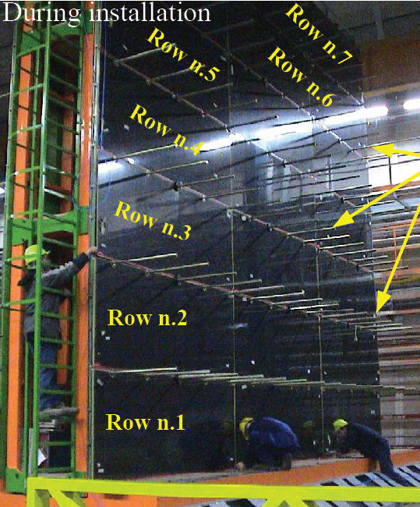
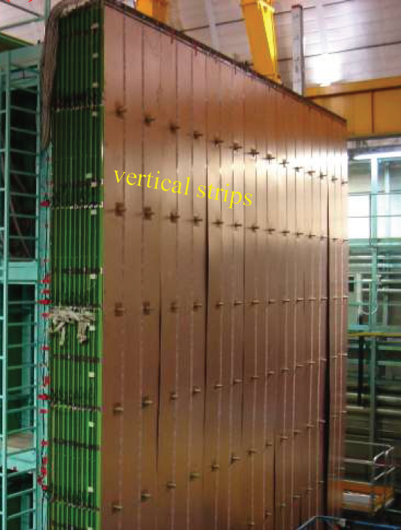
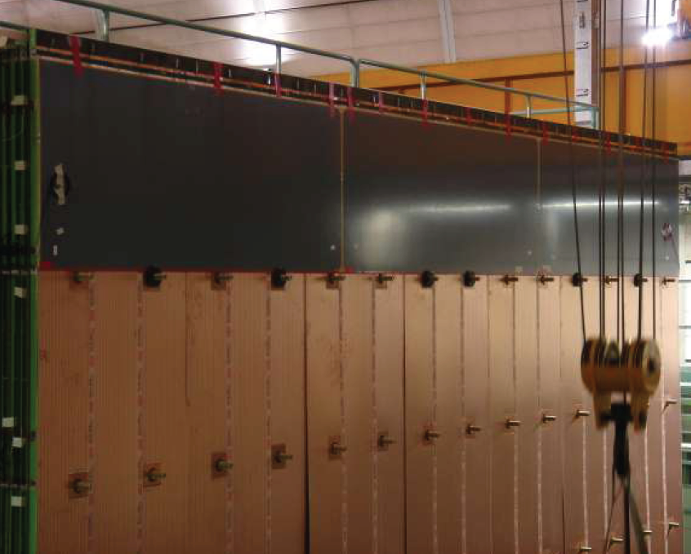
(A)
(C)
(B)
Figure 1. OPERA 8m long strip plane installation. (A) Array of 21 1.14m x 2.91m RPCs; (B) Vertical 8m long strip plane; (C) Layer of RPC installed in front of the vertical strip plane.

The OPERA RPC detectors are buried inside of iron slabs, after installation they would not be fully accessible. To repair a bad RPC during the normal operation of the experiment would be very difficult without a major interruption to the whole experiment. This situation is true for Daya Bay RPC system with the long strip readout scheme. But with the extremely stringent Q/A and Q/C program during the mass production and installation period, and the relative friendly operation environment (very low rate) like OPERA’s we believe this would be a very rare scenario although we could not completely rule it out. The report from OPERA on the performance of the long readout strip plane is positive, no any mention on the deterioration of the performance due to the length of the strip plane.

Test results from Princeton and IHEP
- Princeton test results
Princeton tested 8m long strip readout . To test the strip width effect on the signal shape three different strip groupings are tested: single strip, grouping of 3 strips, grouping of 5 strips.
Gas mixture used in the tests is Ar/R417A(50/50), which is similar to our usual gas mixture Ar/R134A/Isobutane (50/42/8). The strip band is made of 27μm copper strip (5cm in width) on 0.28mm thick flexible Mylar base.
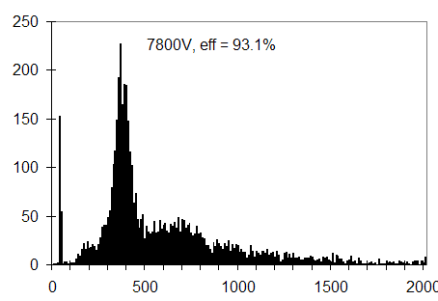
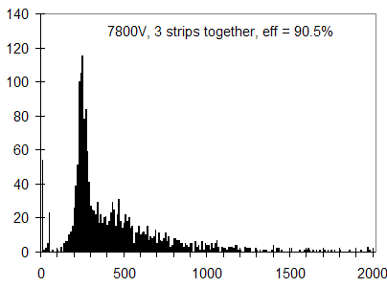
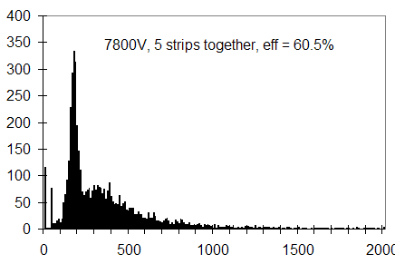
a
b
c
Figure 2. Peak sensitive ADC spectra for 3 different strip groupings. (a) single strip; (b) 3 strips; (c) 5 strips. The X-axis is in the unit of ADC channel. To convert it to mV unit a calibration curve should be used: V(mV)=0.181*ADC ch + 9.88.

We use a peak sensing ADC module to record the spectra. The grouping of the strips are done at two ends, three different cases are recorded: single strip, 3 strips and 5 strips. The recorded ADC spectra are shown in Fig. 2. When deriving the efficiency we set the threshold at 45mV. We can see that the pulse height of the strip signal is sensitive to the strip grouping number. Figure 3 shows the screen capture of the strip signal for three different grouping cases. These signals show that more strips grouping together the pulse height would be less, and the pulse width would be broader.
To save the electronics channels we prefer use wider strip, but as we shown above that will decrease the pulse height. To preserve the pulse shape for the wider strip we have tested a simple buffer circuit as shown in figure 4. This circuit can have 4 inputs connected to 4 narrower strips in parallel. The first stage of the buffer circuit isolates the strips, thus preserves the pulse shape as in the single strip mode, the second stage then adds all inputs together in the analog fashion.

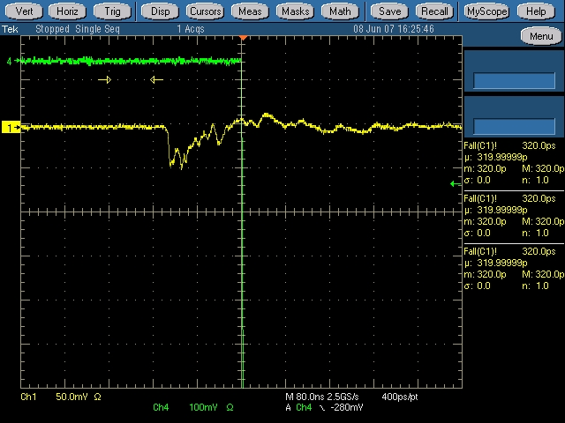
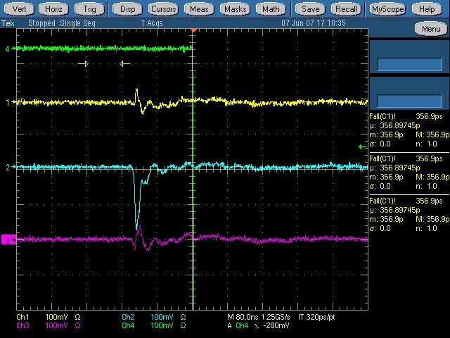
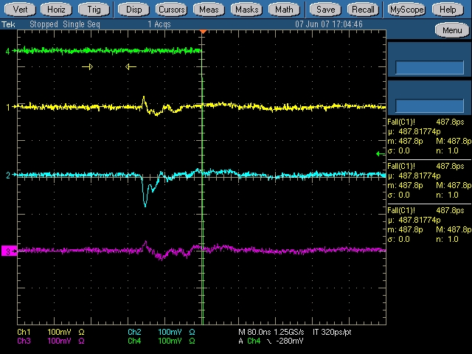
a
b
c
Figure 3. Screen capture of the strip signal. (a) Single strip; (b) group of 3 strips; (c) group of 5 strips.

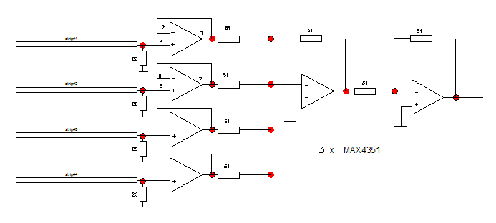
Figure 4. Buffer circuit: isolate the strips from each other and add all inputs together in the second stage.

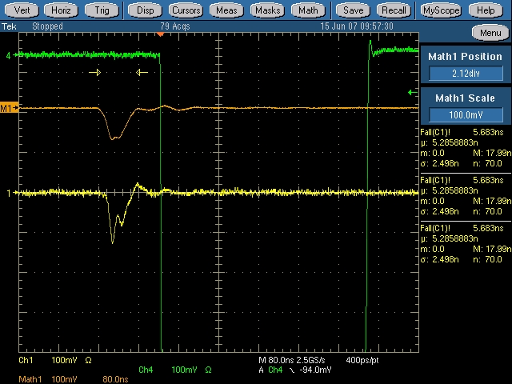
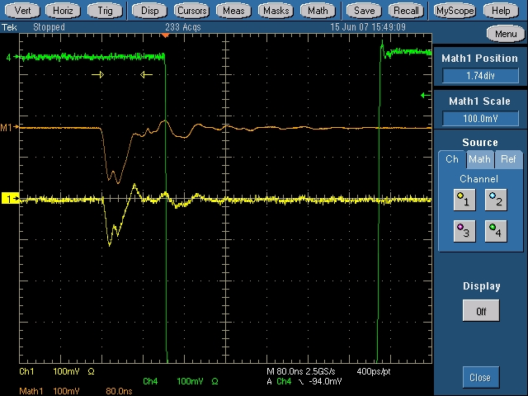
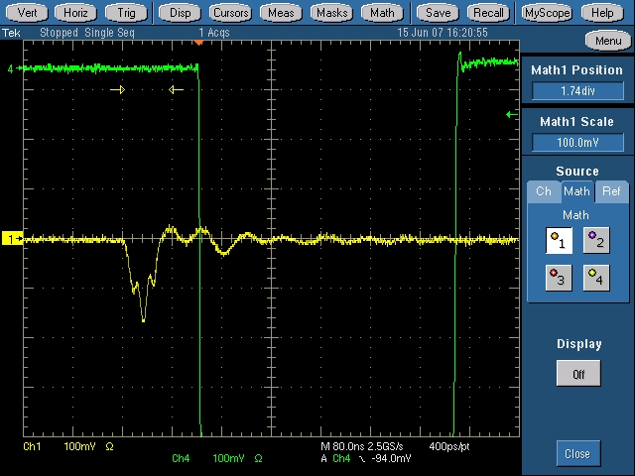
(a)
(b)
(c)
Figure 5. Strip signal shape after the buffer circuit. (a) single strip; (b) 3 strips; (c) 4 strips.

Figure 5 shows the pulse shape after the buffer circuit, it is clearly seen that the pulse shapes are essentially the same for 1, 3 and 4 strips cases. Figure 6 shows the efficiency plateau curve and the ADC spectrum.

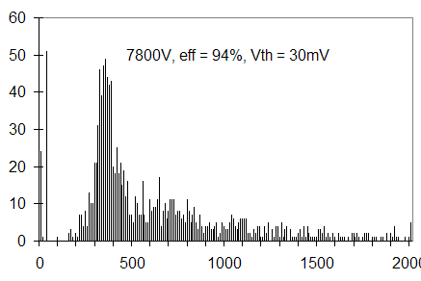
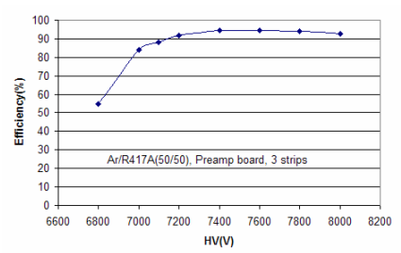
Figure 6. Use buffer circuit to test the efficiency plateau curve, (a) efficiency plateau curve; (b) peak ADC spectrum.

(a)
(b)

- IHEP test results
IHEP has tested 1m, 2m and 6m long strip readout for 5, 10, 15 and 25cm strip width, the 2m and 6m long strip test results are shown in figure 7 and 8, respectively. It is shown that the strip width does affect the pulse height, but the strip length has little influence on the pulse shape. The self-triggering threshold is set at -8mV for all cases.
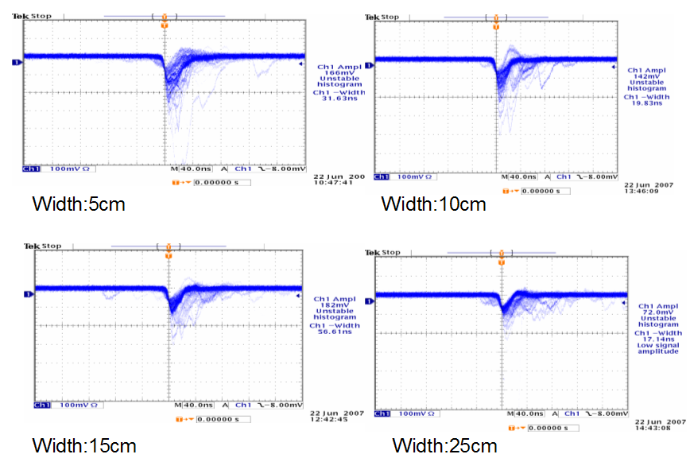
Figure 7. Screen captures of the IHEP 2m long strip readout for 5, 10, 15 and 25cm strip widths.

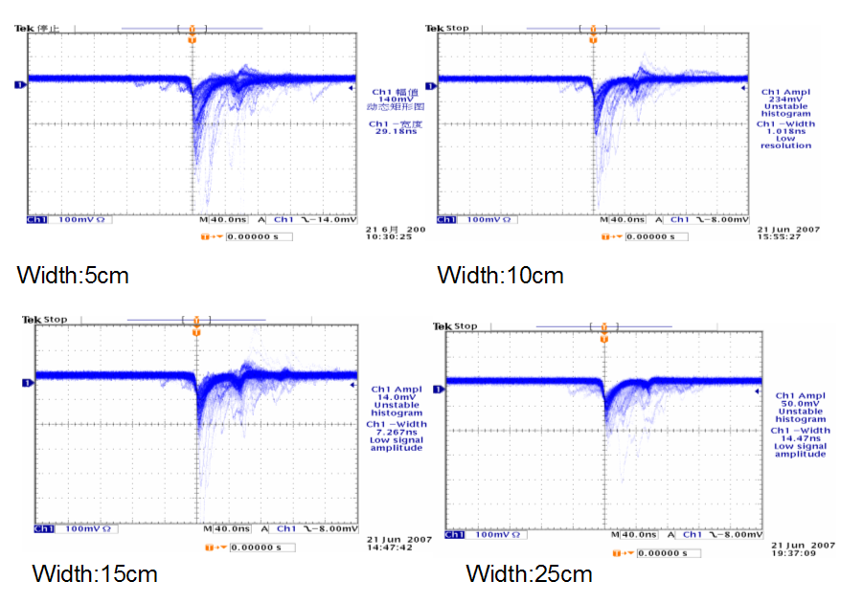
Figure 8. Screen capture of the IHEP 6m long strip readout for 5, 10, 15 and 25cm strip widths.

The test results from both groups are consistence, they point out that the strip length won’t deteriorate the signal’s quality.

Implementation of long strip readout scheme
We have two implementation schemes to utilize the long strip readout: modular structure and non-modular structure.
- Modular structure
Instead of 2m x 2m module we can make larger module to use longer strip plane. We propose a module size of 4m x 6m, which will consist 48 1m x 2m RPCs in four layers.
For the far hall, we need 15 modules to cover the whole 18m x 18m area with 3 columns and 5 rows. For the near halls we need 9 modules to cover 12m x 18m area. The arrangement is shown in figure 9.
Overlapping the edges of the modules can reduce the dead space. We can have four different sizes of modules: A-type 4m x 6m; B-type 4m x 6.2m; C-type 4.2m x 6.4m and D-type 4.2m x 5.9m. Tiling the modules in the way as shown in Fig. 10 can maintain the overlapped width of the modules for 10cm that is sufficient to eliminate the dead space.
The RPCs in a module are shown in Fig. 11. Two RPCs will form a 2m x 2m pair, cut the adjacent corner from each RPC to install the gas feedthrough there. Connect two RPC’s gas volumes together at that corner. By this way we can reduce the dead space. For each layer there are 3 gas inlets and 3 gas outlets, total we need 12 inlets and 12 outlets for a module.

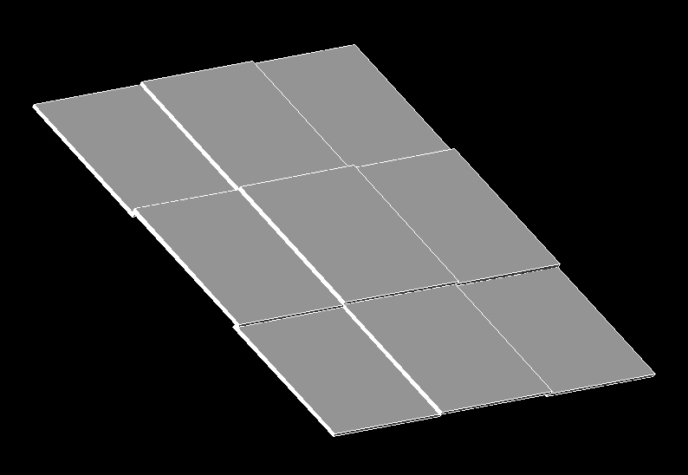
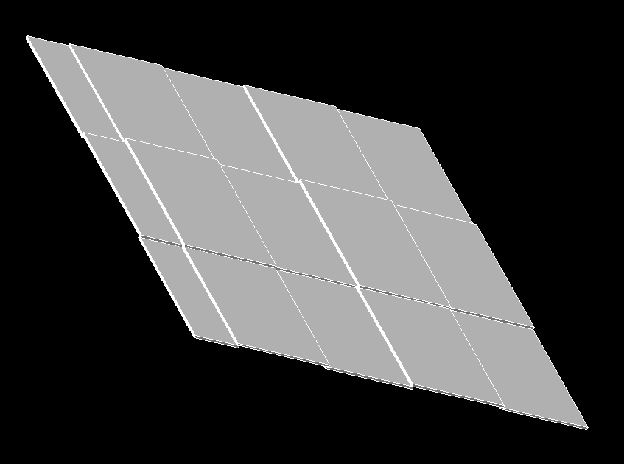
Figure 10. Modular tiling arrangement, (A) near hall, 9 4m x 6m modules, (B) far hall, 12 4m x 6m modules and 3 2m x 6m modules.
(A)
(B)
(A)

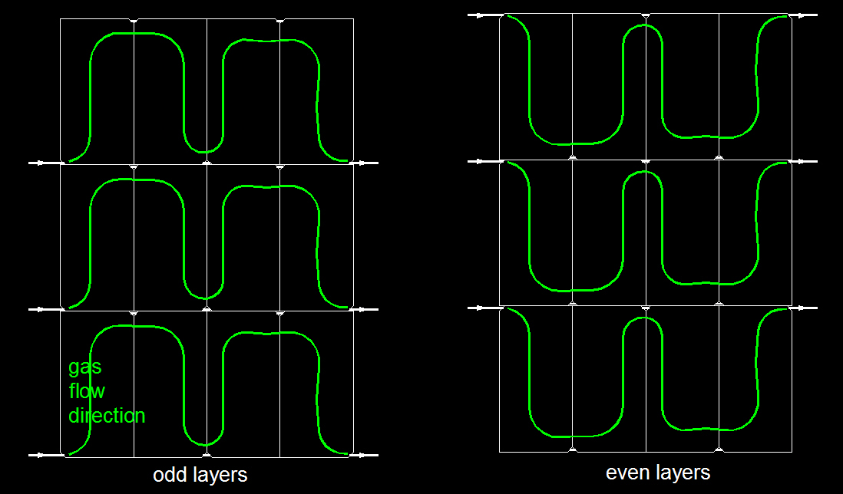
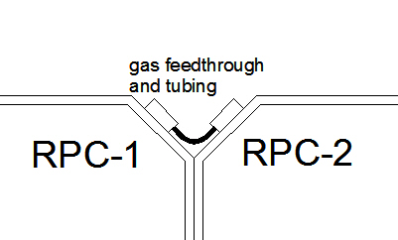
Figure 11. (A) RPCs in a module. Green lines show the gas flow direction; (B) Details of the corner gas connection for a pair of RPCs.

(A)
(B)

- Non-modular structure
The non-modular structure is similar to OPERA: Polypropylene base/copper sheet ground shielding bands are directly placed on the flat honeycomb panel, copper side faces up, on which then lay down the RPCs. Pack them tightly side by side to form 9m x 9m RPC array, then lay down 1m x 9m strip bands to cover whole area along one direction. The strip side should face the RPC chambers. Second honeycomb panels or foam panel will be stacked on top of the first layer, and repeat the above procedure, but the second layer’s strips should be lying along the perpendicular direction. In same manner to finish the third and forth layers, see Fig. 12 and 13 for the details. Make some slots on the honeycomb panels or foam panels to pass the utilities (gas tubings and HV cables) from inner region to the edges.
The transmission line is formed by ground shielding/RPC/strip band sandwich, with which we can get the largest induced signal from streamer.
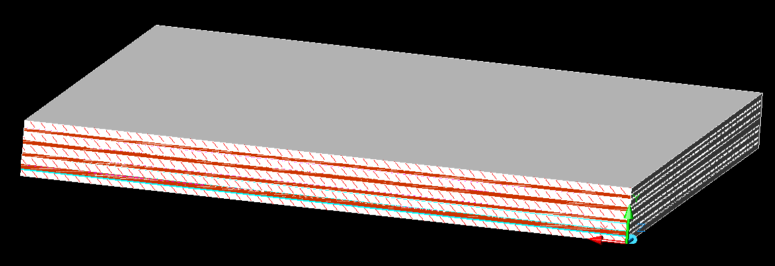
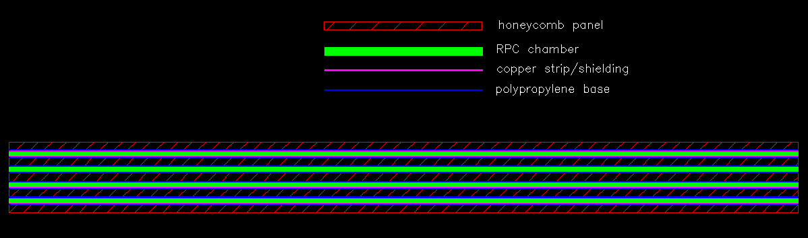
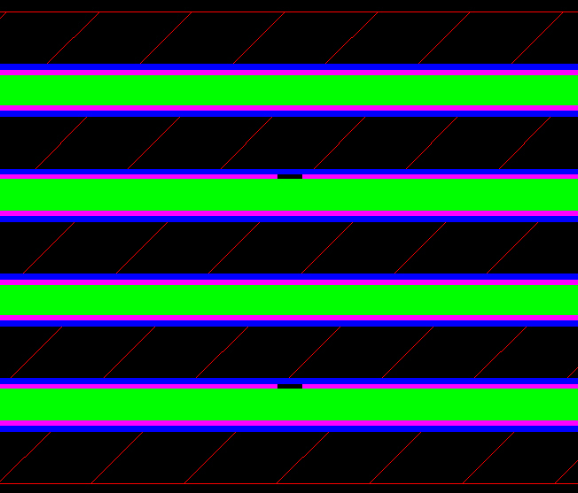
Figure 12. Non-modular structure, (A) 3D view; (B) detailed layer’s structure. (C) enlarged layer structure.
(A)
(B)
(C)

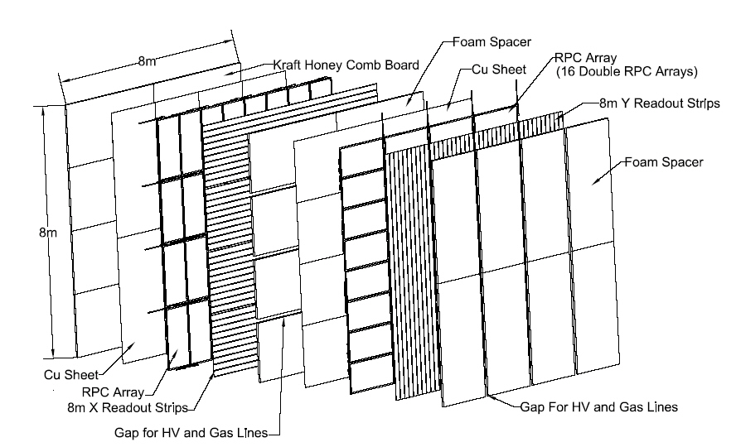
Figure 13. 3D explosive view of the layers. This is only for illustration purpose, the dimensions on the plot are not up to date. All 8m dimension should be replaced by 9m. Notice the slots on the foam spacer, as mentioned in the text they are used to pass the utilities from inner region to the edges.

References
- The OPERA muon spectrometers, A. Garfagnini et al., NIM A 572 (2007) 177–180
2. The OPERA RPC system: installation and underground test results, A. Longhin,
Talk at VII Workshop on Resistive Plate Chambers and Related Detectors, Korea University, Seoul, October 10-12, 2005.

