C. Lu
Princeton University
5/25/2001

Potential distribution on the surface of
Linseed oil coated Bakelite plane
- Comparison of the test results and the model calculation

We have proposed a simple resistor network model to explain the behavior of Linseed oil stalagmite inside of the RPC chamber, (in the Appendix I attached a slightly modified version of this model). So far no direct experimental test result to justify this model. In this note we present experimental test results, which are consistent with the model calculation.

- Test set-up
A 1’×1’×1/8” Bakelite plane has been coated with Linseed oil on one side and coated with Indian ink on the other side. The Linseed oil coating has been exposed to air for more than 5 months, it has been cured. We measured the volume and surface resistivity for this plane, the measured numbers are as follows: ρ = 6.7×10¹¹Ωcm, σ = 2.7×10¹¹Ω/. The Indian ink provides a conductive film on one side of the Bakelite plane as an electrode. We apply high voltage on this side.
To measure the potential distribution on Linseed oil coated side while a small spot is grounded we need a grounded pin to contact with the surface, and another pin to contact the surface at various distances from the grounded pin. To accomplish this task we utilized a home-made probe as shown in figure 1(a). Two springs on each side of the probe keep the pins having good contact with the Linseed oil film while we clamped down the probe. Total 13 pins were used. The left most pin was connected to ground, the other 12 pins served as probes that were placed in various distances from the grounded pin. The pitch of those pins is 2.5mm. By this arrangement we can measure the potential distribution surrounding a grounded spot from 0 up to 3cm. The test set-up is shown in figure 1(b).
Because of the nature of very high resistivity for the material we are dealing with, the electronic electrometer is not suitable. Those devices need to draw current from the testing object that will distort the test results. We use an electroscope instead. The electroscope virtually draws no current, so the measured value represents the true potential on the surface.

- Test results
The calibration curve of the electroscope is shown in figure 2.

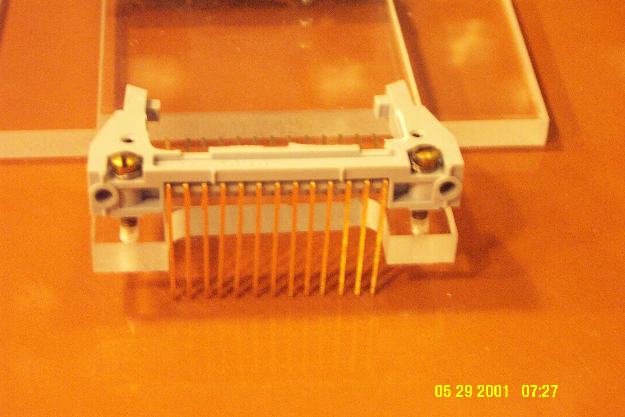
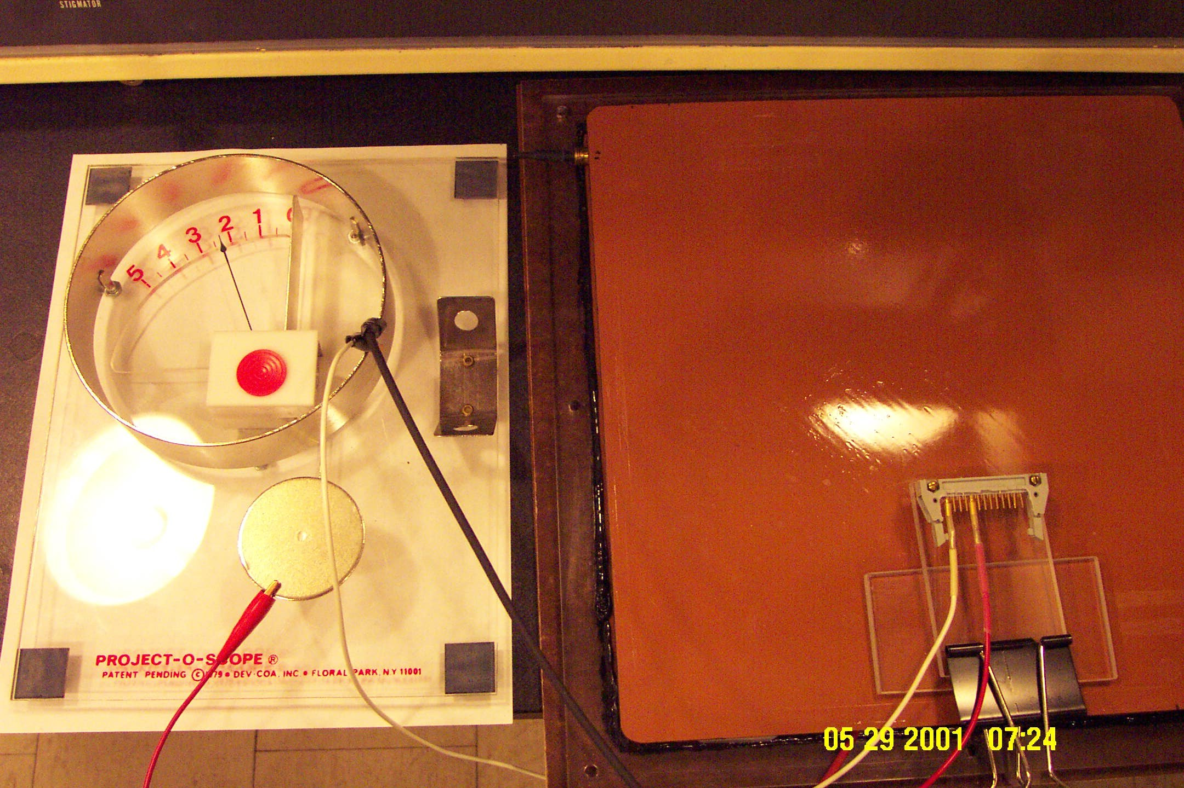
Figure 1. (a) Tets probe, (b) Surface potential test device.

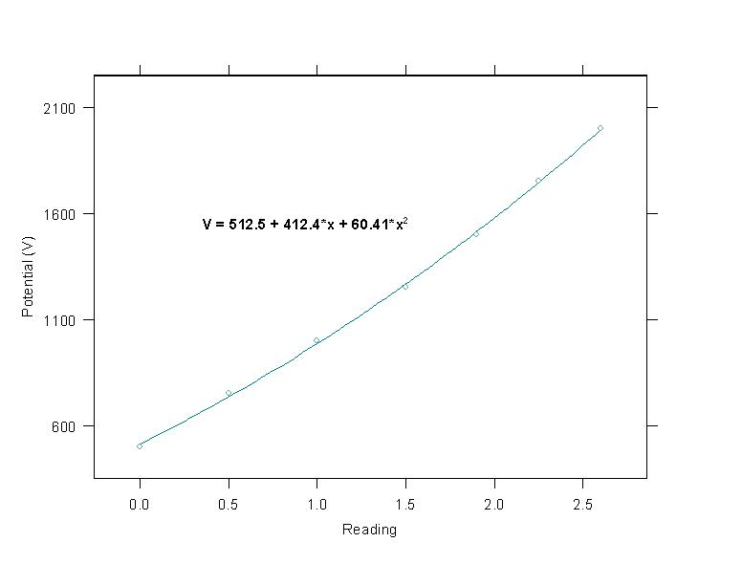
Figure 2. Calibration curve of the electroscope.

The measured and calculated potential distributions are shown in figure 3.
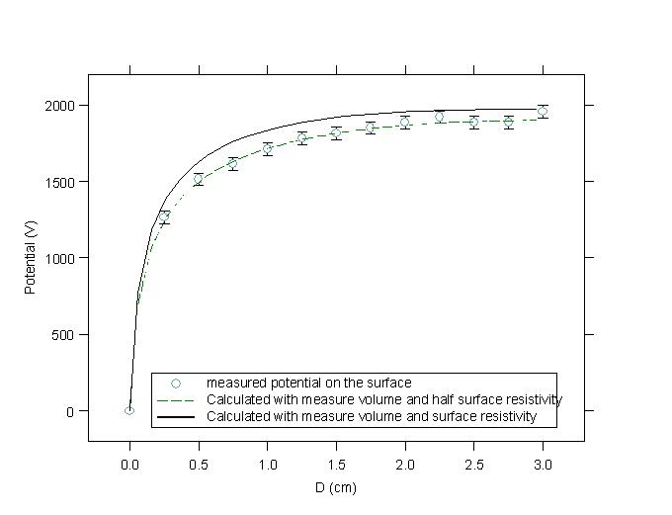
Figure 3. Measured and calculated potential distribution on the Linseed oil coated Bakelite surface.

In the calculation we entered the volume and surface resistivity directly measure from the test plane. From figure 3 we can see that the calculated curve fits the measure data points reasonably well. If we reduce the surface resistivity by half in our calculation, the calculated curve fits the data points almost perfect.
The measure total current drawn from the high voltage supply is 10.5nA. In the calculation this number depends on the radius of the grounded pin. Because the probe is not round pin, it is square pin with dull cone tip, we used two extreme radius for the calculation: R₀ = 0.01mm and 0.2mm. The real value is certainly within this range. For R₀ = 0.01mm I_{total} = 6.9nA, and R₀ = 0.2mm I_{total} = 11.6nA. If we take R₀ = 0.1mm I_{total} = 10.5nA, which is very close to the measured number.

- Conclusion
The direct test results of the potential distribution on the Linseed oil coated Bakelite plane further confirm our understanding on how the oil stalagmite affects the electric field distribution and the dark current. Our resistor network model gives consistent results with the data; therefore we can use this model with more confidence.

- Appendix
Attached is a Mathcad file to calculate the potential distribution and dark current due to a stalagmite shorting the high voltage gap.
When oil droplet formed in RPC gap, because the resistance of the oil droplet is much smaller than the volume resistance of the Bakelite sheet, we can neglect the resistance of the oil droplet, and assume the potential of this spot on the inner surface of Bakelite sheet is grounded. The outer surface is at potential V. Using this spot as the center of a circle, we are calculating the potential distribution on the inner surface of the Bakelite sheet.
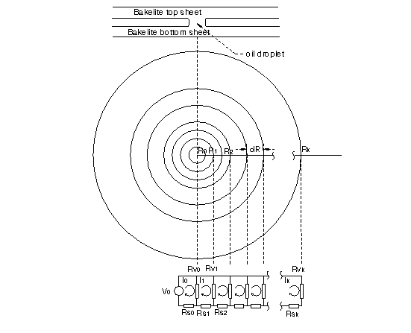

Rv_{i} and Rs_{i} are the volume resistance and inner surface resistance of the Bakelite sheet. Since we already measured the volume and surface resistivity, Rv_{i} and Rs_{i} are known. The mesh network shown in the bottom of the figure can be solved with the mesh current method. We assign the loop currents as shown in the figure. We divide a circle surrounding the oil droplet spot by n-concentric rings. n in our example is k. The increment of each ring is denoted by dR. The volume resistivity for the ring with radius of Rv_{i} is calculated for the ring with inner radius of Rv_{i} -dR/2, and outer radius of Rv_{i} +dR/2. The surface resistivity Rs_{i} is calculated from the circle with radius R_{i} to the circle with radius R_{i-1}. Rs₁ is 0, and Rv₁ is the resistivity of the central cylinder of radius of dR/2.

Calculation of volume resistors:
Imax = 30
t = 0.315cm, thickness of the Bakelite sheet,
ρ = 6.7×10¹¹ Ωcm, measured Bakelite volume resistivity.
dR = 0.1cm
The radius of oil droplet
volume resistivity:

Calculation of surface resistors:
Ω⁄, measured surface resistivity of Linseed oil film

Solve the resistor’s network problem:
We use Kirchhoff's law to write a linear equation system. The matrix form of the system can be written as follows:
[M][I] = [V],
where [I] and [V] are one column matrices. [I] represents the loop currents as indicated in the figure, [V] is the voltage source. Mi,i is the sum of all resistances through which mesh current Ii passes, Mi,i+1 are the sum of all resistances through which mesh currents Ii and Ii+1 pass. If Ii and Ii+1 are in the same direction the sign of Mi,i+1 is +, otherwise is -.

Get M matrix:
For
For
For rest of the elements of M matrix
Now we have all elements for M matrix.

Get V matrix:

Solve the linear equation system:
The solution is matrix I.
A
The voltage distribution on the inner surface is PAk:
The surface potential distribution is shown in the following plot:

C. Lu, Linseed oil stalagmite and its effect on the leakage current and detection efficiency of the BaBar RPC chamber, http://feynman.princeton.edu/~lu/BaBar_RPC/linseed_oil_droplet.pdf

