Microscope Study of BESIII-type RPC Aging Phenomena

Changguo Lu, Kirk T. McDonald, and A. J. S. Smith

Joseph Henry Laboratories, Princeton University, Princeton, NJ 08544, USA
(September 8, 2010)

Abstract
Various samples from virgin BESIII-type Bakelite sheet, aged BESIII-type RPC and virgin Italian Bakelite sheet are studied under microscope, the aim of this study is trying to understand the aging mechanism for the BESIII-type RPC. Preliminary results and a working hypothesis are presented in this report.

Keywords: RPC, BESIII-type RPC, aging, Bakelite, microscopic image

Introduction
BESIII-type RPC [1] has achieved acceptable dark noise rates without Linseed oil coating, thus attracts high energy physics community’s attention. A preliminary study of the Daya Bay Muon System RPC, which is same as BESIII RPC, has indicated a significant aging effect [2, 3]. To understand the mechanism of this aging phenomenon, we have to study the internal damage for the aged RPCs. We adopted the optical microscope in this study because its magnification is suitable in this specific application, also the color change on the sample’s surface can be revealed.

Aging test of BESIII-type RPC
We have used a BESIII-type 50cm×50cm RPCs in the test. Under a Co-60 source radiation we produced several aged RPC chambers, their anode and cathode electrodes are the major investigation subjects.

Test set-up
Figure 1 shows the test RPCs stack and the cosmic ray trigger scintillation counter array. The upper and down trigger arrays sandwich the test RPC stack, they can divide the overall cosmic triggering events into 16 regions as shown in figure 1(B).
Figure 1. (A) Test RPC stack of five chambers; (B) Cosmic ray trigger array and trig logic.

The working gas used in this test is Daya Bay gas mixture: Ar/R134A/Isobutane/SF6 (65.5/30/4/0.5), the flow rate is 10 SCCM. The aging test chamber’s dimension is 50 × 50 cm². The readout strip is 6 cm × 50 cm in size.

Efficiency degradation
A 0.1mCi Co-60 source is placed on top of the RPCs through an 18mm thick stack of copper plates (region #1, see Fig. 1). At the end of aging test the efficiency plateaus for all five chambers are tested, three of them are shown in figure 2. The severe efficiency drop on RPC #1, #3 can be clearly seen, RPC #5 shows mild efficiency degradation. The order of severity of efficiency degradation is roughly as follows: #1, #3, #4 and #5, which is consistent with their distance to the source.
Figure 2. Efficiency plateaus at the end of aging test.

We plot the efficiency vs. area at the end of aging test for HV = 7600V in figure 3.
Figure 3. At the end of aging test, efficiency distribution among 16 areas, HV = 7600V.
A very interesting observation is that the worst efficiency area for RPC #3, #4 and #5 is not the area #1, the area direct underneath the source, but is area #4. However the worst area for RPC#1 is area #1. From figure 1 we can find that these areas are located near the gas inlet ports, where the HF concentration density is assumed to be the highest. We’ll compare the surface of area #8 to area #4 for RPC #3 later to see if there is correlation between efficiency drop and surface corrosion.

Microscope study on various aged Bakelite electrodes
The above mentioned aging test chambers provided us valuable investigation samples, which reflect different degree of damage due to the aging.

Aged RPC electrode surface images
After opening the aged RPCs we found a lot of sparking marks all over the surface for both anode and cathode. Figure 4 shows some typical images. The distribution density of the marks varies and shows a correlation between the severity of efficiency drop and the density of the sparking marks. RPC #1 has suffered the highest aging dose, and shows the highest sparking density, see figure 4(A). RPC #5 has the least aging dose and shows lowest sparking mark density, see figure 4(D).
B
A
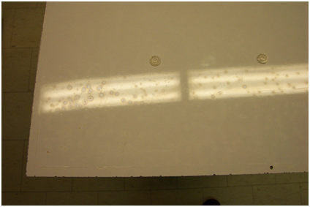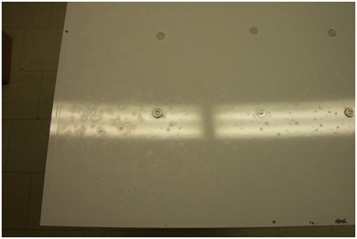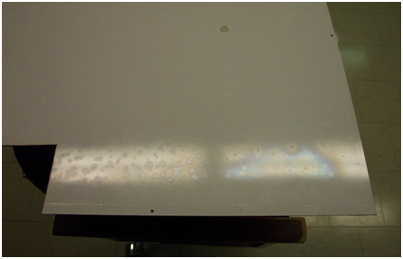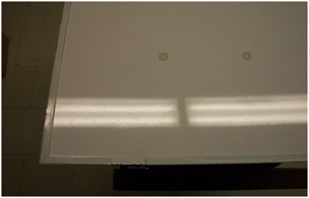
Figure 4. Aged RPCs anode electrode's image, (A) RPC#1; (B) RPC#3; (C) RPC#4; (D) RPC#5.
D
C
A
B
C
D

Microscope images of the electrode’s surface
Under the microscope we can further reveal the surface change due to the aging. As a reference we first show a virgin BESIII-type Bakelite sample’s image in figure 5. The surface shows characterized “skin-like” texture. The total width of this picture is 2.9 mm, so the “wrinkle” scale is ~ 10 μm.
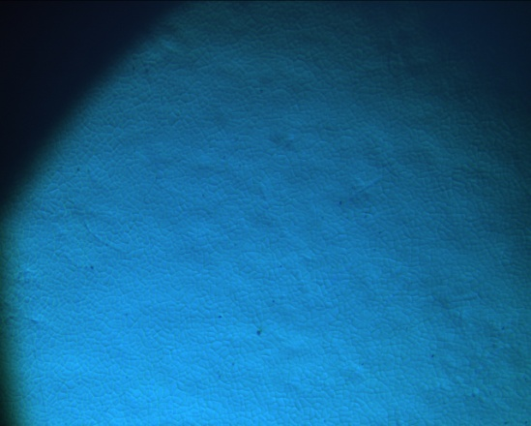

Figure 5. Virgin BESIII-Bakelite surface image under microscope.
In figure 6 we provide the microscope images from RPC #1, #3, #4 and #5 electrodes.

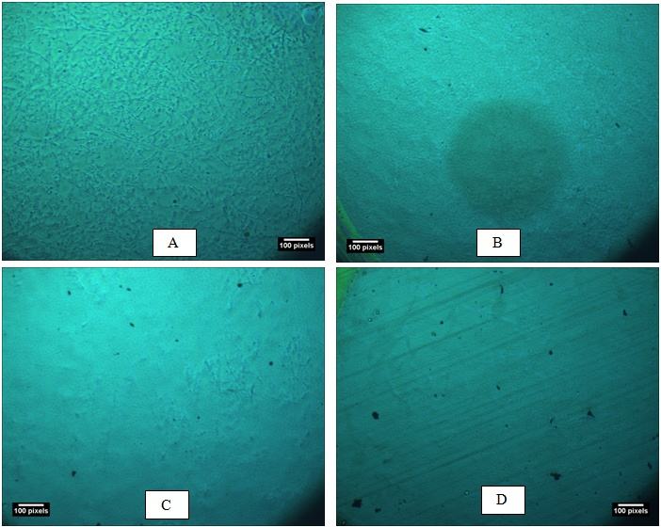
Figure 6. Microscopic images, (A) RPC #1, (B) RPC #3, (C) RPC #4, (D) RPC #5.
The sample for RPC #1 is from area #1, where the source is located and the gas inlet port is nearby. This region suffered most intensive aging dose, the efficiency at the end of the test is almost zero. Figure 6(A) shows severe eroded surface, no more “skin-like” texture can be seen. Figure 6(B) shows RPC #3, area #4 that is near the gas inlet area. This area is less damaged, so the surface looks better than (A), but we start to see the “veins” on surface, which is the first step of the HF corrosive effect. We’ll have more discussion latter. Figure 6(C) is the fourth RPC in the stack from the source. The sample is from area #4 too, that is near the gas inlet area. The Surface also shows “veins”, however the original “skin-like” texture is still can be seen. Figure 6(D) is from RPC #5, area #1. The efficiency test confirms this area is having very mild aging, the microscope image shows very faint “veins”, and the “skin-like” texture is well preserved.
Figure 3 shows that the aged RPC’s efficiency varies on different areas. With the microscope we can study if this variation related to the severity of the surface corrosion. In figure 7 two different areas are shown, (A) shows the area #8 anode and (B) shows the area #4. According to figure 3 area #4 has much worse efficiency degradation then area #8, the reason for this difference is exactly revealed in figure 7(A) and (B). Figure 7(A) shows reasonable smooth surface for area #8, but figure 7(B) shows badly damaged surface for area #4.


A
B
Figure 7. RPC#3, (A) area #8; (B) area #4.

To make sure if the eroded surface is due to the HF corrosive effect, we made an additional test. The test setup is shown in figure 8. We drop 90 μL HF (40% of concentration) into the container, then cover the container with the samples/cover plate as shown in the figure. The inner surface of the test samples are then exposed to the HF vapor. The equivalent dose of 90 μL HF is a 2m² RPC operated at 5μA for 12.4 years [2]. After 24 hours the cover is opened, the test sample’s surface shows corrosion. In figure 9 we show their microscopic images. Compared to the virgin sample surface the HF vapor exposed surface apparently shows “bumps” and “veins”. The bumps are vulnerable to the discharge that may be the origin of the sparking marks we saw on the aged RPC electrode. The “veins” have very similar looking to the aged RPC electrode surface. In figure 9(A) besides the “bumps” and “veins” we still can see the “skin-like” texture for most of the area, but on figure 9(B) there is no such “skin-like” texture leftover, it means that the entire surface has been eroded by HF vapor.

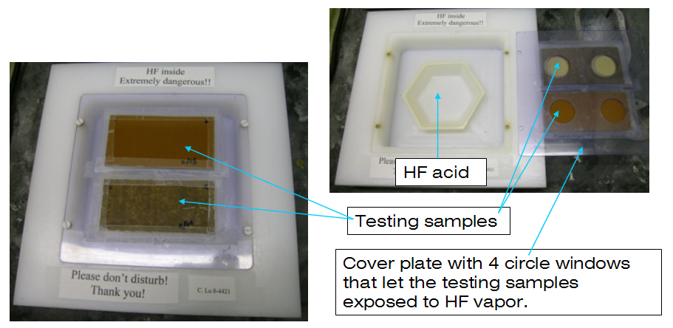
Figure 8. HF vapor test setup.

Figure 9. Two BESIII-type Bakelite samples exposed to HF vapor.

Based on the above observation we propose the following aging mechanism for BESIII-type RPC: with the gas mixture of Freon and others, the gas avalanches will produce HF molecules [2]. These HF molecules are adsorbed on the inner surface, form HF acid with the water molecules released from the Bakelite electrodes. The corrosive action will take place on the inner surface as shown in figure 9. As the results the bumps may help to initiate the sparks, some samples of the sparking marks are shown in figure 10. With the progress of the HF corrosion the inner surface is getting worse and worse, it would destroy the Bakelite surface completely as shown in figure 9 (B), the characteristic “skin-like” texture is therefore completely disappeared.

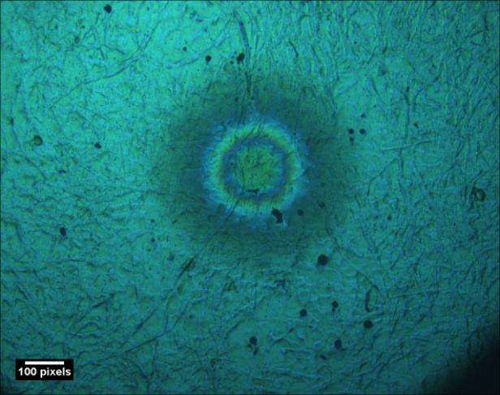
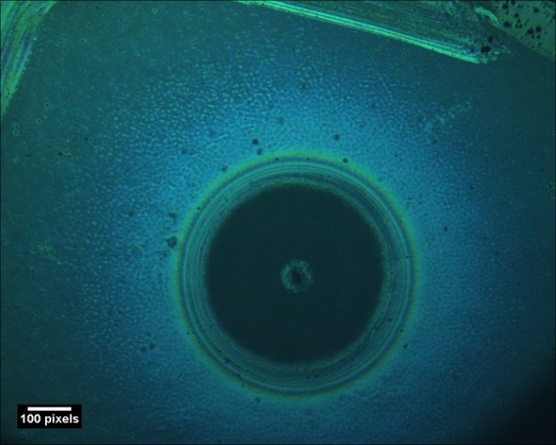
Figure 10. Sparking marks on the anode surface.

BaBar RPC study
The new generation RPCs of the BaBar endcap muon detector system had been operating at PEPII for five and half years since November 2002 [4, 5]. The circular ring region surrounding the beam pipe endured the highest particle flux and showed serious efficiency loss. It was therefore of special interest to study these samples and determine the cause of the aging. Figure 11 shows three samples of BaBar Bakelite: the left is new Bakelite, the middle is the sample from the high particle flux region, and the right is the sample from the lower flux region.
The sample disc from the high flux central region shows a highly discolored surface with an “orange peel” looking texture. Some samples show no Linseed oil coating on the surface. The disc from the lower flux region is less discolored, its Linseed oil coating film looks smooth, and a cotton tip with ethanol easily removes the oil film, revealing a shiny Bakelite surface. It seems that the high dose of radiation and resulted erosion from high concentration of HF has “eaten” the Linseed oil coating and caused the dye in the surface layer paper to discolor; and also caused the “orange peel” texture on the surface. Figure 12 shows a comparison between high dose and low dose BaBar samples.

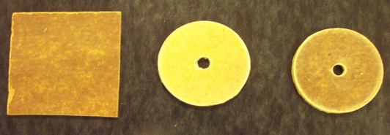

Fig. 11. BaBar RPC sample discs.

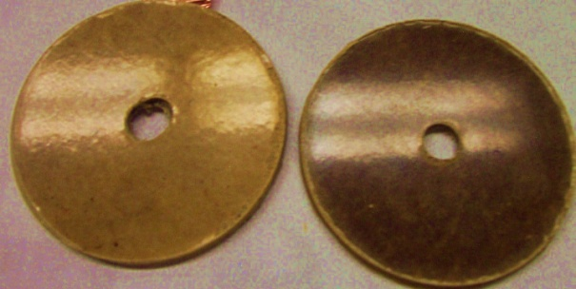

Fig. 12. The left disc is high dose sample, it shows discolored “orange peel” texture on the surface;
the right disc is low dose sample, its surface looks reasonably smooth and darker.

Surface resistance change
A Trek Model 152-1-CE high resistance meter together with Model 152-2p two-point resistance probe is used to measure the surface resistance for these BaBar sample discs. The probe’s two contacts are 3.2mm in diameter, 6.4mm in separation. The test results are summarized in Table 1.
These discs come from same RPC so we can assume their initial surface resistivity was approximately the same. Table 1 shows the surface resistance measured for high dose samples is less than from low dose samples, the ratio is ~ 1:5.
Test sample |  |  | Resistance (Ω) | Average R (Ω)
BT26-6 | High dose | Highly discolored | 6.6 × 10¹⁰ Ω | 6.0 × 10¹⁰ Ω
BT23-1 | High dose | Highly discolored | 5.3 × 10¹⁰ Ω | 6.0 × 10¹⁰ Ω
BT14-1 | Low dose | Less discolored | 2.5 × 10¹¹ Ω | 2.8 × 10¹¹ Ω
BT10-1 | Low dose | Less discolored | 3.0 × 10¹¹ Ω | 2.8 × 10¹¹ Ω

Table 1. Surface resistance of the BaBar sample discs.

Surface microscope study
Compared to the BESIII RPC we notice that sparking marks are very rare on BaBar RPC samples. We did find one and its microscope image is shown in figure 13, quite different looking from BESIII-type RPC.

The different appearance of the sparking marks for Linseed oil coated BaBar RPCs and oil-free BESIII-type RPCs might be related to their different surface material. The Linseed oil coating, when it is completely cured, has a long carbon chain, as shown in figure 14(A) [6], and the melamine structure, which is the surface material of BESIII Bakelite, is shown in figure 14(B) [7].

Fig. 13. Sparking mark, (A) BaBar sample; (B) BESIII-type aging test chamber #8 sample.
The red microscope scale (0.5mm) is shown in (B), it should be same for (A).

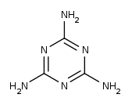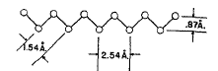
(A)
(B)
Fig. 14. Chemical structure of Bakelite surface material. (A) cured Liseed oil film;
(B) Melamine resin.

Acknowledgement
This work is supported by the US DoE Program of University Linear Collider Detector R&D, Project 6.19.

References
[1] Aging Study for SiD Hcal and Muon System RPCs, C. Lu et al., March 26-30, 2010, Proceedings of LCWS10;
[2] RPC electrode material study, C. Lu, N.I.M. A602(2009)761;
[3] Mechanisms affecting performance of the BaBar resistive plate chambers and searches for remediation, F. Anulli et al. N.I.M. A508(2003)128;
[4] Performance of BABAR second generation of resistive plate chambers, F. Anulli et al. N.I.M. A552(2005)276;
[5] The second generation BaBar RPCs: Final evaluation of performances, F. Ferroni, N.I.M. A602(2009)649;
[6] Drying of Linseed oil, Electron Diffraction Study, D.H. Clewell, Industrial and Engineering Chemistry, 29(1937)650;
[7] http://en.wikipedia.org/wiki/Melamine

The authors would like to thank Henry Band for providing the BaBar aged RPC samples that made this study possible.

