Daya Bay Project RPC Gas System Installation

I. Definition of Terms

- Buyer: Princeton University, Princeton, NJ 08544, USA
- Vendor: IHEP, Gaonengkedi Science and Technology Co. Ltd, Beijing, P.R. CHINA
- LIM: Local Installation Manager (See Appendix C).
- Site: The Daya Bay Near Hall, also known as Experimental Hall #1, at the Daya Bay Reactor Neutrino Experiment.

II. Statement of work

The work described in this document is the first of three stages involved in the installation of the RPC gas system of the Daya Bay Reactor Neutrino Experiment. This first stage corresponds to installation in the Daya Bay Near Hall, and the 2nd and 3rd stages correspond to installation in the Ling Ao Hall and in the Far Hall.

Princeton University will provide gas mixing panel, gas control crates, digital bubbler system, etc. The Vendor is to prepare and install the gas supply side equipment, install the gas pipe from gas room to experimental hall, prepare and connect plastic tubing from gas distribution crates to RPC modules. The detailed instructions are in Section IV. All work is under the supervision of the Buyer, and the Vendor will comply with all instructions from the Buyer. Appendix A lists the Buyer Responsibilities. Appendix B lists the Vendor Responsibilities. Appendix C lists the LIM Responsibilities.

III. Special Cautions

- Gas supply side equipment will be under high gas pressure, they should be tested according to relevant Chinese regulation before putting into use.
- All work will be performed on the ground level. Because the work place may have other installation activity hard hats are required at all times.
IV. Installation Procedures

The following procedures are to be followed by the Vendor except as noted:

- The Vendor should prefabricate the gas supply side equipment, such as gas manifold for 6-pack argon cylinders, gas cylinder clamping fixtures, flexible cylinder connection hoses, etc., and perform pressure test according to Chinese regulation. Make sure the connectors used for the flexible hoses are consistent with the gas cylinders that will be used for the experiment.
- The Vendor will install the ventilation pipe onto the isobutane gas cabinet.
- Mount the gas cylinder clamping fixtures, argon gas cylinder auto-switchover panel, R134a and SF5 gas cylinder manual switchover panels onto wall. Cut 3/4” OD copper tubing to length and mount on the wall. Connect the pipe piece by piece and route the entire tubing through the wall from gas mixing room to the experimental hall. Make sure the entire pipe is gas sealed. Princeton will provide a Restek leak detector, with which all fittings and connectors should be leak checked. No any leak should be detected within its sensitivity.
- Procure 11,000m of 6-mm-OD plastic tubing, which is sufficient for all three Experimental Halls. Prepare 216 tubes for the Near Experimental Hall; each tube should be labeled on both ends, and capped on both ends until final installation. For the detailed specification of the tube lengths and labels see Appendix B.
- Lay down the tubes into the cable trays on the RPC supporting structures.
- Connect the tubes to the RPC modules.
- Procure and install 12.3m long 3/4” OD braided flexible gas hose into the cable tray in the experimental hall.

V. Technical Specification

- Gas manifold for 6-pack argon cylinders
A sketch of the gas manifold is shown in Fig.1. Each Experimental Hall requires 2 manifolds; for three Halls total of six gas manifolds are required. The coils shown in Fig. 1 can be flexible hoses, on which the connectors have to be compatible with the argon gas cylinders that will be used for Daya Bay RPC gas system. The primary gas pressure from the gas cylinder will be ~2800psi.
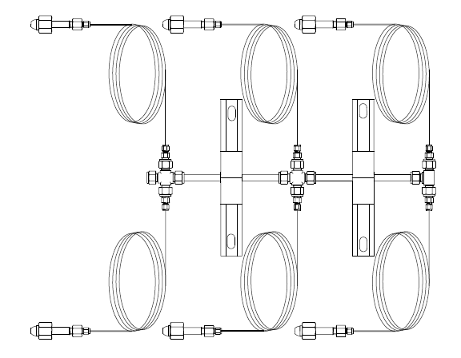

Fig. 1. Gas manifold.
- Gas cylinder clamping fixtures
The Vendor will provide the gas cylinder clamping fixtures for argon, SF6 and R134A. Since SF6 and R134A cylinders will be rest on the scales and weighted by the scales the cylinders should not be completely tighten to the fixtures. They should retain minimum interference to the weight of the cylinders.
- Gas cylinder switchover panels
Princeton will provide the switchover panels for argon, SF6 and R134A cylinders. The switchover panel is shown bellow:

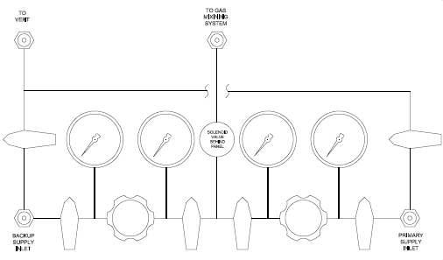
Fig. 2. Manual gas cylinder switchover panel.

The vender will mount these panels onto the wall and provide/connect the ventilation pipe to the fitting marked as “TO VENT” on the panel. Fig. 3 shows the pictures of these panels.
(A)
(B)
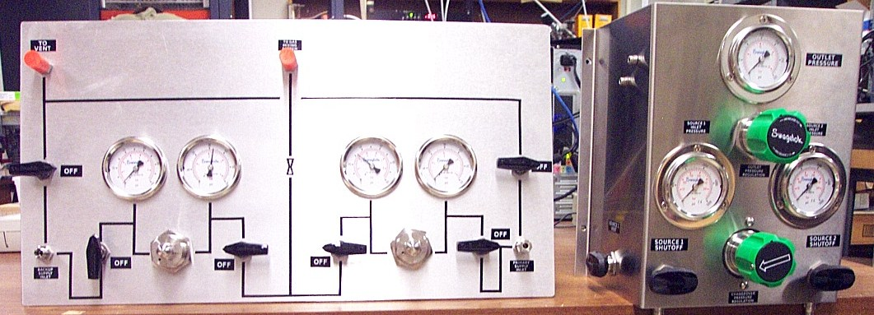
Fig. 3. Pictures of the cylinder switchover panels. (A) Auto switchover panel for argon, (B) Manual switchover panel for R134A, SF6.

- Plastic gas tubes
For the Near Experimental Hall the lengths of the plastic gas tubes are listed in Table 1.

Tube length (m) |  | Row1 | Row2 | Row3 | Row4 | Row5 | Row6
Column | 1 | 5.48 | 7.48 | 9.48 | 11.48 | 13.48 | 15.48
Column | 2 | 6.39 | 8.39 | 10.39 | 12.39 | 14.39 | 16.39
Column | 3 | 4.48 | 6.48 | 14.48 | 16.48 | 18.48 | 20.48
Column | 4 | 6.79 | 8.79 | 10.39 | 12.39 | 14.39 | 16.39
Column | 5 | 4.88 | 6.88 | 8.88 | 10.88 | 12.88 | 14.88
Column | 6 | 6.39 | 8.39 | 10.39 | 12.39 | 14.39 | 16.39
Column | 7 | 4.48 | 6.48 | 14.48 | 16.48 | 18.48 | 20.48
Column | 8 | 6.79 | 8.79 | 10.39 | 12.39 | 14.39 | 16.39
Column | 9 | 4.88 | 6.88 | 8.88 | 10.88 | 12.88 | 14.88
Table 1. Lengths of the tubes

For each length specified above 4 identical tubes are required; thus a total of 216 tubes are required..
The labels of the tubes are shown in Table 2.

 | Column | Row1 | Row2 | Row3 | Row4 | Row5 | Row6
Inlet tubing Branch 1 | 1 | H1C1R1B1In | H1C1R2B1In | H1C1R3B1In | H1C1R4B1In | H1C1R5B1In | H1C1R6B1In
Inlet tubing Branch 1 | 2 | H1C2R1B1In | H1C2R2B1In | H1C2R3B1In | H1C2R4B1In | H1C2R5B1In | H1C2R6B1In
Inlet tubing Branch 1 | 3 | H1C3R1B1In | H1C3R2B1In | H1C3R3B1In | H1C3R4B1In | H1C3R5B1In | H1C3R6B1In
Inlet tubing Branch 1 | 4 | H1C4R1B1In | H1C4R2B1In | H1C4R3B1In | H1C4R4B1In | H1C4R5B1In | H1C4R6B1In
Inlet tubing Branch 1 | 5 | H1C5R1B1In | H1C5R2B1In | H1C5R3B1In | H1C5R4B1In | H1C5R5B1In | H1C5R6B1In
Inlet tubing Branch 1 | 6 | H1C6R1B1In | H1C6R2B1In | H1C6R3B1In | H1C6R4B1In | H1C6R5B1In | H1C6R6B1In
Inlet tubing Branch 1 | 7 | H1C7R1B1In | H1C7R2B1In | H1C7R3B1In | H1C7R4B1In | H1C7R5B1In | H1C7R6B1In
Inlet tubing Branch 1 | 8 | H1C8R1B1In | H1C8R2B1In | H1C8R3B1In | H1C8R4B1In | H1C8R5B1In | H1C8R6B1In
Inlet tubing Branch 1 | 9 | H1C9R1B1In | H1C9R2B1In | H1C9R3B1In | H1C9R4B1In | H1C9R5B1In | H1C9R6B1In
Branch 2 | 1 | H1C1R1B2In | H1C1R2B2In | H1C1R3B2In | H1C1R4B2In | H1C1R5B2In | H1C1R6B2In
Branch 2 | 2 | H1C2R1B2In | H1C2R2B2In | H1C2R3B2In | H1C2R4B2In | H1C2R5B2In | H1C2R6B2In
Branch 2 | 3 | H1C3R1B2In | H1C3R2B2In | H1C3R3B2In | H1C3R4B2In | H1C3R5B2In | H1C3R6B2In
Branch 2 | 4 | H1C4R1B2In | H1C4R2B2In | H1C4R3B2In | H1C4R4B2In | H1C4R5B2In | H1C4R6B2In
Branch 2 | 5 | H1C5R1B2In | H1C5R2B2In | H1C5R3B2In | H1C5R4B2In | H1C5R5B2In | H1C5R6B2In
Branch 2 | 6 | H1C6R1B2In | H1C6R2B2In | H1C6R3B2In | H1C6R4B2In | H1C6R5B2In | H1C6R6B2In
Branch 2 | 7 | H1C7R1B2In | H1C7R2B2In | H1C7R3B2In | H1C7R4B2In | H1C7R5B2In | H1C7R6B2In
Branch 2 | 8 | H1C8R1B2In | H1C8R2B2In | H1C8R3B2In | H1C8R4B2In | H1C8R5B2In | H1C8R6B2In
Branch 2 | 9 | H1C9R1B2In | H1C9R2B2In | H1C9R3B2In | H1C9R4B2In | H1C9R5B2In | H1C9R6B2In
Outlet tubing  Branch 1 | 1 | H1C1R1B1Out | H1C1R2B1Out | H1C1R3B1Out | H1C1R4B1Out | H1C1R5B1Out | H1C1R6B1Out
Outlet tubing  Branch 1 | 2 | H1C2R1B1Out | H1C2R2B1Out | H1C2R3B1Out | H1C2R4B1Out | H1C2R5B1Out | H1C2R6B1Out
Outlet tubing  Branch 1 | 3 | H1C3R1B1Out | H1C3R2B1Out | H1C3R3B1Out | H1C3R4B1Out | H1C3R5B1Out | H1C3R6B1Out
Outlet tubing  Branch 1 | 4 | H1C4R1B1Out | H1C4R2B1Out | H1C4R3B1Out | H1C4R4B1Out | H1C4R5B1Out | H1C4R6B1Out
Outlet tubing  Branch 1 | 5 | H1C5R1B1Out | H1C5R2B1Out | H1C5R3B1Out | H1C5R4B1Out | H1C5R5B1Out | H1C5R6B1Out
Outlet tubing  Branch 1 | 6 | H1C6R1B1Out | H1C6R2B1Out | H1C6R3B1Out | H1C6R4B1Out | H1C6R5B1Out | H1C6R6B1Out
Outlet tubing  Branch 1 | 7 | H1C7R1B1Out | H1C7R2B1Out | H1C7R3B1Out | H1C7R4B1Out | H1C7R5B1Out | H1C7R6B1Out
Outlet tubing  Branch 1 | 8 | H1C8R1B1Out | H1C8R2B1Out | H1C8R3B1Out | H1C8R4B1Out | H1C8R5B1Out | H1C8R6B1Out
Outlet tubing  Branch 1 | 9 | H1C9R1B1Out | H1C9R2B1Out | H1C9R3B1Out | H1C9R4B1Out | H1C9R5B1Out | H1C9R6B1Out
Branch 2 | 1 | H1C1R1B2Out | H1C1R2B2Out | H1C1R3B2Out | H1C1R4B2Out | H1C1R5B2Out | H1C1R6B2Out
Branch 2 | 2 | H1C2R1B2Out | H1C2R2B2Out | H1C2R3B2Out | H1C2R4B2Out | H1C2R5B2Out | H1C2R6B2Out
Branch 2 | 3 | H1C3R1B2Out | H1C3R2B2Out | H1C3R3B2Out | H1C3R4B2Out | H1C3R5B2Out | H1C3R6B2Out
Branch 2 | 4 | H1C4R1B2Out | H1C4R2B2Out | H1C4R3B2Out | H1C4R4B2Out | H1C4R5B2Out | H1C4R6B2Out
Branch 2 | 5 | H1C5R1B2Out | H1C5R2B2Out | H1C5R3B2Out | H1C5R4B2Out | H1C5R5B2Out | H1C5R6B2Out
Branch 2 | 6 | H1C6R1B2Out | H1C6R2B2Out | H1C6R3B2Out | H1C6R4B2Out | H1C6R5B2Out | H1C6R6B2Out
Branch 2 | 7 | H1C7R1B2Out | H1C7R2B2Out | H1C7R3B2Out | H1C7R4B2Out | H1C7R5B2Out | H1C7R6B2Out
Branch 2 | 8 | H1C8R1B2Out | H1C8R2B2Out | H1C8R3B2Out | H1C8R4B2Out | H1C8R5B2Out | H1C8R6B2Out
Branch 2 | 9 | H1C9R1B2Out | H1C9R2B2Out | H1C9R3B2Out | H1C9R4B2Out | H1C9R5B2Out | H1C9R6B2Out
Table 2. Tube labels

The Vendor will lay down these tubes into the cable tray on the RPC module support structure and connect them to the RPC modules on one end and to the gas distribution crates on the other end. Fig. 4 shows the detailed arrangement of the tubes. The green lines represent the gas tubing. In the figure seven gas distribution crates are shown. Table 3 lists the assignment of the gas distribution crates to the gas tubes.

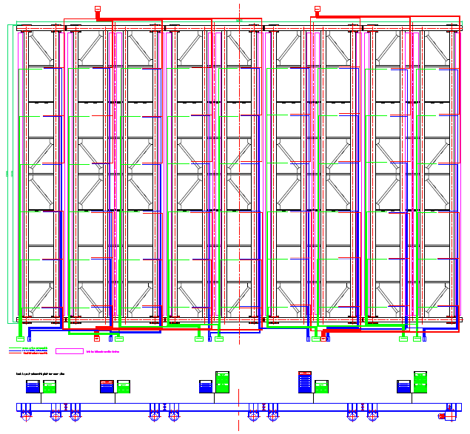
Table 3. Crate assignment of the tubes.
Fig. 4. DB Near Hall RPC gas tubing arrangement. Green lines represent gas tubing.
Column | Row1 | Row2 | Row3 | Row4 | Row5 | Row6
1 | crate #1 | crate #1 | crate #1 | crate #1 | crate #1 | crate #1
2 | crate #2 | crate #2 | crate #2 | crate #2 | crate #2 | crate #2
3 | crate #2 | crate #2 | crate #3 | crate #3 | crate #3 | crate #3
4 | crate #4 | crate #4 | crate #3 | crate #3 | crate #3 | crate #3
5 | crate #4 | crate #4 | crate #4 | crate #4 | crate #4 | crate #4
6 | crate #5 | crate #5 | crate #5 | crate #5 | crate #5 | crate #5
7 | crate #5 | crate #5 | crate #6 | crate #6 | crate #6 | crate #6
8 | crate #7 | crate #7 | crate #6 | crate #6 | crate #6 | crate #6
9 | crate #7 | crate #7 | crate #7 | crate #7 | crate #7 | crate #7

- 12.3m long braided flexible hose
According to IHEP RPC module installation plan the gas hose, HV cables and signal cables will lay down inside a flexible cable tray, in case of moving the entire RPC supporting structure out of the water pool, these utilities won’t need to be disconnected from the module. Therefore the main gas hose to the gas distribution crate needs to be flexible. Fig. 5 shows the details.
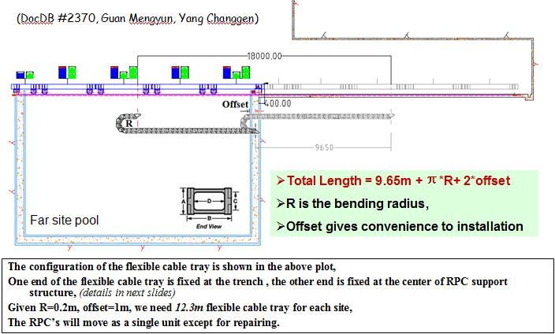
Fig. 5. Flexible cable tray.

VI. Contacts

Kirk McDonald
Princeton University
Jadwin Hall, Washington Road
Princeton, NJ 08544
Email: kirkmcd@Princeton University
Office phone: 1-609-258-

Changguo Lu
Princeton University
Jadwin Hall, Washington Road
Princeton, NJ 08544
Email: changguo@Princeton University
Office phone: 1-609-258-4421

Appendix A - Buyer Responsibilities

- The Buyer provides detailed installation instructions to the Vendor.
- The Buyer provides detailed Quality Assurance Requirements to the Vendor.
- The Buyer has at least one person available for consultation, supervision, and inspection.
- The Buyer Pays the Vendor through an IHEP Account.

Appendix B - Vendor Responsibilities

- The Vendor stops work at specified Hold Points in the procedure, until the Buyer gives approval to proceed.
- The Vendor stops work at any time if requested by the Buyer or LIM.
- The Vendor will comply with the Buyer’s Quality Assurance Requirements.

Appendix C – LIM Responsibilities

- Local Installation Manager (LIM), working with the Local Safety Coordinator (LSC), must approve all work.
- The LIM provides the Vendor with all required training, including safety training.
- The LIM ensures that the Vendor is in compliance with all required training, including safety training.
- The LIM declares when the Site is ready for installation work to commence.
- The LIM ensures that the conditions at the Site are safe at all times during the installation work.
- The LIM provides all required electrical power, water, lighting, ventilation, telephones, fire protection, basic safety systems (in place and operational).

