Daya Bay Project RPC Gas System Installation
(10/15/2009)

I. Definition of Terms

- Buyer: Princeton University, Princeton, NJ 08544, USA
- Vendor: IHEP, Gaonengkedi Science and Technology Co. Ltd, Beijing, P.R. CHINA
- LIM: Local Installation Manager (See Appendix C).
- Site: The Daya Bay Near Hall, also known as Experimental Hall #1, at the Daya Bay Reactor Neutrino Experiment.

II. Statement of work

The work described in this document is the first of three stages involved in the installation of the RPC gas system of the Daya Bay Reactor Neutrino Experiment. This first stage corresponds to installation in the Daya Bay Near Hall, and the 2nd and 3rd stages correspond to installation in the Ling Ao Hall and in the Far Hall.
The Buyer will provide gas mixing panels, gas control crates, digital bubbler systems, etc. See Appendix D for their photos. The Vendor needs to prefabricate and install the gas handling equipments, such as gas manifolds, cylinder clamps, etc., install the gas pipe from the gas supply room to the gas distribution crates in the experimental hall, prepare and connect plastic tubing from gas distribution crates to RPC modules. Detailed instructions are in Section IV. All work is under the supervision of the Buyer, and the Vendor will comply with all instructions from the Buyer. Appendix A lists the Buyer Responsibilities. Appendix B lists the Vendor Responsibilities. Appendix C lists the LIM Responsibilities, Appendix D show the photos of the final version of the gas mixing panel and gas distribution/digital bubbler crate.

III. Special Cautions

- The gas supply side equipment will be operated under high gas pressure, and should therefore be tested according to relevant Chinese regulations before use.
- All work will be performed on the ground level. Because the work place may have other installation activity hard hats are required at all times.
IV. Installation Procedures

The following procedures are to be followed by the Vendor except as noted:

- The Vendor should prefabricate/procure the gas handling equipments, such as gas manifold for 6-pack argon cylinders, gas cylinder clamps, flexible cylinder hoses, etc., and perform pressure tests according to Chinese regulations. The connectors used for the flexible hoses must be consistent with those on the gas cylinders that will be used for the experiment. For argon cylinder the flexible hose must meet the requirement for the high pressure up to ~200 bar.
- The Vendor will install the ventilation pipe and fire extinguishing water pipe onto the isobutane gas cabinet.
- Mount the gas cylinder clamps, argon gas cylinder auto-switchover panel, R134a and SF5 gas cylinder manual switchover panels onto wall. Cut 18-mm-OD copper tubing to length and mount on the wall. Connect the pipe piece by piece and route the entire tubing through the wall from gas mixing room to the experimental hall. Make sure the entire pipe is gas sealed. The Buyer will provide a Restek leak detector, with which all fittings and connectors should be leak checked. No leak should be detected within the sensitivity of this device.
- Procure 11,000m of 6-mm-OD fire retardant plastic tubing, which is sufficient for all three Experimental Halls. Prepare 216 tubes for the Daya Bay Near Hall; each tube should be labeled on both ends, and capped on both ends until final installation. The Buyer will provide label maker and caps for this use. For the detailed specification of the tube lengths and labels see Appendix B.
- Lay down the tubes into the cable trays, which are embedded inside of the RPC supporting structures.
- Connect the tubes to the RPC modules and gas distribution crates.
- Connect the exhaust gas from all digital bubblers to the ventilation pipe.
- Procure and install a 12.3-m-long 18-mm-OD S.S. braided flexible gas hose into the flexible cable tray in the experimental hall.

V. Technical Specification
- Gas manifold for 6-pack argon cylinders
A sketch of the gas manifold is shown in Fig.1. Each Experimental Hall requires 2 manifolds; for three Halls a total of six gas manifolds are required. The coils shown in Fig. 1 can be high pressure flexible hoses, on which the connectors have to be compatible with the argon gas cylinders that will be used for Daya Bay RPC gas system. On each hose there will be an additional manual valve (not shown in the figure) installed, in case of any cylinder valve showing a leak, this valve will isolate it from the rest of the cylinders. The primary gas pressure from the gas cylinder will be ~ 200 bar.

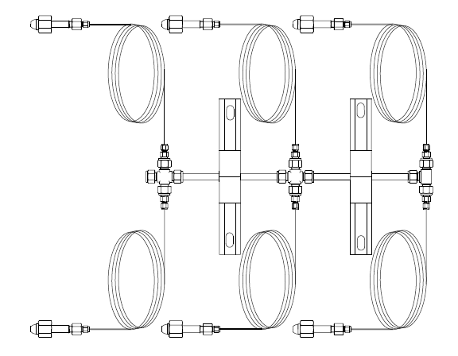

Fig. 1. Gas manifold (additional valve for each branch is not shown here).
- Gas cylinder clamps
The Vendor will provide the gas cylinder clamps for argon, SF6 and R134A. Since SF6 and R134A cylinders will be rest on and weighted by the scales the cylinders should not be completely tighten to the clamps. They should retain minimum interference to the weight of the cylinders.
- Gas cylinder switchover panels
The Buyer will provide the switchover panels for argon, SF6 and R134A cylinders. The manual switchover panel is shown in Fig. 2.

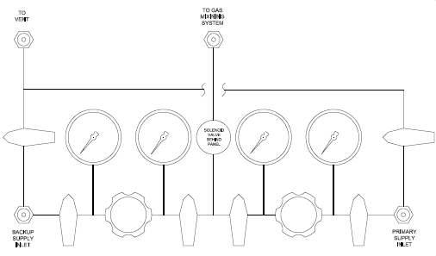
Fig. 2. Manual gas cylinder switchover panel.

The Vendor will mount these panels onto the wall and provide/connect the ventilation pipe to the fitting marked as “TO VENT” on the panel. Fig. 3 shows the pictures of these panels.

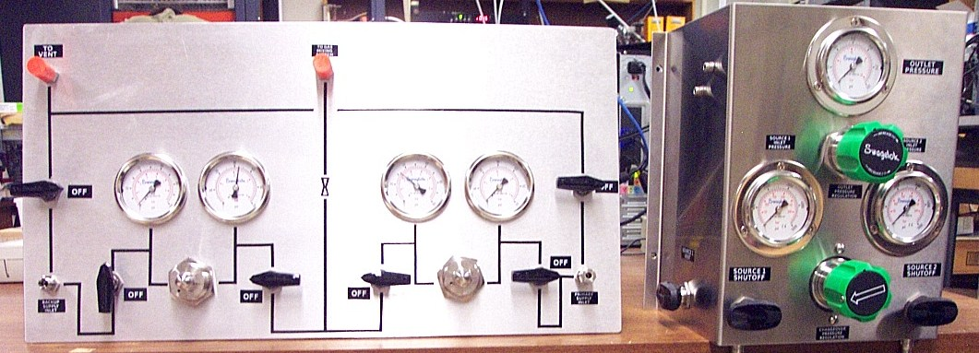
(A)
(B)
Fig. 3. (A) Manual cylinder switchover panel; (B) Automatic cylinder switchover panel.

- Plastic gas tubes
For the Daya Bay Near Hall the lengths of the plastic gas tubes are listed in Table 1.

Tube length (m) |  | Row1 | Row2 | Row3 | Row4 | Row5 | Row6
Column | 1 | 5.48 | 7.48 | 9.48 | 11.48 | 13.48 | 15.48
Column | 2 | 6.39 | 8.39 | 10.39 | 12.39 | 14.39 | 16.39
Column | 3 | 4.48 | 6.48 | 14.48 | 16.48 | 18.48 | 20.48
Column | 4 | 6.79 | 8.79 | 10.39 | 12.39 | 14.39 | 16.39
Column | 5 | 4.88 | 6.88 | 8.88 | 10.88 | 12.88 | 14.88
Column | 6 | 6.39 | 8.39 | 10.39 | 12.39 | 14.39 | 16.39
Column | 7 | 4.48 | 6.48 | 14.48 | 16.48 | 18.48 | 20.48
Column | 8 | 6.79 | 8.79 | 10.39 | 12.39 | 14.39 | 16.39
Column | 9 | 4.88 | 6.88 | 8.88 | 10.88 | 12.88 | 14.88
Table 1. Lengths of the tubes

For each length specified above 4 identical tubes are required; thus a total of 216 tubes are needed.
The labels of the tubes are shown in Table 2.

 | Column | Row1 | Row2 | Row3 | Row4 | Row5 | Row6
Inlet tubing Branch 1 | 1 | H1C1R1B1In | H1C1R2B1In | H1C1R3B1In | H1C1R4B1In | H1C1R5B1In | H1C1R6B1In
Inlet tubing Branch 1 | 2 | H1C2R1B1In | H1C2R2B1In | H1C2R3B1In | H1C2R4B1In | H1C2R5B1In | H1C2R6B1In
Inlet tubing Branch 1 | 3 | H1C3R1B1In | H1C3R2B1In | H1C3R3B1In | H1C3R4B1In | H1C3R5B1In | H1C3R6B1In
Inlet tubing Branch 1 | 4 | H1C4R1B1In | H1C4R2B1In | H1C4R3B1In | H1C4R4B1In | H1C4R5B1In | H1C4R6B1In
Inlet tubing Branch 1 | 5 | H1C5R1B1In | H1C5R2B1In | H1C5R3B1In | H1C5R4B1In | H1C5R5B1In | H1C5R6B1In
Inlet tubing Branch 1 | 6 | H1C6R1B1In | H1C6R2B1In | H1C6R3B1In | H1C6R4B1In | H1C6R5B1In | H1C6R6B1In
Inlet tubing Branch 1 | 7 | H1C7R1B1In | H1C7R2B1In | H1C7R3B1In | H1C7R4B1In | H1C7R5B1In | H1C7R6B1In
Inlet tubing Branch 1 | 8 | H1C8R1B1In | H1C8R2B1In | H1C8R3B1In | H1C8R4B1In | H1C8R5B1In | H1C8R6B1In
Inlet tubing Branch 1 | 9 | H1C9R1B1In | H1C9R2B1In | H1C9R3B1In | H1C9R4B1In | H1C9R5B1In | H1C9R6B1In
Branch 2 | 1 | H1C1R1B2In | H1C1R2B2In | H1C1R3B2In | H1C1R4B2In | H1C1R5B2In | H1C1R6B2In
Branch 2 | 2 | H1C2R1B2In | H1C2R2B2In | H1C2R3B2In | H1C2R4B2In | H1C2R5B2In | H1C2R6B2In
Branch 2 | 3 | H1C3R1B2In | H1C3R2B2In | H1C3R3B2In | H1C3R4B2In | H1C3R5B2In | H1C3R6B2In
Branch 2 | 4 | H1C4R1B2In | H1C4R2B2In | H1C4R3B2In | H1C4R4B2In | H1C4R5B2In | H1C4R6B2In
Branch 2 | 5 | H1C5R1B2In | H1C5R2B2In | H1C5R3B2In | H1C5R4B2In | H1C5R5B2In | H1C5R6B2In
Branch 2 | 6 | H1C6R1B2In | H1C6R2B2In | H1C6R3B2In | H1C6R4B2In | H1C6R5B2In | H1C6R6B2In
Branch 2 | 7 | H1C7R1B2In | H1C7R2B2In | H1C7R3B2In | H1C7R4B2In | H1C7R5B2In | H1C7R6B2In
Branch 2 | 8 | H1C8R1B2In | H1C8R2B2In | H1C8R3B2In | H1C8R4B2In | H1C8R5B2In | H1C8R6B2In
Branch 2 | 9 | H1C9R1B2In | H1C9R2B2In | H1C9R3B2In | H1C9R4B2In | H1C9R5B2In | H1C9R6B2In
Outlet tubing  Branch 1 | 1 | H1C1R1B1Out | H1C1R2B1Out | H1C1R3B1Out | H1C1R4B1Out | H1C1R5B1Out | H1C1R6B1Out
Outlet tubing  Branch 1 | 2 | H1C2R1B1Out | H1C2R2B1Out | H1C2R3B1Out | H1C2R4B1Out | H1C2R5B1Out | H1C2R6B1Out
Outlet tubing  Branch 1 | 3 | H1C3R1B1Out | H1C3R2B1Out | H1C3R3B1Out | H1C3R4B1Out | H1C3R5B1Out | H1C3R6B1Out
Outlet tubing  Branch 1 | 4 | H1C4R1B1Out | H1C4R2B1Out | H1C4R3B1Out | H1C4R4B1Out | H1C4R5B1Out | H1C4R6B1Out
Outlet tubing  Branch 1 | 5 | H1C5R1B1Out | H1C5R2B1Out | H1C5R3B1Out | H1C5R4B1Out | H1C5R5B1Out | H1C5R6B1Out
Outlet tubing  Branch 1 | 6 | H1C6R1B1Out | H1C6R2B1Out | H1C6R3B1Out | H1C6R4B1Out | H1C6R5B1Out | H1C6R6B1Out
Outlet tubing  Branch 1 | 7 | H1C7R1B1Out | H1C7R2B1Out | H1C7R3B1Out | H1C7R4B1Out | H1C7R5B1Out | H1C7R6B1Out
Outlet tubing  Branch 1 | 8 | H1C8R1B1Out | H1C8R2B1Out | H1C8R3B1Out | H1C8R4B1Out | H1C8R5B1Out | H1C8R6B1Out
Outlet tubing  Branch 1 | 9 | H1C9R1B1Out | H1C9R2B1Out | H1C9R3B1Out | H1C9R4B1Out | H1C9R5B1Out | H1C9R6B1Out
Branch 2 | 1 | H1C1R1B2Out | H1C1R2B2Out | H1C1R3B2Out | H1C1R4B2Out | H1C1R5B2Out | H1C1R6B2Out
Branch 2 | 2 | H1C2R1B2Out | H1C2R2B2Out | H1C2R3B2Out | H1C2R4B2Out | H1C2R5B2Out | H1C2R6B2Out
Branch 2 | 3 | H1C3R1B2Out | H1C3R2B2Out | H1C3R3B2Out | H1C3R4B2Out | H1C3R5B2Out | H1C3R6B2Out
Branch 2 | 4 | H1C4R1B2Out | H1C4R2B2Out | H1C4R3B2Out | H1C4R4B2Out | H1C4R5B2Out | H1C4R6B2Out
Branch 2 | 5 | H1C5R1B2Out | H1C5R2B2Out | H1C5R3B2Out | H1C5R4B2Out | H1C5R5B2Out | H1C5R6B2Out
Branch 2 | 6 | H1C6R1B2Out | H1C6R2B2Out | H1C6R3B2Out | H1C6R4B2Out | H1C6R5B2Out | H1C6R6B2Out
Branch 2 | 7 | H1C7R1B2Out | H1C7R2B2Out | H1C7R3B2Out | H1C7R4B2Out | H1C7R5B2Out | H1C7R6B2Out
Branch 2 | 8 | H1C8R1B2Out | H1C8R2B2Out | H1C8R3B2Out | H1C8R4B2Out | H1C8R5B2Out | H1C8R6B2Out
Branch 2 | 9 | H1C9R1B2Out | H1C9R2B2Out | H1C9R3B2Out | H1C9R4B2Out | H1C9R5B2Out | H1C9R6B2Out
Table 2. Tube labels

The Vendor will lay down these tubes into the cable tray on the RPC module support structure and connect them to the RPC modules on one end and to the gas distribution crates on the other end. Fig. 4 shows the detailed arrangement of the tubes. The green lines represent the gas tubing. In the figure, seven gas distribution crates are shown. Table 3 lists the assignment of the gas distribution crates to the gas tubes.

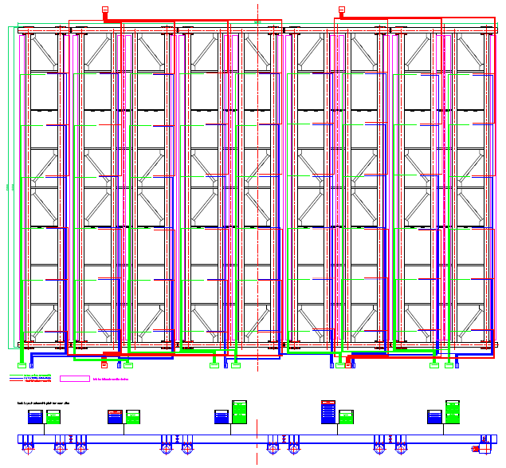
Table 3. Crate assignment of the tubes.
Fig. 4. DB Near Hall RPC gas tubing arrangement. Green lines represent gas tubing.
Column | Row1 | Row2 | Row3 | Row4 | Row5 | Row6
1 | crate #1 | crate #1 | crate #1 | crate #1 | crate #1 | crate #1
2 | crate #2 | crate #2 | crate #2 | crate #2 | crate #2 | crate #2
3 | crate #2 | crate #2 | crate #3 | crate #3 | crate #3 | crate #3
4 | crate #4 | crate #4 | crate #3 | crate #3 | crate #3 | crate #3
5 | crate #4 | crate #4 | crate #4 | crate #4 | crate #4 | crate #4
6 | crate #5 | crate #5 | crate #5 | crate #5 | crate #5 | crate #5
7 | crate #5 | crate #5 | crate #6 | crate #6 | crate #6 | crate #6
8 | crate #7 | crate #7 | crate #6 | crate #6 | crate #6 | crate #6
9 | crate #7 | crate #7 | crate #7 | crate #7 | crate #7 | crate #7

- 12.3-m-long S. S. braided flexible hose
According to IHEP RPC module installation plan the gas hose, HV cables and signal cables will lay down inside a flexible cable tray, in case of moving the entire RPC supporting structure out of the water pool, these utilities won’t need to be disconnected from the module. Therefore the main gas hose to the gas distribution crate needs to be flexible. Fig. 5 shows the details. The Vendor should procure and install this hose.
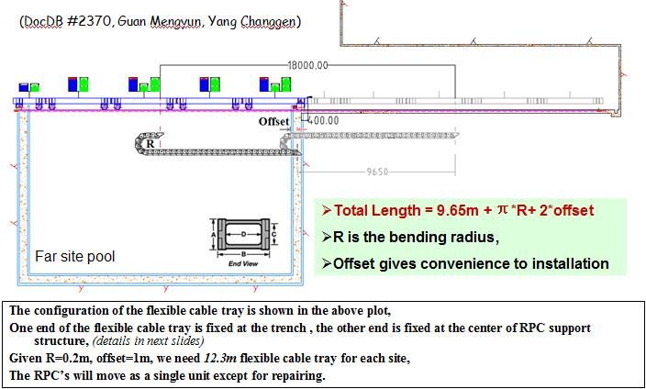
Fig. 5. Flexible cable tray.

VI. Contacts

Kirk McDonald
Princeton University
Jadwin Hall, Washington Road
Princeton, NJ 08544
Email: kirkmcd@Princeton University
Office phone: 1-609-258-6608

Changguo Lu
Princeton University
Jadwin Hall, Washington Road
Princeton, NJ 08544
Email: changguo@Princeton University
Office phone: 1-609-258-4421
VII Total cost
The total cost of this contract is based on the following material and labor estimation:
- Argon manifold
Each 6-pack argon manifold ¥4,200, for three E.H. total need 6 manifolds, ¥25,000;
- Copper tubing, 12mm OD, from gas mixing room to E.H. ¥50/m x 200m,
¥10,000;
- Plastic tubing, ¥5/m x 14,000m, ¥70,000;
- Labor cost for installation of all plastic tubing, 6 man*month, ¥48,000;
- Water sprinkler/exhaust pipe installation, ¥9,000;
Total cost $24,000.

Appendix A - Buyer Responsibilities

- The Buyer provides detailed installation instructions to the Vendor.
- The Buyer provides detailed Quality Assurance Requirements to the Vendor.
- The Buyer has at least one person available for consultation, supervision, and inspection.
- The Buyer Pays the Vendor through an IHEP Account.

Appendix B - Vendor Responsibilities

- The Vendor stops work at specified Hold Points in the procedure, until the Buyer gives approval to proceed.
- The Vendor stops work at any time if requested by the Buyer or LIM.
- The Vendor will comply with the Buyer’s Quality Assurance Requirements.

Appendix C – LIM Responsibilities

- Local Installation Manager (LIM), working with the Local Safety Coordinator (LSC), must approve all work.
- The LIM provides the Vendor with all required training, including safety training.
- The LIM ensures that the Vendor is in compliance with all required training, including safety training.
- The LIM declares when the Site is ready for installation work to commence.
- The LIM ensures that the conditions at the Site are safe at all times during the installation work.
- The LIM provides all required electrical power, water, lighting, ventilation, telephones, fire protection, basic safety systems (in place and operational).

Appendix D – Photos and Drawings

- Gas mixing panel.
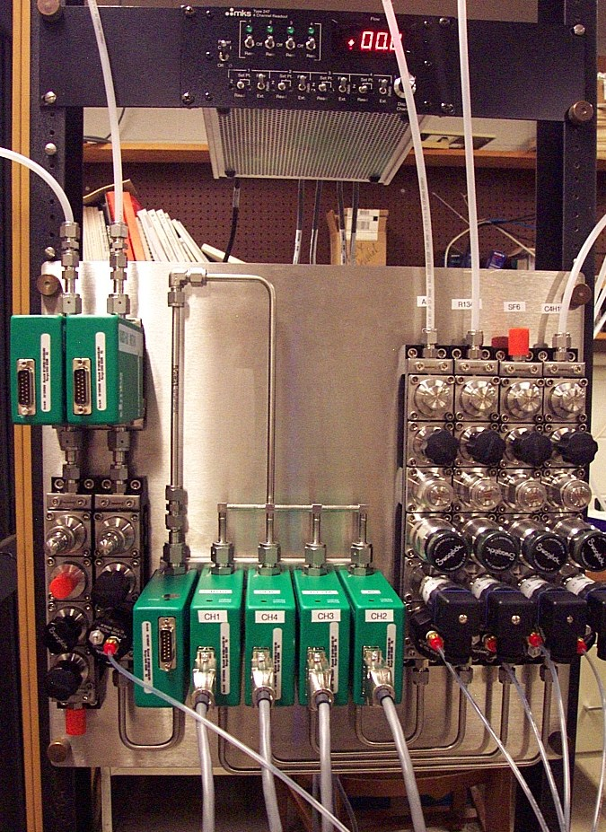

- Gas distribution/digital bubbler crate.
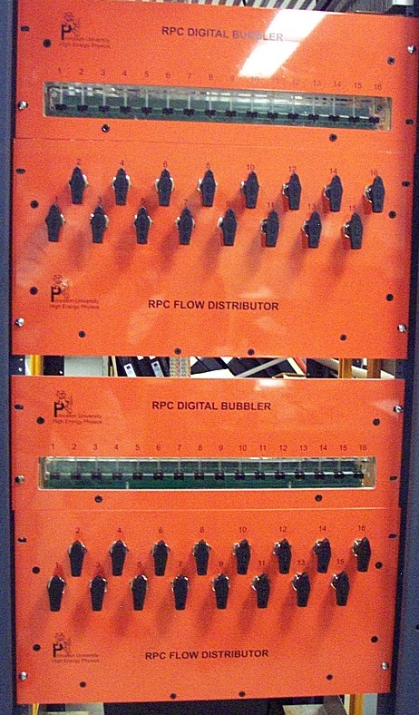

- Nearly completed gas system
Control crates
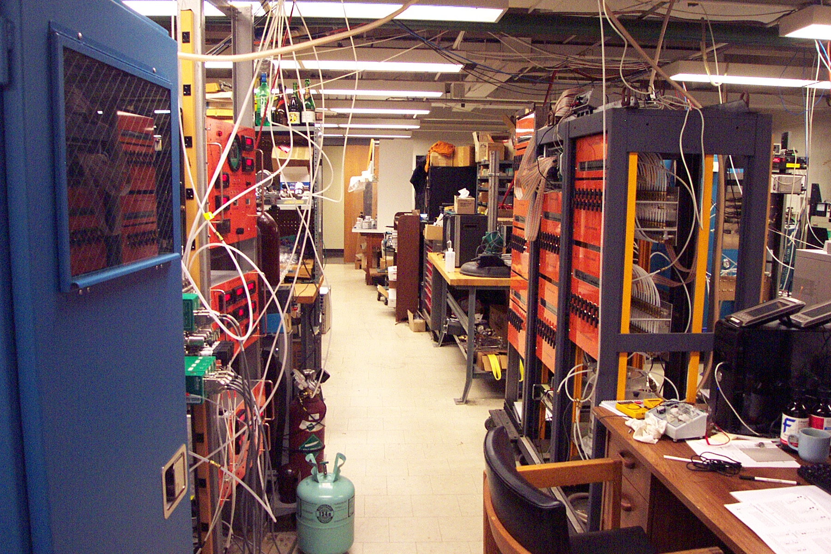
Gas cabinet
Mixing panel
Digital bubblers

