**Digital Bubbler of the Daya Bay RPC Gas System**

C. Lu, K,T. McDonald, W.R. Sands, S. Chidzik, M. Peloso

Joseph Henry Laboratories, Princeton University, Princeton, NJ 08544, USA

**Abstract**

The gas distribution and digital bubbler systems for the resistive plate chambers of the Daya Bay reactor antineutrino experiment are described, and their performance in test lab is presented.

1. **Introduction**

The Daya Bay reactor antineutrino experiment [1] uses resistive plate chambers (RPCs) [2] as part of its muon veto system. A total of 54, 81 and 54 RPC modules [3] will be installed in Daya Bay Near Hall, Far Hall and Lin Ao Near Hall, respectively. Each RPC module consists of eight 2 m × 1 m RPCs arrayed in two groups of four with separate gas flow for each group.

Each experimental hall has a gas-distribution system that protects the RPCs from overpressure; distributes the gas uniformly into the RPC modules, and monitors the gas flow rate for each gas-distribution branch via digital bubblers.

Because Daya Bay experiment is set in an underground laboratory, safety concern has highest priority. We have chosen Ar/R134A/Isobutane/SF6 (65.5/30/4/0.5) as a non-flammable gas mixture used for the streamer mode RPCs [4].

1. **RPC Gas Distribution and Digital Bubbler System**

Three gas systems are identical except the total branch’s number: two near halls are the same 108 branches, and far hall is 162 branches. To illustrate the working principle we use Daya Bay near hall system as an example in the follows. The primary gas flow is split into 7 panel-branches and each panel-branch is further split into 16 sub-branches.

* 1. Panel-Branch Manifold

The manifold used to split the primary gas flow into 7 panel-branches is shown in Fig. 1.

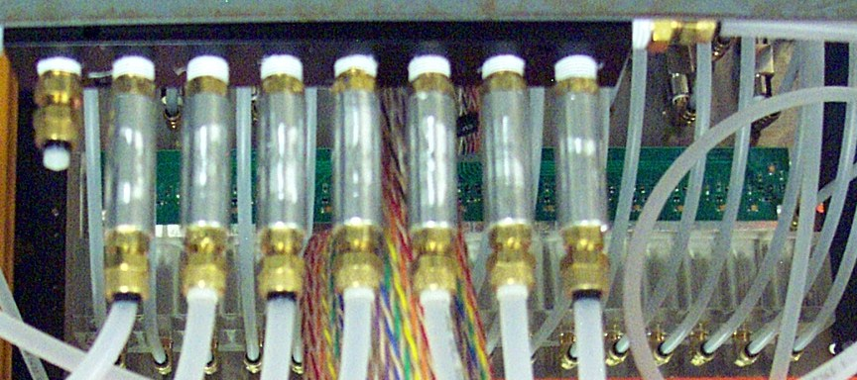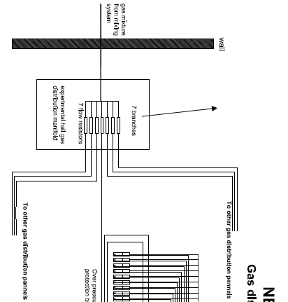

Fig. 1. Panel branch of the gas distribution system.

Because it is hard to control all downstream gas flow resistors (5cm long, 0.25mm ID) having same flow resistance, it has been revealed that some distribution panels are having higher flow resistance than others, so the overall flow rate for 7 panel-branches won’t be the same. It can be seen in Fig. 2 bottom plot. The solution is adding an additional flow resistor to each branch of the gas manifold. These flow resistors are made of 5cm long, 0.5mm ID S.S. tubes, they are cut from 2 20cm long S.S. tubes. With these flow resistors the uniformity of the bubbling rate distribution among all 112 channels is much better as shown in the top plot of Fig. 2.

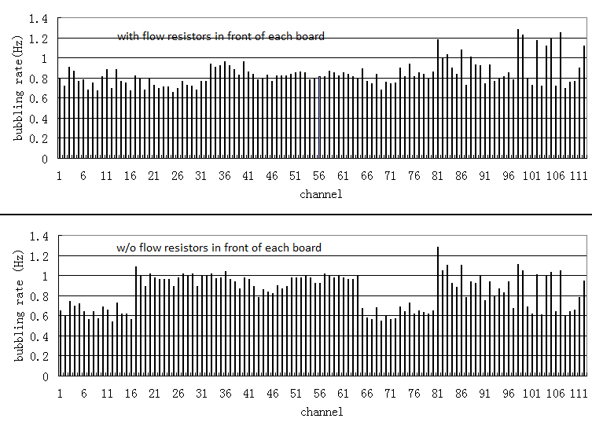

Fig. 2. The gas bubbling rate distribution for 112 channels. Top plot: with the panel-branch flow resistors; bottom plot: w/o the panel-branch flow resistors.

One panel-branch of gas distribution/digital bubbler system is sketched in Fig. 3(A), its photo is in Fig. 3(B).

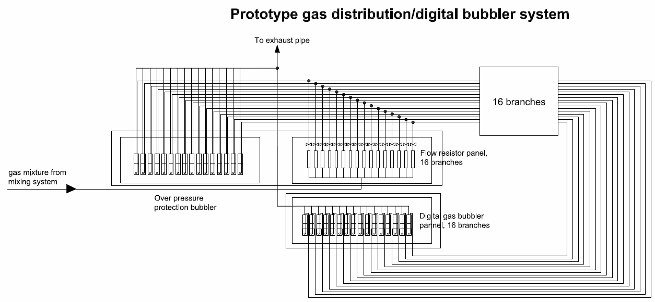

Fig. 3(A). One panel-branch of gas distribution/digital bubbler system

Fig. 3(B) Gas distribution (bottom) and digital bubbler (top) panels.

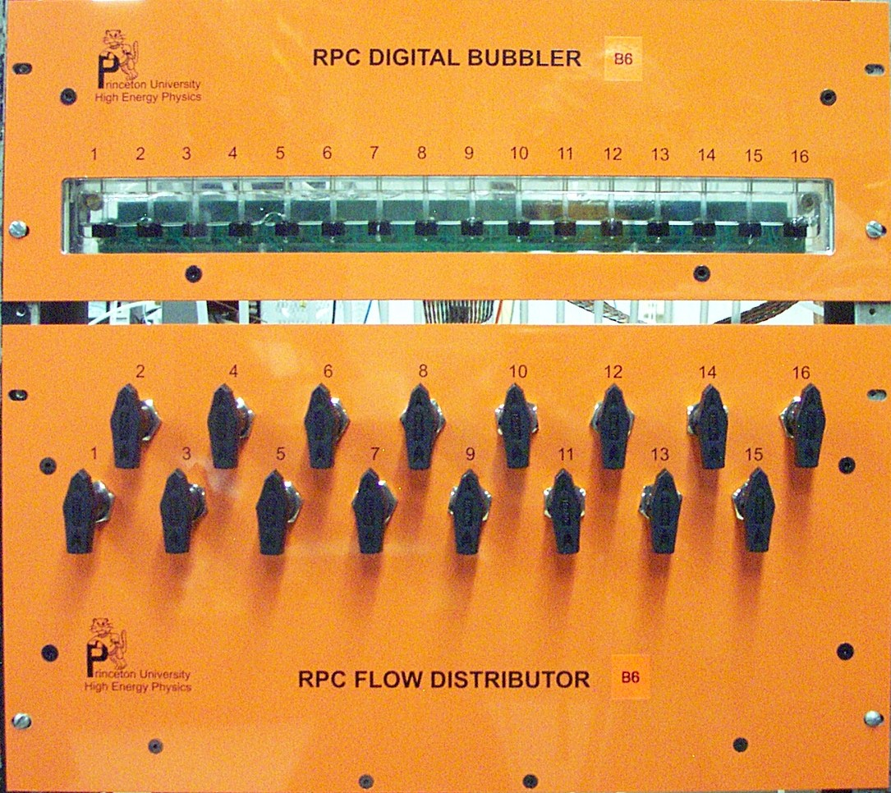

* 1. **RPC inlet overpressure protection bubbler**

Figure 4 shows an inlet protection bubbler crate. Each crate consists of 16 channels. For each channel a straw tube is dipped into an oil well with a depth of ~ 3cm. The inlet gas pressure will be manifested as the gas column in the straw tube above the oil level (indicated as h in the insert). The maximum inlet pressure will be limited at ~3cm oil. If the gas pressure overpasses this limit, the gas mixture will escape through this protection channel.

Gas column above the oil level, its height indicates the inlet gas pressure, see the right side insert.

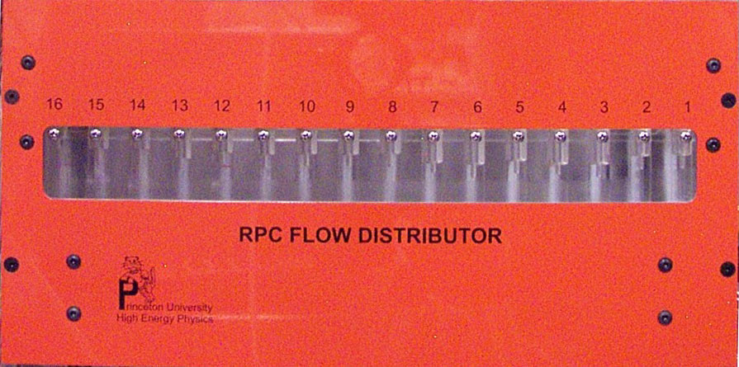

Fig. 4. Gas inlet overpressure protection bubblers.

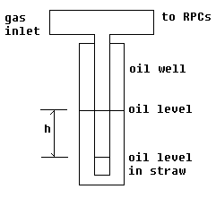

* 1. **Digital bubbler**

For a gas detector system the oil bubblers are always used at the outlets of the chambers to isolate the gas chamber from air. Besides this basic function the digital gas bubbler can provide a quick on-line diagnosis of gas flow; according to BaBar and Belle it turns out to be a very useful system [5, 6]. We use a similar digital bubbler design as Belle RPC used [7].

The hardware of the16 channel digital bubbler with the oil catcher is shown in figure 5(A). To prevent the oil from sucking back into the gas tubing we add an oil catcher for each channel as shown in figure 5(B). In case of negative gas pressure occurred in the RPC chambers, the oil in the outlet bubbler will be sucked back into the oil catcher instead of getting into the gas tubing.

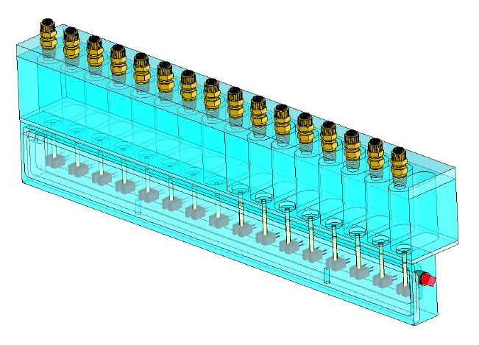

Fig. 5. (A) 16-channel digital bubbler with oil catcher; (B) Illustration of the oil catcher.

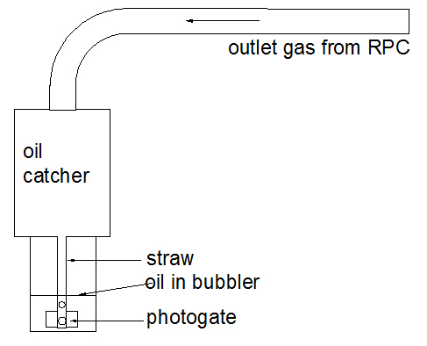

(B)

(A)

In this system the bubblers are instrumented with photogates. Its working principle is illustrated in figure 6. Without gas bubble the light reaches the photogate through oil without interruption. When a bubble passes, it will reflect partial light, and the light intensity at that moment would be reduced, thus generates a pulse signal to the photogate PC board.

A schematic of the digital bubbler photogate PC board is shown in figure 7. This is a 16-channel board that provides input signal to the microcontroller readout board. Each of the microcontroller board can handle 16 channels. TI MSP430F1611[8] microcontroller is used on the board, figure 8(A) shows the functional block diagram of MSP430x161x chip. It has 10KB RAM and 48KB flash memory. The build-in 12-bit ADC can sequentially sample 8 channels of the input at a time with the sampling rate set by a 32768-Hz (215) watch crystal oscillator. When the ADC finishes the sampling for the first 8 channels it will generate a switch signal that subsequently will be sent to two MAX4674 multiplexer chips, each of which can handle 4 channels. Thus the next 8 channels will be sampled by the ADC. The system will be running for a few seconds that is long enough to collect several cycles of the bubbles. All the data is stored in the RAM memory of the microcontroller and waiting to be read out by the host PC through RS232 port. A USB extender pair is used to connect the USB port on PC to a USB hub with 7 USB slots. The CAT5E cable used to connect the pair of USB extender can be as long as 100ft. Each USB slot through a USB to RS232 convertor cable is connected to a digital bubbler readout board. For the near hall we need 7 16-channel bubblers.

Figure 6. Digital gas bubbler. (A) Mechanical structure of the bubbler (for illustration purpose only, not the same as used in our gas system); (B) Working principle of the photogate; (C) The digital bubbler output signal recorded by microcontroller, it shows 8 channels are bubbling, the other 8 channels are not.

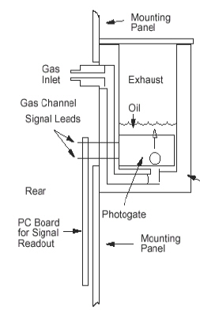

(A)

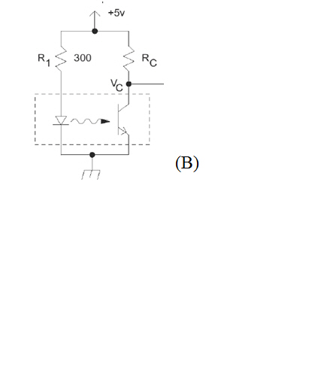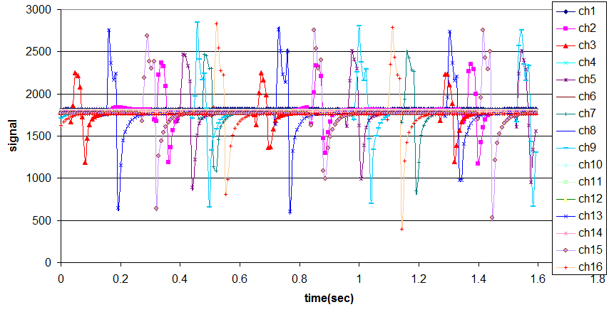

(C)

(B)

To digital bubbler readout board

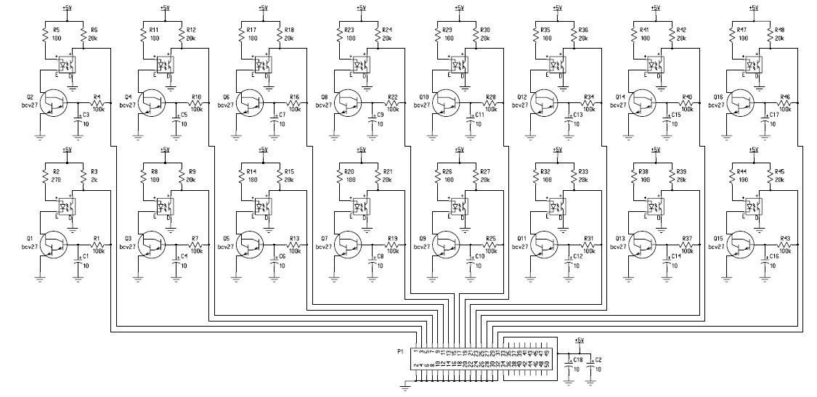

Fig. 7. Digital bubbler photogate PC board schematics.

The schematic of the microcontroller readout test boards shown in figure 8(B). Figure 9 is a photo of this system.

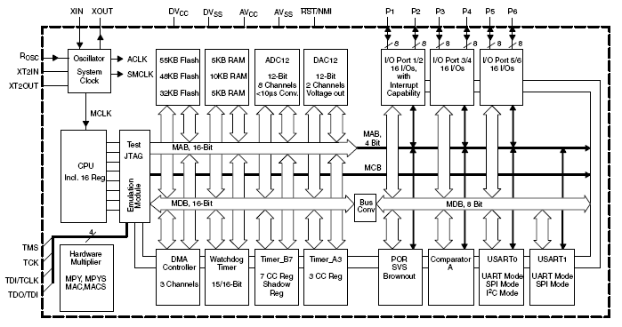

Fig.8(A) MSP430x161x functional block diagram.

Fig. 8(B) Digital bubbler readout board schematic. Top is TI microcontroller readout part; Bottom is the Universal Bootstrap Loader Interface part.

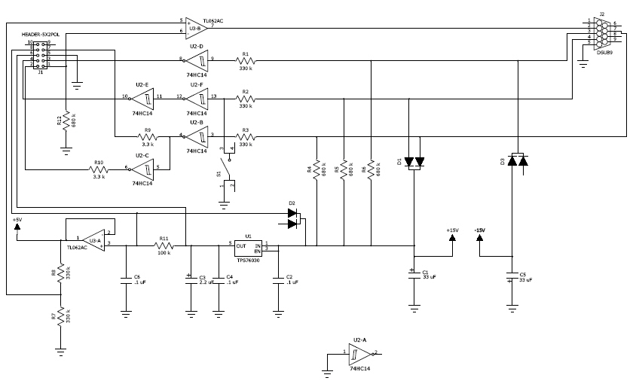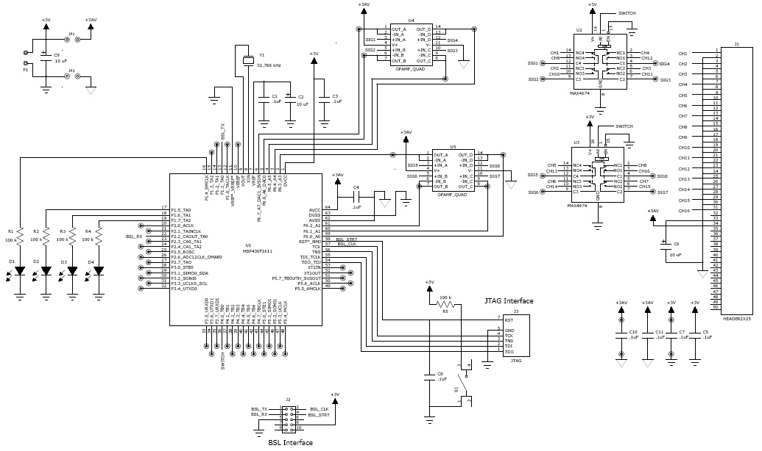

Fig. 9 Digital bubbler readout crate and its host PC with USB extender/100 ft long CAT-5E cable.

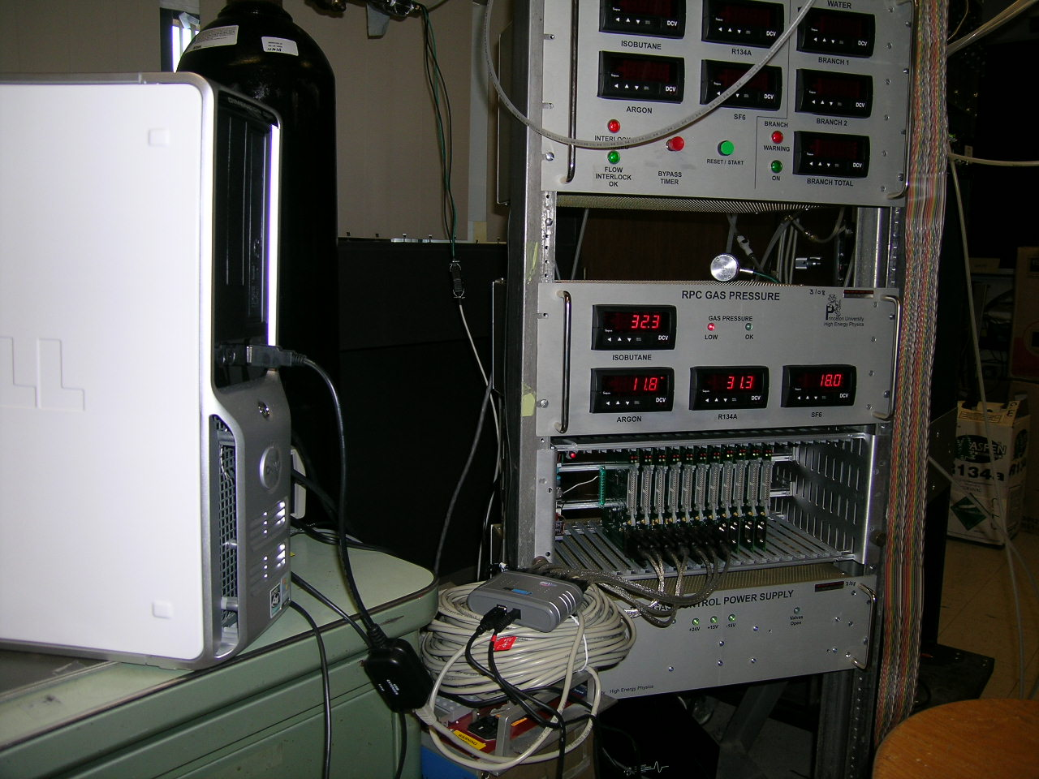

Digital bubbler readout crate

USB extender with 100 ft CAT-5E cable

Host PC and its USB port

7-Port USB hub with 7 USB to RS232 converters

Through flat cables connect to bubbler photogate PC boards

The cable interconnection of the digital bubbler system is shown in figure 10.

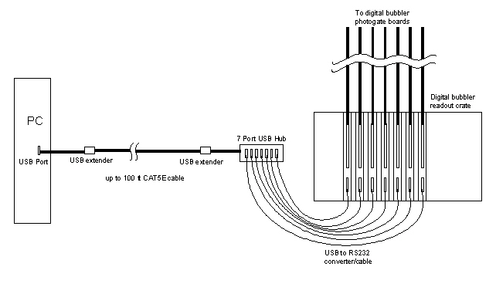

Fig. 10 Interconnection of the digital bubbler system.

The host PC will be in the gas mixing room, the digital bubbler hardware and readout crate will be located on the RPC module supporting platform that is located in the experimental hall. The distance between two locations is around 20m. Use of the USB extender and one 100 ft CAT5E cable should be long enough to link them together.

* 1. **Performance of the gas distribution system**

A sample Excel strip plot is shown in figure 10. We can see the bubbling rate distribution among 112 channels measured by the digital bubbler is reasonably uniform. The flow rate vs. bubbling rate from 500 SCCM to 3.5 SLM range is shown in figure 11. Below 2 SLM the linearity is quite good, thereafter the flow rate becomes lower than linear extrapolated value, it could be the gas volume for each bubble not the same under different flow rate.

Fig. 10 Bubbling rate distribution of 112 channels.

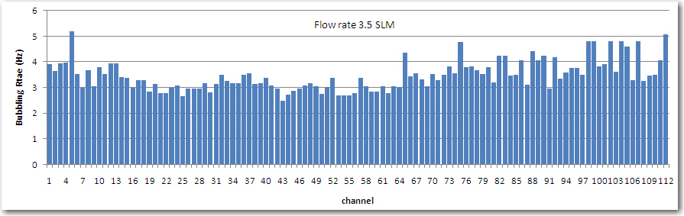

Fig. 11. Gas flow rate vs. bubbling rate.

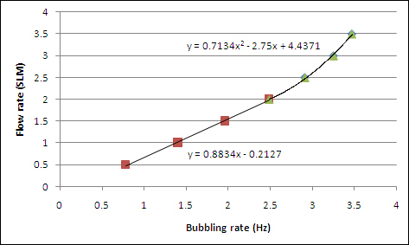

**References**

(2)

(3)

(4)

1. The Daya Bay Collaboration, “Daya Bay Proposal -- A Precision Measurement of the Neutrino Mixing Angle θ13 Using Reactor Antineutrinos at Daya Bay” (Dec. 2006), http://arxiv.org/abs/hep-ex/0701029

2. R. Santonico and R. Cardarelli, “Development of Resistive Plate Counters”, Nucl. Instr. and Meth. A **187** (1981) 377.

3. J. Zhang et al., “Daya Bay RPC Detector” (July 19, 2010), <http://puhep1.princeton.edu/~mcdonald/dayabay/Zhang/zhang_DYBRPC.pdf>

4. C. Lu and K. McDonald, “Daya Bay RPC Gas Safety System Design” (Jun e 19, 2008), <http://puhep1.princeton.edu/~mcdonald/dayabay/Lu/GasSafetySystemFDR_F.pdf>

5. A. Abashian *et al.*, “The KL/μ detector subsystem for the BELLE experiment at the KEK B-factory”,

Nucl. Instr. and Meth. A **449** (2000) 112.

6. S. Foulkes *et al.*, “Gas system upgrade for the BaBar IFR detector at SLAC”, Nucl. Instr. and Meth. A **538** (2005) 801.

7. M. Ahart *et al.*, Flow Control and Measurement for RPC Gases, Belle Note 135 (Aug. 26, 1996), [http://wwwphy.princeton.edu/~marlow/rpc/gas/flow.ps](http://wwwphy.princeton.edu/~marlow/rpc/gas/flow.ps%20%20%20)

8. “MSP430x15x, MSP430x16x, MSP430x161x Mixed Signal Microcontroller”, Texas Instruments.