Proposal for Making a Prototype of the Daya Bay RPC Gas System

Changguo Lu, Princeton University
(2/7/2007)

The Daya Bay experiment needs three RPC gas stations for one far site and two near sites muon systems. These three gas stations are identical. The first prototype proposed here can be used at any one of three sites. This prototype also can be used for our R&D work for the following several years, therefore we can test its stability and explore its long term operation behavior.
We have investigated the gas system used at BaBar RPC/LST system and Belle RPC system. Their long term running experience provides us a lot of valuable and practical advices, which are certainly will be incorporated into our design consideration.

Gas mixing system
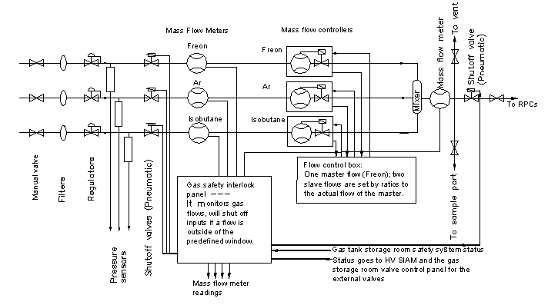
Figure 1. Block diagram to show the functionality of various components of the gas system.

A photo of the BaBar RPC/LST gas system is shown in figure 2. Certain redundancy is adopted in this design such as besides the mass flow controllers, which can set and display the actual flow rates for all three components, we add additional three gas flow meters to show the flow rates and control the shutoff valves in case of any one of the gases runs off the predefined flow rate range. As the long running experience shows that the gas controller can run into trouble at any time without any early sign. This design provides a quick diagnosis of the whole system.

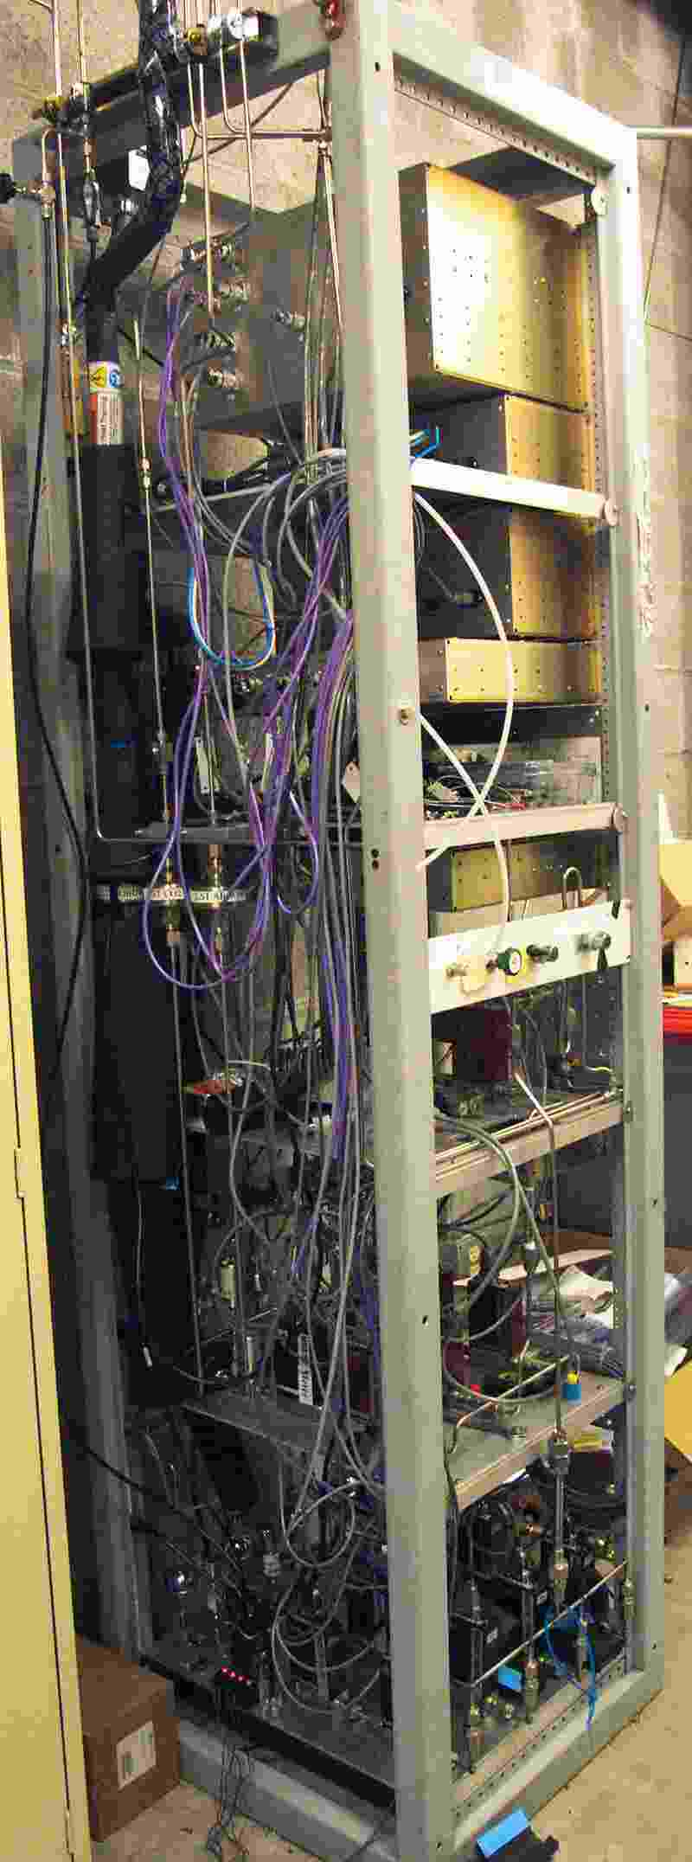
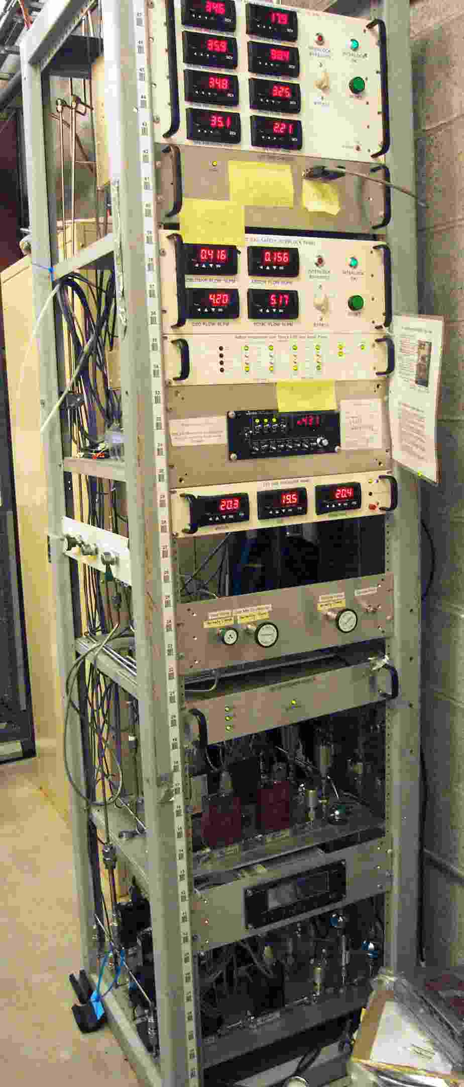
Figure 2. BaBar LST/avalanche RPC gas sytem photos, (a) Front view; (b) Side and rear view.
LST gas mixing panel
Avalanche RPC gas mixing panel
RPC(Ava.) flow meters/flow controllers
LST flow meters/flow controllers

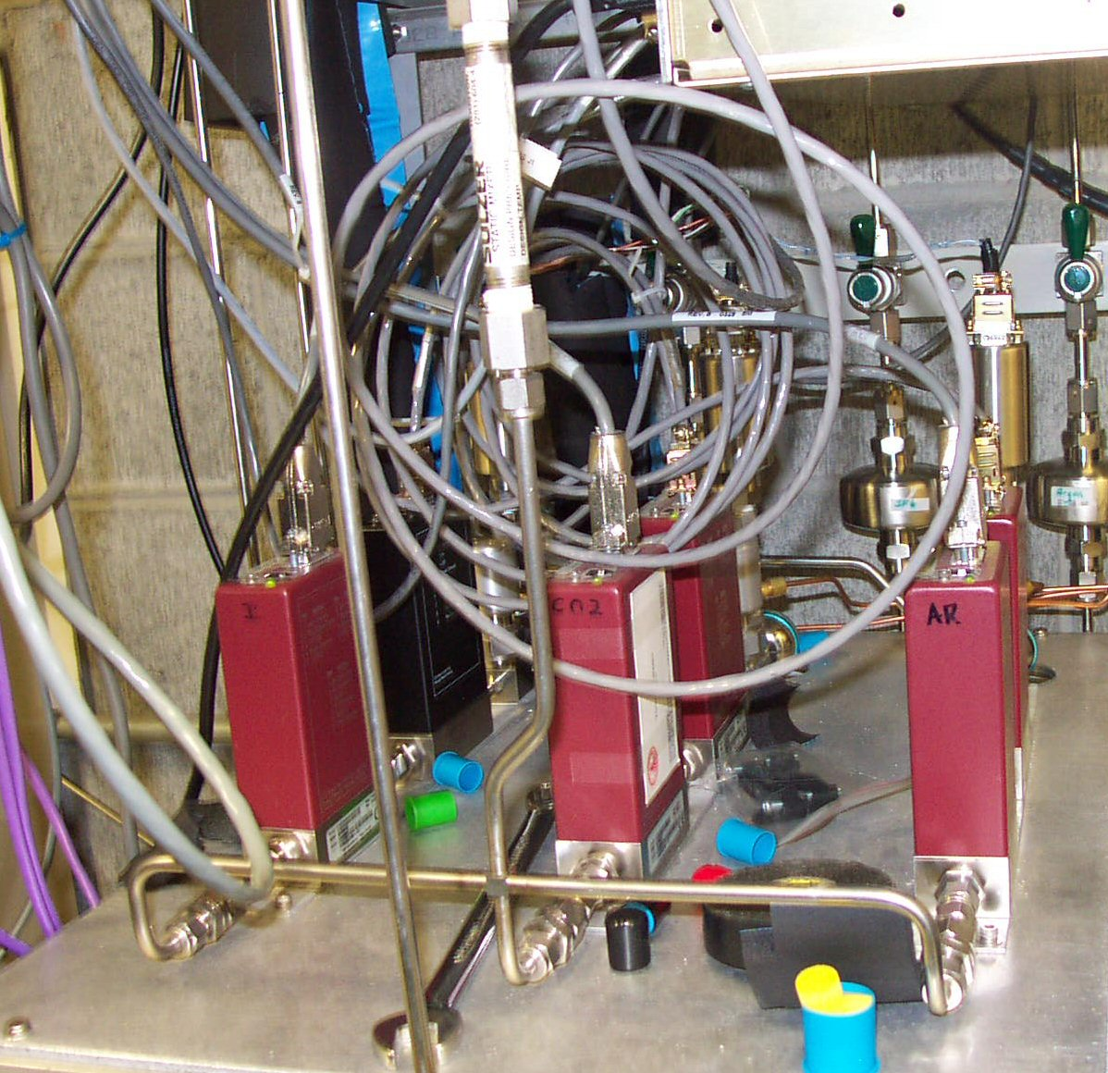
Flow meter
Flow controller
Pressure sensor
Gas mixer
Gas filter
Figure 3. Three components gas flow and control system.

The gas volume for the far hall and the near hall RPC systems are 2.88 mP^{3P}, 1.92 mP^{3P},P ^{P}respectively. We design identical gas system for far and near hall. Based on the far hall RPC’s gas volume and assuming the gas flow rate is set at 1 vol/day, if we use the gas mixture R134A/Ar/Isobutane (44/50/6%), three gas component’s flow rate should be set at 0.9, 1.0 and 0.12 SLM, respectively. The equivalent nitrogen flow rate should be rounded off to 3.0, 1.0 and 0.5 SLM, respectively.

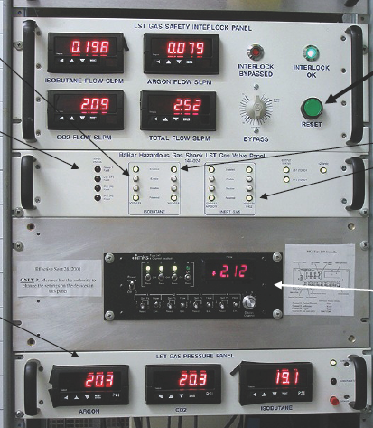
Figure 4. Main panels of gas flow control system.
(1)
(2)
(3)
(4)

Figure 4 shows four panels of the gas system. The top panel (1) is the gas safety interlock panel, it displays actual gas flow rates for three components and the mixture, it also shows interlock status. The circuit diagram is shown in Appendix (1). The second panel (2) is the exterior gas valve power control panel; this is connected to the Gas Shack safety rack. In case of gas shack alarm it closes the external valves. Its circuit diagram is shown in Appendix (2). The panel (3) is for the gas flow control box, it sets the gas flow rate and the mixing ratios for all three gases. Panel (4) is for the gas pressure monitor, it shows the gas pressure at the inlet side. It also monitors a pressure sensitive switch looking at the isobutane. This switch can turn off the system in case of too low isobutane pressure occurs. The circuit diagram is shown in Appendix (3).

Gas distribution system
When we design the gas distribution system we keep the following considerations in mind:
• Parallel connections preferred because the exhausted gas from a working RPC tends to be poisoned as it passes through an operating RPC;
• Large chamber count, ~ 840 2×2 mP^{2P} RPCs;
• Low cost/channel;
• On-line monitoring capability;
• Keep certain degree of redundancy to maintain highly safe operation;
• Gas might be exhausted to the detector hall directly just like BaBar RPC/LST.

For the BaBar LST/RPC the gas mixture, through long pipe, is transported to detector site. The gas distribution racks are located on the platform above the detector. Figure 5 shows the gas inlet distribution panel and outlet bubbler panel. We are proposing a similar design for Daya Bay RPC gas distribution system. This system can be located on the roof of each detector hall. To incorporate the movable roof design we only need to use a flexible gas pipe to connect the gas from fixed port on the wall to the gas inlet port on the roof.
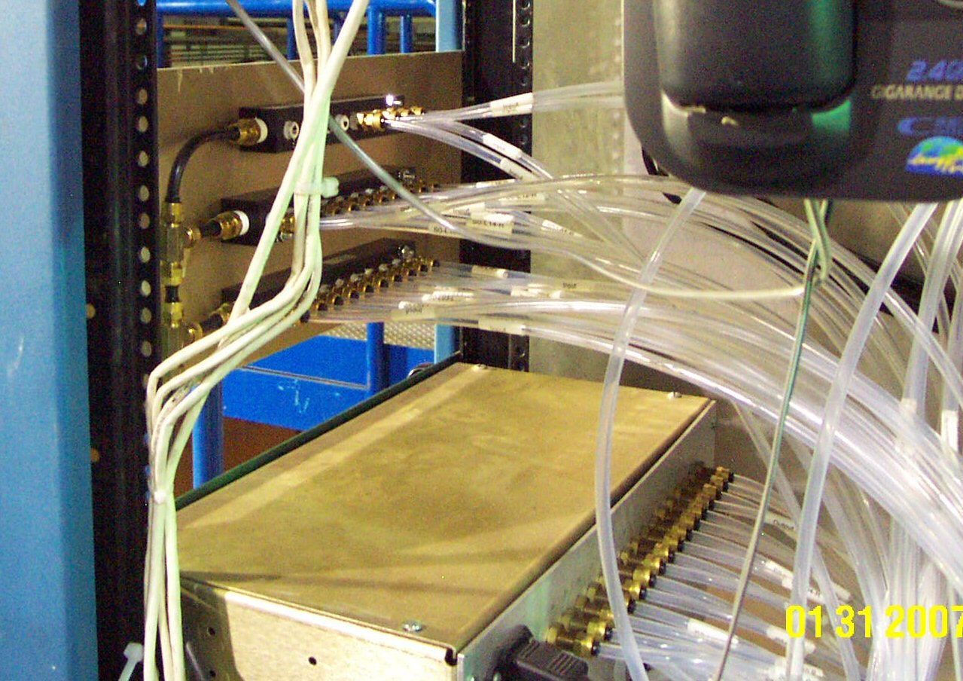
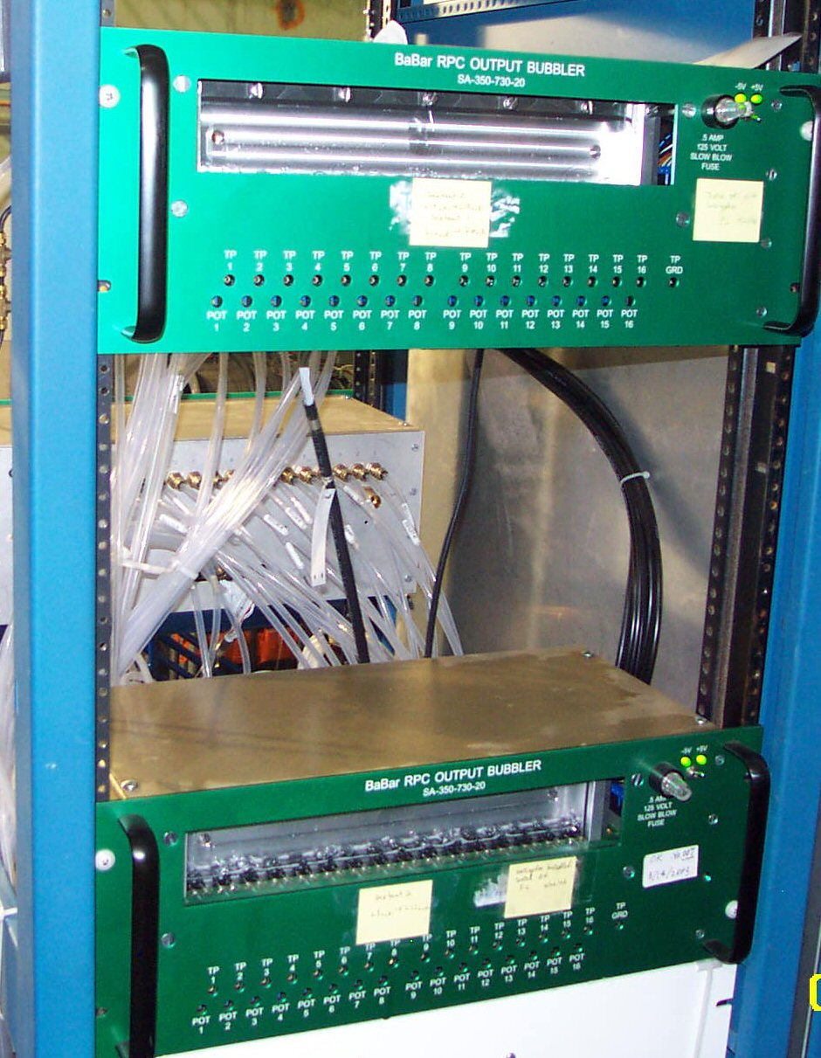
(A)
(B)

Figure 5. BaBar LST gas distribution system. (A) Inlet gas distribution branches; (B) Outlet digital gas bubblers.
Figure 6 shows a block diagram of the gas distribution system.

Electronic gas bubbling system
For a gas detector system the bubblers are always used at the output of the chambers. The digital gas bubbler can provide a quick diagnostic of gas flow on line; according to BaBar and Belle it turns out to be a very useful system. We are going to copy the digital bubbler design from Belle RPCTPPT. In this system the bubblers are instrumented with photogates, which are used to verify the flow rate. Its working principle is illustrated in figure 7. A photo of a real digital bubbler built by Princeton EP Lab is shown in figure 8.
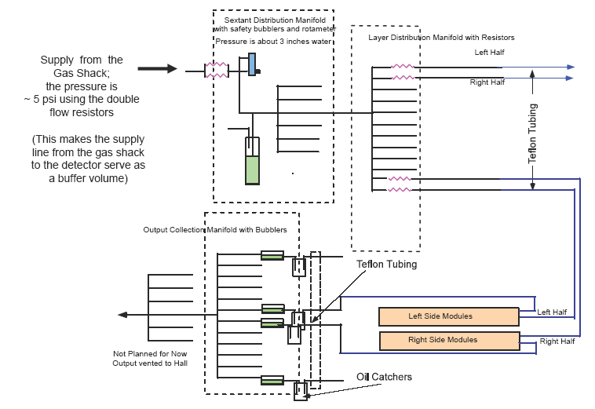
Figure 6. Block diagram of the gas distribution system.

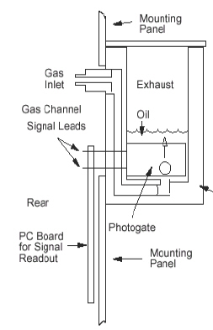
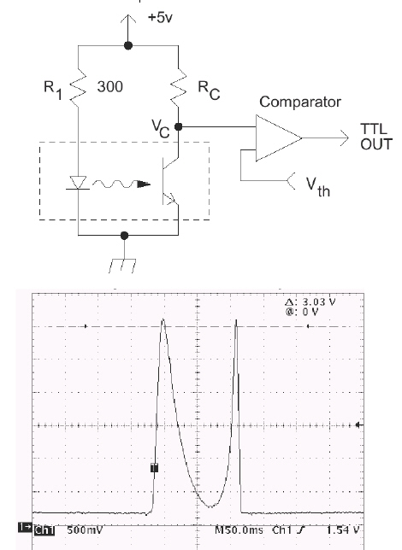
(A)
(B)
(C)
Figure 7. Electronics gas bubbler. (A) Mechanical structure of the bubbkler; (B) Circuit diagram of the photogate; (C) Output pulse of the digital bubbler.

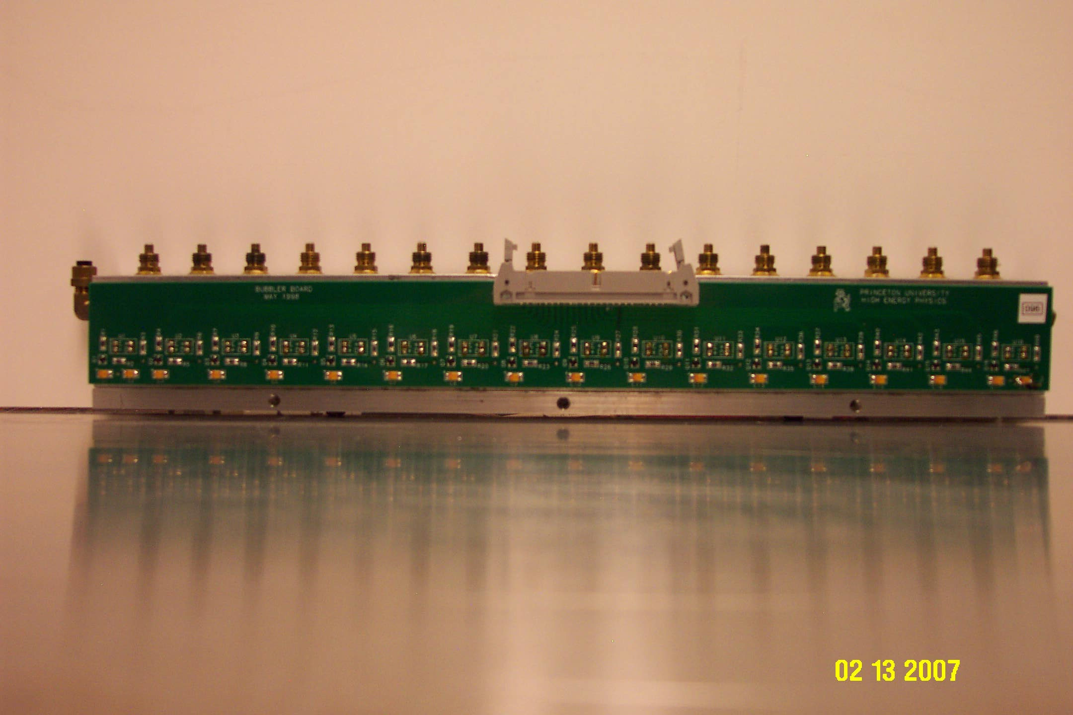
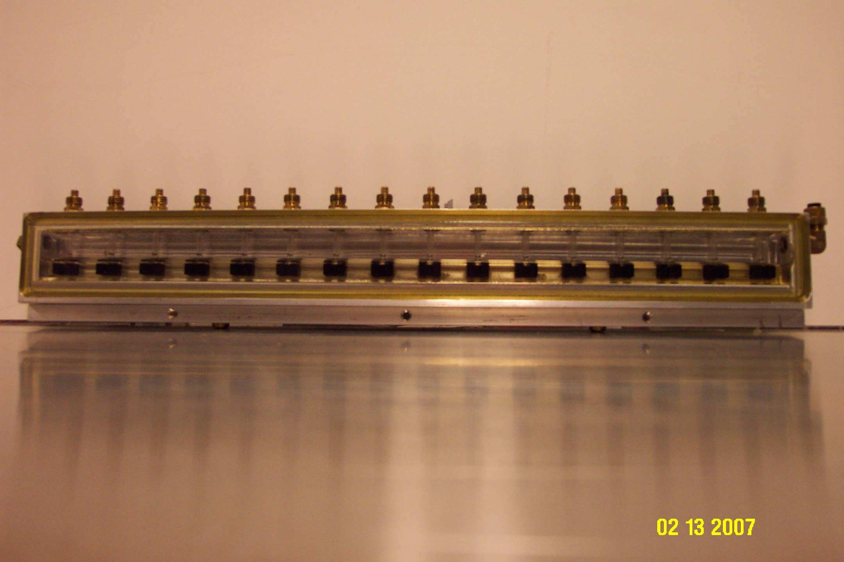
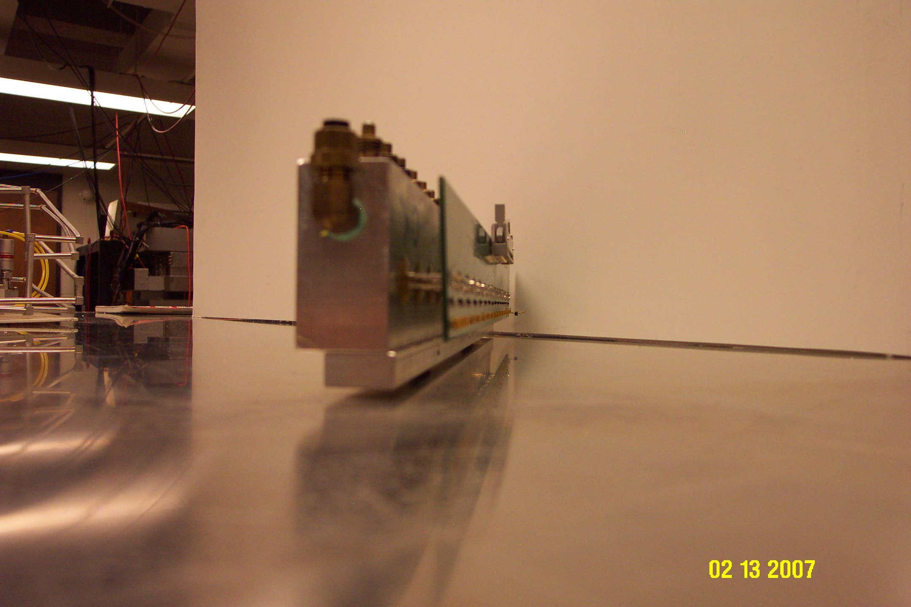
Figure 8. A real gas bubbler built by Princeton EP Lab, front, back and side view.

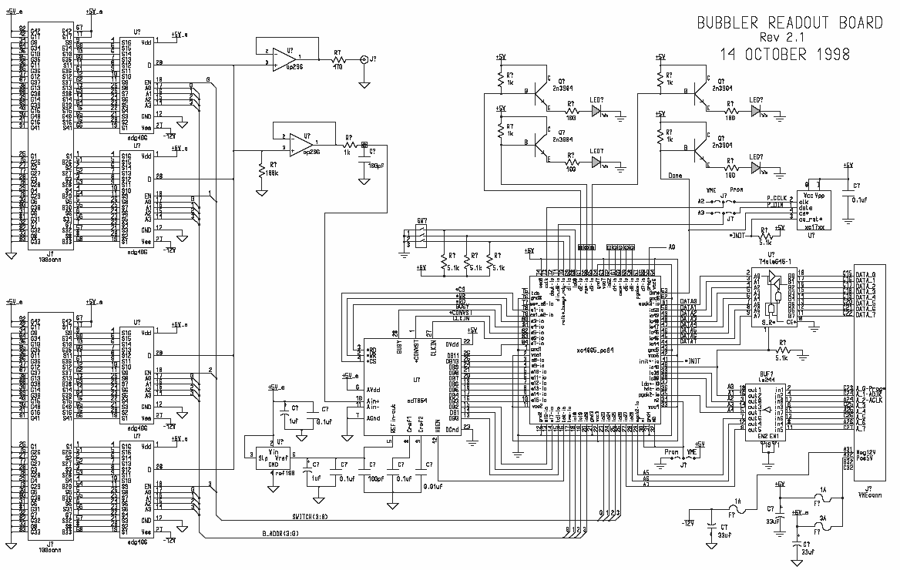
Without the gas bubble the light reaches the photogate through oil with no interrupt. When bubble passes, it will reflect partial light, and the light intensity at the sensor will be reduced that causes the current to drop, therefore produces a positive pulse. Bubble has been recorded as an electronic pulse. By counting the pulse rate, we’ll be able to monitor the gas flow rate. Belle uses the VME modules shown in figure 9 to count and record the bubble’s rate, each module has 64 channels that can used for 64 digital bubblers. In Daya Bay far hall we’ll have 360 2×2 mP^{2P} RPCs, if each RPC has its own bubbler, we need 6 VME modules. Near halls we’ll have 240 RPCs/each hall, 4 VME modules/each hall.
Figure 9. Digital bubbler's readout VME module.

- Hazardous Atmosphere Detection (HAD) System
Figure 10 shows the hazardous atmosphere detection system for BaBar, it also should be implemented for Daya Bay experiment.
All HAD sensors are connected to their display/controllers on the HAD control panel as shown in figure 10 (4).
(1)
BaBar uses VME Summary Interlock and Alarm Module (SIAM) as the interface of its gas safety hardware system to the slow control system. The SIAM is a VME compatible module which can generate an output signal (trip) based on the latched state of eight input conditions (faults). Several modules can be daisy-chained to form a larger set of input conditions. Detailed description of SIAM can be found from this linkT Uhttp://www.slac.stanford.edu/BFROOT/www/Detector/DAQ/Det_Cntrl_Monitor/siam/siam.htmlUT.

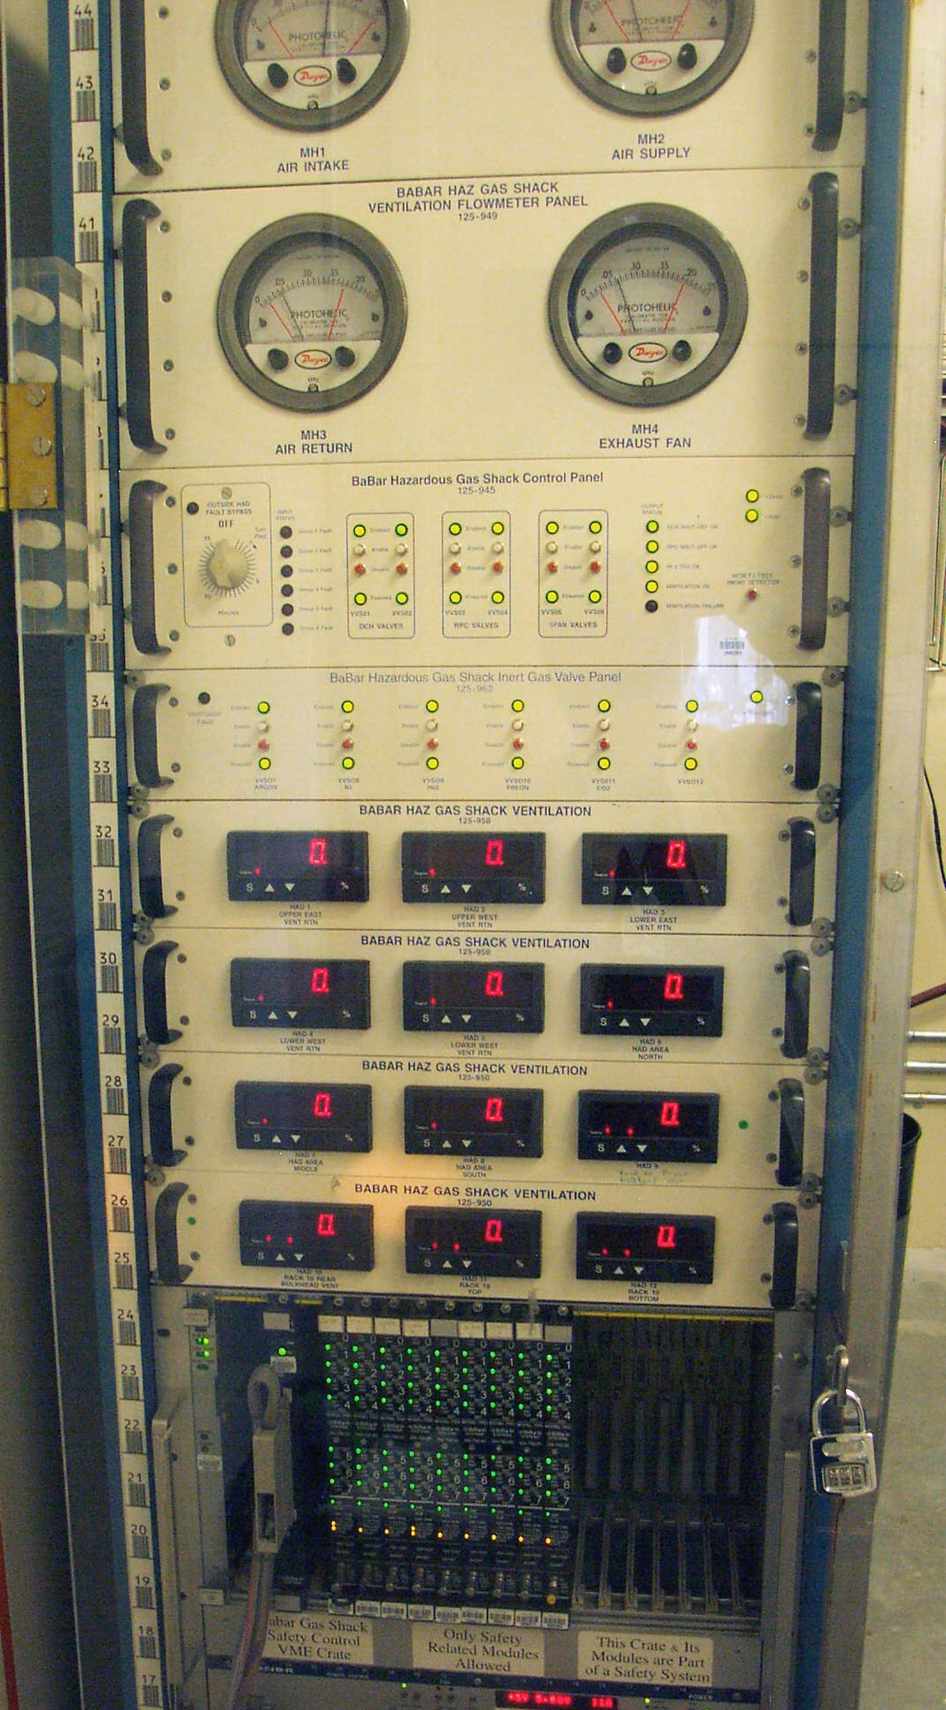
Figure 10. BaBar gas safety display/interlock panel.
(1) Ventilation flowmeter panel;
(2) Hazardous gas shack control panel ;
(3) Inert gas valve panel;
(4) HAD sensor display/control panels;
(5) SIAM modules.
(5)
(4)
(3)
(2)
(1)

(2)

(3)

(4)

Material cost estimation
An incomplete material cost estimation is listed in table 1. Main part of the material cost and part of labor cost without contingency are around $41,000.

- Some considerations for constructing the gas system
As we mentioned in section 2 any gas control unit can malfunction at any time without prewarning, our design should facilitate the system maintenance. My suggestions are:
  - Use VCR fitting for all interconnection on the gas system panels;
  - Keep the layout of the gas control components panel spacious;
  - Stock spare gas control units at any time;

- Integrated Gas System solution
We have researched a new gas system solution — Integrated Gas System (IGS) from Fujikin Inc. Actually in our lab there is a used IGS system that Kirk purchased from eBay sometimes ago. Its compact design, standardized building blocks, “surface mounting’ type of architecture makes maintenance very easy. Figure 11 shows an old used system in our lab. More information can be obtained at TUhttp://www.technofittings.com/pdf/igs/igsbroc.pdfUT.
We are also investigating Fujikin’s patented new type of gas flow control system (FCS), according to their literature this flow meter is based on different working principle. It is more stable, accurate and simple. More information can be found at TUhttp://www.fujikin.co.jp/fujikinHP_e/product/english/bin/712-01_FCS_eng.pdfUT.
Although these are very attractive option, but we still don’t know if they can be used for our application, and whether or not the cost fits Daya Bay’s budgetary situation. We have requested quotation and more technical information. More follow-ups are under the way.

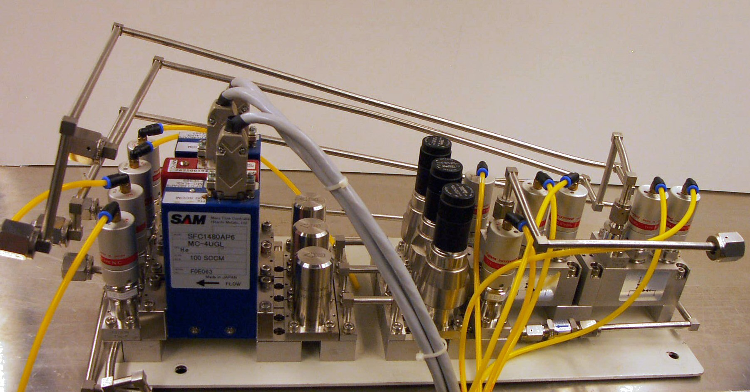
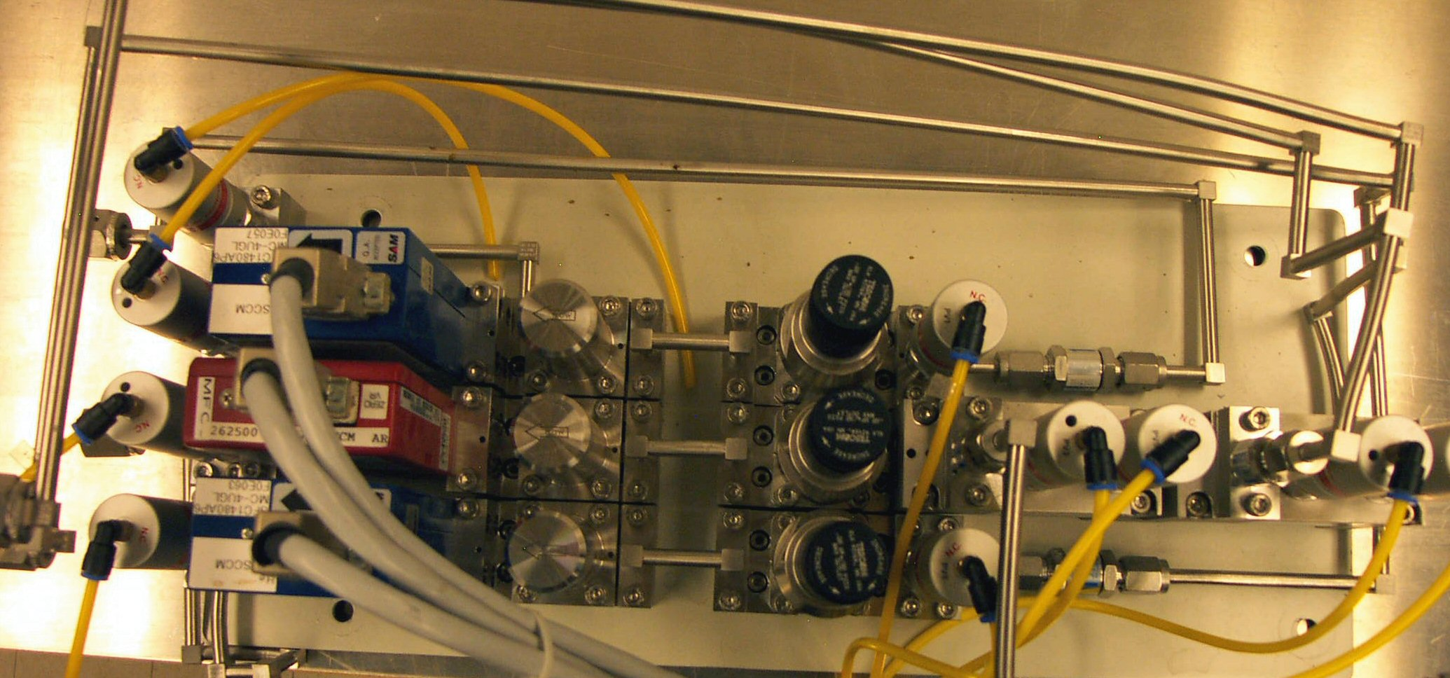
Figure 11. An old used Fujikin IGS system, (a) side view; (b) top view.

Table 1. Material and part of labor cost estimation (incomplete, very preliminary)

- Appendixes
    - RPC gas safety interlock box (AutoCAD file: RPC_SAFETYSK.dwk) circuit diagram is shown in figure A1.
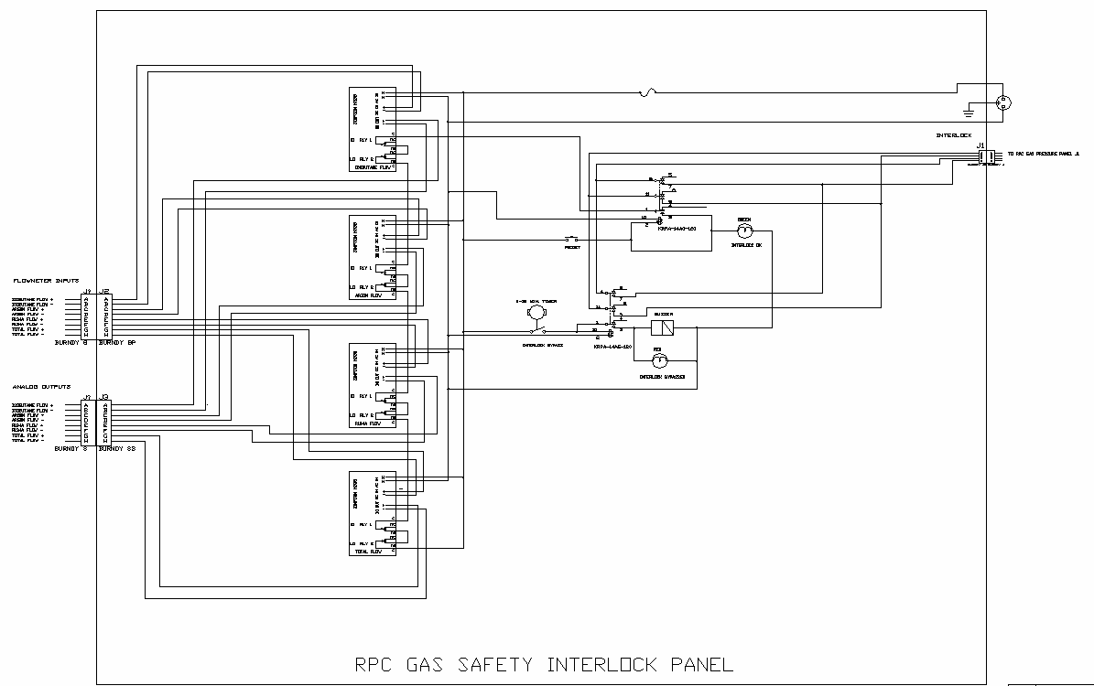
Figure A1. Circuit diagram of gas safety panel.

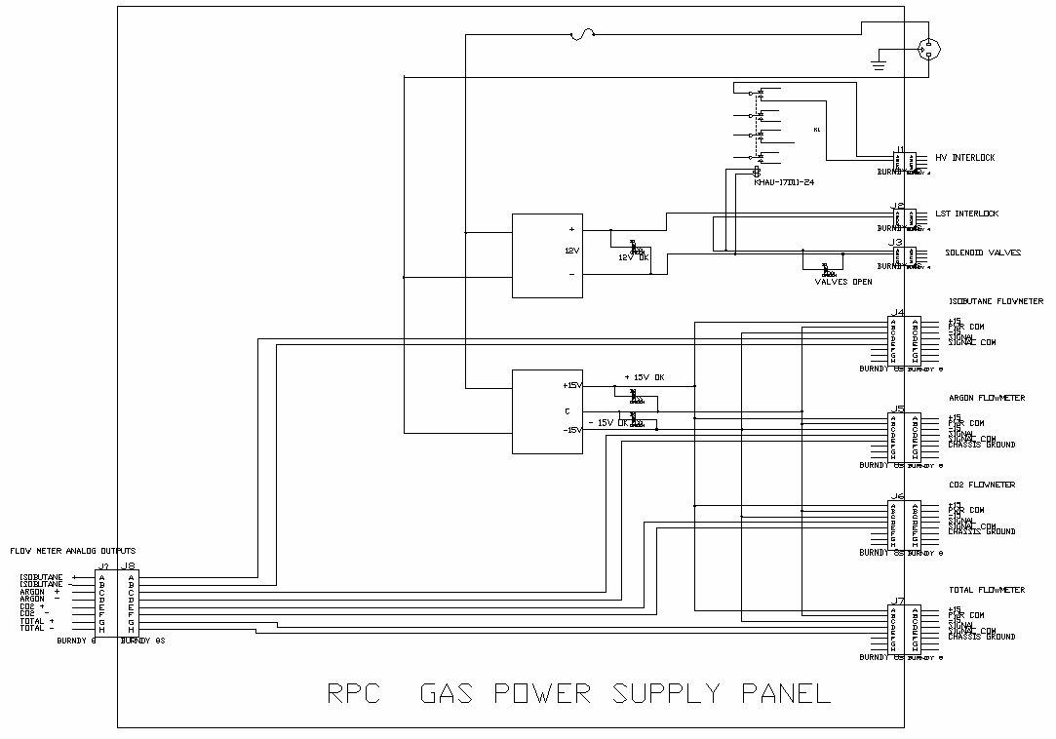
(2) Gas pressure gauge power control box (AutoCAD file: RPC_POWERSK.dwk) circuit diagram is shown in figure A2.
Figure A2. RPC gas power supply box.

- Gas pressure display box (AutoCAD file: RPC_PRESSURESK.dwk) circuit diagram is shown in figure A3.

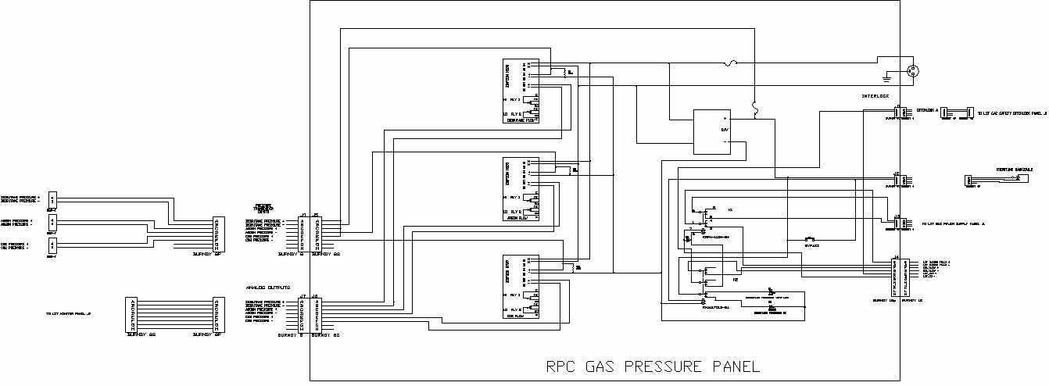
Figure A3. Gas pressure panel diagram.

TP?PT Daniel Marlow, “Glass Resistive Plate Chamber in the Belle Experiment”, Seminar at Rice University, July 9, 1999. TUhttp://wwwphy.princeton.edu/~marlow/talks/rice/rice.pdfUT .

