Daya Bay RPC gas system design report

C. Lu, Princeton University
(7/3/2007)

The RPC gas system will be similar to that used in the BELLE [1] and BABAR [2] experiments, in which a gas mixing systems distributes gas to the individual RPCs through simple “flow resistors”, with the output flow from each chamber separately monitored by a low-cost electronics bubbler [3]. A high-level diagram of the system is given in Fig. 1.
Mixing of the chamber gases is performed with mass flowmeters, as sketched in Fig. 2. It will be advantageous to use “drop-in” modular mixing components recently developed for the semiconductor processing industry, such as the Integrated Gas System of Fujikin [5].
The electronic bubbler system [3] monitors the chamber gas flow by counting gas bubbles in a small oil bubbler as they pass a photogate, as indicated in Fig. 3. Detailed histories of the input and output gas flow will be available via the online slow-control system. The gas will be input from multiple, switchable sources to minimize interruptions of the gas flow during
chamber operation. However, the gas flow rate will be only 1 volume per day, so that short interruptions of the flow will be of little consequence.
An extensive safety system with status monitors and interlocks will be implemented via the slow-control system. For a recent example of a muon-chamber-gas safety system, see [4].

- Major gas system parameters
Daya Bay neutrino experiment has three experimental halls, two near halls and one far hall. The near hall RPC system will cover an area of 12 x 18 m² with four layers of 1 x 2 m² RPC chambers, and the far hall will cover larger area of 18 x 18 m².
The basic design assumption is the normal gas flow rate at 1 volume change/day. When we choose the gas flow controllers we put the possible 3 times larger gas flow rate into consideration. The major gas system parameters are listed below:

Common to both near and far halls:
Number of RPCs/Gas branch N_{b} = 4,
Gas volume/branch V_{b} = 0.016 m³, 1 volume/day = 0.016/(3600*24) = 1.85*10⁻⁷ m³/sec,
RPC module size A_{m} = 4 m x 6 m,
Number of RPCs/module = 48,
Gas branches/module B_{m} = 12,
Number of branches/gas distribution panel = 16,

Far hall:
Total number of RPC = ~700,
Total gas volume = 2.8 m³,
Total number of modules (4 x 6 m²) in far hall = 3 x 5 = 15,
Total number of gas distribution panel = 12.

Near hall:
Total number of RPC/near hall = ~432,
Total gas volume/near hall = 1.73 m³,
Total number of modules/near hall = 3 x 3 = 9,
Total number of gas distribution panel/near hall = 7.
Total number of gas distribution panels for one far hall and two near halls is 12+14 = 26.

- Gas mixing system
The gas mixing system diagram is shown in fig. 1. We have incorporated the BaBar RPC/LST gas system experience and Daya Bay RPC system’s requirement to design our own gas system. We are still facing two possible options: conventional gas mixing system panel construction and a new breed of Integrated Gas System (IGS) solution. The finished system may look similar as shown in Fig. 2 for conventional panel and Fig. 3 for IGS panel.

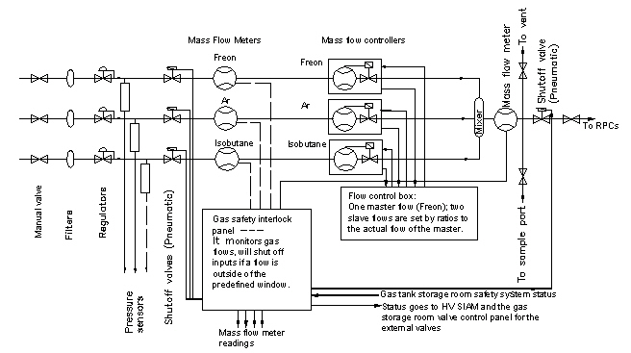

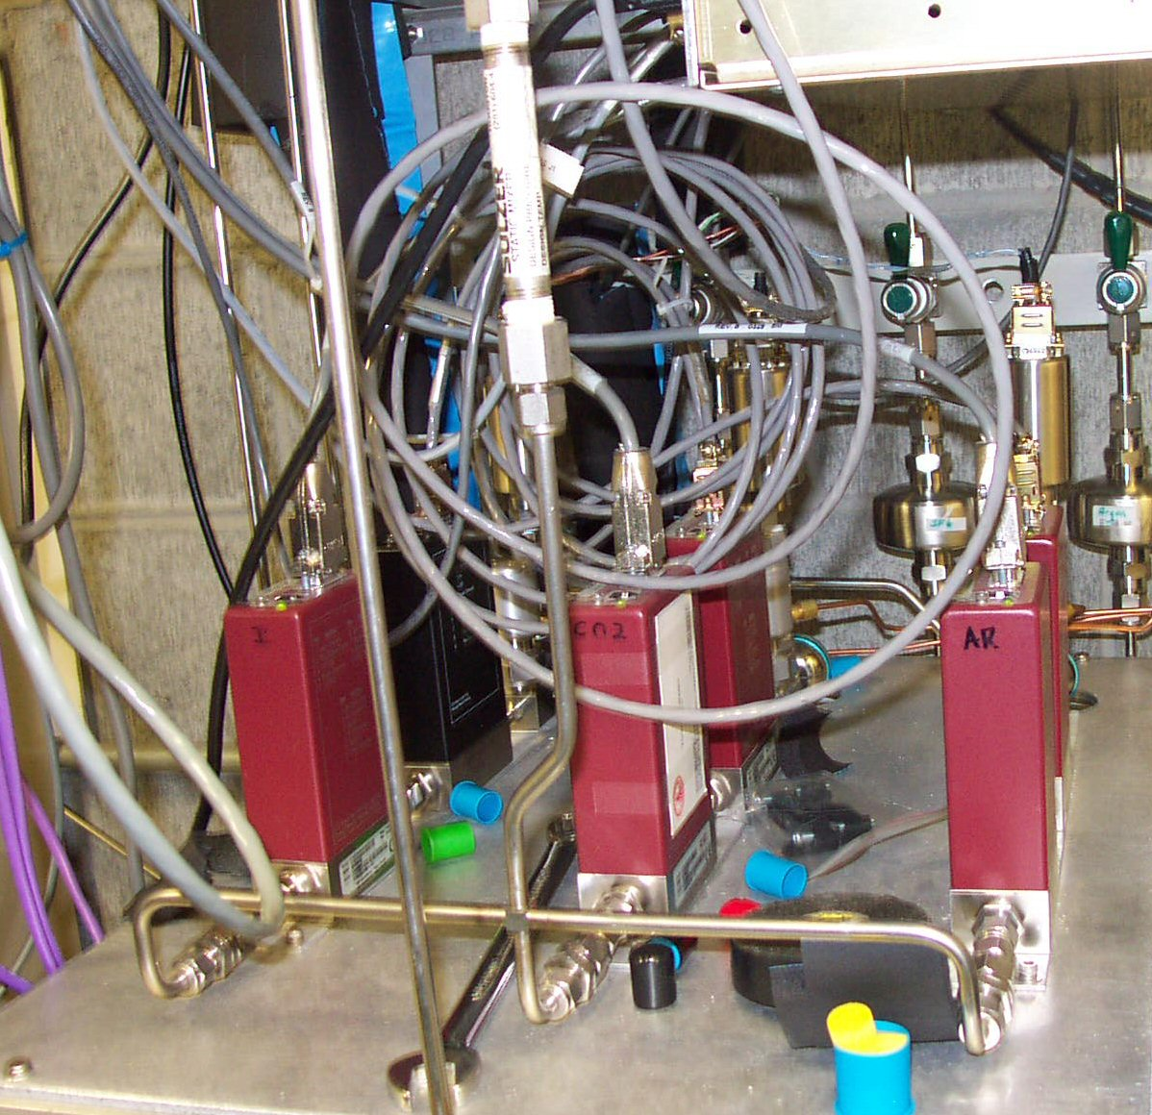
Figure 2. Conventional gas system panel.

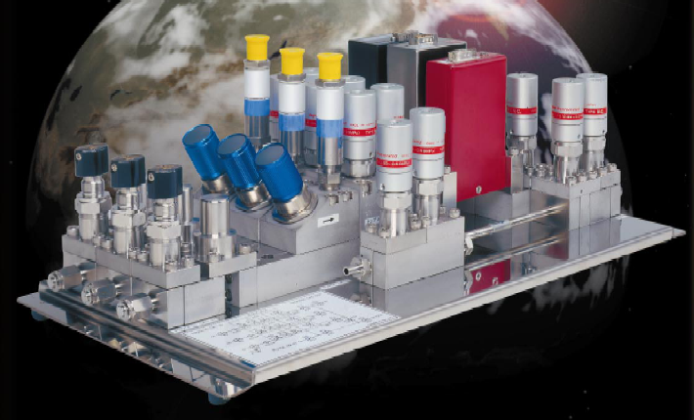
Figure 3. Gas system panel constructed with IGS technology.

Budget for gas mixing system
We list the material cost for one such mixing system in the Table 1. The labor cost is not included. To construct one of such system, the panel design and assemble need 100 hours of our machine shop. The main components for two construction options are the same. The additional cost for the standard building blocks needed in IGS is used to trade the labor cost and fittings in the conventional option. The overall cost should be more or less the same.
Table 1. Budget estimation for one gas mixing system with conventional building technology (labor cost not included).

- Gas distribution system
The gas mixture after the mixing system needs to be distributed to every RPC in an experimental hall. The design goal can be summarized as following:
- Uniformly distribute the gas mixture to every RPC in the system;
- Divide the entire RPC system into branches that should be isolated from each other. In case of one branch has leaky RPC the rest of the system should not be affected;
- The RPCs in the same branch are better to be in parallel, not in series, to prevent the poison gas produced in upper stream polluting the down stream chambers;
- At the end of each branch should implement a monitoring device to check if there is any leaky RPC.
A sketch diagram of the gas distribution system is shown in figure 4.
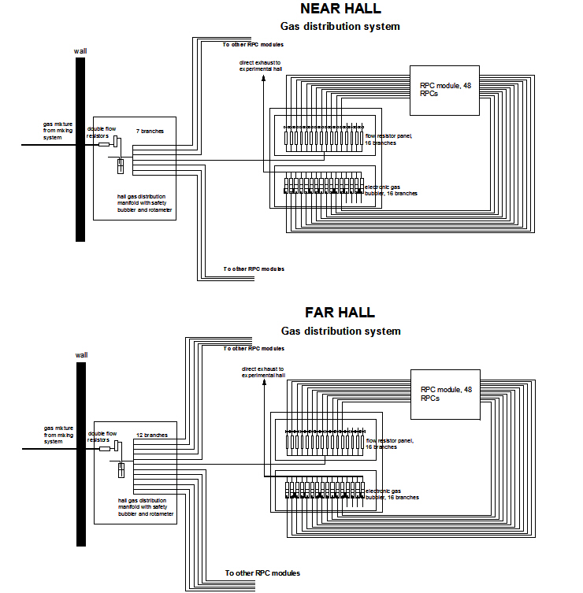
Figure 4. Daya Bay near and far hall RPC gas distribution system sketch diagram.

In far hall the main gas manifold provides 12 branches, each of which will come to a 16-channel flow resistors panel. A S.S. capillary with 0.01” diameter bore and 5cm length serves as flow resistor. Because the flow resistance of this capillary is much higher than the rest in the gas path, even there is a leaky RPC in the down stream, it will not affect the overall flow resistivity for this branch. 12 out of 16 flow resistors on the panel will be connected to an RPC module, which consists 48 RPCs. Each flow resistor provides gas mixture to 4 RPCs. To ease the gas tubing interconnection these 4 RPCs are connected in series. The gas outlet from this sub-branch will return to a digital bubbler panel, which is mounted on the same rack as flow resistor panel. The digital gas bubbler can count the rate of the output bubbles, therefore can record the returning gas flow rate. The detailed structure and circuit diagram of this digital gas bubbler can be found in [6].
In near hall the main gas manifold provides 7 branches. The rest of the system is just the same as far hall’s.
The double flow resistors in front of the gas manifold is used to keep the gas pressure in the input gas tubing higher, therefore the whole long tubing can be served as an input gas buffer.

Budget for gas distribution system
The construction of gas distribution system includes two main tasks: 1, Installation of gas transporting pipe from gas control room to the experimental hall, 2, manufacture of the flow resistor’s panels and digital bubbler’s panels.
According to the source loaded DB Integrated Schedule (see Appendix 3) the first task will be constructed by IHEP. The second task is Princeton’s responsibility. Main expense will be the labor cost. All parts need to be made at Princeton machine shop, and the whole system will be assembled at Princeton. Total we need to build 26 gas distribution panels, each of which includes one 16-channel flow resistor panel and one 16-channel digital bubbler panel.

- Hazardous Atmosphere Detection (HAD) System
We will use the same hazardous atmosphere detection system for BaBar as our Daya Bay safety system.
All HAD sensors are connected to their display/controllers on the HAD control panel as shown in figure 5 (4).
(1)
We use VME Summary Interlock and Alarm Module (SIAM) as the interface of its gas safety hardware system to the slow control system. The SIAM is a VME compatible module which can generate an output signal (trip) based on the latched state of eight input conditions (faults). Several modules can be daisy-chained to form a larger set of input conditions. Detailed description of SIAM can be found from this linkT Uhttp://www.slac.stanford.edu/BFROOT/www/Detector/DAQ/Det_Cntrl_Monitor/siam/siam.html
Since this gas safety system need involve the effort from several different institutions and subsystems, it is pending for the collaboration wide discussion.

- Slow control of the gas system

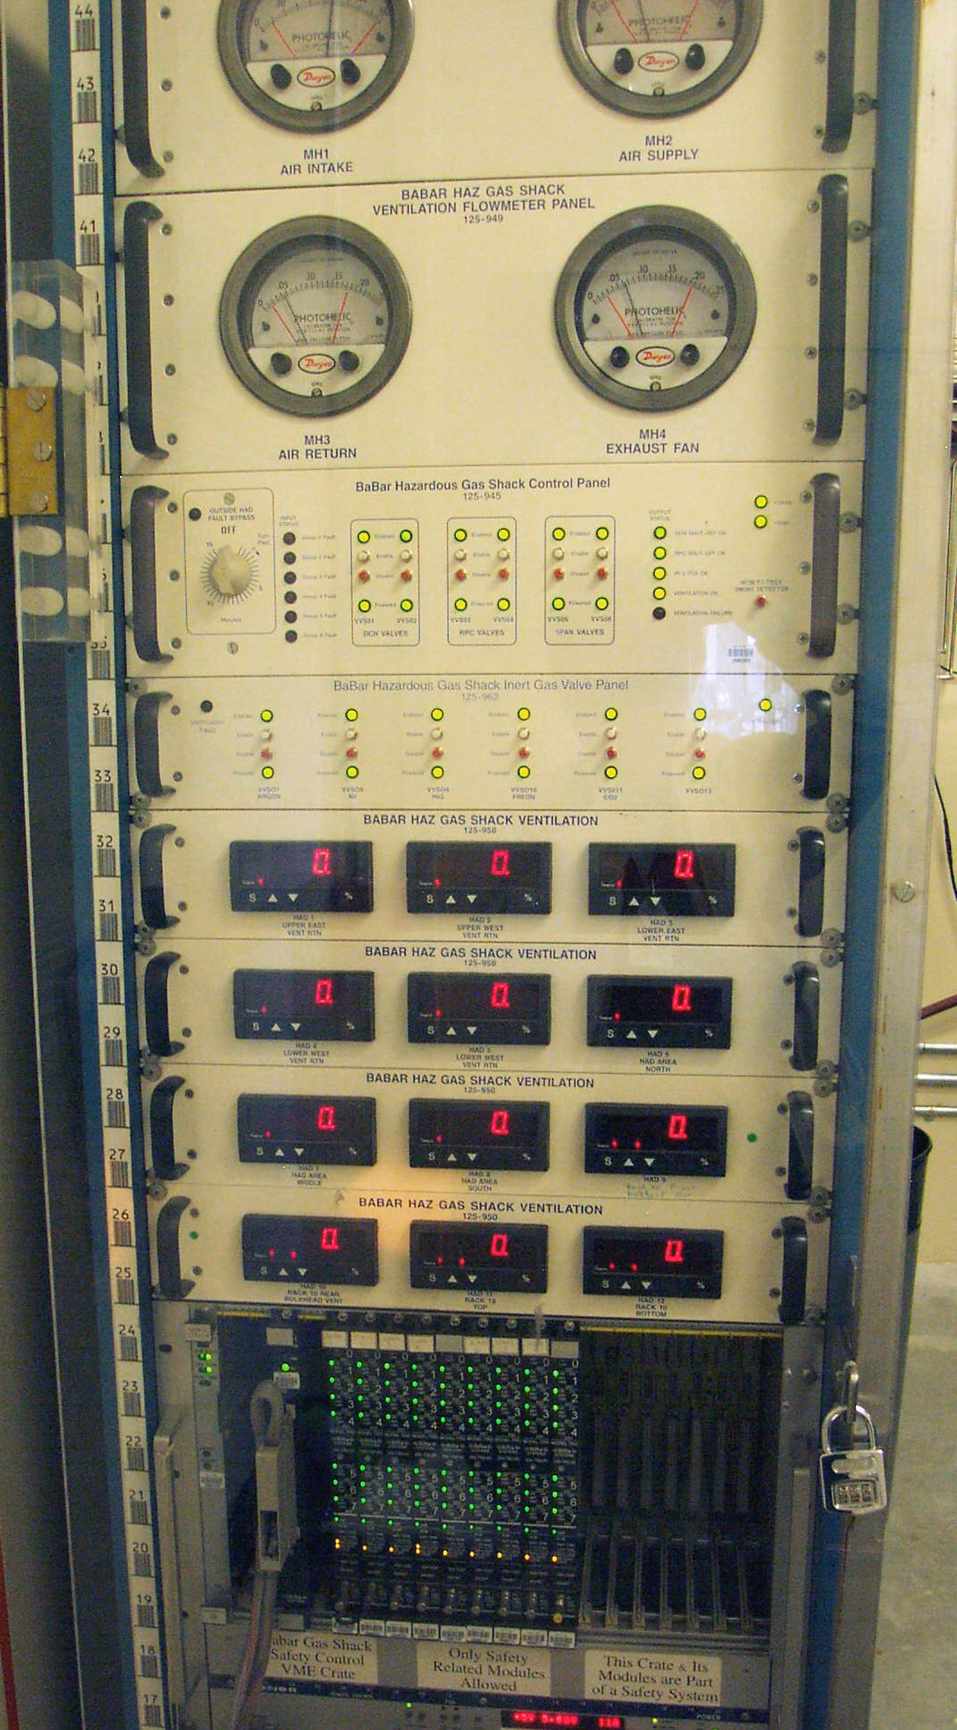
Figure 5. BaBar gas safety display/interlock panel.
(1) Ventilation flowmeter panel;
(2) Gas storage room hazardous gas control panel ;
(3) Inert gas valve panel;
(4) HAD sensor display/control panels;
(5) SIAM modules.
(5)
(4)
(3)
(2)
(1)

For the Daya Bay RPC detector we need slow control system for gas status monitor and on-line emergency control, HV monitor/control and on-line RPC performance. monitoring. Here we only consider the gas slow control part.
What need to be monitored and controlled for the RPC gas system?
  - Gas flow rate for three or four components and the total flow rate for the gas mixture;
  - Gas pressure at the gas supply end to avoid running out of the gas without noticed;
  - Ventilation air flow rate monitoring;
  - HAD sensors monitoring;
  - Gas tank storage room temperature monitoring.

References
(2)
(3)
(4)

1. A. Abashian et al., Nucl. Instr. Meth. A449, 112 (2000).
2. S. Foulkes et al., Gas system upgrade for the BaBar IFR detector at SLAC, Nucl. Instr. Meth. A 538, 801 (2005).
3. M. Ahart et al., Flow Control and Measurement for RPC Gases, Belle Note 135 (Aug. 26, 1996), http://wwwphy.princeton.edu/ ˜ marlow/rpc/gas/flow.ps
4. R. Messner, The LST Gas Mixing System(Oct. 4, 2004),
http://puhep1.princeton.edu/ ˜ mcdonald/dayabay/BaBar gas system/messner LST gas system.pdf
5. Fujikin Integrated Gas System Brochure, http://www.technofittings.com/pdf/igs/igsbroc.pdf
6. C. Lu, Proposal for making a prototype of the Daya Bay RPC gas system, DYB-doc-743-v3.

Appendix

1, Pressure drop in 10m long ¼” tubing
The general formula of gas flow (full developed laminar flow) Poiseuille's law:
Q=(p*D⁴/(128*µ))*(P1-P2)/L,
where
D (diameter of the tubing) = 0.17”=0.004318m, (1/4” OD tubing, 0.17” ID)
µ(viscosity of the air) = 1.85*10^(-5) (N*s/m^2), our gas mix may be different, but should in same order of magnitude,
P1-P2 = ∆P(N/m^2), pressure difference between gas inlet and outlet,
L (length of the tubing) = 10m, actually the flow resistance of the RPC system is mainly due to the long gas tubing, chamber itself has much larger cross section,
Q = 0.008m³/day (four 2m×1m RPCs in series, 1 volume change/day) = 9.2*10⁻⁸m³/sec,
thus
∆P=Q*L*128*µ /(p *D⁴) = 9.2*10^(-8)*10*128*1.85*10^-5/(3.1416*0.004318^4)
≅ 2N/m^2 = 2Pa = 0.2mm WC.

For the gas flow rate at 1 volume change per day for 4 RPCs it will produce ~0.2mm water overpressure inside the RPC due to the flow resistance of 10m long ¼” polyflo tubing, even ten times higher flow rate the overpressure would be only 2mm water. Therefore it should pose no any threat to the safety of RPC. In the case of rapid atmospheric pressure swing, 10% of atmospheric pressure/3hours, the additional flow rate due to the pressure swing is similar to the regular flow rate, so RPC should be quite safe in this situation.

2, Pressure drop in a flow resistor
If we use the capillary with 0.01” (2.54*10⁻⁴ m) bore diameter, 0.05 m length, the
pressure drop through the capillary:
∆P=Q*L*128*µ /(p *D⁴) = 1.85*10⁻⁷*.05*128*1.85*10⁻⁵/(3.1416*(2.54*10⁻⁴)⁴)
≅ 1675 N/m² = 1675 Pa = 1.68% of atm = 16.7 cm WC.
We can see that the pressure drop through a capillary is much higher than 10 m long ¼” tubing.

3, Source loaded DB Integrated Schedule (the gas system schedule)
