**Fast Timing R&D addressing high rate capable technologies using a single electron, 3 picosecond beam**

M. Chiu, BNL Physics

M. Diwan, BNL Physics

T. Tsang, BNL Instrumentation

S. White, BNL Physics (PI)

M. Fedurin, BNL ATF

V. Yakimenko, BNL ATF

K. McDonald, Princeton University

C. Williams, CERN and University of Bologna

j. Va’vra, SLAC (to be confirmed)

C. Royon, Saclay

H. Grabas, (PhD student), Saclay

D. Varga, Budapest

Summary:

We propose to implement what we have learned over the past year, while we were working collaboratively but informally with the ATF team, into a fully developed resource for studies requiring of order one 80 MeV electron per pulse.

Our focus, which is the original motivator for this work, is on characterizing novel detector technologies which specifically address the challenge of high resolution timing (~10-11 sec) at high rates (up to 10^7 Hertz) needed for future projects in high energy and nuclear physics. Our focus on high rates (and hence lifetime issues), where we start from the required specification of 10MHz, is unique in this field. The small bunch length (3 psec RMS) at ATF simplifies timing studies with these challenging requirements.

After characterizing components, which we now have in hand, we expect to spend part of our beam time (4-5 days) demonstrating their possible application in a specific project such as RHIC upgrades, eIC or ATLAS AFP.

The primary benefit output from this work will be several papers on advanced detector technologies by our group. Establishing this detector test facility is also likely to have a lasting impact since there is already interest by potential future users.

The main impact of this proposal on ATF resources, other than 3+10 days of beam time, is the expected participation of Misha Fedurin in codifying rules for optimizing this beam for future users and also we are likely to require limited help with vacuum installation and satisfying safety requirements from Karl Kusche. We are not requesting any additional funds or equipment.

Introduction:

Over the past year, tests at the ATF have demonstrated the feasibility of a single electron beam concept based on Hofstadter large angle scattering off a thin Beryllium target. Surprisingly, background rate from the beam, detected in APD based devices at distances of ~30 cm from the target are small when compared to the scattered electron signal in spite of the large (~10^9 electrons) primary beam intensity. The “target in” background, mostly due to ~MeV gamma rays, can be reduced to an acceptable level when Beryllium is used as the scattering target.

A number of applications motivated the development of this beam- notably the application as a calibration accelerator for LBNE and as a testbed for new ideas in high precision, high rate time-of-flight detectors now being discussed for use in RHIC upgrades, and the eIC as well as applications in outside facilities such as SuperBelle and the LHC. All are potentially important for the BNL lab mission.

The purpose of this proposal is to develop this beam concept into a useful facility through the focus on high performance time-of-flight development. We propose to evaluate a number of new technologies, now in hand, which are mostly APD based (various APD structures used directly as particle detectors and a hybrid APD to be used as a photodetector). A microchannel plate(MCP) detector is also being prepared.

This activity will bring this beam concept from its infant state into a reliable facility, which could be used for other research. It would also strongly make the case for this BNL-based proposal to the LBNE collaboration.

Time-of-Flight Detector Goals:

Much of current research on timing detectors with a goal of ~10-11 sec resolution in high energy or nuclear physics is focused on MCP photodetectors. The rate limitation of these devices (~0.1Coulomb/cm2 for 20% loss in quantum efficiency) is well known and is a major issue, even at SuperBelle. Progress in addressing this limit has been incremental and there is concern that one might never reach 10 MHz or even 1 MHz rate with lifetimes of order 1 year in a real detector application. A new hybrid APD (HAPD) device from Hamamatsu, which we possess, has been shown to achieve >250 Coulomb/cm2. Our laser based tests have also demonstrated 11 picosecond timing resolution for single photons.

In addition to the HAPD, we have studied the potential timing performance with several novel APD structures used as ionizing particle detectors. We find that even in a high rate application the time resolution of these detectors, dominated by radiation induced bulk leakage current, should allow one to build a 10 MHz detector of minimum ionizing particles with a time resolution of <10 picoseconds. We will also study the timing resolution of several new configurations of MCP photodetectors.

Additional Instrumentation:

Our tests have demonstrated <2.5 picosecond “start time” jitter using the standard ATF stripline beam pickup. These tests were done using a 20 GS/s Tektronix scope. We will install, as a permanent resource, 0.8 GHz, 5 GS/s single board, 4 channel waveform digitizers that we have been evaluating. These DRS4 single board scopes were first loaned to us by Henry Frisch and are now on order from PSI.

Beam Time:

We request 3 days of beam development time and 10 days of detector R&D. In some applications our tests will not interfere with other work in the same beamline at the ATF.

Below we address the specific requests for ATF proposals:

* *The names of the experimenters, their affiliation and designation of a Spokesperson for the experiment.*

The collaboration structure is organized around the 3 phases of our program:

1. final configuration of the single electron facility as a permanent resource for research at the ATF.
2. Characterization of novel devices now in hand at BNL
   1. Large area deep-depleted APDs from RMD
   2. Several geometry APDs from Hamamatsu and Perkin Elmer
   3. A pre-production hybrid APD (R-10467-U) from Hamamatsu
3. Tests of detector ideas targeted at applications such as sPHENIX and eIC

In addition we mention groups that have expressed an interest in making future supplemental proposals once our program is complete.

A core group, mostly local to BNL has developed the concept of this beam to the point that several tests have demonstrated single electron time-of-flight measurement with deep depleted APDs from Radiation Monitoring Devices as well as the Hybrid Avalanche Photodetector from Hamamatsu coupled to a quartz Cerenkov radiator.

This group will work with the ATF team to codify beam setup for the single electron beam optimizing machine backgrounds and targeting with the aim of producing something like a turnkey configuration. We will also study the stability of the, electrostatic pickup based, “start time signal” and determine the overall incoming electron time resolution. Currently we find 3 picosecond beam pulse width (using a streak camera or running linac rf phase "off-crest or "zero" crossing technique equivalent) and instrumental resolution of < 2 picoseconds.

The group will also contribute and install a permanent data acquisition system, based on the PSI designed DRS4, 4-channel waveform digitizer. We have demonstrated 1.6 picosecond electronic time resolution on similar waveforms. The facility, including the scattering chamber and the data acquisition system, could most likely remain in place when the ATF is being used for other projects. For some applications, where increased beam emittance is not an issue, the scattering target could even be inserted (it is remotely operated hydraulically) for parasitic running of the single electron beam.

The same core group will also be responsible for characterizing the devices which are now in hand.

The core collaboration consists of:

M. Chiu, M. Diwan,T. Tsang, S. White (PI), K. McDonald,M. Fedurin, V. Yakimenko, and H. Grabas

The expected required beam time for phases 1) and 2) is 3 days+ 5 days, recognizing that, except for beam setup, this whole project easily adapts to opportunities to use idle ATF beam time, as was shown during the past year.

During phase 3), for which we request another 5 days of beam time, specific configurations based on Cerenkov radiator designs and electronics which may be suited to a large detector system will be tested. The additional collaborators for phase 3), who are likely to spend more limited time at BNL are:

C. Williams, j. Va’vra(to be confirmed),C. Royon, D. Varga,

Groups now expressing interest in future supplementary proposal are, for example:

Levin, Daniel S. (1), Chapman, John W. (1),Weaverdyck, Curtis (1), Ball, Robert (1), Dai, Taisheng (1), Zhou, Bing (1), Friedman,Peter S. (2), Etzion, Erez (3), Ben Moshe, Meny (3), Benhammou, Yan (3), Silver, Yiftah(3), Beene, James (4), Varner, Robert L. (4), White, S. (5)

for plasma panel sensor testing.

And

T. Csorgo (Prof) [csorgo@rmki.kfki.hu](mailto:csorgo@rmki.kfki.hu)

D. Varga (PhD) [dezso.varga@cern.ch](mailto:dezso.varga@cern.ch) head of the RD51 group in Hungary

R. Vertesi (MSc) KFKI

+ 1-2 students to be named later

together with other members of the above collaboration for RHIC upgrade and eIC detector development.

* *The nature of the problem to be investigated and its scientific or technological impact on accelerator or beam physics.*

(see above introductory section. This project will primarily produce 1) a permanent unique beam facility at the ATF, 2) a series of publications on detectors for 10 psec time-of-flight measurement at rates up to 107Hz/ detector element. 3) a strong case for a BNL based proposal for LBNE calibration.)

* *A thorough study of how the experiment is to be done.*

Except for details discussed above the proposed experimental setup has already been installed and its impact on the ATF is understood. Below we illustrate the beam concept, including graphics relevant to its performance. We are likely to require limited help with vacuum installation and satisfying safety requirements from Karl Kusche, who has been helpful in the early stages.

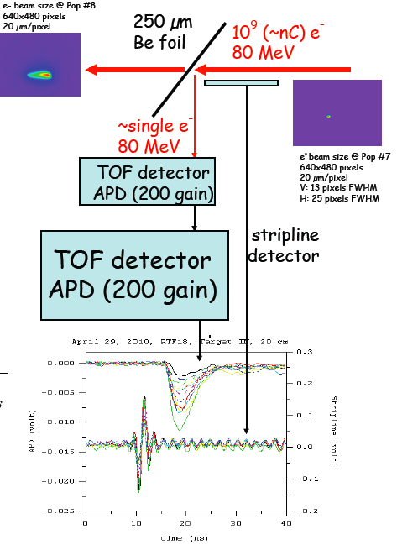

A photograph of the actual setup is shown below:

(note the target, in the inserted position tilted 45 deg. to the beam direction and the electrostatic pickup which has SMA connectors at the top, bottom and 2 sides, located to the right of the scattering chamber. An APD, under test, is located in the black tube just below the target.)

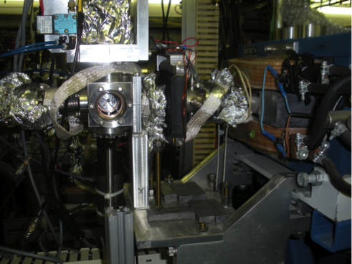

* *Estimate of the amount of beam time needed for the experiment.*

(discussed above: 3 days setup, 5 days device characterization, 5 days tests of system concepts). We would expect a gap in beam time of a few months between the 2nd and 3rd phases.

* *Suggested location on the ATF experimental floor.*

(the setup is currently located in beamline 3)

* *Discussion of the interference with existing equipment.*

(we are not aware of any interference)

* *Needs for equipment and/or manpower from the ATF.*

We would expect to interact mostly with M. Fedurin and V. Yakimenko during the beam setup phase and possibly more regularly with M. Fedurin during the data taking phases. It is not clear that we need to request additional equipment for the ATF.

* *Information on the student involvement.*

The expected student involvement is:

-Robi Vertesi, currently holding an MSc at Budapest and

-Herve Grabas is a student of Royon’s and is currently stationed in the US with Henry Frisch. Henry has encouraged us to work together.

-For the accelerator aspects, this project would be an excellent opportunity for a student in accelerator physics, who could use this as a starting point for developing a beam design for LBNE, for example.

* *Discussion of the ability of the proposing group to carry out the research (including manpower and funding).*

We’ve already shown we can do it with the core collaboration. Funding for Robi or Dezsa’s travel needs to be discussed but will probably be limited to 1 or 2 trips in any case. Construction funding for detector concepts will be requested from within the relevant collaborations (PHENIX, Super-B, AFP, for example if needed).