Request for Project Funding from the RD51 Common Fund   
- Date: *20-05-2014*

**Title of project:** Fast Timing for High-Rate Environments: A Micromegas Solution **Contact persons:** *Sebastian White (co-PI),CERN/ Rockefeller sebastian.white@cern.ch*

*Ioannis Giomataris (co-PI), Saclay [ioa@hep.saclay.cea.fr](mailto:ioa@hep.saclay.cea.fr)*

**RD51 Institutes: 1.** *IRFU-Saclay, contact person Ioannis Giomataris* [*ioa@hep.saclay.cea.fr*](mailto:ioa@hep.saclay.cea.fr)

*+* Alan Peyaud, Eric Delagnes

**2*.*** *NCSR Demokritos, contact person George Fanourakis* [*gfan@inp.demokritos.gr*](mailto:gfan@inp.demokritos.gr)

**3*.*** *CERN, contact Leszek Ropelewsky Leszek.Ropelewski@cern.ch*

*+Sebastian White [swhite@rockefeller.edu](mailto:swhite@rockefeller.edu)*

*+* Eraldo Oliveri and Filippo Resnati

*+RD51&Uludag University, Rob Veenhof* [*veenhof@mail.cern.ch*](mailto:veenhof@mail.cern.ch)

**4.** *Universidad deZaragoza, Diego González Díaz*

*diegogon@unizar.es*

**Ext. Collaborators:****1***. Rockefeller/FNAL, contact person Sebastian White* [*swhite@rockefeller.edu*](mailto:swhite@rockefeller.edu)

**2.** *Princeton University, contact person K.T. McDonald,* [*kirkmcd@princeton.edu*](mailto:kirkmcd@princeton.edu)

*+ Changguo Lu*

**Request to RD51:** *14’500 €*

**Total project cost:** 39*’000 €*

**Abstract**:

The current state of the art in fast timing for existing experiments is of the order of 100 picosec[1-2] on the time of arrival of both charged particles and electromagnetic showers. Current R&D on charged particle timing is approaching the level of 10 picosec [1] but is not primarily directed at sustained performance at high rates and under high radiation (as would be needed for HL-LHC pileup mitigation). The purpose of this proposal is to demonstrate this level of performance based on a Micromegas photomultiplier with Cerenkov-radiator front window producing sufficient UV photons to convert the 100-picosec single-photoelectron jitter into an incident particle timing response of order 10 picosec. This proposal requests funding to build and test a demonstrator yielding 100 ps single photoelectron jitter, and for follow-up tests as a time of flight (TOF) detector in a charged-particle beam.

**Project description**:

Modern photo-lithographic technology has enabled a series of inventions of novel Micro Pattern Gaseous Detector (MPGD) concepts: Micro-Strip Gas Chamber (MSGC), Gas Electron Multiplier (GEM), Micro-mesh gaseous structure (Micromegas) and many others revolutionizing cell size limits for many gas detector applications. The Micromegas concept fulfills the needs of high-luminosity particle physics experiments, and compared to classical gas counters these detectors offer intrinsic high rate capability, excellent spatial resolution and excellent time resolution [3-4].

In typical gaseous detectors the time resolution is of the order of a several ns because of the time jitter of primary ionization (for high energy MIPs) in the 3-mm-drift gap. The strategy to improve the time resolution is to detect fast signals induced by UV Cherenkov light emitted in a 5-mm MgF2 crystal. A thin CsI photocathode is deposited in the micromesh (reflective mode) or in the drift electrode (transmission mode) as shown in Fig. 1 and it is used to convert UV photons to electrons. The time spread of the Cherenkov light (~15 picosec) is too small to limit the projected time accuracy.

photon

electron

insulator

anode

micromesh

photocathode

avalanche

crystal

photon

electron

insulator

anode

micromesh

photocathode

avalanche

crystal

preamplification

**Figure 1:** a) Principle of the reflective photocathode mode, a thin CsI layer is deposited on top of the micromesh; b) CsI is deposited on the bottom surface of the UV crystal, defining a drift gap with the micromesh

In the transmission mode the photocathode is deposited in the bottom face of the MgF2 crystal at a distance of the micromesh of about 100-300 m to limit longitudinal diffusion. Our calculations show that both configurations will allow reaching our goal: a time resolution of better than 100 ps for single photoelectrons. Therefore in the full system where several tens of photoelectrons will be produced we could reach a time resolution of the order of 10-20 ps.

A simulation was carried out to investigate the transmission mode (the reflective mode will be also simulated). Results are shown in Fig. 2 where the longitudinal time jitter in 1-cm drift gap is plotted as function of the drift field for several gas mixtures. The best result is achieved in pure CF4: 350 picosec for 5 kV/cm drift field. Using a 100 m drift gap will provide a time resolution of 35 picosec, a very competitive performance. Using other gas mixtures (such as CF4 in neon or pure CH4) the resolution is degraded by a factor of two but still is within our performance goal. Notice that a double amplification could also be performed: a first preamplification in the small drift gap (by increasing the drift field to ~50kV/cm) followed by the final amplification in the Micromegas gap. Earlier investigations have shown a further improvement of a factor of two in this configuration.

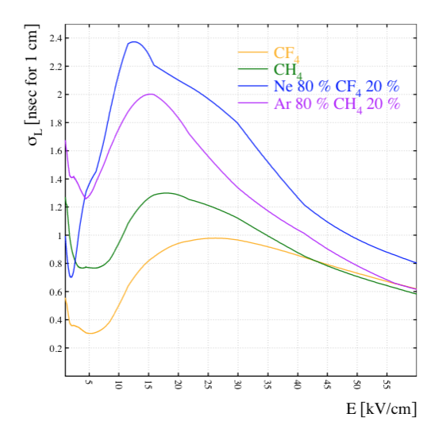

**Figure 2:** The longitudinal time jitter in 1-cm drift gap as function of the drift field for several gas mixtures.

*Proposed geometry of the demonstrator*

A first prototype detector will be constructed (Fig. 3) to demonstrate that time resolution for single photons of the order of 100 picosec can be achieved. The detector will be specially designed for operation in both semi-transparent and reflective mode.

The Micromegas will be constructed using the Microbulk technology [3]. A single-anode, 1cm2 Microbulk detector will be fabricated on a larger Kapton foil (∅ 3 cm). A Kapton ring with a thickness of 200 μm will to be used to support the MgF2 crystal on which the photocathode will be deposited. The ring will be metalized on the top surface, so that it can be used as a contact which for the polarization voltage to the photocathode, where a thin (3 nm) Al layer will be deposited on the MgF2 crystal before the CsI.

The assembly Micromegas-crystal will be encased in a stainless-steel chamber. A quartz window, transparent to the UV laser, will be mounted on the top surface of the chamber.

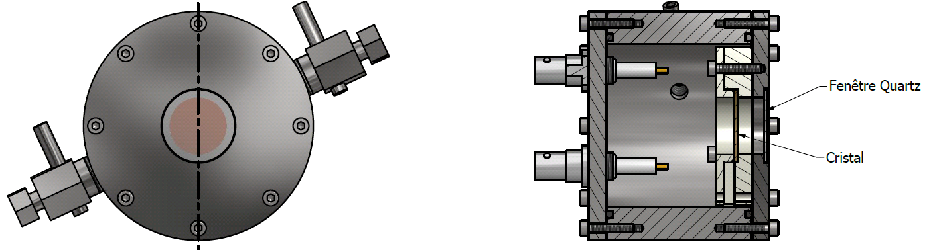

**Figure 3:** Engineering drawing of the proposed chamber

Replacing the MgF2 with a BaF2 crystal and placing an α source inside the chamber will allow us to observe fast scintillation light, while the same chamber could be installed in charged particle beam for a full scale test.

The detector will be characterized at the Saclay Laser-matter Interaction Center (SLIC), which includes four intense femtosecond lasers and a large suite of experimental endstations to study ultrafast phenomena and laser-matter interaction at high intensity. Research carried out at SLIC encompasses a broad spectrum of areas: development and applications of intense coherent femtosecond/attosecond XUV sources, laser driven particle acceleration, laser-solid interaction at high intensity, femtochemistry and femtobiology are typical examples. In particular, we are planning to characterize our detector with the FLUME set-up at frequencies ranging from 1 to 76 MHz at 267 nm wavelength and a focalization of 10 µm.

The Microbulks will be produced with an innovative technique, which includes plasma etching of the Kapton instead of the chemical one. This new technic is expected to be more precise than the traditional one, allowing better uniformity, which will lead to larger surface detectors, which was not possible with the present technology.

The development of resistive Micromegas has made those detectors more resistant to sparks, so, more appropriate for high particle flux environments. We plan to develop an innovative technology using Kapton-diamond foils in order to produce resistive Microbulks and study the effect of the resistive foil on the time resolution.

The detector chamber has to be constructed for operating without gas circulation, in order to facilitate the tests in the IRAMIS laser facility, but also to achieve a long lifetime for the photocathode. A modified chamber can be constructed in a second phase, in order to support multi channel readout.

Special electronics are needed in order to achieve the desired time resolution. This includes fast amplifiers with low impedance (<50 Ohm) to achieve risetime of the order of 1ns and fast acquisition system (≥ 4GHz ADC) with small time jitter (≤ 25 ps). Single channel amplifiers will be developed in a first phase, while the possibility to produce multi-channel boards will be also investigated. As a fall-back solution, 250 spare channels (preamp+TDC+DAQ) used for timing RPCs (40 ps jitter) could be made available by one of the partners (UZ).

The choice of Micromegas photodetector scheme is motivated by earlier promising results obtained with a UV-sensitive CsI photocathode, and also the ability to fabricate low cost CsI detectors using industrial processes [2]. These detectors provide high gain due to the suppression of photon feedback, which is very effective especially in the reflective mode case. A particular advantage of Micromegas, compared to other gaseous detectors, is its good energy resolution giving a well peaked single-electron distribution. The benefit is that high single-photon efficiency could be achieved at moderate gas gains: Figure 4 shows pulse height distribution from single photoelectron in Ne + 10% ethane; a clear separation from the pedestal is observed.

The time distribution was first investigated by using a CsI photocathode deposited on the micromesh, with a UV hydrogen flash lamp as photon source. A time jitter with standard deviation of 680 ps was measured [4], as shown in Figure 5.

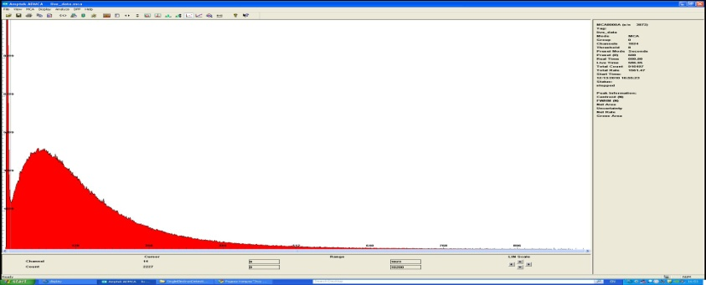

**Figure 4:** Micromegas response to single UV photons in reflection mode.

The time resolution was dominated by the UV lamp time jitter so it is an upper limit. Later on we measured 350 picosec rms timing with single photoelectrons and a pulsed nitrogen laser. This unpublished result was quite promising and again it is an upper limit since it was still dominated by the time jitter of the nitrogen laser.

We are planning to demonstrate the principle of the very fast photodetector scheme by the end of this year using a fs (or ps) laser. As discussed before, contacts have been taken with SLIC (IRAMIS-Saclay). We started discussing the possible collaboration and the installation of our detector prototype in this facility. We hope to be able to start first tests this summer.

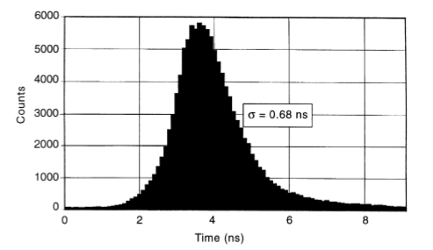

**Figure 5:** Measured time resolution for single photoelectrons in the reflection mode, using a flash deuterium UV lamp.

In summary we are proposing to test a fast Micromegas photodetector using a CsI photocathode. The reasons for choosing the Micromegas technology are four fold:

1. The Micromegas responds very well to a single electron signal, both in neon- and helium-based gases, it is compatible with CF4, behaving well at a very large gain.
2. High-gain can be achieved in a single-stage Micromegas, while double amplification can be used to reach even higher gains;
3. Micromegas detectors can be manufactured with much higher purity process and therefore a long-term poisoning of the photocathode is less likely.
4. A strong ion-backflow suppression can be achieved with Micromegas detectors, which is key point to avoid photocathode deterioration.
5. Fast current induced by the electron-multiplication process could provide fast pulses of rise time less than 1 ns, a key point to obtain time resolution of better than 100 ps in single electron signal mode

In parallel we will study other important issues:

* Design and fabrication of a full sealed system with UV radiator crystal, CsI photocathode and Micromegas detector.
* High-rate capability and ageing.
* Scaling for LHC future applications.
* Electronic chip adequate for these applications.
* Reduction of the capacity of the detector (pixel size-segmented mesh).

*References*

[1] Crispin Williams et al., Nucl.Instrum.Meth. A594 (2008) p.39-43.

[2] see eg.H. de La Torre Perez presentation CHEF 2013

https://indico.in2p3.fr/conferenceOtherViews.py?confId=7691&view=standard

and S. White “Very Forward Calorimetry at the LHC-Recent Results from ATLAS”

http://xxx.tau.ac.il/abs/1101.2889

[3] Y. Giomataris, P. Rebourgeard, J.P. Robert , Georges Charpak, Nucl..Instrum..Meth. A376 (1996) 29.

[4] I. Giomataris, Nuclear Instruments and Methods A419 (1998) 239.

[5] S. Andriamonje et al., JINST 5 (2010) P02001

[6] J. Derre, Y. Giomataris, P. Rebourgeard, H. Zaccone, J.P. Perroud, Georges Charpak, Nucl. Instrum. Meth. A449 (2000) 314.

**Importance and potential benefits of the project for the RD51 /MPGD Community**

If the goal of this project is achieved it will be demonstrated that detectors based on Micromegas technology can reach time resolution of the order of few tens of ps. This would be the first MPGD capable of reaching this fast timing. Being also a gaseous detector suitable for high rate applications, with an already illustrated scalability (ATLAS-NSW project) it would make it a good candidate for the upgrades foreseen for the phase II of the LHC

In parallel, this R&D develops the proposed Micromegas photodetector concept. The good localization properties and the relatively low cost of the detector make this instrument an excellent tool for UV light detection over a broad field of applications in basic and applied research. The study could be extended to other types of photocathodes with sensitivity in the visible region. One example of application is the RICH detector. The advantage of Micromegas is that very large area can be produced easily and that they can be operated in high magnetic field. In the medical imaging sector, these detectors could be used for PET applications where excellent time resolutions are needed and their insensitivity to external magnetic fields would be of value.

It is relevant to note that Hamamatsu is developing a visible photodetector based on Micromegas with preamplification using a Microchannel plate (MCP) and a bialkali photocathode.

**Timescale**

|  |  |  |  |  |  |  |  |  |
| --- | --- | --- | --- | --- | --- | --- | --- | --- |
| **Workpackage** | **Triemester (1-8)** | | | | | | | |
| **WP1: Design & Construction of chamber** | x |  |  |  | x |  |  |  |
| **WP2: Gas Purification System** | x | x |  |  |  |  |  |  |
| **WP3: Photocathode** |  | x |  |  |  |  |  |  |
| **WP4: Microbulk production** |  | x |  |  | x | x |  |  |
| **WP5: Analogue Electronics** | x | x |  |  |  | x | x |  |
| **WP6: DAQ & fast digitizers** | x | x |  |  |  |  |  |  |
| **WP7: Performance tests, optimization** |  |  | x | x |  | x | x | x |

**Total project costs, expected financial contributions from participating institutes and   
request to the RD51 common fund**

The total investment for the project is estimated to **40’000CHF**. The **25’000CHF** are expected to be covered by the institutes, while the total request to the RD51 common fund is for **15’000CHF**. The cost analysis of the project is shown in the following table

|  |  |
| --- | --- |
| **Total project cost:** | **40,000 CHF** |
| Sealed mode operation  Chambers  Gas purification system | 5,000 CHF  7,000 CHF |
| Microbulks with plasma etching | 5,000 CHF |
| Resistive Microbulks | 5,000 CHF |
| Development of fast amplifiers | 5,000 CHF |
| Fast digitizers & DAQ | 7,000 CHF |
| High quantum efficiency photocathode and UV crystals | 4,000 CHF |
| Studies for the development of multi channel electronics | 2,000 CHF |
| **Request to RD51:** | **15,000 CHF** |
| Demokritos | 5000 CHF |
| IRFU | 5000 CHF |
| Zaragoza University | 5000 CHF |

The task-share among the institutes is described here:

**IRFU:**

IRFU will be responsible for the construction of the gas purification system (7000 CHF). IRFU will also construct the desired fast analogue electronics (5000 CHF) and study the development of future multichannel device (2000 CHF). It will also be responsible for the fabrication of the high quantum efficiency photocathode, the transparent metalized UV crystals and their integration to the detector (4000 CHF). CEA Saclay will also provide the setup for the characterization of the detector in the femtosecond-laser facility.

*Saclay will cover 11000 CHF of a total cost of 16000 CHF. The request to RD51 is for 5000 CH*F.

**Institute of Nuclear and Particle Physics – Demokritos:**

Demokritos will be in charge for the development of the data acquisition and the required instrumentation and software (total 7000 CHF, to be covered by the institute). Demokritos will be in charge for the production of the Microbulks with the plasma etching technique (5000 CHF).

*The total investment is 12000 CHF, the contribution of Demokritos is 7000 CHF and the request to RD51 is for 5000 CHF*.

**Zaragoza University:**

The University of Zaragoza will be responsible for the design and construction of the chambers for sealed mode operation with single and multi-channel readouts (5000 CHF) and for the development of resistive Microbulks for fast timing (5000 CHF).

*The total investment will be 10000 CHF, the contribution of the institute will be 5000 CHF and the request to RD51 is for 5000 CHF.*

**CERN:**

CERN will be in charge of the simulations and the optimization of the performance of the gas and the detector in terms of time resolution and gain. No request for RD51 funding.

**External Collaborators (no budget request)**

**Princeton University:** Partial salary support for K.T.McDonald and C. Lu, plus a $5k/year budget for materials and supplies for detector R&D is provided by the existing DOE/Princeton High Energy Physics grant.

**Rockefeller University:** S. White is receiving support, through US CMS operations to develop, collaboratively, initiatives for pileup mitigation at High Luminosity LHC.