**PENN Fast Amp for Use with an RMD 8x8 mm2 APD**

Mitch Newcomer, Michael Reilly, Emmanuel Morales

University of Pennsylvania, HEP

March 3, 2017

**BFR1**

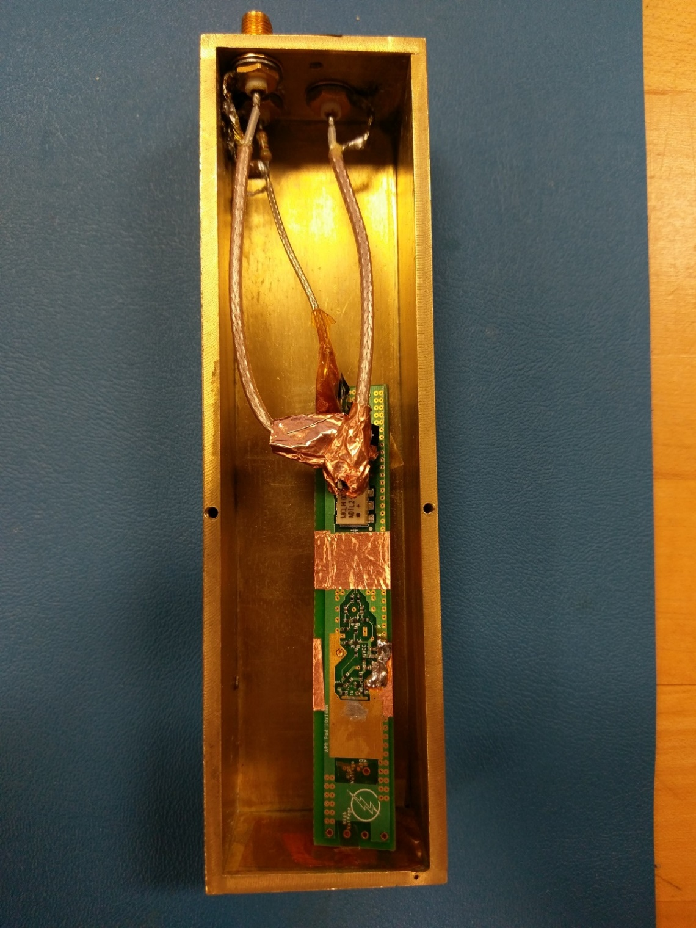Top view of the board:

From top to botom, the first segment of copper tape covers the components on the back of the board, and soldered to ground on two points, although there is somo exposed copper underneath the tape that is connected by contact. There is a layer of Kapton tape on top the of the components being covered, keeping them from shorting.

The second segment of copper tape is only making ground contact with strips of exposed copper on the board’s top and bottom layers. This strip is covering the differential pair that travels from the output transistor to the transformer.

There is Kapton tape on the board covering the exposed high voltage nodes, with the exception being the pad that is meant to have bond wires for supplying high voltage to the APD.

**Notes**

* A 3-pin to BNC adapter is included as an alternative to delivering high voltage to the board.
* The “G” labels stand for ground (GND).
* The board’s power connector cannot be plugged in while the output signal connector is plugged in.
* High voltage breakdown occurred inside regular SMA cables that were being used to deliver high voltage.
* A piece of thin custom cable was included in the packaging in case it is necessary to make a high voltage connection.
* The 2-pin connector that carries the output signal has a small exposed connection. Normal handling of the connector shouldn’t short them, but it may be possible for the copper tape to short out the output signal.

**Assembly**

The connectors on the board are packed tightly, but the connections are protected with kapton and shielded with copper. The 3.5V connector must be plugged in first before the signal output cable because of the size and angles of the connectors. All connectors can only be plugged in one way.

It is recommend to connect the 3-pin connector (high voltage), followed by the board’s power (angled 2-pin connector), and then the signal output (2-pin connector with exposed connection).

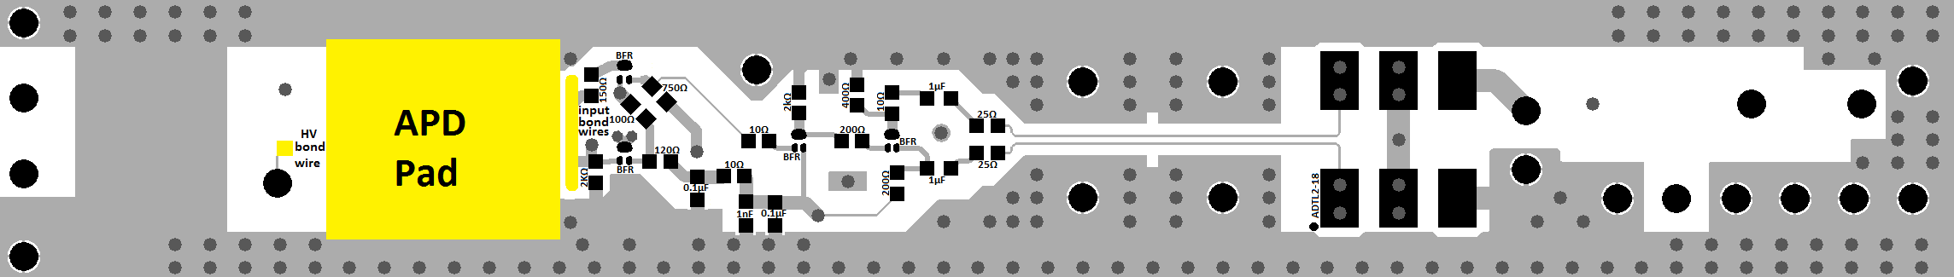

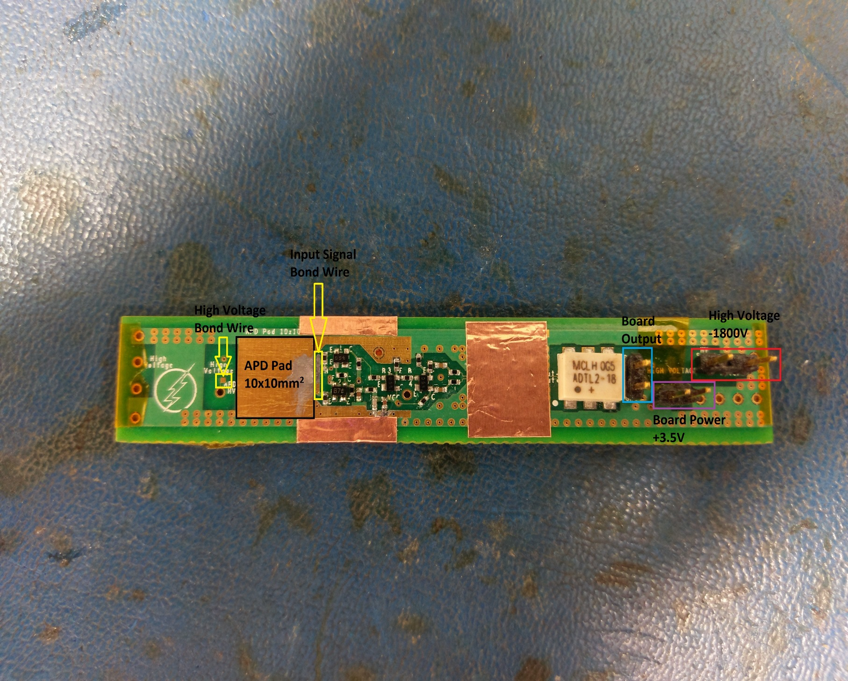

**LT Spice Schematic**

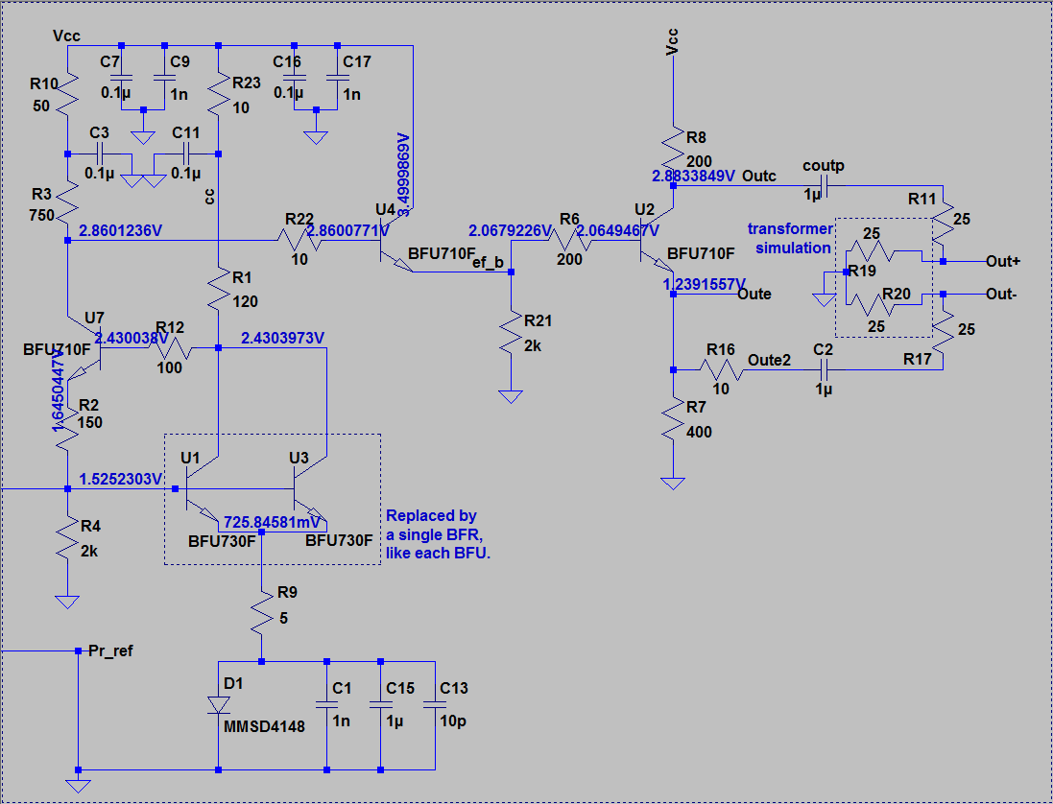

Each transistor on the LTspice schematic is a BFR8840L3HESD on the board.