**PENN Fast Amp for CMS Detector at CERN**

Mitch Newcomer, Emmanuel Morales

University of Pennsylvania, HEP

**Penn4**

Top view of the board:

**Notes**

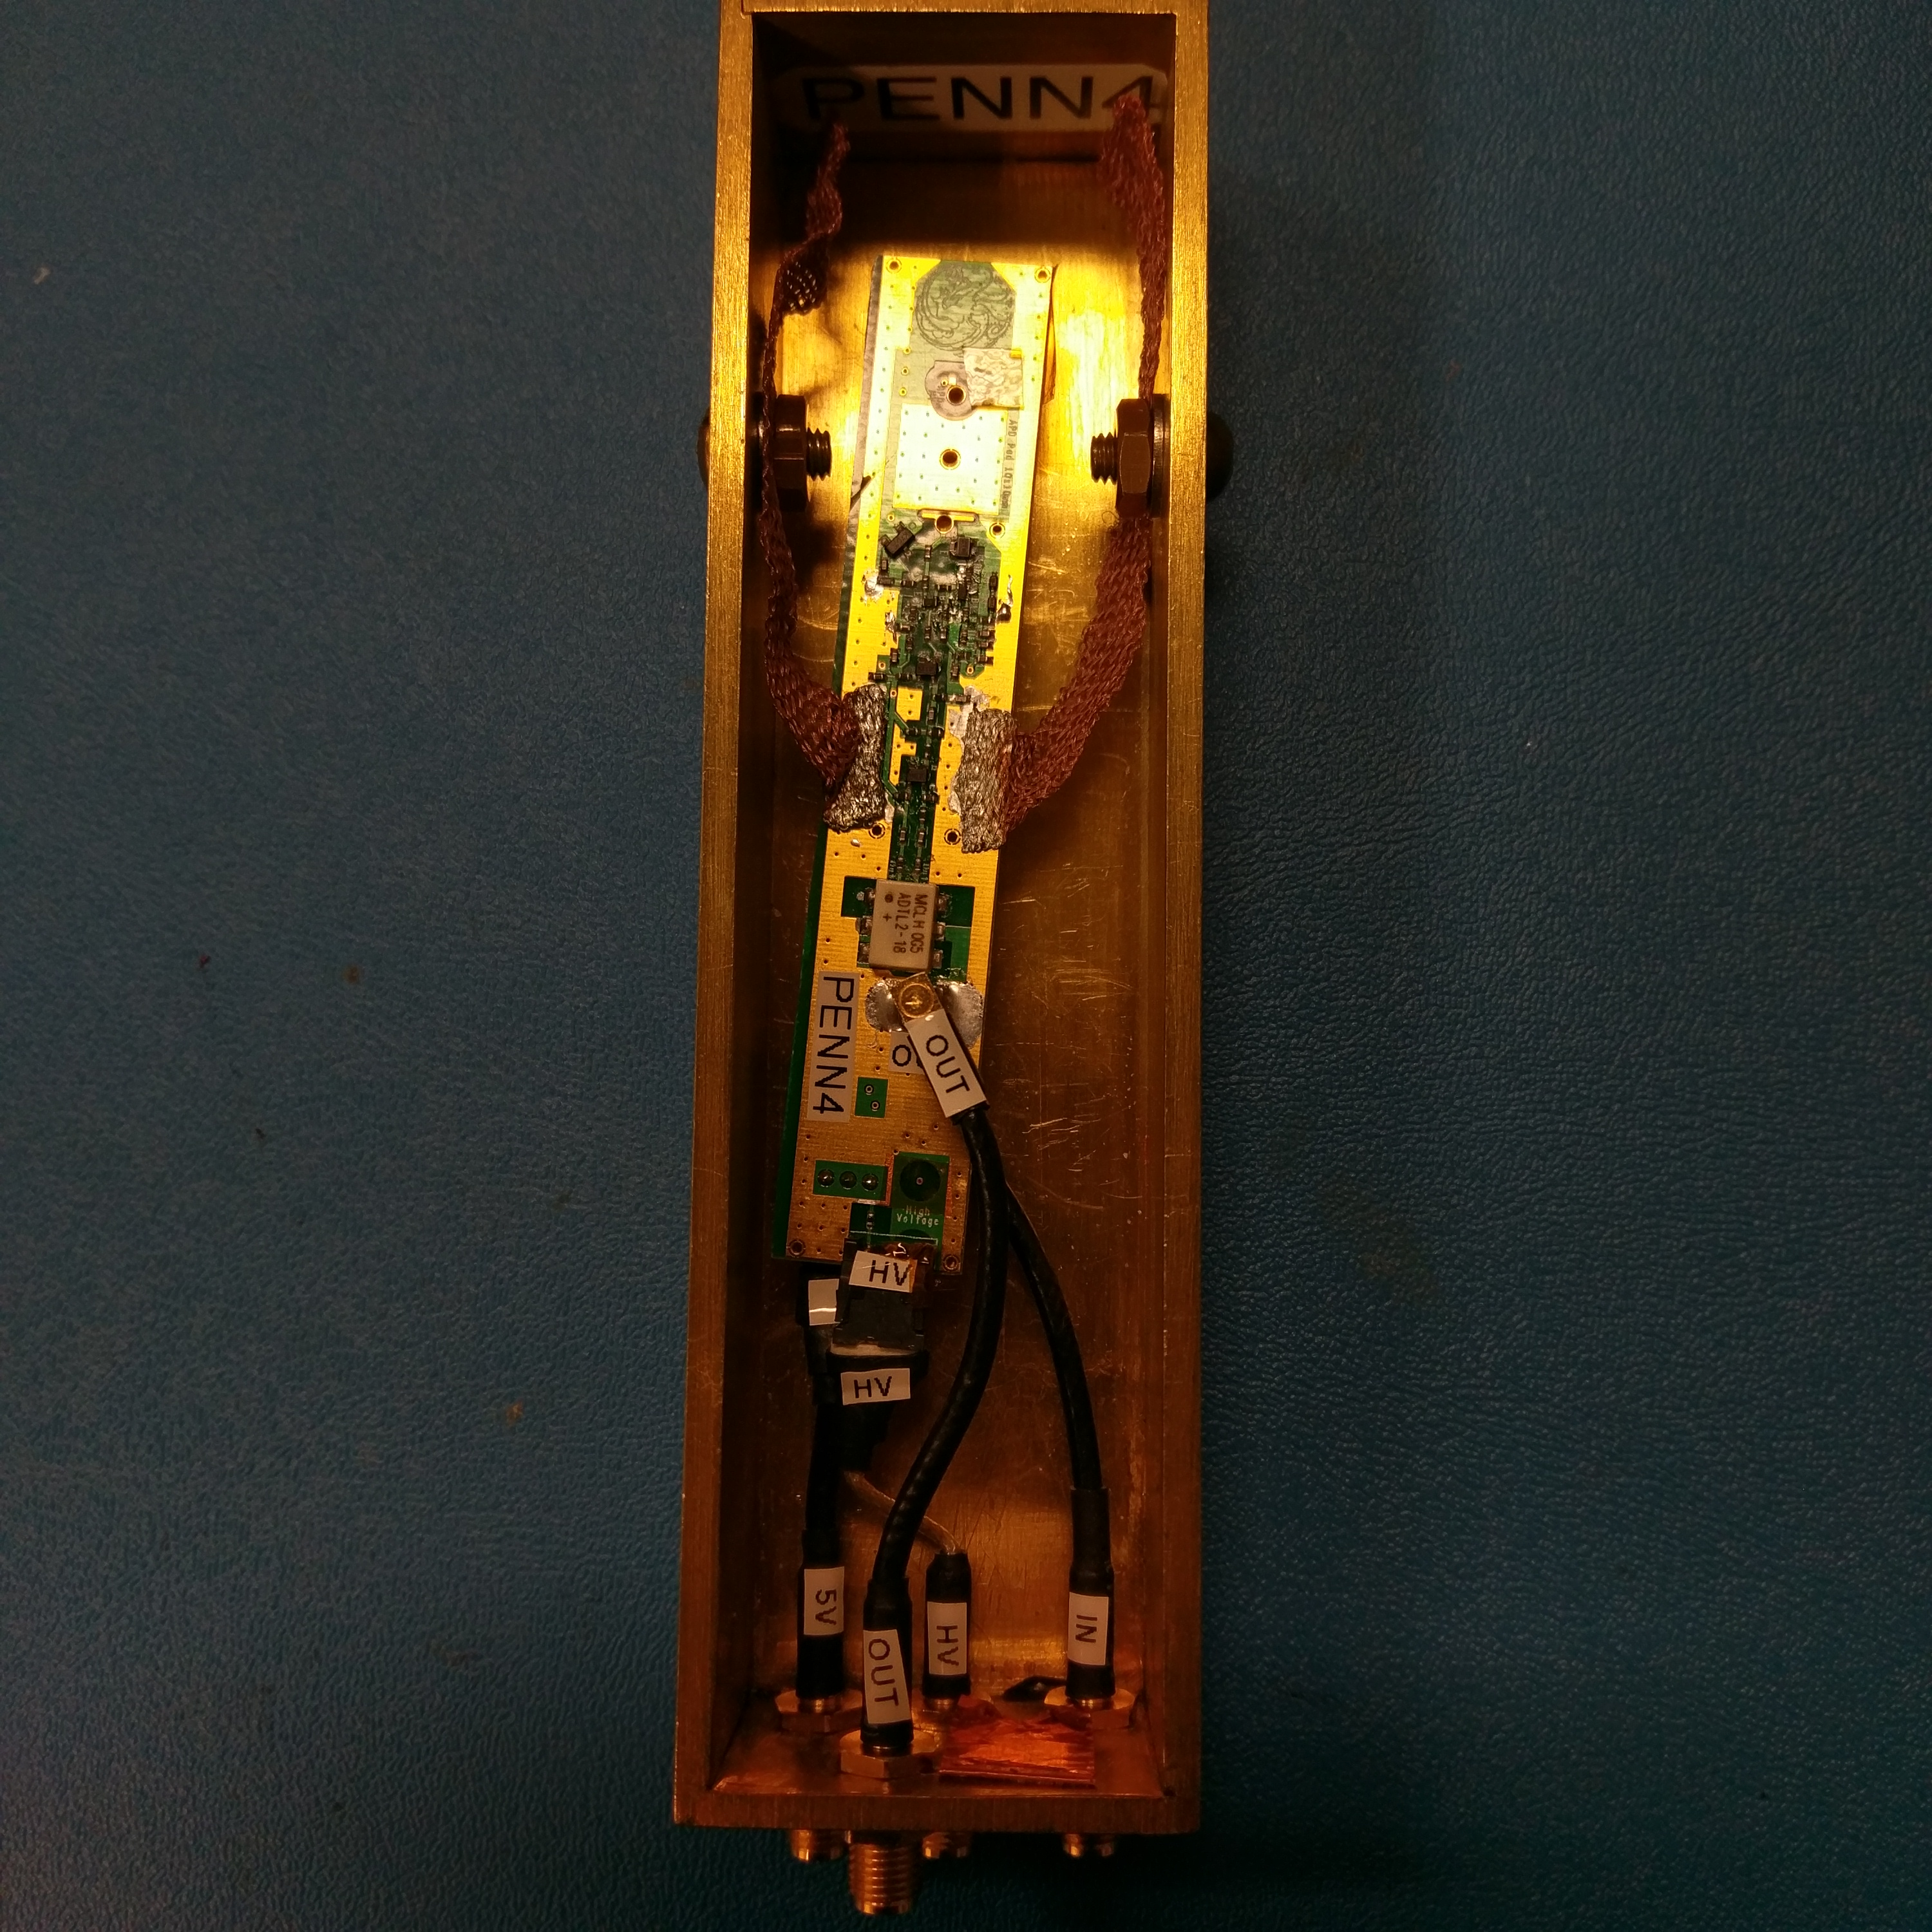

* There’s some copper braid on the sides for making better ground contact with the box, as well as keeping the board a bit steadier and not free-floating as much.
* The pulser input and board output connectors are MMCX connectors. You only need to push in to connect or pull it at the head to unplug. There is a bit of force needed to unplug, but it’s safe since it has enough solder on the jack to withstand the force.
* I’ve labeled connections and connectors so that anyone can connect or disconnect the board. There is no specific order to connect or disconnect cables on the board, but I’ve found it easier to start by disconnecting HV, 5V, OUT, and then IN.
* I placed some Kapton over most of the exposed High Voltage nodes for safety.
* This board has the same bonding pads as Penn1 and Penn2, but there’s also through holes for pins in case a pinned APD is used.
* Beware that the hole for the high voltage pin is fairly close to the ground pad. The APD ground pad isn’t completely square to keep the ground away from the high voltage, but if an APD is getting bonded over the pad as before, the copper at the hole must be isolated from the APD to prevent arcing. Some coating or kapton can be placed over the hole, or the copper could scraped off with an x-acto knife or small drill.
* There is copper tape over an unused hole on the brass box to cover the hole.

**Box Connections**

The brass box has four SMA jacks that connect to the board:

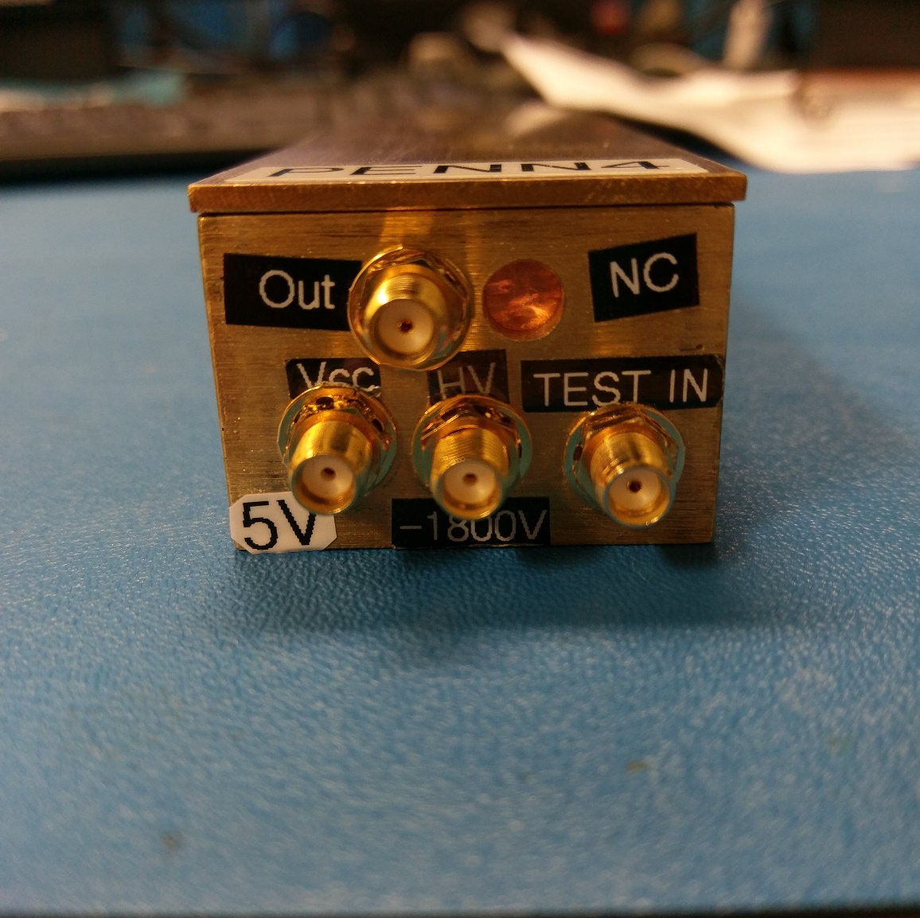

Inputs and outputs on the box

* **Out** is the board’s output for connecting to an oscilloscope.
* **Vcc** or **5V** is the board’s power input. The board needs +5V DC, and draws about 17mA.
* **HV** or **-1800** is the APD’s high voltage input and has been tested to work up to -1800V. Note: there is a 1nF capacitor rated for up to 2kV on the high voltage line.
* **TEST IN** is the input for a test pulse. The parasitics in the path towards the input node of the amplifier can significantly slow test signals. The schematic below shows the LTspice schematic used to mimic the effect of the parasitics, where V3 on the left is the pulser and the right most node is the input of the amplifier which has a 15pF capacitor to ground.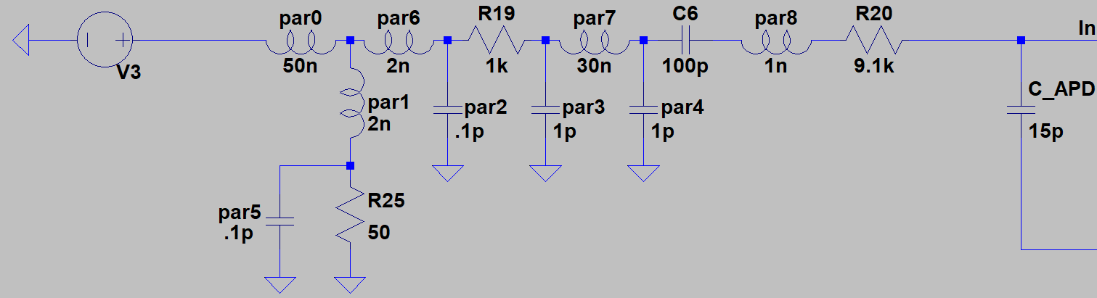

**LT Spice Schematic**

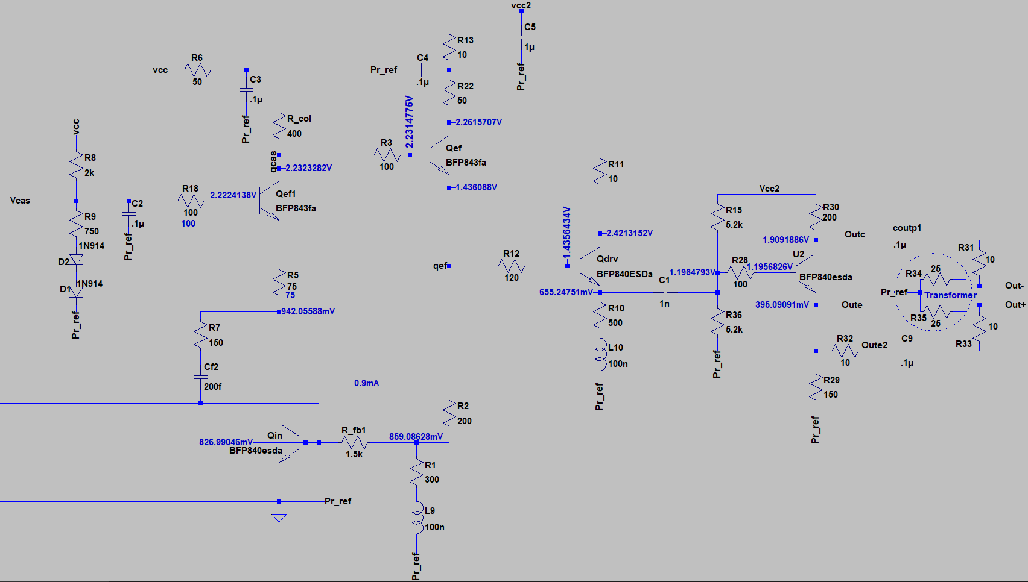

This schematic shows what the circuit on the board is like.