**Fast Amp with Carrier Board Emmanuel Morales, Aug. 27, 2019**

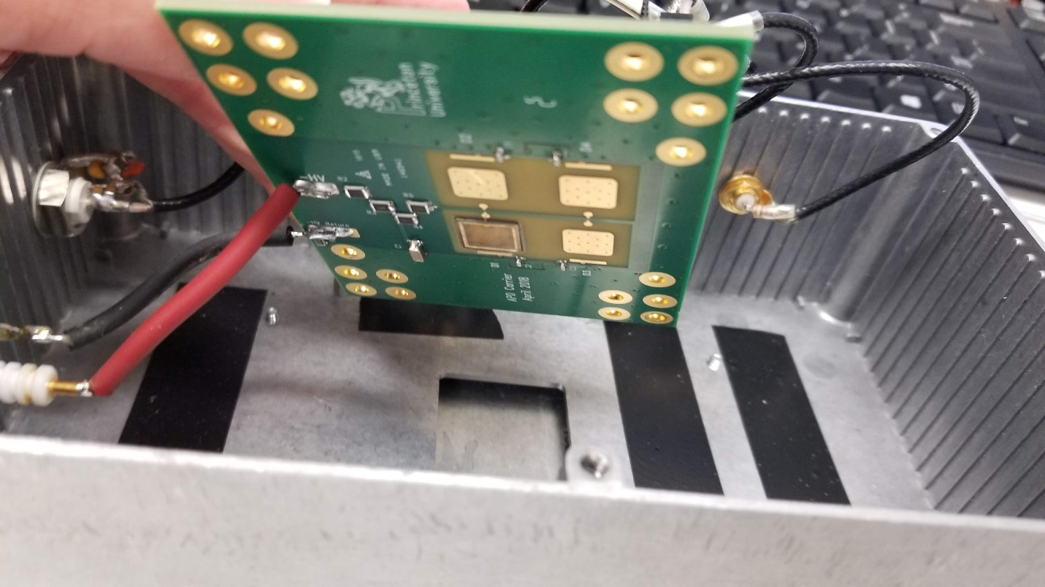

Bottom side of the carrier board has one APD stuffed, with three empty lots for bonding APDs.

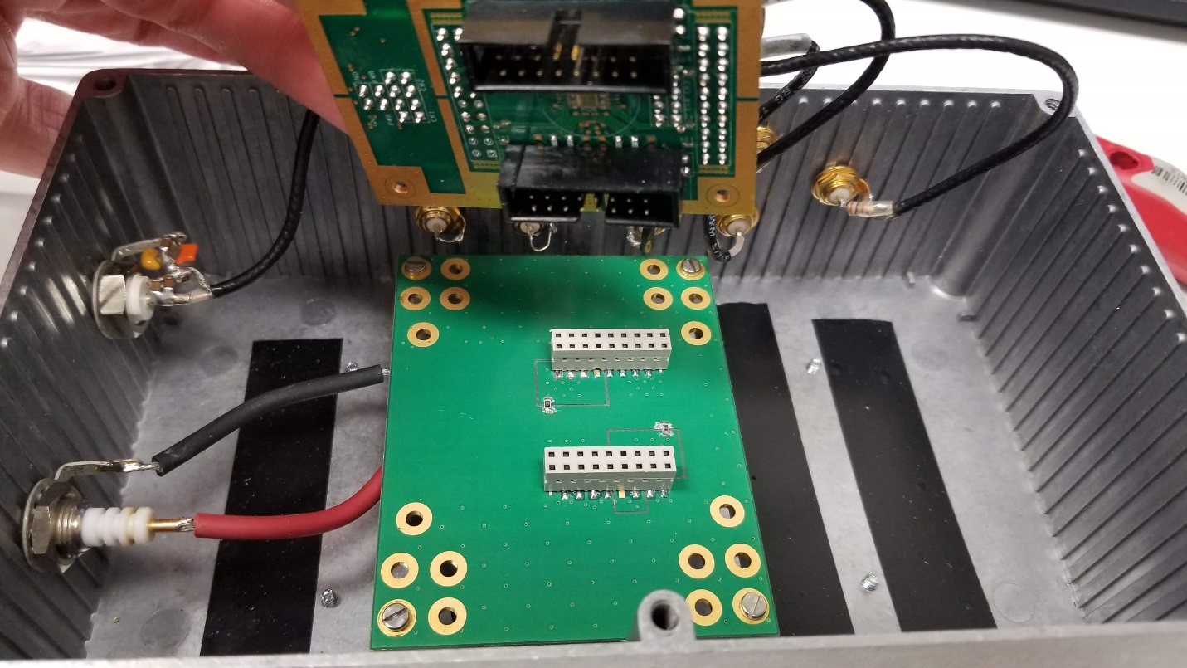

Top side of the carrier board shows a carved moat around the APD’s ground which is connected to the carrier board ground by a 0Ω (0805 package). The bottom side of the Fast Amp board has the Fast Amp IC, and headers that mate with the APD board.

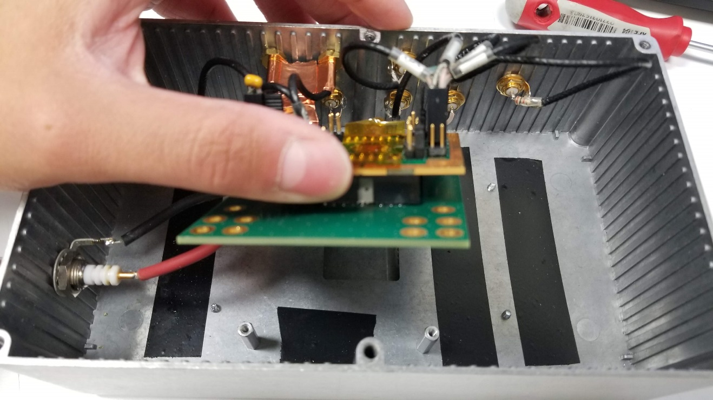

Fast Amp board mated with the APD board.

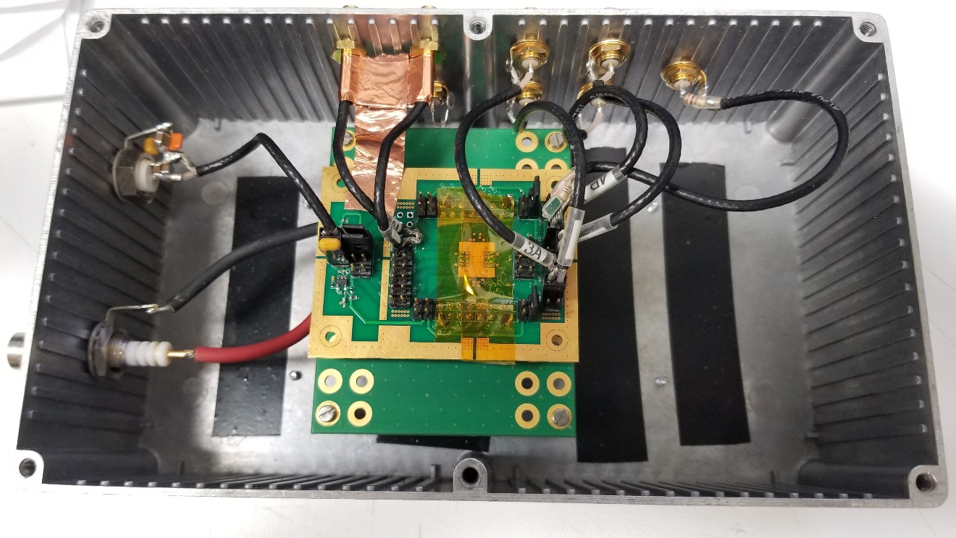

Top side of the Fast Amp board has headers for powers, gain toggle, and outputs. However, the two outputs being used are sent out the box through two coax soldered directly to the board that have a bulkhead SMA connector on the other side. The copper tape seen is making contact with the connectors and the board ground to keep the outputs from oscillating. One of the challenges with the current design is getting signals out of the board without oscillations, and this is what’s helped the most so far.