How to import a macro module into Excel

1, Save the attached “Module7” file to a temporary directory, such as C:\temp;

2, Open Excel;

3, In Excel press ALT + F11 to bring up the VB editor:

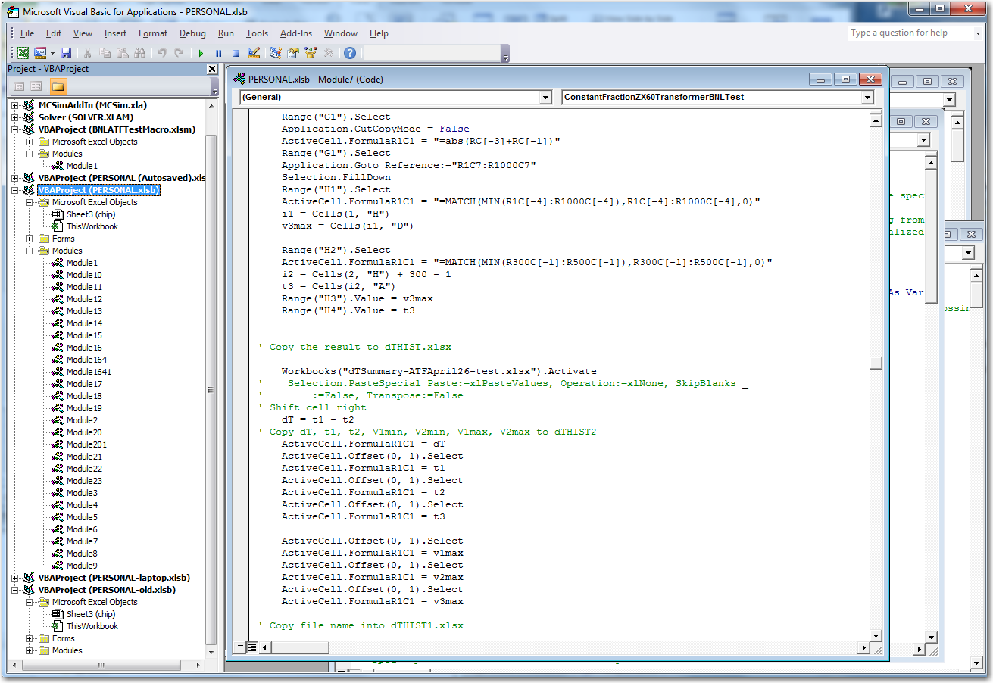

4, Click File on the top menu bar, on the drop down menu select ”Import File”, and get the above “Module7” file imported to Excel; 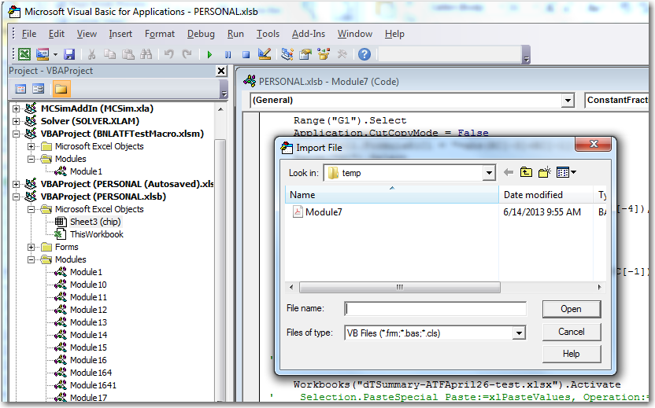

5, Now you will be able to see various macro files in this macro module in the Excel thru Excel|View|macros|View Macros: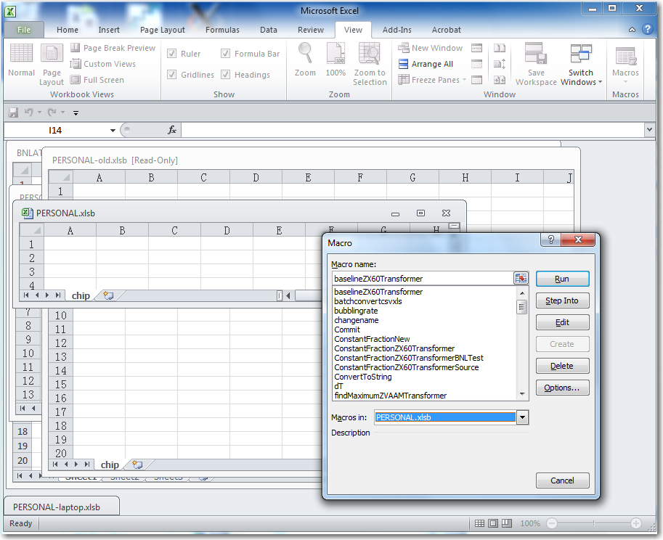

To prepare running the following macro you have to put the data files into a certain directory, and rename these data files accordingly, but of course you can edit the Macro for the directory and file name you want to use. In the attached Macro file I set the directory at "C:\Users\Lu\FastTiming\BNLBeamTest\ATF April 26\", the analysis results histogram file’s name as "dTSummary-ATFApril26-peak.xlsx", and the data file name as TXXXX.csv, where XXXX is a number, such as 1, 2, …, 10000. The original data file name is ATF 2600001 up to ATF 2601343, I used a software “bulk rename utility”, which you can download from internet for free, to rename these data files.

Bulk Rename Utility

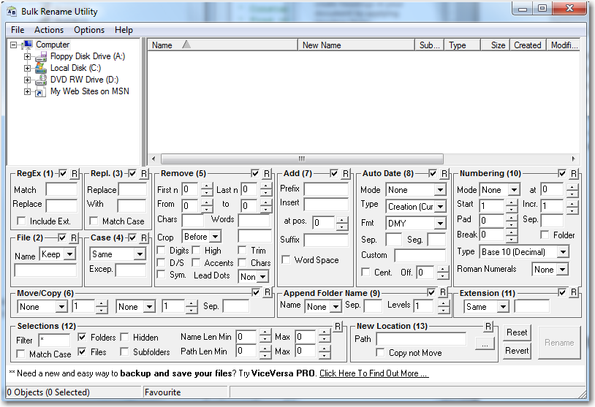

6, Open a macro named as “PeakTimingZX60TransformerBNLTest”: 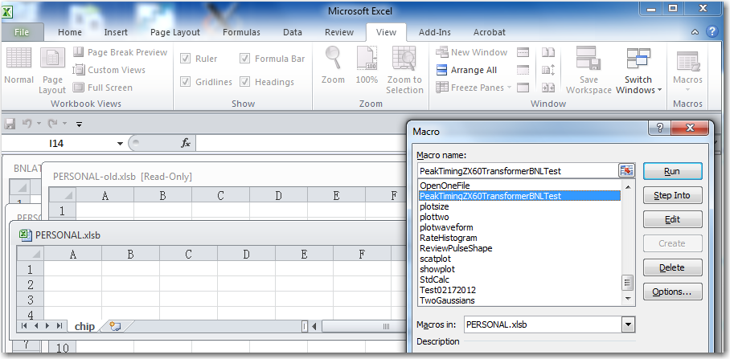

7, Code of the Macro:

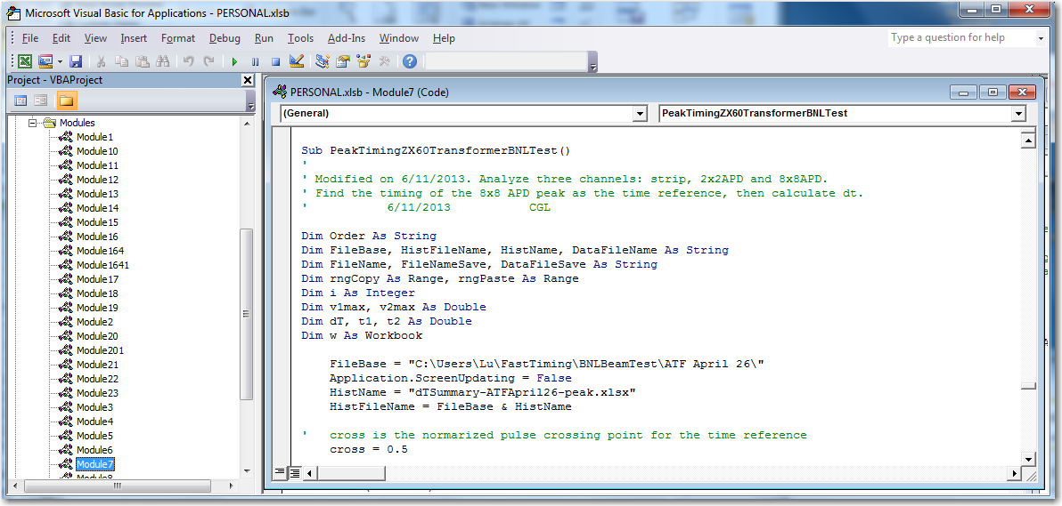

You can click Debug on the top menu bar, on the drop down menu select “Step into”, the Debug will highlight Sub PeakTimingZX60TransformerBNLTest() , use F8 key to run the macro step by step, or F5 key to run the macro continuously.

This Macro is using APD peak point as its time reference, strip signal uses the middle point between maximum and minimum as its time reference. I tried constant fraction algorithm, but the results are not good due to bad S/N ratio and APD signal itself is jumping around, make finding the zero crossing point very difficult. You can run “Sub ConstantFractionZX60TransformerBNLTest()”, which is in the attached Macro file, to get the sense of this difficulty. You are welcome to make new development to these macros and make the macro smarter to be able to overcome the mentioned difficulties.