**Princeton MountedPackaged APD**

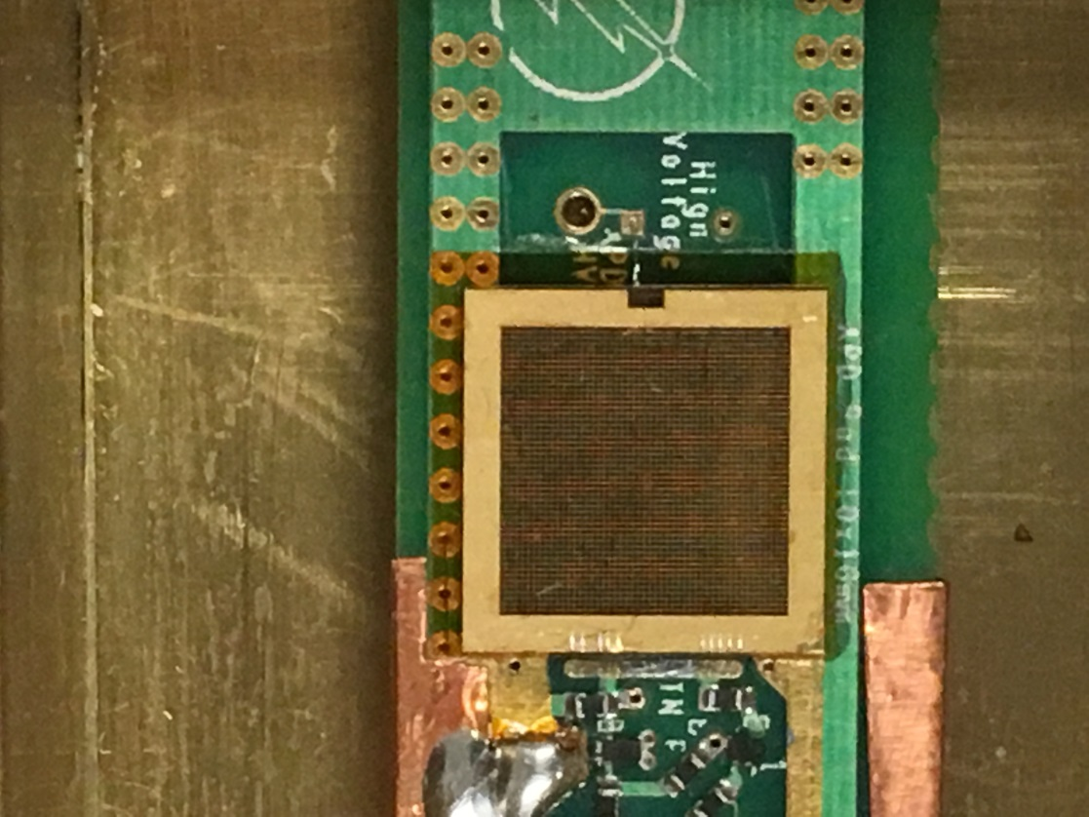

**APD Mounted to PCB Amplifier**

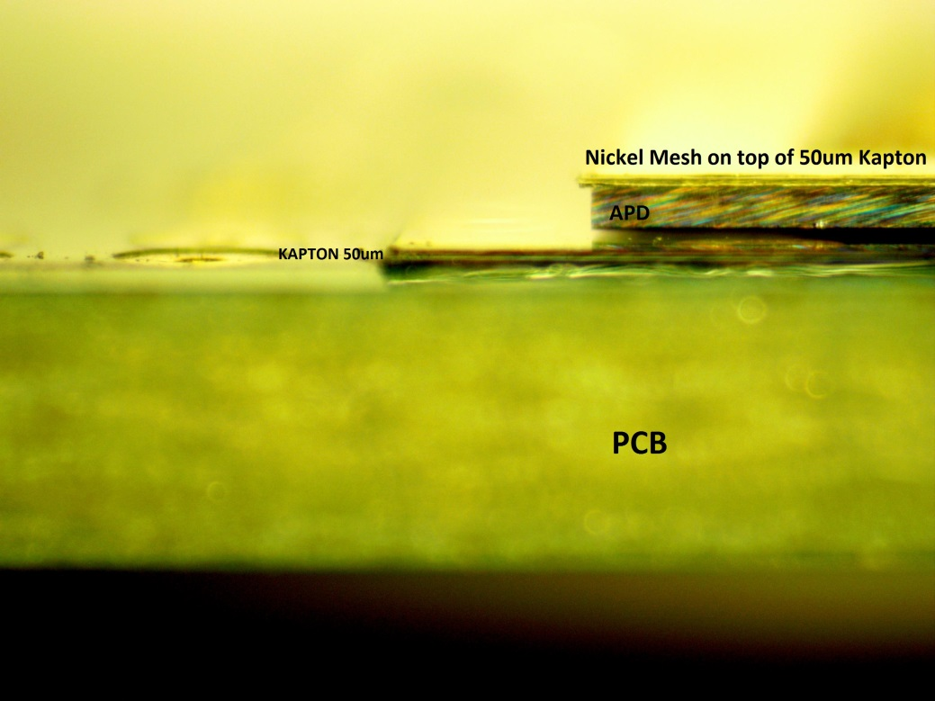

**Stack up Profile**

Packaging Detailed Images

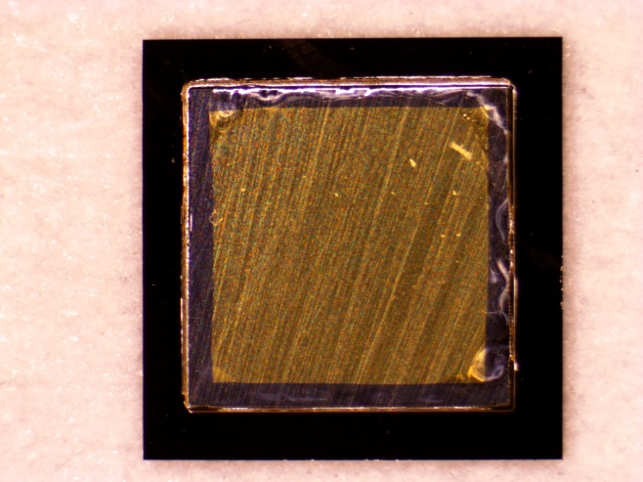

Sputtered Backside Contact

Ti/Au (20/200nm) respectively

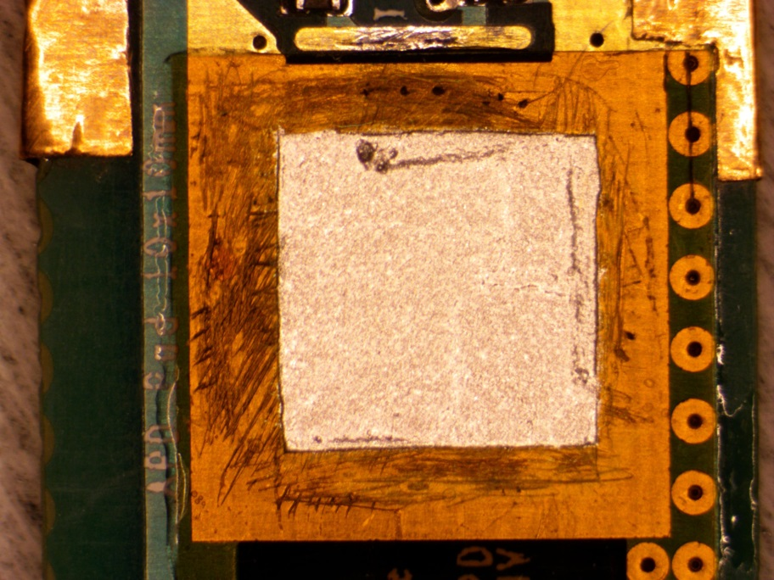

Kapton opening with silver based epoxy to mount backside contact

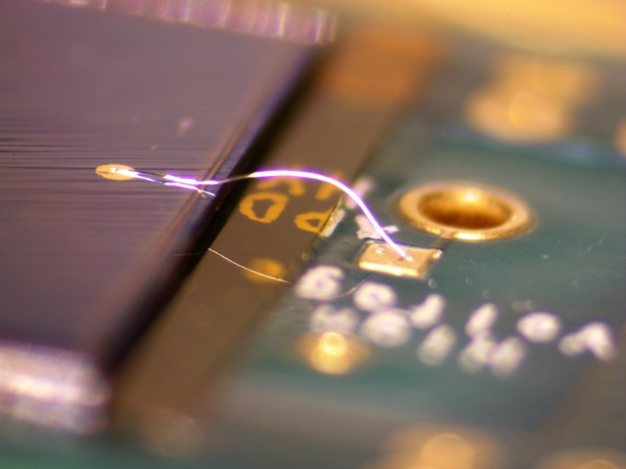

Mounted to PCB with 25um Al Wirebond detailing HV Top Contact

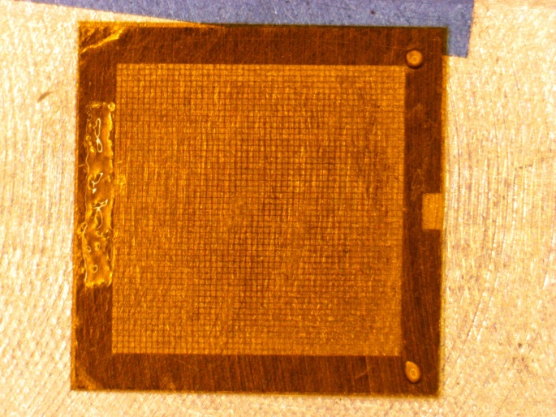

5um Kapton/Nickel Mesh detailing Araldite 2011 mounting epoxy

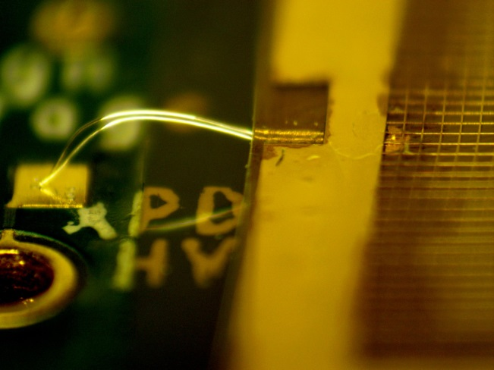

Mounted Mesh to Top of APD

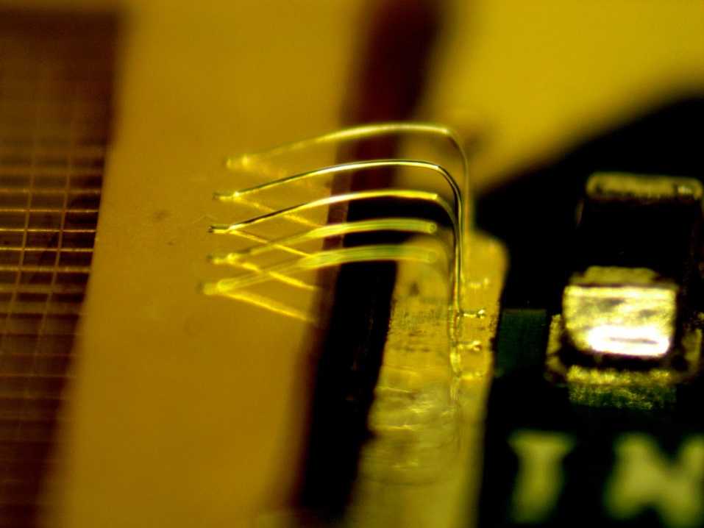

25um Al Wirebonded Mesh to Amplifier Input

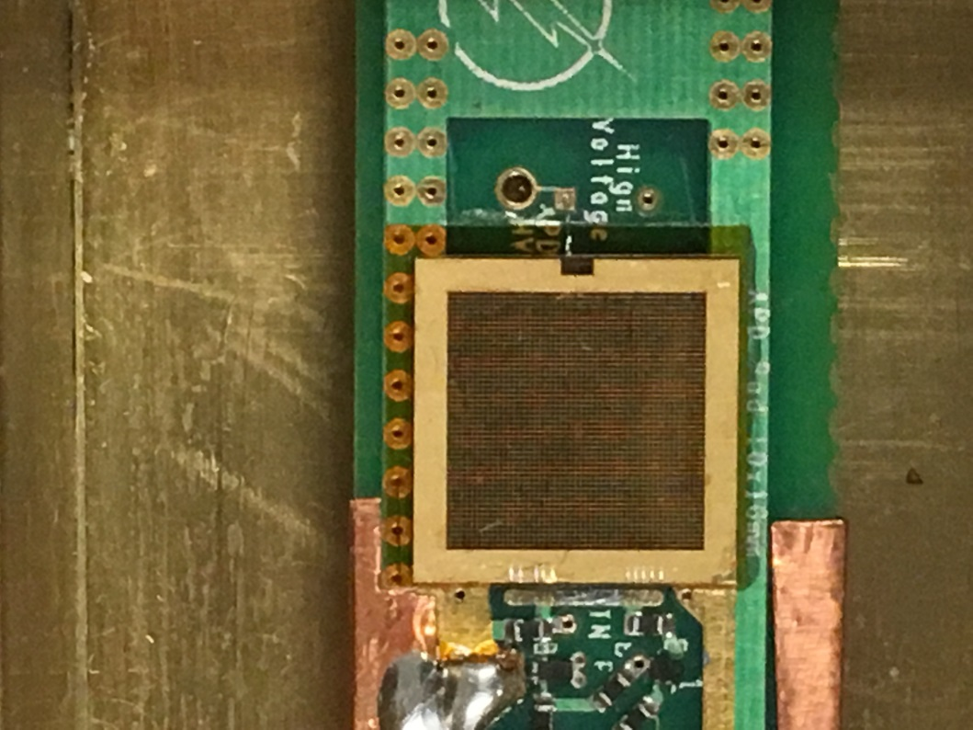

**Completed Package**