Measurements performed with SAMPIC on Nov 21st at CERN using S. White’s APD setup

*Draft V0.0*

*E. Delagnes CEA/IRFU/Sedi*

*S. White*

## 1 Description of the setup.

The measurement setup used is shown on Fig.1 and Fig. 2. A custom-made fast pulser,based on bipolar transistor breakdown generates short pulses. Its output is splitter in two parts by a passive splitter. A first output of the splitter drives a VCSEL, providing then short laser pulses which are sent, through an optical fiber to a White’s “mesh- APD”. The intensity of the light pulse received by the APD can be changed by modifying the optical coupling between the optical fiber and the APD. The output voltage of the APD is taken on the mesh, amplified by 50dB before to be sens to be digitized by SAMPIC. The second output of the splitter, attenuated by 10 dB is sent to another channel of the same SAMPIC chip.

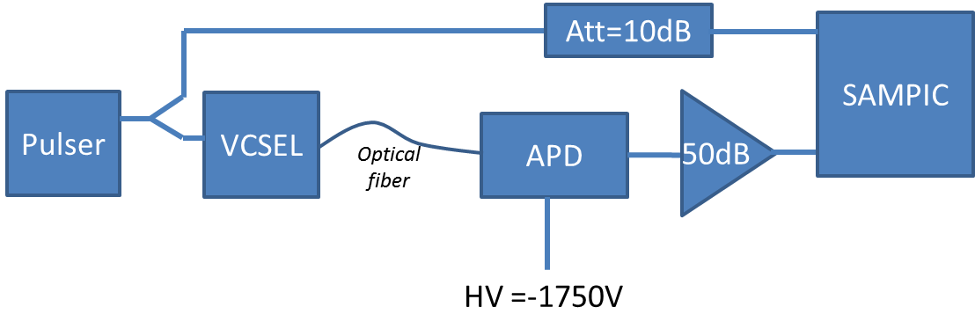

Figure 1: Principle of the test setup

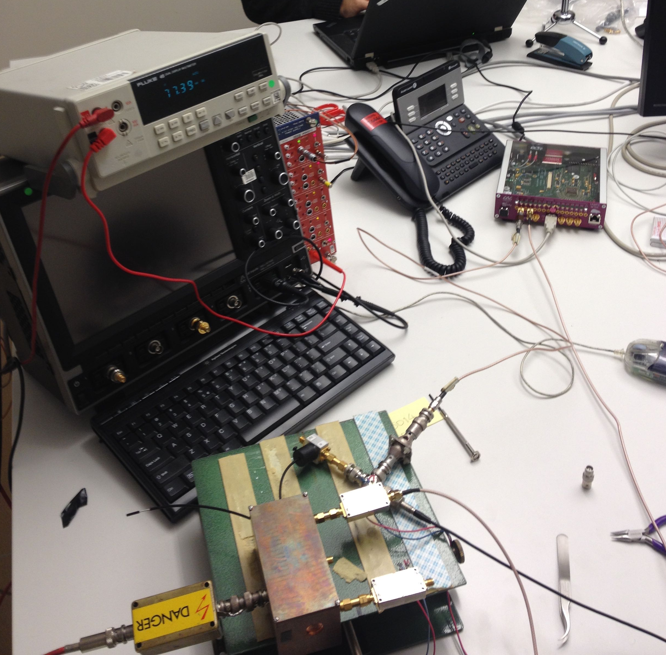

Figure 2: picture of the test setup

The characteristics of the main elements of the test setup are summarized her:

**Pulser:**

Repetition rate: 12 kHz

**VCEL:**

VCSEL 980 de Thorlab, 2mW (970-980nm),

Rise/fall time = 100ps rise/fall time

Jitter = 35 ps peak to peak

**APD :**

High Voltage applied = 1750V.

From previous measurements, at this voltage and using the same amplifier, a MIP corresponds to 300mV (Most probable value or average value ?).

**Amplifier :**

Wenteq ABL0100-01-5010

Gain = 50dB => Voltage Gain = 316

Bandwidth :10MHz-1GHz

Input Impedance= 50 Ohm

Noise: 1dB noise figure

**SAMPIC :**

Used in self-trigger mode on both independent channels.

Readout by USB

Sampling rate = 6.4 GSample/s (156.25ps/step)

Resolution mode: 11 bit => 1 ADU =0.5mV

The threshold was set to -150mV (wrt the baseline set to 1600 ADU)

## 2. Measurement results, large amplitude

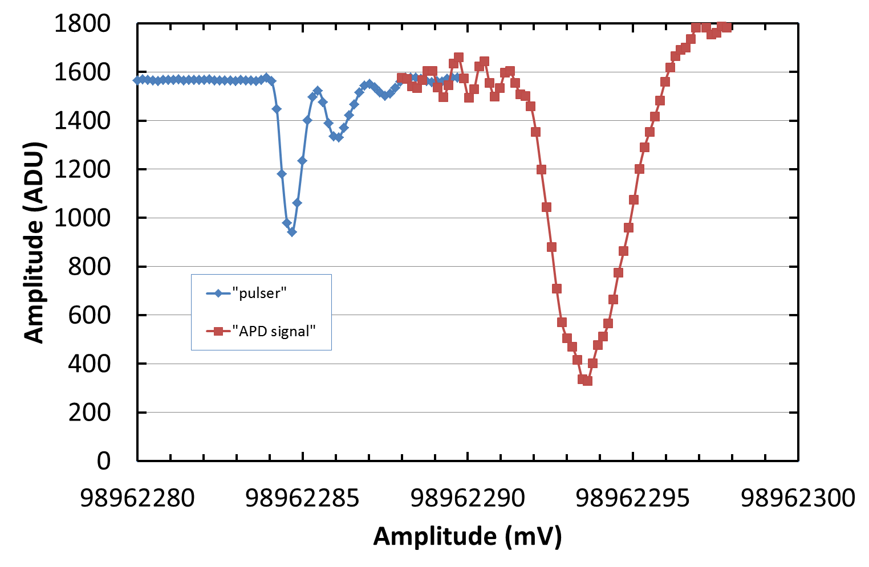

Figure 3: Pulser and APD signals digitized by SAMPIC.

A typical acquisition is shown on Fig.3.

The amplitude of the digitized pulser signal is ~320 mV and its duration is less than 700ps FWHM, (4.7 ns at the baseline level if the ringing is taken into account) with a risteime of ~170ps.

The detector pulse appears to be delayed by ~12ns wrt the pulser signal. It is preceded by a perturbation (synchronous with the pulse).

The amplitude of the digitized amplified detector signal is ~650mV with a risetime of ~1.3ns and a FWHM of 2.8 ns.

The timing of both pulses has been extracted using a dCFD algorithm with a fraction of 0.6. The distribution of the time difference between the two pulses obtained is shown on Fig 4 and 5 (50.000 events).It is nicely Gaussian with a standard deviation of **12 ps RMS** (also equal to the fitted sigma). This value has to be compared with the 35ps peak-peak jitter specified for the VCSEL

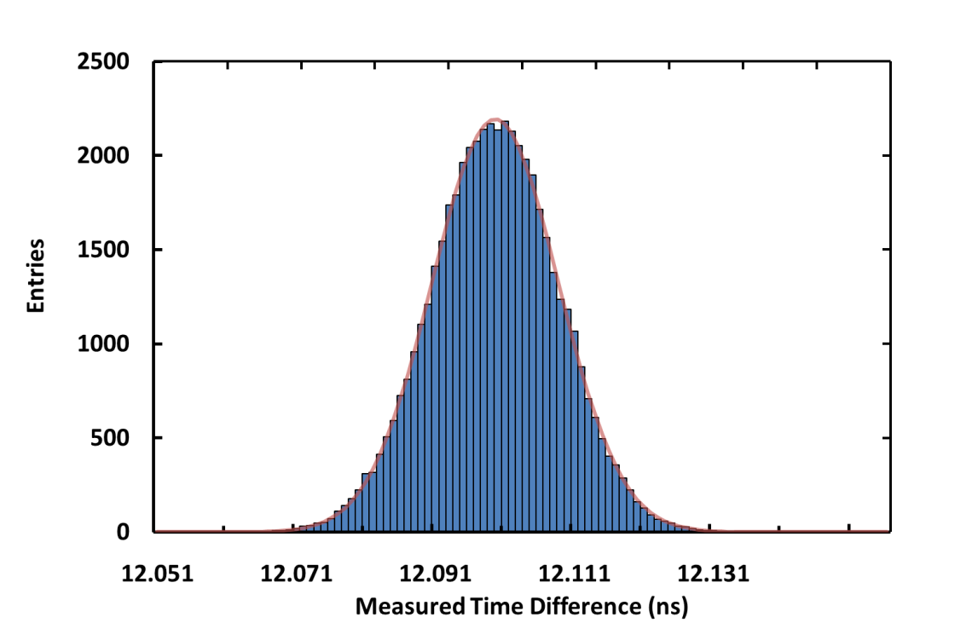

Figure 4: Distribution of Time difference between pulser and detector signals (+ Gaussian fit in red ) for amplified detector signal amplitude of 600mV. The standard deviation is 12 ps RMS.

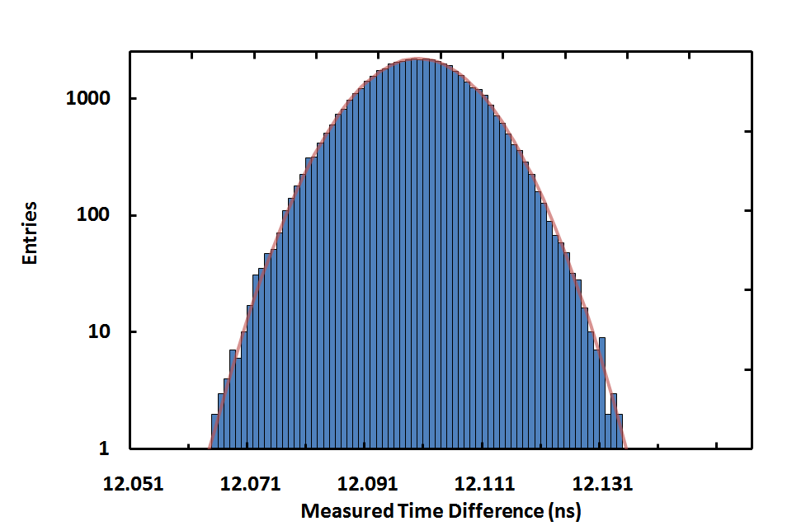

Figure 5: Same distribution than on Fig.4 but in log scale.

## 3. Measurement results, varying amplitude

The light sent to the detector has been varied by changing the optical coupling between the VCESL and the APD. Four configurations have been studied corresponding to the 4 curves with 4 different amplitudes shown on the Fig. 6.

The shape of the pulse is unchanged when the incoming light is changed.

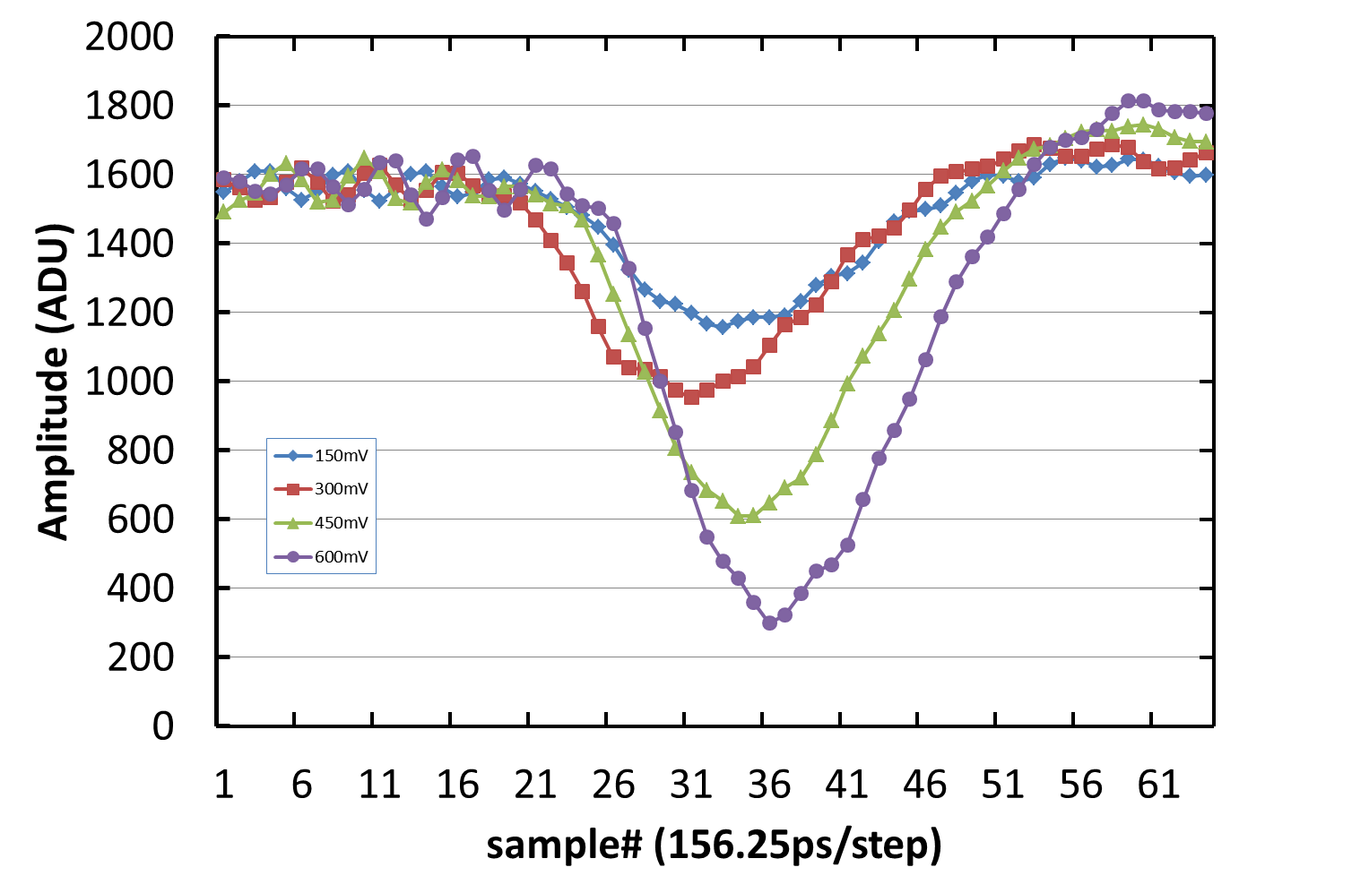

Figure 6: Digitized detector pulses for the 4 light amplitudes.

The timing resolution (standard deviation of the time difference) extracted from these 4 amplitudes is plotted on Fig. 7. Two algorithms have been used to extract the time. The first one is a standard digital CFD using a fraction of 0.6. The second consists to average the times extracted from 3 CFDs with fractions of 0.2, 0.4, 0.6. With this method the effective number of samples used for timing is increased (it is only 2 for CFD). This last method improves slightly the timing resolution to less than 9ps RMS for a 650mV amplitude.

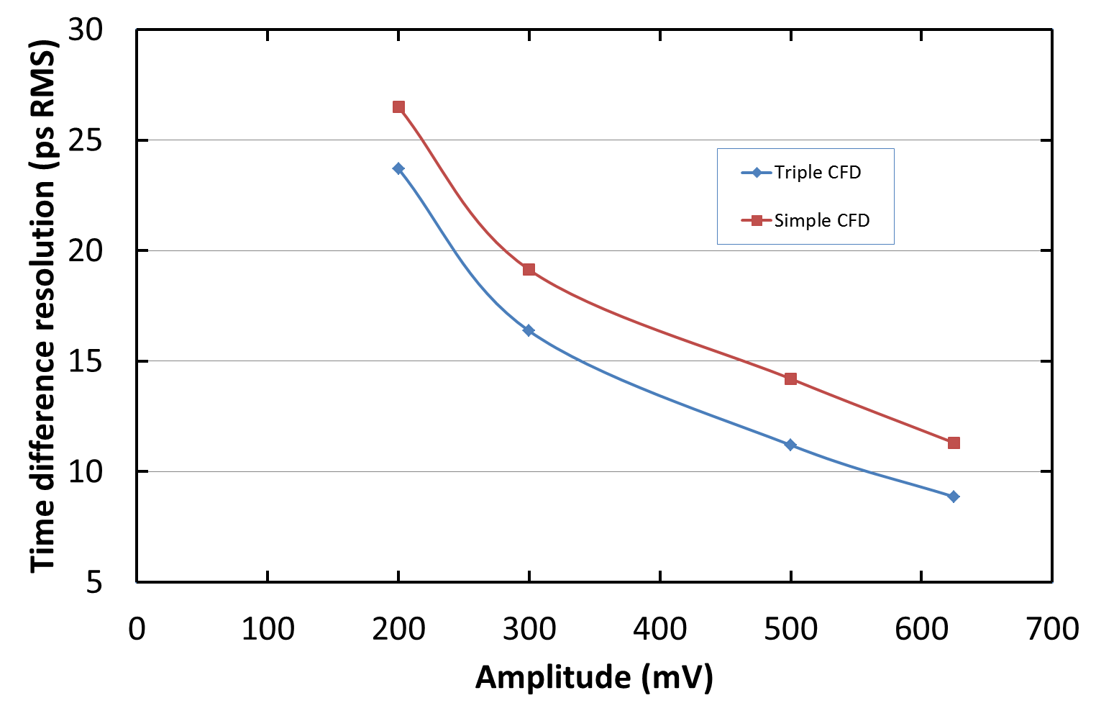

Figure 7: Standard deviation of the time difference between pulse and trigger as a function of pulse amplitude . The red curve is for timings extracted by a simple CFD algorithm whereas they are extracted by the “triple CFD” algorithm on the blue curve

For both time extraction methods, the timing resolution is mainly unchanged if we use spline rather than linear interpolation between the samples.

There are probably possible improvements of timing extraction using signal filtering or other algorithms. It has to be studied.

## 4. Parasitic signal

We firstly though that the peak-peak amplitude of the parasitic signal was varying linearly with the light amplitude. Fig.8 shows that the mechanism is probably more complex and has to be studied. Actually when we changed the optical coupling, we probably also moved other things affecting the CEM.

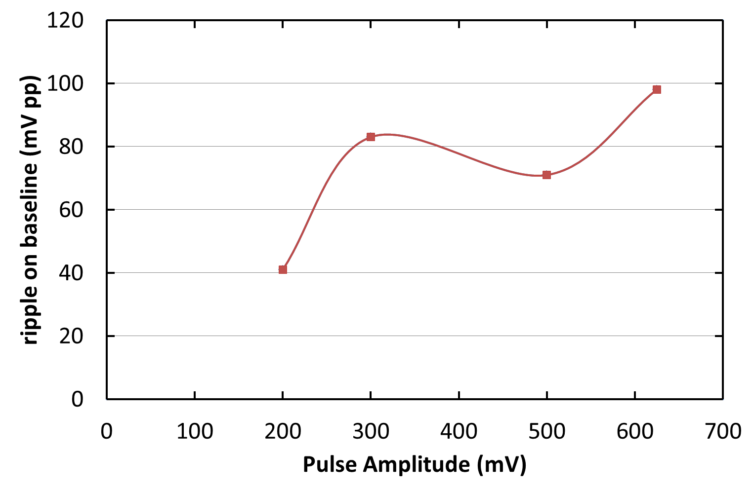

Figure 8: variation of the ripple on baseline as a function of the pulse amplitude