Looking Up: Professor James E. McDonald 1955-1970
John Kenneth Gillin
Senior Thesis, University of Arizona
(June 2013)

The Special Collections Library at the University of Arizona is a place where people from all corners of academia, history, and even just the curious come to find answers to questions that cannot be answered anywhere else. If you search hard enough amongst the maps of the Gadsden Purchase, rare books, and one-of-a-kind pictures of Senator Barry Goldwater, you will find two standard letter-sized envelopes, each containing soil. If you are wondering why on earth there would be two envelopes containing soil within this incredible archive, then you are in exactly the same position that I found myself in when I was first presented with this one box from MS 412, or, as it is more commonly known, the James E. McDonald Papers.
One of the first answers to the very first questions I found myself asking, was what exactly these envelopes contained, and as it turned out this was no ordinary dirt, but in fact, soil samples from a supposed UFO landing sight in South Hill, Virginia that were sent specifically to Dr. James E. McDonald at the University of Arizona for testing. This would be the first of hundreds of questions I would be asking myself over the next few months of research on this fascinating scientist, all of which would lead me to ask; how is it that a scientist who focused on two polar opposite fields of study in just over a decade affected those at the university where he worked, in the United States, and even across the world. I would find most of my answers, and more questions, within the 58 boxes of the James E. McDonald papers.
James McDonald was a sign of the times. Like few other scientists in his field, he did extensive research into the effects of placing Inter-Continental Ballistic Missile (ICBM) silos around his home city of Tucson, and was extensively involved in liberal student clubs, including the Peace and Freedom Association as well as the Students for a Democratic Society. McDonald was also a true believer in UFOs, so much so that he testified on their behalf in front of congress, and in 1968 he was one of the main critics of the lackadaisical nature of a United States Air Force (USAF) project at the University of Colorado that set out to investigate thousands of UFO sightings. He would be the man to single handedly step up against the USAF on two occasions, and in the process would become a worldwide cult hero.

The Professor
James Edward McDonald was born on May 7th 1920 in Duluth, Minnesota. He first attended college at the University of Omaha where he graduated in 1942, he went on to receive his masters degree at Massachusetts Institute of Technology, and eventually a doctorate from Iowa State University in 1945. Soon after this he began his career in academia at the University of Chicago where he spent just one year before making his way to the Sonoran Desert and his eventual homeport of research, The University of Arizona. McDonald began his career in Tucson as an educator in atmospheric sciences and meteorology, and by the year 1957 he was a senior physicist at the U of A.
Within a few short years McDonald shifted his focus from teaching to research, something that he was exceptionally good at. To anyone who worked or interacted with McDonald it was clear that he was an incredibly intelligent scientist, and a great writer who made sure to choose his words very carefully. Even in short memorandums to other professors at the U of A he had a stern and elegant way of getting his points across. Sometimes it was pushy, however most of the time he just made it very hard to argue his points. This is a skill that would prove to be vital later on in his career when faced with opponents like the USAF, which admittedly had to create a certain firewall to protect themselves from scientific facts that McDonald had a knack for throwing their way. Nothing got by McDonald; in one instance in 1959 he was disappointed with the lack of funds that he had been appropriated for specific scientific journals he wished to receive from the Library, so he sent a memorandum to then President Richard A. Harvill noting this, to which he received a response that included a short apology and that they would take his considerations into account for the next semester. However, this would not suffice for McDonald who in response to Harvill sent a two-page letter that accepted the apology, but also showed the exact amounts of the budget which thirteen other major universities appropriate for the same exact material each year, and conveniently, Arizona ranked 13th. These were the kind of things that McDonald would do for his entire tenure at the U of A. At one point he even asked the Dean of the Graduate College if it was possible to regularly test graduate degree candidates on the competence of their writing skills, a clear reflection of his belief that words could be one of the greatest scientific tools that one has.
James E. McDonald’s was a highly respected scientist and teacher, however involvement at the University of Arizona went beyond just his teaching; he elected to be part of part of the Committee of Eleven, a faculty council, which met to discuss issues around the University that they deemed to be most important. For McDonald the issues ranged from imposing a writing requirement for graduate students as mentioned above, to increasing traffic safety around the university. McDonald had a keen interest in the students here at the U of A, and was an avid supporter of more student involvement in various clubs and governing bodies around the university.
As a professional if McDonald had one flaw, it was the fact that he could not avoid conflict. His involvement with organizations at the U of A were no exception to this, and his involvement in the Students for a Democratic Society (SDS), the creators of the “New Left” in America, would garner him a lot of attention from none other than the Federal Bureau of Investigation (FBI), attention which McDonald was never actually aware of. This is not as surprising as it may seem, due to McDonald’s open belief in UFOs and his stance against the Vietnam War. The FBI considered for a while whether or not an interview with McDonald would be worth their time, using evidence that they gained from other U of A faculty whose names remain classified to this day. After years of close watch on McDonald as he continued his research on UFOs and gave student presentation on the dangers of using Napalm, McDonald would inadvertently get himself off the hook in 1969 when he stated that he had become disenchanted with the “young hippie protégés.” Although it should be noted within his FBI file there is still a redacted paragraph, which under FBI code remains confidential due to “an executive order to be kept secret in the interest of national defense or foreign policy.” It is still unclear why exactly the FBI was keeping tabs on a meteorology professor, what is clear however, is that during the various other times throughout McDonald’s career when he found himself the concern of a major government agency he was well aware, and was not shy about making his voice heard.

Titanization
During the Cold War there were few more opinionated places to be than on a college campus. During this time the U of A even proposed replacing an ROTC requirement with a Cold War education program. The students were just as concerned with what Russia’s next move was, as they were with their respective majors. In a September 1961 Daily Wildcat Article Dr. Harvill discussed the changing life of the student in the midst of the cold war, making it clear that this was something much bigger than them. James McDonald arrived at the U of A not even a decade into the Cold War, a conflict that would continue on even after his death in 1971. His arrival time could not have come soon enough, because just five years after his arrival, McDonald would find himself butting heads with the USAF, as well as Arizona Senator Barry Goldwater on the grim prospect of nuclear war in Tucson, Arizona.
The city of Tucson had a USAF presence since the full military activation of Davis Monthan Air Force Base in 1940. The base ran training flights throughout The Second World War, and got a second wind in March of 1946, with the onset of the Cold War, and the establishment of the Strategic Air Command (SAC). The Strategic Air Command was the branch of the military assigned to be on high alert at all times, in case of a nuclear war with Russia. Armed with B-29 Superfortress, and eventually the more modern and long range B-52 Stratofortress, the base flew round the clock flights of nuclear-armed airplanes. The military presence in Tucson is not something Jim greatly concerned himself with until 1959, when it was first proposed that Tucson receive $80 million to construct a ring of ICBM missile sites, a handful of which would be placed upwind of the city.
McDonald’s concern over these sites came early on, even before definite plans were in place for Tucson to be home to the massive underground silos. His most pressing concern was the issue of Tucson immediately becoming a target of attack, due to the fact that the city would be home to 18 ICBM’s. Compounded by this was McDonald’s real fear of the danger of nuclear fallout. As it was mentioned before, McDonald was an expert in atmospheric science, and like many Americans at the time, he was well informed of the disastrous effects a nuclear attack would have on American soil, specifically the idea of nuclear fallout. Nuclear fallout is the residual radiation that resides on the ground and in the air long after a nuclear explosion has taken place. This fallout can be very easily carried in the wind for days at a time. Through his research McDonald calculated that this would affect many cities that had silos already under construction, including the major metropolitan areas of Topeka, Cheyenne, and even Los Angeles. McDonald was so concerned, in fact, that he sent out ten letters to the largest cities that had, or were planning to have Titan or Atlas missile silos placed around them. Within each letter he included two articles from the Arizona Daily Star that showed the erroneous errors that the USAF was making in proposing to locate the silos just tens of miles away from the cities. The major point that McDonald focused on was the sheer distance that these bases would have to be separated from the cities, not just to protect them from the nuclear blast itself, but also the fallout in the following days. In a letter to William R. Matthews the Editor of the Arizona Daily Star, Jim suggests that this problem has always been there, but no city that has been chosen by the USAF has had competent enough atmospheric scientists to put these dangers into prospective. Which is why when Tucson was finally selected for these bases McDonald brought his time and research to the attention of both the military, and Arizona Senator Barry Goldwater. However he would learn that Tucson proved a unique case in the “Titanization” of a landscape.
“Major population centers are largely avoided, and in most cases existing air bases with their supply and housing facilities can be used to support Missile sites and crew.” These are the sentiments of the USAF when discussing the optimal locations in which ICBM silos can be built, Tucson caters to these criteria except, in 1961 the city was home to over 250,000 people, and growing. McDonald felt this was too many people to put in the path of massive nuclear fallout; especially in a city where the prevailing winds blow from west to east ten months out of the year. At first Jim and the Citizens Against Ringing Tucson with Titans (CARTT) scientifically-backed claims seemed to fall on deaf ears. In a 1960 letter to the editor of Manchester (England) Guardian, he stated, “…because $80 million dollars will be spent in defense funding, local business leaders are blinded to the logic of our protest.” Even the prominent Dr. Harvill at the U of A made statements regarding much of the economy of Arizona being built by the Department of Defense. A truth made even clearer by the ad space bought by NASA, Hughes, Boeing, and Douglas in the Arizona Daily Wildcat catering to engineering grads.
It seemed that everywhere that McDonald turned he was met with a counter argument, or a misinterpretation of his claims, and no one was guiltier of this than Arizona Senator Barry Goldwater. Much in the way an adult will shoo away a curious child, Senator Goldwater wasn’t all too clear in his responses to Jim’s claims. In one instance Senator Goldwater reassured Jim that a missile going off within a silo wouldn’t pose any threat to the people of Tucson, something that Jim and CARTT were already well aware of, and did not discuss in any of the information that Jim had sent to the Senator, giving away the fact that Senator Goldwater hadn’t even read the material sent to him by the U of A professor. This isn’t all that surprising when one looks at the Senator of Arizona, and the way he was regarded by his political allies and adversaries. When Goldwater was elected to run as the Republican candidate for president in 1964, even a few members of his own party were concerned he would only escalate nuclear tensions with the Soviet Union.
It wasn’t just the Senator that Jim was trying to convince of the danger but the people of Tucson themselves, pleading to their economical side by saying, “Tucson will become an exceedingly dangerous place to live, an unwise bet as far as business and industry is concerned,” this is a point he emphasizes more in countless letters to the Tucson Chamber of Commerce. However for each claim McDonald made, the USAF had a rebuttal with one constant recurring claim being that Tucson was already a target due to the SAC base right in its midst, and placing ICBM missiles around the city wouldn’t change that. This was a valid point, however McDonald was no fool, and understood that by the time the missile program was fully up and running, attack by plane would go the way of trench warfare and cannonballs. The first sign of this came in 1961 when Secretary of Defense McNamara cut the B-70 bomber program, the plane proposed to replace the B-52.
The figurative nail in the coffin for all of McDonalds efforts came in October of 1962, and the onset of the Cuban Missile Crisis. In what is now regarded as the closest that the US and Soviet Union have ever come to actual nuclear war, President Kennedy sent a military blockade to Cuba, and demanded that the Soviet Union both stop sending supplies and missiles to Cuba, as well as dismantle any armaments they had already constructed. This weeklong stand-off created a time of tension and fear in the US, a sense best seen through the eyes of a Daily Wildcat reporter, who stated “The events in Cuba during the past week jolted the attention of the campus away from mid-semester exams and football fortunes, to the threat of nuclear war.” Just as Dr. Harvill stated before, the cold war was something much bigger than any student or even the university. In pictures throughout the October 28th issue, students are seen huddled around TV’s, and making phone calls home with a very morose sense of urgency. An event like this only strengthened support for these missiles around Tucson, regardless of wind direction, with the head of the Government Department at the U of A, Currin V. Shields, stating the need for “…the largest and most efficient military machine for peace time.”
The Titan missile finally became active in 1964, the very same year that that Davis Monthan terminated 24/7 flights of SAC bombers; a true validation of McDonalds prediction of a new kind of warfare.

“The Most Pressing Issue in American Science Today”
One of the first well documented sightings of a UFO in the US was in 1896 where countless witnesses in Oakland, California, and later on all the way in Chicago, claimed to have seen a cigar shaped craft moving through the sky. This was seven years before the Wright Brothers would take off from Kitty Hawk, and twelve years prior to the world famous Zeppelins. This early sighting would help set the precedent of UFO cases for decades to come, due to its large number of reliable witnesses. The sighting of unidentified objects in the sky happened prior to 1896, and continued on well after, hitting “epidemic” proportions in 1947, and creating a culture of literature and small organizations dedicated to the investigating these sightings. However, by the 1960s despite the best efforts of these organizations, and the UFO culture that had developed, and even one major Ohio University offering a class called “Flying Saucers,” the study of UFOs always found itself designated as a fringe science. This was a problem that McDonald would battle with his entire career, trying to prove not only that his results were valid, but that doing this research in the first place was a truly worthwhile scientific endeavor.
It is easy to believe McDonald’s work with CARTT was a waste, because if you were to take a short trip down I-19 south of Tucson today, you can actually see one of the massive Titan Missiles that were constructed. However, the work was not a total loss, because during this entire process McDonald’s science was never taken into question, he was very good at what he did, and his data was confirmed by dozens of scientists throughout the “Titanizing” period. This is one of the tools that McDonald had going forward with his research, because just as was the case with his accusations of neglect with respect to the ICBMs, the USAF had to deal with an expert on UFOs who was incredibly intelligent, well spoken, and would not take no for an answer.
The most puzzling aspect of McDonald’s constant need to prove the merits of his work comes in the form of the general attitude of Americans towards the competition and opportunities that lay outside our own atmosphere in the 1960s. The year 1961 saw the very first American flown into orbit, dubbed Project Mercury: NASA flew Alan B. Shepherd Jr. on a sub-orbital mission for 15 minutes. This was the first great step for the United States in the space race with the Soviet Union, and a lesser-known race between NASA and the USAF. William E. Burrows, author of This New Ocean stated, “The cold war would become the great engine, the supreme catalyst, that sent rockets and their cargoes far above Earth and worlds away.” With this in mind, every man put in space by the US was a figurative needle in the side of Khrushchev or Brezhnev; small Cold War victories without a single nuclear warhead leaving earth’s atmosphere.
James McDonald’s homeport of the University of Arizona was not exempt from the part-race, part-war with the Soviet Union. In 1960 the Russians claimed to have discovered a tenth planet past Pluto. The students at the University were so concerned that the Reds could make such a groundbreaking discovery before America that they took the issue up with U of A astronomer Edwin Carpenter. The students were relieved to hear that a discovery of this magnitude needs to go through the appropriate channels, and for Russia to make such a claim was comical. The article notes that any discovery of this nature would have a profound effect on the U of A, whose astronomy and space program was growing exponentially. The president of the astronomy department notes in a 1967 issue of the alumnus magazine that, “Development at the U of A and Kitt Peak will mean that this is a place no astronomer can afford to miss.”
Throughout McDonald’s exploration into the UFO problem, he met just as many supporters as he did scientists ready to refute his every claim. One of the most notorious of these men was the “Sherlock Holmes of UFOlogy (pronounced ‘youf-ology’)”, Philip J. Klass. Klass was a journalist and skeptic who thought there was not a qualified enough voice on the opposing side of UFO existence, and claimed that

“The idea that Earth has played host to hundreds of thousands of spaceships from other worlds for 22 years or longer is an adult fantasy has gotten out of hand. It is a fantasy that has been nurtured by charlatans who have exploited the public’s curiosity for their own enrichment or for personal publicity.”
In his original findings he claimed that many of the sightings could be explained by ball lightning, an atmospheric phenomenon that to this day little is known about, but still remains one of the most widely accepted explanation for many UFO sightings by skeptics. Naturally McDonald took exception to claims that atmospheric and meteorological phenomena could explain these sightings, because he was such an expert in the field, and could quickly disprove these claims. McDonald had dealt with skeptics before, but the real controversy concerning Klass occurred when McDonald received a grant from the Office of Naval Research (ONR) to study cloud formations in Australia from November 1 to October 31 of 1967-68. During his trip he interviewed UFO witnesses and met with UFOlogists in Australia including Dr. Marin Lindten, who regarded McDonald as an expert in the field. McDonald did not try to conceal the fact that he was doing UFO work during his time in Australia, however Klass made claims that he was making these presentations and interviews with the $21,000 ONR grant, and not using the money for its intended purpose. McDonald was adamant that all his UFO work was being done on his own time and budget. McDonald was a man who in numerous letters humbly asks about the honorarium he would receive for doing UFO speeches and talks because he was funding most of his research, the main cost of which were countless long distance phone interviews. Despite McDonald’s claims Klass began an in depth investigation into his own accusations by turning to the Navy and the University of Arizona for answers.
Phillip Klass first turned his attention to the Navy showing them evidence from speeches, where McDonald claimed to have been working full time on his UFO research since 1966, a full year prior to his Australia trip. This was enough for ONR to contact McDonald in December of 1967 asking him to clarify this, which he summarily did by saying once again that his work was done on his own time. Due to Klass’ continued muckraking McDonald’s word was not enough to satisfy the ONR who turned their attention to McDonald’s employer, The University of Arizona. In a September, 1968 letter to U of A President Richard Harvill, Robert. A. Frosch, Assistant Secretary of the Navy, states that a Navy auditor will be going over all documentation regarding McDonald’s Australia trip currently in the U of A’s possession. It should be noted that in this same letter Frosch not so subtly hints at the ten-year running contract of grants that the Navy has with the University. Not only did president Harvill agree to this, he defended McDonald’s claims that any work he did on UFOs was on his own time, a bold move on the University’s part to defend a man who at times was touted as quite controversial; however this enhanced McDonald’s standing at the school. Unfortunately for McDonald, the work of Klass was too controversial for the ONR who would end up cutting funding to the atmospheric scientist in 1968.
At times it seemed like Klass had a personal vendetta against McDonald; however he (McDonald) took the good with the bad and like any scientist McDonald did have his supporters. A psychiatrist by the name of Berthold Eric Schwartz also interviewed many UFO witnesses and came to the conclusion that they are not psychotic, suffering from hallucinations, or publicity seekers, but “more, on the contrary, fearing ridicule, are embarrassed to testify what they saw.” Even J. Allen Hynek the Air Force’s original expert on UFOs was said to have been converted by much of the work that McDonald conducted, claiming “I can no longer dismiss the UFO phenomena with a shrug.”
When discussing the types of professionals that supported or denounced the type of work that James E. McDonald conducted, it is important to note one of the great ironies of McDonald’s career. In 1988, almost 20 years after McDonald’s death, talk show host Larry King asked a guest on his radio show if he thought the government was withholding secrets about UFO’s, to this, the now 79 year old former Senator of Arizona, Barry Goldwater, replied “Yes, I do.”

The Condon Committee
In 1966 the USAF awarded $300,000 dollars to the University of Colorado (U of C) to study the UFO Problem, which became the single most elaborate study by a private group into UFOs up to that point in history. The 36-scientist committee was to be headed by Edward Uhler Condon, an accomplished man of science, who even before he agreed to head the controversial UFO study found himself in hot water with the government. Condon was an expert in nuclear physics, and in 1943 was selected to help in The Manhattan Project. A research post that Condon hastily resigned from due to the extreme security measures that he had to deal with on a regular basis. This is a decision that would not bode well for Condon in the future, because in 1945 he was selected to be head of the National Bureau of Standards, but as his security clearance was raised so were the questions regarding his allegiance to America, at one point he was deemed “one of the weakest links in atomic security.” He resigned from his position in 1948 rather than face any more controversy. It may have been with this in mind that the USAF placed Condon at the head of the committee assigned to investigating UFO sightings, a very low security clearance job in which he could flex his intellectual muscle.
When it was announced in 1967 that the U of C study was getting under way, McDonald supported the project, for he deemed it to be the major government assistance that the UFO problem needed. While his bid to act on the committee was rejected, William K. Hartman, a U of A planetary scientist was added onto the group. The project was ambitious and a bit out of the ordinary, and even at it’s home base in Boulder it received some negative press for not being in the best interest of the school and the students, accusations that weren’t helped when committee scientist James E Wadsworth was arrested in a narcotics probe before the study even got underway. Despite this minor backlash the project went ahead as planned, although it didn’t take long for McDonald to become disenchanted with the project as a whole.
For a man with the credentials of McDonald the project had a lot of transparency, and within a year of its commencement he saw major flaws as to how the UFO problem was being approached. One of the things that McDonald saw as a major flaw on the part of Condon was his emphasis on the fringe and “crackpot” UFO accounts, an approach that McDonald claimed was an “Evident lack of attention to the scientific side.” As would be the case throughout the project Condon had little to say in response to McDonald’s claims, but he did admit in a 1967 interview with the Rocky Mountain News that “…such studies should be discontinued unless someone comes up with a new idea on how to approach the problem.” Comments of this nature from Condon led to McDonald’s single biggest issue with the report, and his accusations that Condon was not taking the project half as seriously as he should be. One of McDonald’s collogues, Mary Lou Armstrong, who was part of the committee was so disenchanted by the way in which it was being approached that she ended up leaving the committee in early 1968, citing that Robert Low and Condon were trying to independently write the report. McDonald’s displeasure with the manner in which the project was run would hit a tipping point when a memo surfaced from Robert Low discussing a way to “trick” the American public while still seeming unbiased, thus proving to McDonald that the entire project was a ruse from the start.
The Low memo was the single most crippling piece of evidence against the lack of scientific rigor of the Condon Committee. The memo came into McDonald’s possession not long after the start of the project, and once it was known he had it Condon threatened legal action to get the memo back. Once it had been determined that McDonald had acquired the memo through legitimate channels, his next move was to decide if or how to release this damaging piece of evidence to the public. In a letter from another prominent UFOlogist Richard H. Hall, it is said that the memo would be the best tool to help “overcome the big name of Condon.” McDonald’s next move was as tactical as it was sinister. He took the memo, as well as damaging information he had from people he knew inside the committee, to Look Magazine which on May 14th, 1968 published the single most damaging piece of literature against the Condon committee to date. The article lambasted the committee as an illegitimate scientific investigation from the start, going so far as to say that Condon should “give the money back.” The article helped bring to light all of the issues that McDonald found with the project from the start.
Despite the Look publication the committee published a final report in January of 1969 that was immediately scrutinized by UFO supporters as being biased and incomplete. While the general public was interested in the findings, the campus of U of A was interested in the strongly conflicting opinions of McDonald and Hartman. McDonald was very quick to criticize the report claiming that it doesn’t help prove the existence of UFOs any more than if the project had never happened. When Hartman got word of this his reply in the Arizona Daily Wildcat was that “You can’t convict someone of killing Kennedy by criticizing the Warren Commission.” In a few lighthearted letters after these comments between Hartman and McDonald they both agreed that the Wildcat was not the best platform for two men of science to bickering. Although one of the points that Hartman did make clear to the Wildcat was that the purpose of the CU project was not to prove Extra Terrestrial Intelligence, but to study all the evidence presented. He went on to say that the UFO problem is more of sociological phenomenon than anything else.

“When A Scientist States that Something is Possible He Is Most Certainly Right. When He States That Something is Impossible, He Is Very Probably Wrong”
-Arthur C Clarke

Throughout his scientific career McDonald undertook what might look like endless, thankless, and fruitless endeavors, yet when the time period is looked at as a whole, the results of his work can be seen much more clearly. McDonald was an incredible scientist who used his background in atmospheric physics to determine that the USAF was putting Tucson in grave danger if it were to place 18 ICBM sites around the city. He did this work not only for Tucson, but also many other cities, which were being put in the same danger. When he eventually switched his interest towards the UFO problem he was met with stark criticism from other scientists, yet he was one of the foremost experts in the budding science of UFOlogy, a fringe science which desperately needed a man like McDonald to add a degree of scientific rigor.
On June 13th 1971 James E. McDonald committed suicide at the age of 51, the precise cause has never been determined, and even those who knew him his entire life will probably never get a definite answer. However, what is clear, is that McDonald spent the latter part of his life fighting an uphill battle against the Air Force, the government, and maybe most profoundly his scientific peers. Towards the end of his life McDonald found it very difficult to be taken seriously, in one instance his stance against the development of Super Sonic Transport, was shut down when the topic soon turned to “little green men.” These instances which became all to common may not have led directly to McDonald taking his own life, but it is logical to assume that these did nothing to quell this incredible man’s own personal demons.
Throughout the course of my research there has been one omnipresent question that I have yet to escape, and a question that not one interested observer at a research symposium failed to ask; do you believe in UFOs? To say that I am putting myself in the shoes of the very man I am researching by having people ask me that question would only undermine everything that McDonald accomplished in his 17 years of work at the U of A and abroad. However what I am able to notice is the way in which people react to my answer. I can honestly say in the infancy of my research I was more inclined to place myself in the camp of E.U. Condon and Klass, but by the time I began putting the pieces together and learning about the life that this professor lived, my opinion shifted, because a part of me wanted to believe that James E. McDonald’s work was not in vain, and the simple fact that his life long work, and unrelenting scientific struggle demands admiration.
Just two years before his death in 1969, there was a write up in the Tucson Daily Citizen about a trip that McDonald had just made to Chicago to do an interview for ABC. The opening paragraph reads “The dreamers must always precede the doers across new horizons.” James E. McDonald was a doer turned dreamer who didn’t deserve to lose an ounce of credibility, because he decided to focus his immeasurable scientific work ethic towards what many deemed a fringe science. Because at one point every science was a fringe science, and some day down the road when there is undeniable evidence of intelligent life outside of earth, and UFOs lose their unidentified designation, people will look back on McDonald as a scientific revolutionary. A Copernicus, a Galileo, a man who was fascinated with the sky, not only for what lies in our own atmosphere, but more importantly, what lies beyond.

Special Collections, The University of Arizona Libraries, James E. McDonald Papers (1904 1997) MS412 – Box 21.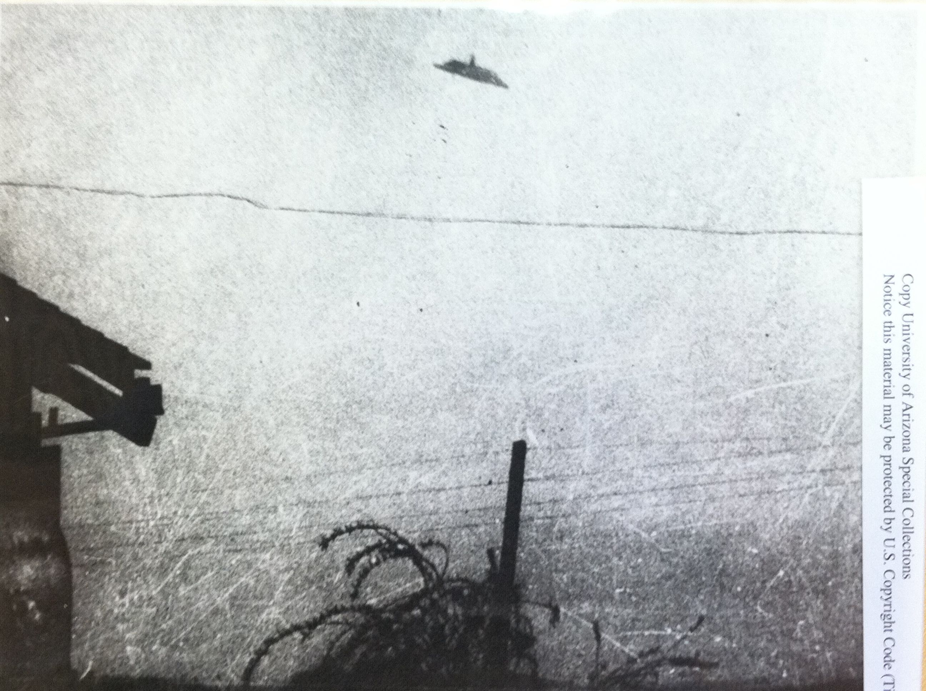 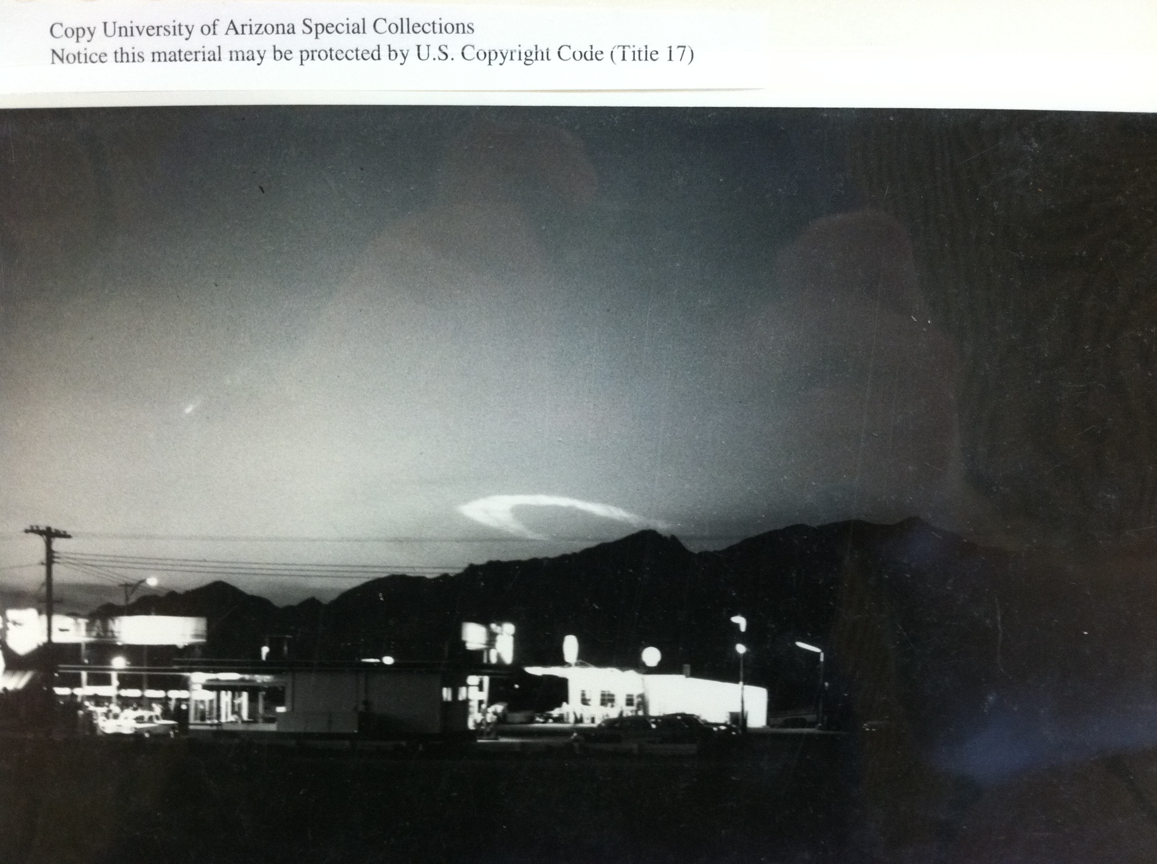

Special Collections, The University of Arizona Libraries, James E. McDonald Papers (1904-1997) MS412 – Box 21. Picture of a circular stratospheric cloud over Tucson, Arizona (Feb. 28, 1963).

Bibliography

1) Two Samples of Scorched Earth From Reported UFO Landing Site, South Hill Virginia (April 21, 1967), Special Collections, The University of Arizona Libraries, James E. McDonald Papers (1904-1997) MS412 – Box 31.

2) Anne Druffle, Firestorm: Dr. James E. McDonald’s Fight for UFO Science (The Wild Flower Press, Albuquerque, 2003).

3) James E. McDonald Papers, Special Collections, The University of Arizona Libraries. MS412 – Box 49.

4) James E. McDonald Papers, Special Collections, The University of Arizona Libraries. MS412 – Box 49.

5) Memorandum, SAC (Special Agent in Charge), New York, To Director, FBI (March, 24, 1969).

6) Memorandum, SAC, Phoenix, To Director, FBI (May 19, 1969).

7) Robert Mueller, Air Force Bases Volume I, Active Air Force Bases Within the United States of America on 17 September 1982, Office of Air Force History (Washington, DC,1989).

8) Paul S. Martin and Cornelius Steelink, "The Titanizing of Tucson." Bulletin of the Atomic Scientists 17, no. 4: 167-168 (1961).

9) James E. McDonald, “An analysis of Effects of a Nuclear Attack on Tucson and Phoenix,” Journal of the Arizona Academy of Science , Vol. 1, No. 2 (Oct., 1959), pp. 41-52.

10) James E. McDonald Papers, Special Collections, The University of Arizona Libraries. MS412 – Box 49.

11) “US Scientists Say Air Force Making Deadly Errors,” Arizona Daily Star (Nov. 9, 1959).

12) James E. McDonald Papers, Special Collections, The University of Arizona Libraries. MS412 – Box 49.

13) “Missile Might – Minute Men Action”, Wall Street Journal (May 15, 1962), Special Collections, The University of Arizona Libraries, James E. McDonald Papers (1904-1997) MS412 – 48.

14) James E. McDonald Papers, Special Collections, The University of Arizona Libraries. MS412 – Box 49.

15) James E. McDonald Papers, Special Collections, The University of Arizona Libraries. MS412 – Box 5.

16) “US Cuts Back on B-70,” New York Times (April 18, 1960), Special Collections, The University of Arizona Libraries, James E. McDonald Papers (1904-1997) MS412 – 48.

17) “Cuban Crisis Stirs Campus,” Arizona Daily Wildcat (Oct. 28, 1962), Special Collections, The University of Arizona Libraries.

18) Donald Menzel, Flying Saucers (Harvard University Press, Cambridge, 1953).

19) Thornton Page, “Educational Aspects of the UFO Phenomena, a Summary,” AIAA Presentation, (Oct 22, 1969).

20) William Burrows, This New Ocean (Random House, New York,1999).

21) “Truth Claims Reds Have Pluto’s Leash,” Arizona Daily Wildcat (March 4, 1960), Special Collections, The University of Arizona Libraries.

22) Arizona Alumnus Magazine, Calendar Issue (1967), The University of Arizona Libraries, James E. McDonald Papers (1904-1997) MS412 – Box 34.

23) Philip Klass, “The Fly in the Saucer,” Parade (April 4, 1969), Special Collections, The University of Arizona Libraries, James E. McDonald Papers (1904-1997) MS412 – Box 7.

24) James E. McDonald Papers, Special Collections, The University of Arizona Libraries, MS412 – Box 9.

25) Contract Between ONR and James E. McDonald $38,000 ($17,000 Salary) (July 28, 1966), The University of Arizona Libraries, James E. McDonald Papers (1904-1997) MS412 – Box 9.

26) Robert A. Frosch, The University of Arizona Libraries, James E. McDonald Papers (1904-1997) MS412 – Box 9.

27) Paul Harvey, “Dr. McDonald Not Alone, UFOs get Official Recognition,” Tucson Daily Citizen (Jan. 3, 1969), The University of Arizona Libraries, James E. McDonald Papers (1904-1997) MS412 – Box 49.

28) “Normal Criteria Not Met, CU Aide Slaps Study,” Denver Post (Oct. 6, 1966), The University of Arizona Libraries, James E. McDonald Papers (1904-1997) MS412 – Box 19.

29) “Dr. Condon Held Key Atom Roll,” Denver Post (Oct. 7, 1966), The University of Arizona Libraries, James E. McDonald Papers (1904-1997) MS412 – Box 19.

30) “UFO Prober Held in Boulder Narcotics Raid,” Rocky Mountain News (March 2, 1968), The University of Arizona Libraries, James E. McDonald Papers (1904-1997) MS412 – Box 19.

31) “UFO Study Assailed as Inadequate,” Denver Post (Feb. 18, 1968), The University of Arizona Libraries, James E. McDonald Papers (1904-1997) MS412 – Box 19.

32) Mary Lou Armstrong, The University of Arizona Libraries, James E. McDonald Papers (1904-1997) MS412 – Box 3.

33) James E. McDonald Papers, Special Collections, The University of Arizona Libraries. MS412 – Box 3.

34) John G. Fuller, “The Flying Saucer Fiasco,” Look Magazine (May 14, 1968).

35) “Only Congress Can Resolve UFO Problem,” Arizona Daily Wildcat (June 21, 1968), The University of Arizona Libraries, James E. McDonald Papers (1904-1997) MS412 – Box 3.

36) No Author, “UFO Research Chief at CU Disenchanted,” Rocky Mountain News (Sept. 22, 1967).

37) Special Collections,The University of Arizona Libraries, James E. McDonald Papers (1904-1997) MS412 – Box 41, Letter from fellow U of A scientist William K. Hartman.

38) James E. McDonald, "Cities Into Targets," The Nation 190, no. 21: 436-438 (1960).

39) E.U. Condon, Scientific Study of Unidentified Flying Objects (The Condon Report)(Bantam Books, New York,1969).
40) J. Allen Hynek,"Are All Flying Saucers Real?" Saturday Evening Post 239 (1966).
41) Phillip M. Boffey, “UFO Study: Condon Group finds No Evidence of Visits from Outer Space,” Science, Vol. 163 (1969) 260-262.

42) Frank B. Salisbury, “The Scientist and the UFO.” BioScience Vol. 17 No 1 (1967) 15-24.

43) F.P. Hughes, “A Trained Eye on UFO's.” Science Vol. 156, No. 3780 (Jun. 9, 1967), pp. 1311-1312.

44) Eugene Burdick and Harvey Wheeler, Fail-Safe (Harper Collins, New York, 1962).

45) Ron Westrum, “Social Intelligence about Anomalies: The Case of UFOs,” Social Studies of Science Vol. 7, No. 3 (Aug., 1977), pp. 271-302.

46) E.U. Condon, "UFOs I Have Loved and Lost," Bulletin of the Atomic Scientists 25, no. 10: 6-8 (1969).

Two Samples of Scorched Earth From Reported UFO Landing Site, South Hill Virginia (April 21, 1967), Special Collections, The University of Arizona Libraries, James E. McDonald Papers (1904-1997) MS412 – Box 31.
Anne Druffle, Firestorm: Dr. James E. McDonald’s Fight for UFO Science (The Wild Flower Press, Albuquerque, 2003).
James E. McDonald to Richard Harvill (March 14 1960), Special Collections, The University of Arizona Libraries, James E. McDonald Papers (1904-1997) MS412 – Box 49.
James E. McDonald to Dean of Graduate Studies (May 18, 1959), Special Collections, The University of Arizona Libraries, James E. McDonald Papers (1904-1997) MS412 – Box 49.
Memorandum, SAC (Special Agent in Charge), New York, To Director, FBI (March, 24, 1969).
Memorandum, SAC, Phoenix, To Director, FBI (May 19, 1969).
Robert Mueller, Air Force Bases Volume I, Active Air Force Bases Within the United States of America on 17 September 1982, Office of Air Force History (Washington, DC, 1989).
Paul S. Martin and Cornelius Steelink, "The Titanizing of Tucson," Bulletin of the Atomic Scientists 17, no. 4: 167-168 (1961).
James E. McDonald, “An Analysis of Effects of Nuclear Attacks on Tucson and Phoenix,” Journal of the Arizona Academy of Science , Vol. 1, No. 2 (Oct. 1959), pp. 41-52.
James E. McDonald to the Editors of the major newspapers of Topeka, KA, Kansans City, MO, Cheyenne, WY, Los Angeles, CA, Denver, CO (1959), Special Collections, The University of Arizona Libraries, James E. McDonald Papers (1904-1997) MS412 – Box 49.
“US Scientists Say Air Force Making Deadly Errors,” Arizona Daily Star (Nov. 9, 1959).
James E. McDonald to William R. Matthews, Editor, Arizona Daily Star (May 12, 1961).
“Missile Might – Minute Men Action,” Wall Street Journal (May 15, 1962), Special Collections, The University of Arizona Libraries, James E. McDonald Papers (1904-1997) MS412 – 48.
James E. McDonald to Editor, Manchester Guardian (Nov. 30, 1960), Special Collections, The University of Arizona Libraries, James E. McDonald Papers (1904-1997) MS412 – Box 48.
James E. McDonald to Senator Barry Goldwater (May 29, 1960), Special Collections, The University of Arizona Libraries, James E. McDonald Papers (1904-1997) MS412 – Box 5.
“US Cuts Back on B-70,” New York Times (Apr. 18, 1960), Special Collections, The University of Arizona Libraries, James E. McDonald Papers (1904-1997) MS412 – 48.
“Cuban Crisis Stirs Campus,” Arizona Daily Wildcat (Oct. 28, 1962), Special Collections, The University of Arizona Libraries.
Donald Menzel, Flying Saucers (Harvard University Press, Cambridge, 1953).
Thornton Page, “Educational Aspects of the UFO Phenomena, a Summary,” AIAA Presentation, (Oct. 22, 1969).
William Burrows, This New Ocean (Random House, New York, 1999).
“Truth Claims Reds Have Pluto’s Leash,” Arizona Daily Wildcat (March 4, 1960), Special Collections, The University of Arizona Libraries.
Arizona Alumnus Magazine, Calendar Issue (1967), The University of Arizona Libraries, James E. McDonald Papers (1904-1997) MS412 – Box 34.
Phillip Klass, “The Fly in the Saucer,” Parade (April 4, 1969), Special Collections, The University of Arizona Libraries, James E. McDonald Papers (1904-1997) MS412 – Box 7.
James E. McDonald to Philip J. Klass (Sept. 28, 1966), Special Collections, The University of Arizona Libraries, James E. McDonald Papers (1904-1997) MS412 – Box 9.
Contract Between ONR and James E. McDonald, $38,000 ($17,000 Salary) (July 28, 1966), The University of Arizona Libraries, James E. McDonald Papers (1904-1997) MS412 – Box 9.
Robert A. Frosch to Richard Harvill (Nov. 4, 1968), The University of Arizona Libraries, James E. McDonald Papers (1904-1997) MS412 – Box 9.
Paul Harvey, “Dr. McDonald Not Alone, UFOs get Official Recognition,” Tucson Daily Citizen (Jan. 3, 1969), The University of Arizona Libraries, James E. McDonald Papers (1904-1997) MS412 – Box 49.
“Normal Criteria Not Met, CU Aide Slaps Study,” Denver Post (Oct. 6, 1966), The University of Arizona Libraries, James E. McDonald Papers (1904-1997) MS412 – Box 19.
“Dr. Condon Held Key Atom Roll,” Denver Post (Oct. 7, 1966), The University of Arizona Libraries, James E. McDonald Papers (1904-1997) MS412 – Box 19.
“UFO Prober Held in Boulder Narcotics Raid,” Rocky Mountain News (March 2, 1968), The University of Arizona Libraries, James E. McDonald Papers (1904-1997) MS412 – Box 19.
“UFO Study Assailed as Inadequate,” Denver Post (Feb. 18, 1968), The University of Arizona Libraries, James E. McDonald Papers (1904-1997) MS412 – Box 19.
Mary Lou Armstrong to James E. McDonald (Feb. 1, 1968), The University of Arizona Libraries, James E. McDonald Papers (1904-1997) MS412 – Box 3.
Richard H. Hall to James E. McDonald (Feb. 12, 1968), The University of Arizona Libraries, James E. McDonald Papers (1904-1997) MS412 – Box 3.
John G Full, “The Flying Saucer Fiasco,” Look Magazine (May 14, 1968).
“Only Congress Can Resolve UFO Problem,” Arizona Daily Wildcat (June 21, 1968), The University of Arizona Libraries, James E. McDonald Papers (1904-1997) MS412 – Box 3.

